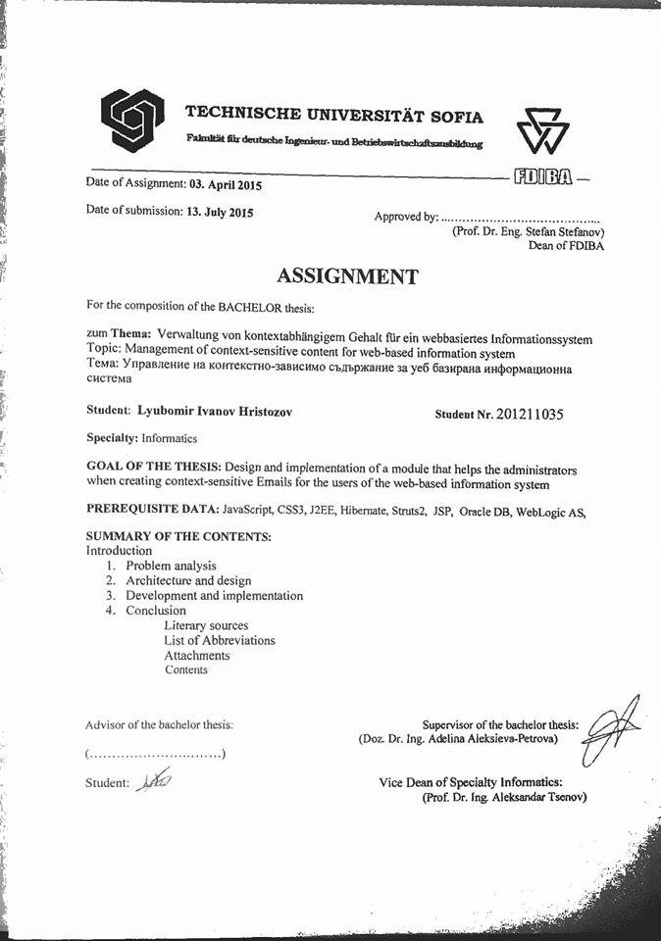

Table of Contents

List of Abbreviations 4

Introduction 5

1. Problem analysis 6

1.1. Overview of already existing solutions 6

1.1.1. Email Templates AutoMailer 6

1.1.2. Templates Email Marketing 9

1.2. Conclusion 11

1.3. Goal and tasks of the bachelor thesis 11

2. Architecture and design 13

2.1. Programing language, platforms, libraries, IDE 13

2.1.1. Java Enterprise Edition 13

2.1.2. JavaServer Pages 13

2.1.3. Struts2 15

2.1.4. Hibernate 17

2.1.5. CSS3 19

2.1.6. Bootstrap 3 19

2.1.7. JavaScript 20

2.1.8. JQuery 20

2.1.9. IDE 21

2.2. Solution to the problem 21

2.3. Web Application Architecture 25

2.3.1. What’s a web application architecture 25

2.3.2. Architecture of the module 26

2.4. Data organization 27

2.4.1. ER model of the DB 27

3. Practical solution 32

3.1. Setting up the Workspace 32

3.2. File Structure of the application 33

3.3. Presentation Layer 34

3.4. Model Layer 39

3.5. Controller Layer 42

3.6. Additional use of the email templates 45

3.7. User guide for the module 47

4. Conclusion 50

4.1. Summary of the results 50

4.2. Ideas for future research and development 50

Literary sources 51

Attachments 52

# List of Abbreviations

|  |  |
| --- | --- |
| Acronym | Meaning |
| IT | Information Technology |
| UI | User Interface |
| SDK | Software Development Kit |
| API | Application Programming Interface |
| GUI | Graphic User Interface |
| XML | Extensible Markup Language |
| HTML | Hypertext Markup Language |
| CSS | Cascading Style Sheet |
| IDE | Integrated Development Environment |
| JSP | JavaServer Pages |
| JS | JavaScript |
| DB | Database |
| WYSIWYG | What You See Is What You Get |
| JVM | Java Virtual Machine |
| MVC | Model View Controller |
| POJO | Plain Old Java Object |
| RMI | Remote Method Invocation |
| EJB | Enterprise Java Beans |
| URI | Uniform Resource Identifier |
| AJAX | Asynchronous JavaScript and XML |
| ORM | Object Relational Mapping |
| JPA | Java Persistence API |
| SQL | Structured Query Language |
| HQL | Hibernate Query Language |
| DOM | Document Object Model |
| SVN | Subversion (Repository) |
| ER | Entity Relationship |
| URL | Uniform Resource Locator |

# Introduction

All around the world people use emails as a mean to communicate with each other. What happens when you have a large network of contacts you wish to inform for some event? No matter how fast and good you are at typing emails, this task is time consuming and nerve wracking. The solution for this problem comes in the form of templates, previously recorded messages which you simply apply to your emails. With the help of templates people can send emails fast and efficiently, but there is one problem. When you send an email with a template you have to make the template “work” in the general cases and from that derive the problem: the people that receive such emails will not feel connection to you and probably ignore your message. To increase the chance not to be ignored you have to use context-sensitive content. With simple words that means that in the templates there are defined key words, which change their context according to the person to whom the email is send.

Considering all of the above, we have chosen as a main objective of this diploma thesis the design and implementation of a module for management of context-sensitive content for web-based information system. For the purpose of completing the objective of the thesis I have identified a few main processes. The first ordeal will be the research of the various ways for extracting data from the emails/DB. The Second will be to choose the most appropriate one and last but not least will be the implementation of the GUI for the management of the context-sensitive content.

In the next few chapters of the thesis a detailed overview of the template module will be given. First a comparison with other modules with the same functionality will be made. After that the technologies that have been used to create the module will be presented and a short explanation of them will be given. An explanation of the module architecture and how the front-end and back end work with each other will also will be given. At the end of the thesis user guide that show the complete form of the module will be presented.

# Problem analysis

## Overview of already existing solutions

The concept of personalized email templates is largely used and has many implementations. In this section we will try to examine and compare different solutions and ours.

### Email Templates AutoMailer

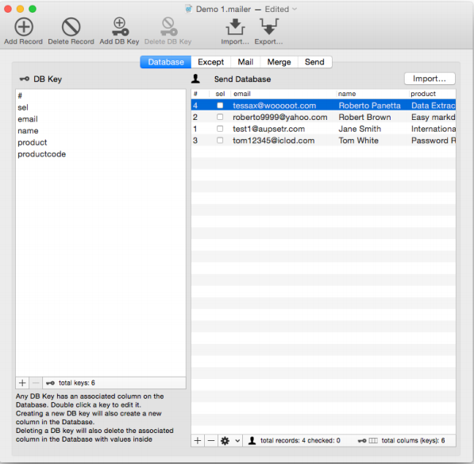

Fig 1: DB keywords creation in AutoMailer

AutoMailer is a flexible tool to manage your mailing list directly from your Mac. It offers a variety of functionalities one of which is personalized emails [1].

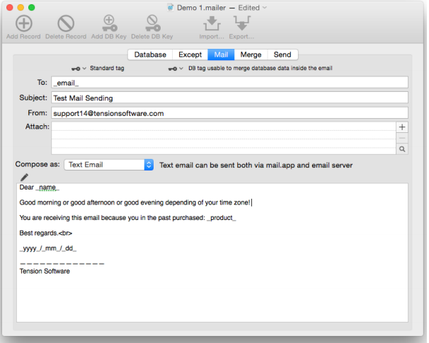

Fig 2: DB keywords usage in AutoMailer

**The email templates of AutoMailer offer the following functionality:**

* Document based, allows to save data and setting and have them ready for successive uses
* Possibility to manage an infinite number of data and letter template thanks to the document based approach with maximum flexibility of use.
* Very simple creation of email templates with keywords insertion to put database data inside the emails for any email recipient
* Automatically updated popup to insert data keywords inside the email template
* Live preview for any email to send with updated data (you see the email as the recipient will see it)
* There's no need to save, the application does it for you. Always.
* Big emphases on simplicity and intuitive way of usage.

The Application is simple, intuitive and with a clean UI. The main functionality is to allow the users to send personalized emails to multiple addresses, each merged with data from an internal database [1].

In the module for management of context-sensitive content, that is the objective of this thesis work, are incorporated some of the functionality from the email templates of AutoMailer application. A flow in AutoMailer is that it is not supported on windows and android devices. That is a major restriction on the windows/android users, which leads to profit loss on the company side. The fact that the user has to install the application on his local device can also be said as a shortcoming – if it was web based the users could have had access to the system from any device at their disposal. The following table (table 1) compares the emails templates of AutoMailer and the module that is object of this thesis.

|  |  |  |
| --- | --- | --- |
|  | **Email Templates of AutoMailer** | **Email Templates Module**  **Of Muffing Gamification** |
| Target Group | People who have large email list and want to send personalized emails. | Direct use in the web based information system Muffin Gamification. |
| Platform | OS X , iOS | It is web-based i.e. it can be used on any platform that supports internet |
| Dropdown menu in the composition of new emails with keywords. | No | Yes |
| Creating new keywords from the UI. | Yes | No |
| List of Templates. | No | Yes |
| Feature to create draft templates. | No | Yes |
| Feature to save templates for later usage. | No | Yes |
| Validation for user actions. | Yes | Yes |
| Live preview for emails. | Yes | No |
| Auto complete of keywords in mail content. | Yes | No |

Table 1: Comparison between Muffin Gamification Email Templates module and AutoMailer Email Templates module

In conclusion the email templates module of the Muffin Gamification web-based information system has bigger functionality than the email templates of AutoMailer.

### Templates Email Marketing

Email Marketing is a web based information system that targets various businesses [2].

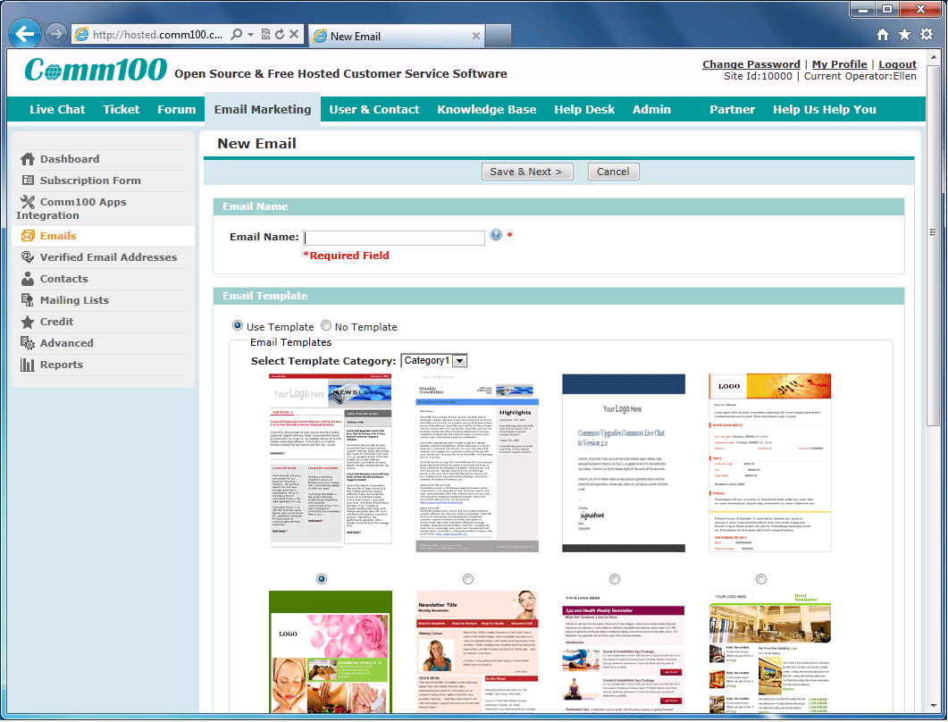

Fig 3: List of premade templates in Email Marketing

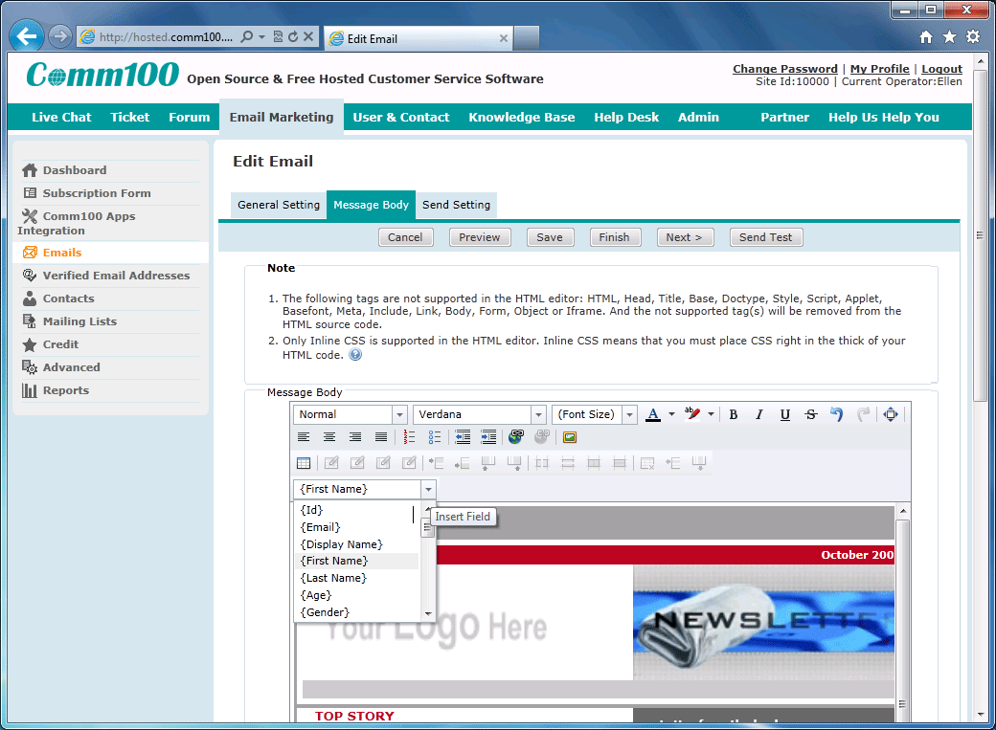

Fig 4: Keywords usage in Email Marketing

**The email templates of Email Marketing offer the following functionality:**

* List of Professional Email Templates
* Easy-to-Use WYSIWYG HTML Editor
* Email Personalization
* No Installation & Zero Maintenance

Email Marketing offers a large variety of premade templates, that the users can change to his or her liking. The users don’t require any technical expertise for personalization of emails with logos, images, color, etc. The application offers a large diversity of the most used keywords such as {First Name}, {Last Name}, {Age}, etc.

The difference between the templates module of Email Marketing and the templates module that is the objective of the thesis is mainly in the WYSIWYG HTML editor of the templates. In the Muffin Gamification templates module the customization of the content is harder and not so refined. Table 2 shows in more detailed way the differences between the two modules.

|  |  |  |
| --- | --- | --- |
|  | **Email templates module of Email Marketing** | **Email Templates Module**  **Of Muffing Gamification** |
| Platform | All devices that have internet access | All devices that have internet access |
| Dropdown menu in the composition of new emails with keywords. | Yes | Yes |
| Creating new keywords from the UI. | No | No |
| List of Templates. | Yes | Yes |
| Feature to create draft templates. | No | Yes |
| Feature to save templates for later usage. | Yes | Yes |
| Validation for user actions. | Yes | Yes |

Table 2: Comparison between Muffin Gamification Email Templates module and Email Marketing Email Templates module.

## Conclusion

In conclusion we can say that there are a lot of similar modules in the application that offer mail services. Every application has added different functionality depending on the needs of the clients but their primary function is the fastest, easiest and the most efficient way of creating personalized emails for mass email sending.

## Goal and tasks of the bachelor thesis

The goal of the bachelor thesis is to create a module that has the main functionality that is defined in the previous section (1.2.). The point of the module is not to be overcomplicated but to be a simple, clean, and intuitive module that can be used by people that have no technical knowledge.

The tasks are:

* Design of the DB that will be used.
* Implementation of a page for visualization and management of email templates.
* Building the UI for the page.

# Architecture and design

## Programing language, platforms, libraries, IDE

This chapter of the thesis describes the technologies used in to implement the module that is the objective of the thesis.

### Java Enterprise Edition

“Java Platform, Enterprise Edition (Java EE) is the standard in community-driven enterprise software. Java EE is developed using the [Java Community Process](http://www.jcp.org/), with contributions from industry experts, commercial and open source organizations, Java User Groups, and countless individuals”[5]. Even though I am not going to use a lot of these features Java EE includes a large variety of APIs such as RMI, e-mail, web services and XML. There are several unique specifications to Java EE: EJB, connectors, servlets, JSP and several web service technologies. If we keep in mind the fact that JDK is free to use and 2 of the best IDE that can be found use Java, Java is one of the main contributors to the open source community. With that been said I would like to point out that there are a lot of free to use libraries, some of them have event become an irreplaceable part of the programming community. Another advantage of Java is the large community that is always ready to help with algorithms, ideas and solutions to various problems.

### TypeScript

With the rapid development of JavaScript (from now called JS for short) emerged a lot of “deficits” that halt the developers to use the language for application-scale development. Features such as object orientation, compile time error handling and strong type checking are highly valued and sought after in today’s programming world. And with that comes TypeScript from now being called TS for short. As said above TS is an object oriented language that supports strong typing and compile time errors with the basic building blocks of JS. With other words TS is an enhanced version of JS (it is often said that TS is typed superset of JS that is compiled to JS).

Some of the important features of the language are exactly that the developers can easily switch from JavaScript to TS because of the similar syntaxes of both languages; TS can be consumed by any JS library and vice versa, meaning JS is TS and TS is JS. TS encompasses most of the basic features of ECMAScript5 (official specification for JS) and also incorporates features such as Modules, classes, generics and type annotations. So to sum up why I am going to use TS instead of JS for the implementation of the web based system:

* Compile time check – JS is interpreted language that needs to be ran to see if the code works, if everything is alright we see the result instantaneous but if there is error somewhere we have to spend a lot of time to investigate where and why our code doesn’t work correctly. TS with its compile time check don’t have such problems and we can save some investigation time.
* Strong Typing – JS doesn’t have types for the variables which inevitably leads to using variables that you are not sure exactly what they are hence increasing the possibility of making errors in your code. Once again TS has a solution for this problem – strong variable type.
* OOP – this is one of the most common and used principle in the programing. Like the back-end language that I am using for the project(Java) TS also supports concepts like classes, interfaces that will in its most insignificant part boost the readability of the code for outside personnel and that is never to be underestimated for future development.

### Spring Framework / SpringBoot

When you start a project one of the things you have to consider are the frameworks that you are going to use. The Spring Framework is one of the most popular and used frameworks for java enterprise applications. Spring is open source, lightweight, high performing framework with which you can develop any java application but it is mostly use for its extensions for building web application on top of J2EE platforms. Some of benefits of using Spring are but not only:

* The design of the framework is modular, meaning even thou there are a lot of packages, classes and interfaces the developer doesn’t need to manage all of them, he or she only needs to tend to the ones he/she is using.

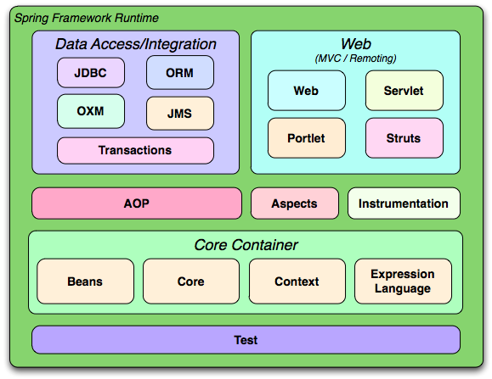

Spring Modules moje bi trqbva da q prepravq ili mahna nz

* The framework incorporates in itself a lot of well know technologies such as ORM frameworks, logging frameworks and J2E.
* Transaction management interface – you can easily scale your transaction up and down when needed.
* Dependency Injection – one of the fundamental concepts in developing application is the ability to test and reuse your code, meaning you don’t want your classes to be tightly coupled with each other. Here comes the Dependency Injection into play – it helps us supply the dependency between two classes. A simple example of that is when you have an object car and you know that the car needs another object engine – the DI can give you the already made instance of the engine object so you don’t need to create the engine manually.
* POJOs – you can use plain old java objects for better testing or simply to get whole objects from forms (send from the client side).

Spring also provides frameworks for security and data that can easily be used in your project to secure your application better or to simplify database access. Another one of the benefits of the framework is the flexibility to configure beans: currently there are 3 types for that – xml based approach, annotations and JavaConfig approach.

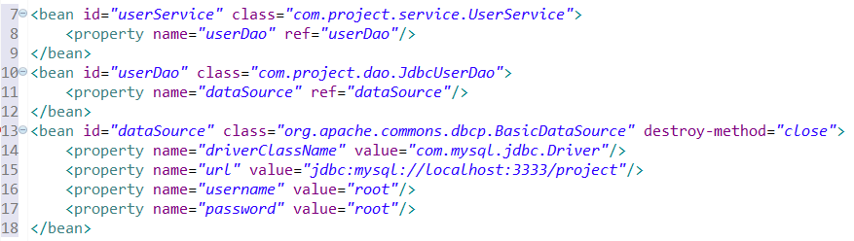

Example of XML approach

The flexibility here comes from the fact that you can use one or more meaning you can combine approaches) of the approaches to configure your beans depending on the situation at hand.

But one of the down sides of the Spring Framework is also the configuration part. Oftentimes when developers new to the framework try to build a project from the ground up, they have numerous problems with the setup. When you try to develop a typical spring/hibernate web application usually the processer of the configuration consists of the following: configure dependencies (using build tools such as maven or gradle), configure the various beans in spring framework (service/dao) – using the latest approach with JavaConfigs ypu can omit some of the lightly descriptions of configurations and using simple properties files (FIGURE)

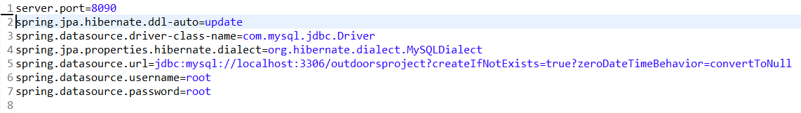

Properties File Figure

And last but not least you have to configure front controller of this Spring Web application, responsible for handling all application requests i.e. the Spring DispatcherServlet which in itself can be configure in multiple ways. As you can already figure out configuring the framework is not very fast and easy if you have not done it multiple times:

* You are not always sure which libraries you need for your project to run, so you can miss some
* You have to spend some extra time while configuring the DB connections (EntityManager, TransactionManager)
* Configuring the various Spring Beans
* Configuring a web application server

All of these configurations are simplified and even in some cases made automatic by SpringBoot. For example the dependency/library management - in case of the most basic application instead of adding numerous dependencies, with SpringBoot you only need to add 2: spring-boot-starter-web and spring-boot-starter-data-jpa. These two dependencies are easily managed and pull every necessary library that you need such as spring-webmvc, spring-data-jpa, hibernate, tomcat and more. Springboot also creates default configurations for some of the most commonly used beans – front controllers and database connections. Spring-boot-starter-web very conveniently also pulls a servlet container (tomcat) on which serves as an embedded container where you can deploy your application without needing to install an external server/container.

<http://javainfinite.com/spring/life-cycle-bean-factory-application-context/>

nakraq flow-a na spring ? https://stackoverflow.com/questions/11359607/understanding-basic-spring-framework-and-total-flow

### Hibernate (spring-boot-starter-data-jpa)

As already mention above the spring-boot-starter-data-jpa is responsible for pulling a lot of useful libraries that help us with the development and one of those is Hibernate. Hibernate is an Object/Relational Mapping (ORM) framework. With that the framework helps the developers to write applications whose data persist after the applications process. In simpler words, that means that the objects that we use can be available for later usage. While Hibernate has its own API it also uses the Java Persistence API (JPA) which further simplifies and eases its use in any environment supporting JPA. Following the natural object-oriented idioms (inheritance, polymorphism, association, composition and java collections framework) Hibernate allows the developers to create persistent classes with ease. With no requirements for a special database tables and SQL generation at the system initialization time – Hibernate has very high performance. Other reasons for the high performance are the numerous fetching strategies and the usage of eager and lazy initialization. [11]

There is no need to fully understand SQL to use Hibernate, but the understanding of table joins is a must. As the core of relational database, the joins define the relationship between two (or more) tables (When we use the term tables, we also mean objects and visa versa. That is possible because Hibernate is ORM - we create objects with the information from the tables). The need to understand the relationships comes from the necessity to define the fetch type. Their role is simple but important. The fetch types decide whether to load all of the relationships of an object or not when it is initially fetched.

Whenever you specify a relationship (OneToOne, OneToMany, ManyToMany) you also have to specify the fetch type. By default the fetch type is set to “Lazy”. That means that whenever you load up something with Hibernate query, Hibernate will not load the information related to other tables (unless explicitly asked) and if you try to access it you will get a NullPointerException. If the “Lazy” fetch type doesn’t allow Hibernate to load the relationships of an object then the “Eager” fetch type does the opposite. It load all of the relationships related to the object. If the “Lazy” fetch type can (and possibly will) throw a NullPointerException why use it? The reason is simple – it’s faster. Imagine that you want access to an object but the object has 10 relationships to other objects. If you use “Eager” fetch method you have to load all of the objects and that’s time consuming. And what happens if every one of those 10 objects has other 10 more relationships to other objects? In conclusion the “Eager” fetch method is more convenient in some ways but can lead to massive delay in the application. With “Lazy” fetch type the developer has to write more code but in the end it’s faster and more efficient.

To ease the usage of Hibernate, it uses a HQL - special query language that’s close to SQL but is fully object-oriented and can understand the OOP principles like inheritance, polymorphism and association. HQL is also case-insensitive (exceptions are the java classes and properties and column names). That means that sElect is the same as SELECT. [14]

|  |  |
| --- | --- |
| SQL | HQL |
| SELECT * FROM users | from Users |
| SELECT *  FROM accounts a, users u  WHERE  a.owner_id = u.user_id  and u.user = '18' | from site.Account account  where  account.owner.id.age = ‘18’ |
| SELECT distinct CONT_NAME  FROM CONTINENT  INNER JOIN COUNTRY on  CONTINENT.CONT_ID = COUNTRY.CONT_ID  WHERE AREA > 10000 | select distinct cont.name  from Continent cont joincont.countries ctry  where ctry.area > 10000 |

Table 3: Comparison between SQL and HQL

With all those features of Hibernate, there is no reason not to use it. And the people from the Spring community come one step further in simplifying its use. With the inclusion of the spring boot starter jpa you automatically get the jpa specification and hibernates implementation as a default, auto reading the data base configurations from the application.properties file and auto creation of entities as tables. Another big improvement is the Spring CrudRepository which builds up on top of the ordinary Hibernate and provides default implementations for the basic CRUD operations i.e. you don’t have (even thou you can) write hql/sql queries.

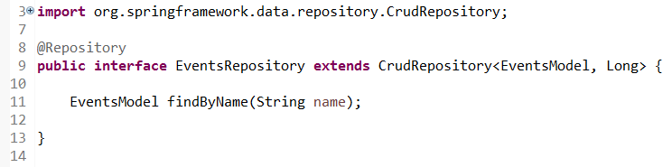

Figure ABOUT CRUD REPOSITORY

### CSS3

CSS3 is the latest standard for CSS. While it supports all of the previous versions of CSS it also adds a lot of new features such as rounded corners, animations, shadows and a few new layouts – multi-columns, grid layout. Due to holdbacks of secondary features CSS level 2 needed 9 years to reach the Recommendation status. Thus the CSS Working Group of the W3C took a different approach. They divided CSS in smaller components called modules. Each module is now independent part of CSS and it is developed at its own pace. Some of the most important CSS3 modules are: Selectors, Box Model, Text Effect, 2D/3D Transformations, Animations, Multiple Column Layout and User Interface.

Sadly a big part of the functionality of CSS3 is not supported by some of the older versions of the web browsers. This leads to the additional use of JS to recreate the missing functionality of the unsupported tags. [8]

### Bootstrap 3

Bootstrap (originally named as Twitter Blueprint) is free, open-source framework created for the purpose of easing the creation of websites and web applications. It contains HTML and CSS based design templates for various elements such as: typography, forms, tables, buttons, navigation and many other interface components. One of the main features of bootstrap is the responsive design. With its flexible grid structure the framework is perfect for web applications that look good on all of the different devices. Bootstrap defines 4 display resolutions categories:

* Xs – extra small (under 768px width, for phones)
* Sm – small (over 768px width, for tablets)
* Md – medium (over 992px width, for desktops)
* Lg – large (over 1200px width, for larger desktops)

The categories above can be combined to create more dynamic and flexible layouts. [9]

### Angular 2/5

OverView of Anuglar

### JQuery

JQuery is a JavaScript library that simplifies the front-end scripting of HTML. Being free, open-source and simple to learn and use, jQuery has become the most popular JS library. The syntax of the library is design to make ease the events handling, creation of animations, DOM element selection and navigation through a document. In its core jQuery has a DOM manipulation library. Being tree-structure every element in the DOM can be easily found, selected or manipulated with jQuery. The library has several advantages [17]:

* Encourages JS and HTML separation
* Brevity and Clarity – usage of chain-able function and shorthand function names is being promoted
* Eliminates cross-browser incompatibilities – while JS can work on some browsers and not on others, jQuery eliminates all those cross-browser inconsistencies and works as intended from the developer.
* Extensible – extending the framework though events, methods and elements is easy

### IDE

The IDE used to accomplish the objective of the diploma thesis is NetBeans. As one of the tree best (Eclipse, IntelliJ) IDEs, NetBeans offers a large variety of functionalities. The developers can adjust almost everything in the visual aspect of the IDE to their liking. NetBeans also offers autocomplete of the code and a debugger witch is very easy and intuitive to use.

## Solution to the problem

To complete the objective of the bachelor thesis we have decided to use the technologies, libraries and programing languages that are described in the previous section of the thesis. To achieve a nice, clean and intuitive module for templates, everything has to be kept as simpler as it can be while keeping as much of the functionality.

When the page is loaded on the left side will be located a list of the already created templates. The list will be loaded from the database automatically when the administrator enters the web page. When the administrator clicks on a template from the list the information for the template will be loaded in the forms next to the list. The list will have the functionality to mark the clicked template. When a new template is being created or an old one is being updated the list will automatically update itself to show the new changes.

Next to the list of templates will be positioned 3 forms. They will serve for:

* Showing the templates that the administrator has chosen from the list.
* Creating new templates
* Editing already existing templates

The first form will be for the name of the template and the second will be the content of the template. The second form has to have several functionalities: save the template as a template, save the template as a draft template, delete the current template and discard the content of the template. These functionalities will be achieved through the use of buttons that are located at the bottom of the form. Another functionality of the second form will be the ability to manipulate the content of the email template. That means that the admin will be able to align the text, change the font to some degree and be able to list various things inside the text. Other useful functionality will be the redo/undo section with which the administrator will be able to navigate through the changes that he or she has made in the current template (it will only work in the current session). To inform the administrator how long is the email template that he or she is writing, a functionality that counts the words in the content will also be added. The main functionality that is required for the completion of the objective of the thesis is the keywords that can be add to the templates. These keywords are special words that have different meaning depending on the context of the template. That means that when an email is being sent to a participant of any of the events that is being organized by MusalaSoft, he or she will receive an email that is specifically designed for him/her. The information which replaces the keywords is being directly extracted from the database and the administrator doesn’t need to do anything but simply create a meaningful template for the occasion that he/she wants. The adding of the keywords will happened with the help of a dropdown menu which is filled with premade keywords. The functionality the administrator to create his/her own keywords will not be a part of the module because this functionality will overcomplicate the module and hinder its usage. The solution of this problem comes in the form of a list (the dropdown menu) with the most used keywords such as first name, last name, email address and others. The last is a button that clears all of the unsaved changes and allows the administrator to start anew. Another functionality that the module has is the validation of the administration actions. When the administrator makes changes to the templates, creates new templates, deletes a template or any other action related to the templates he or she is being reminded that there are changes and that they are not saved. That is being done by a user friendly pop-up screen that offers several options such as OK, SAVE and CANCLE.

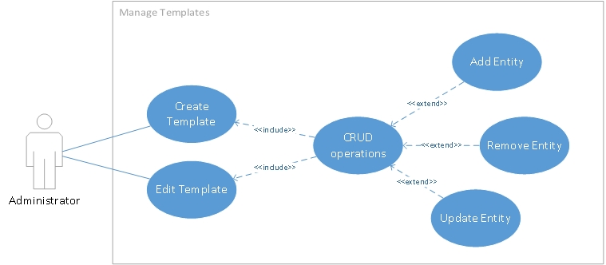

Figure 9: UML Use Case diagram for the template module

The presented Use Case Diagram shows a basic representation of the needed functionality for creating and editing the email templates. The functionalities are supported by the operations that they use.

As for the back-end functionality of the module, the following 2 flow char diagrams show the algorithms which will be used to create ready to be used templates and how draft templates will be made.

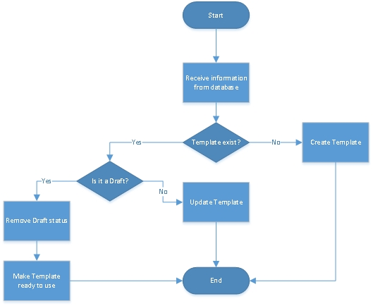

Figure 10: Flow Char diagram of the algorithm for creating a ready to use template

The main goal of the algorithm above will be to check if a template already exist in the database and take actions depending on the discovery. If the template exists the algorithm will make a new verification – if the template is recorded as a draft. If it’s a draft the algorithm proceeds with the necessary steps to convert the template to a usable state. If it’s not a draft, then the algorithm simply updates the already existing template with the new information.

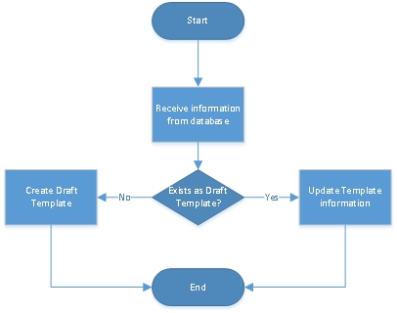

Figure 11: Flow Chart diagram of the algorithm for creating drafts

The main goal of the algorithm shown in fig. 11 will be to identify whether a template exist in the database in form of a draft template. If such template already exists then the algorithm will simply update the information that is stored in the database. If the template doesn’t exist as a draft template in the database the algorithm will create a draft template based on the information that the administrator has filled in the UI part of the module. If a Template with the necessary information, needed to be identified as a draft does not exists then the algorithm will also create a new Draft Template.

Another back-end functionality that is not yet mention will be the ability to substitute the above mention content “keywords” with real data that is extracted dynamically from the database when the administrator sends emails to the users of the Muffin System. All of the algorithms used in the module will be thoroughly shown and explained in the development and implementation part of the thesis.

## Web Application Architecture

### What’s a web application architecture

“Software Architecture is the fundamental organization of a system, embodied in its components, their relationships to each other and the environment, and the principles governing its design and evolution.”[ANSI/IEEE Std 1471‐2000]. Being a vital part of the web application a poorly selected architecture leads to low performance and availability, insufficient maintainability and expandability. On the other hand if the right architecture is being used it makes the system more understandable and flexible.

One of the most commonly used architectures (design pattern) is MVC. It is a 3-layer architecture with data layer, presentation layer and business layer. The data layer (Model) represents the core functionality of the system. It is also responsible to the DB manipulation. The presentation layer (View) renders the results of the requests in the desired format. The business layer (Controller) is responsible to connect the Model and the View. It’s also responsible for the actions of the users.

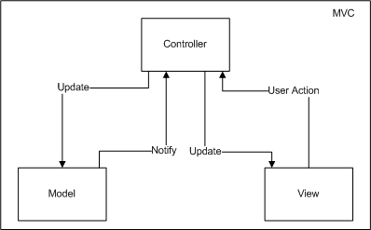

Figure 12: Simple representation of MVC

The MVC design pattern has 3 major benefits which make it one of the most popular and used design patterns in the web programming. The first one is the separation of concerns. The separation in different parts allow the developers to reuse the business logic and on a different units of the program without affection others. The second one is the specialization and focus of the developers. With clearly defined front-end and back-end the developers can focus solely on their tasks of the project i.e. UI developers work on the UI without caring how the back and works and visa versa – the back-end developers don’t need to know how the front-end works. The third benefit is a combination of the first two – parallel development. Without being bound the presentation logic and the business logic can be developed and updated separately from each other and without slowing each other down. With that being said, MVC is simple but very effective design pattern. [15][16]

### Architecture of the module

As shown above MVC fits perfectly for the needs of the module that is the objective of the bachelor thesis because it separates the business logic and the presentation layer.

The Model layer is composed of the following components:

* Oracle Database - object-relational database management system that stores the information
* Hibernate – ORM that uses JPA to manage the communication between the module and the DB
* Entities – Java classes that show the exact structure of the DB and store the information that is pulled from the DB.

The Presentation layer is composed of the following components:

* JSP – Technology that allows the developers to create dynamic web pages.
* Servlets – Java Classes that have doGet and doPost methods that respond to the clients requests.
* Struts2 Actions – Separate methods and classes that transfer date from the request through to the view and determine what result should be rendered in the view.

The Controller layer is composed of the following components:

* JavaBeans – Java classes that encapsulate a set of objects in one object.
* Session Beans – JavaBeans classes that prepare the data to be send or retrieve from the database.

Figure 13 shows graphically, how all of the above mention components are positioned in the MVC design pattern.

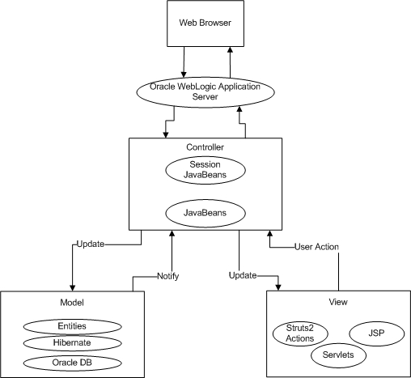

Figure 13: MVC for email templates module

## Data organization

To meet the requirements of the object of the bachelor thesis the module needs a place to store the information for each template. For that purpose we have decided to use an external database - Oracle Database 11g. We have decided on this Database management Systems because we also will be using Java and WebLogic Application Server. All of the three technologies are developed and supported by Oracle. That will ease their use and integration. Combined with Hibernate ORM, the manipulation of information from the DB becomes quick and easy.

### ER model of the DB

The presented relationships between the different DB tables show the database structure for the module. For clarity of the ER model the types of the attributes are not included.

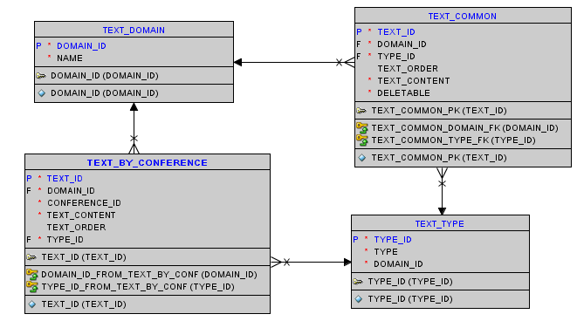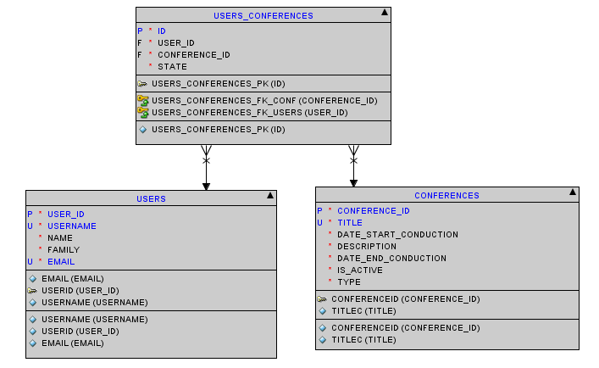

Figure 14: ER Diagram of the DB

Table TEXT_DOMAIN – Except templates there are also different kind of text that are being used in the application. This table serves to divide the different types of text.

|  |  |  |
| --- | --- | --- |
| Attribute | Type | Description |
| DOMAIN_ID | NUMBER | Id of the domain |
| NAME | VARCHAR (256 BYTE) | Name of the domain |

Table TEXT_COMMON – This table stores the information about the templates. It has relationships with TEXT_DOMAIN and TEXT_TYPE

|  |  |  |
| --- | --- | --- |
| Attribute | Type | Description |
| TEXT_ID | NUMBER | Id of the text |
| DOMAIN_ID | NUMBER | Id of the domain |
| TYPE_ID | NUMBER | Id of the type |
| TEXT_ORDER | NUMBER | Order of text |
| TEXT_CONTENT | CLOB | Stores the content of the template |
| DELETABLE | NUMBER | Shows if a template can be deleted |

The table is related to TEXT_DOMAIN and TEXT_TYPE through the DOMAIN_ID and the TYPE_ID. If the DOMAIN_ID is equals to 2, the text is identified as a template. The DELETABLE attribute shows whether a template can be deleted or not. If the value of the field is “0” the administrator can delete the template from the database and if its “1” the administrator can’t.

Table TEXT_BY_CONFERENCE – contains the information for every event

|  |  |  |
| --- | --- | --- |
| Attribute | Type | Description |
| TEXT_ID | NUMBER | Id of the text |
| DOMAIN_ID | NUMBER | Id of the domain |
| CONFERENCE_ID | NUMBER | Id of the conference |
| TEXT_CONTENT | VARCHAR2(3000 BYTE) | Content of the text |
| TEXT_ORDER | NUMBER | Order of text |
| TYPE_ID | NUMBER | Id of the type |

CONFERENCE_ID connects the text to specific event.

Table TEXT_TYPE – this table is used to mainly to store the titles of texts

|  |  |  |
| --- | --- | --- |
| Attribute | Type | Description |
| TYPE_ID | NUMBER | Id of the type |
| TYPE | NVARCHAR2 (256 CHAR) | Type of the text |
| DOMAIN_ID | NUMBER | Id of the domain - FK |

The Type attribute here is used to store the title of texts – all of the names of the templates are stored here

Table USERS_CONFERENCES – This table connects the users and the events

|  |  |  |
| --- | --- | --- |
| Attribute | Type | Description |
| ID | NUMBER | ID of the table |
| USER_ID | NUMBER | ID of the user |
| CONFERENCE_ID | NUMBER | ID of the conference |
| STATE | NUMBER | State of the user for the conference |

State: This attribute shows the state of the user according to the conference. The user can be rejected, approved, fully functional and not fully functional.

Table USERS – the table is used for storing the information of the users

|  |  |  |
| --- | --- | --- |
| Attribute | Type | Description |
| USER_ID | NUMBER | ID of the table |
| USERNAME | VARCAR2 (30 BYTE) | Username of the user |
| NAME | VARCHAR2 (50 BYTE) | Name of the user |
| FAMILY | VARCHAR2 (30 BYTE) | Family name of the user |
| EMAIL | VARCHAR2 (50 BYTE) | Email of the user |

Table CONFERENCES – the table is used for storing the created conferences

|  |  |  |
| --- | --- | --- |
| Attribute | Type | Description |
| CONFERENCE_ID | NUMBER | ID of the conference |
| TITLE | VARCHAR2(200 BYTE) | Name of the conference |
| DATE_START_CONDUCT | DATE | Start time of the conference |
| DESCRIPTION | VARCGAR2(4000 BYTE) | Conference description |
| IS_ACTIVE | NUMBER (1,0) | Field which show if the conference is active |
| TYPE | NUMBER | Field which shows the type of the conference |

IS_ACTIVE: The conferences can be: 0 - draft, 1 - active, 2 – upcoming.

Type: There are 4 kinds of conferences: Seminar, @Uni, @School, @Conference.

# Practical solution

As mention earlier in the thesis the email template module is a part of a larger information system that is in the form of a web application. All of the technologies, libraries and programing languages listed in the architecture and design part of the thesis are being used for the implementation of the module for email templates. This implementation will be thoroughly reviewed and explained. The main focus will be on the presentation layer and the model layer and how they work and interact with each other.

## Setting up the Workspace

Being part of a larger project the first step in the development of the email templates module is to set up the workspace. In this part of the thesis, a short walkthrough will be given on the necessary steps to set up the workspace. Since we are planning to use Java as a main back-end technology first we need to have the Java Development Kit (JDK) installed on the computer that we will be using to develop the templates module. The installation of JDK is free and anybody can download it from the Oracle official site and install it. The next step is the installation of a software versioning and revision control system. We will be using SVN (Apache Subversion) because it offers an easy to use repository of current and historical versions of the projects files. SVN is being distributed as free software under the Apache License. The installation itself is very straightforward and without any configurations. The only configuration is when you connect the SVN to the already existing repository: selecting your project folder, right-clicking on the folder and selecting SVN Checkout. This will open a window with in which you have to fill the URL Repository field. The next step in the setting up of the workstation is the installation of an IDE. As said in the previous section we will be using NetBeans. There are differences between the versions of NetBeans and that can lead to errors in the application. That’s why all of the team members that are developing the application need to use the same version of the IDE. The version we will be using is 8.0. The installation file of NetBeans can be downloaded from their official web site. The framework we will be using is Struts2. NetBeans doesn’t have it integrated in itself but it can be added manually. For that first you need to download the Struts2 framework and extract the content of the archived file. After that in the IDE you have to navigate to Tools->Plugins->Downloaded->Add Plugins->select the content of the archive and click the install button. The next step in the setting up of the workspace is the installation, attaching to NetBeans and configuration of the WebLogic Server. WebLogic is a developed from Oracle and as such, it can be downloaded from their official site. To install the server you have to unzip the file that you have downloaded from the site. After that you have to open the command prompt and set MW_HOME and JAVA_HOME:

C:\Users\lyubomir.hristozov\Desktop\Diploma\Snimki za diplomna\Workspace\CMD.PNG

Figure 15: Example of setting up MW_HOME and JAVA_HOME though the CMD

After that you have to navigate to the installation folder and execute “configure.cmd. This will lead to you entering the username and password with which you will be login to the server’s console. To attach the server to NetBeans you navigate to the Services tab and right-click the servers and choose Add Server. After choosing the server (Oracle WebLogic) you have to navigate to the installation folder -> click OK and enter the username and password that you have used in the installation of the server. The configuration of WebLogic can be done through the server console (<http://localhost:7001/console>). After entering your credentials you have to connect the database of the project to the server. The final step in the setting up is the opening of the project itself and building it (right-click on the already loaded project Run->Clean and Build Project). After that the workstation is ready.

## File Structure of the application

In this section a short explanation of the file structure will be given. Being a J2EE project the files are organized in the standard application assembly (packaging) way. The packages can be divided in 2 types- module and full-fledged applications. A J2EE module is a collection of components of the same type such as web or EJB. The module also has to have the necessary type of deployment descriptors. If there are no deployment descriptors, the module can be deployed as a stand-alone module. There are four types of modules in which all of the projects files are stored: [12]

* EJB – contains bean classes and EJB deployment descriptors.
* Web Application Archive – contains HTML files, servlet class files, JSP files and deployment descriptors.
* Application client module – contains class files and supports the standard J2EE Application Client specifications. It also contains deployment descriptors.
* Resource adapter module – contains all java interfaces, classes, native libraries and resource adapter deployment descriptor.

## Presentation Layer

The presentation layer of the email template module is realized thought the use of JSPs, JS and CSS. The email template module uses a singular JSP which contains all of the necessary elements i.e. the list of existing template, the form for the content and the buttons to save/delete/discard. Because Struts2 framework is being used, the JSP contains Struts2 specific tags. The list of already created templates is displayed through such tags. It uses the <s: iterator> and <s: property> tags to fill a container with the template names. Every template name is being placed in separate div element (the code is shown on figure 16).

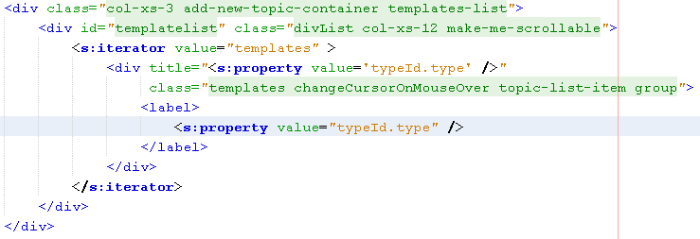

Figure 16: Code Snippet of the template list container.

To achieve the wanted visual outcome of the module (to have the form that is responsible for the content of the templates next to the list of templates) the grid system of bootstrap is being used. By using the bootstrap provided classes we can divide the screen in columns. Each container is divided in 12 columns. For the list of templates “col-xs-3” has been used. That leaves 9 columns for the container that holds the form for manipulating the email template’s content. Inside this container the bootstrap grid system has been used one more time – to arrange the buttons at the bottom of the form. Each one of the four buttons occupies an area of 3 columns of the container.

All of the functionalities in the presentation layers are achieved through the use of JavaScript. The following text and graphics are a detailed explanation of the methods and functions that have been used.

* loadAndRememberText (template) – this function loads the content of templates in to the form design to hold the content. It also remembers the template name.
* areThereAnyChanges – this function checks if there are any changes made in the description (content) and title of the template and returns true or false depending on the result. It is used for validation when the administrator wants to change template or has unsaved information.
* loadTemplateInfoRichBox – this function checks if the form which shows the content of the templates is initialized. If it’s not, this function initializes it with the necessary field. It is called when the page is loaded.
* confirmYourAction (text) – this function opens up a pop-up screen witch asks for the confirmation of the administrator. It offers several text options such as: delete, save, discard, save as draft, start new template, load template. This function is being used every time when the action of the administrator will lead to irreversible consequences regarding the templates.
* confirmYourActionAndSave (text) - in contrast to the previous function, this function allows the administrator to save the changes he or she has made before executing their action. Both functions have to be synchronized with the actions from which they are called. They need to return an answer to a question and depending on the answer, the actions perform differently.
* processTemplate (operation) – this function gets as a parameter a String which represents different kind of operations. The operation can be: save template, save as draft, delete, discard or update. This function is called mainly from the buttons that are located bellow the description (content) of the template.
* deactiveTopicSelectionHighlighting () – this function deactivates the highlighting of the selected template in the list of templates.
* highlightNewSelectedTopic() – this function highlights the clicked template name from the list of templates
* refreshTemplateGroups () – this function refreshes the template list if there are any changes made to the list.

There are several elements in the module that can trigger events:

* Delete Button – the delete button triggers an event leading to the removal of a template from the database:

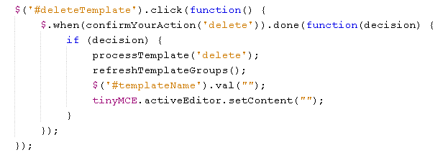

Figure 17: Code Snippet of the logic behind the delete button.

The code from figure 17 shows the logic behind the delete button. When the administrator has selected a template from the template list and clicks the delete button, he or she will be asked if he/she wants to proceed with the action. Here is the place where the “confirmYourAction” function comes in play. If the answer is positive (true) then the JavaScript continues with deleting of the template. After that it refreshes the template list and sets the fields for name and description (content) to an empty string. If the answer to the decision is negative (false) then the click event does nothing.

* Save As Draft Button – this button saves a template as a draft:

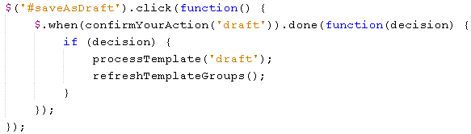

Figure 18: Code Snippet of the logic behind the save as draft button

The logic behind the “save as draft” button is very similar to the logic of the delete button. When clicked the administrator is asked if he/she is sure they want to proceed. If yes the template is being processed (saved in the DB) as a draft template and the list of templates is being refreshed with the new information.

* Discard Button – discards the content of the template

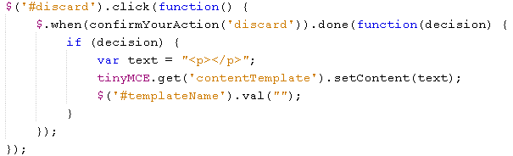

Figure 19: Code Snippet of the logic behind the discard button

When the discard button is being clicked a warning pop up will displayed to warn the administrator that he or she will lose the content (description) and name (title) of the template that is selected. The removal of the content is not permanent if it’s not saved.

* Create Template – prepares the field for a new template.

This button is similar to the discard button because it also clears all of the fields. The only difference is that it also unmarks the chosen email template (if any is selected).

* Save Template Button – saves the templates

This button saves the newly created templates and transforms the drafts to regular templates. The JavaScript here first checks if there are any changes made to the content (description) and the name (title) of the template. If there are changes a pop-up screen to note that is being shown. If the administrator chooses to proceed with the action, the script checks if the template is a draft or not and does the necessary operations to remove the visual draft status from the template.

* The highlighting of the templates in the template list

To prevent the administrator to accidently deleting the progress he or she has made in template that is being worked on, the template list except the highlighting of the chosen template, has the functionality to detect changes in the content (description) and title (name) of the templates. The following text explains the algorithm:

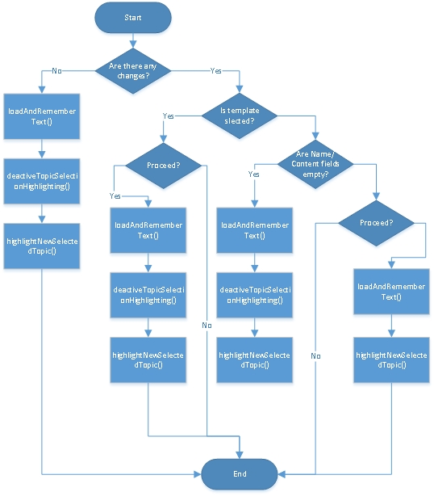

Figure 20: Flow chart diagram of the algorithm for highlighting chosen templates

First the algorithm checks if there are any changes made to the template (if one is loaded). If there are no changes, the script loads the selected template and highlights the name of the template in the template list. If there are changes, the script checks if any template in the template list has been chosen (highlighted). If it finds such a template the algorithm shows a pop-up for confirmation of the action (change of template). When a positive answer is given the algorithm proceeds to load the new template, deactivate the highlighting of the previous template and activates the highlighting of the new one. If the algorithm doesn’t find a chosen (highlighted) template it checks if the content (description) or the name (title) fields are empty the algorithm highlights the desired template and loads it. If the content and name fields aren’t empty the algorithm shows a pop-up for conformation of the action and base on the answer loads or not the content of the template. For better understanding of the algorithm figure 20 can be used.

## Model Layer

In the MVC design pattern the Model has only one purpose and that is to represent the data. The model is independent from the other 2 layers (the view layer and the controller layer). The model layer is composed of Entity classes (Hibernate persistent entities) that represent the database tables. The Entity classes are plain POJOs and as such they have to follow some simple rules:

* Persisted classes need a default constructor
* Persisted attributes should be encapsulated and should have the appropriate getters and setters
* All classes should contain ID for easy identification of objects within Hibernate and the DB.

Because the Entity classes follow the same rules they all have similar form and an explanation only to one of those classes will be given. The class that will be view is called Conferences and as the name suggests it represents the table Conferences from the Database. As a POJO that follows rules first it has to have a default constructor:

C:\Users\lyubomir.hristozov\Desktop\Diploma\Snimki za diplomna\Code\defaultConstructor.PNG

Figure 21: Code Snippet of the default constructor for the Conference class

To instantiate a persistent class Hibernate must have no-argument constructor because it uses Constructor.newInstance(). If there are other constructors in the entity class, the default constructor is not needed - it is provided by the JVM.

Every column in the table should be represented by a field with the same name as the name of the column. The access level of the fields must be set to private. As private fields they must also have the appropriate getters and setters methods.

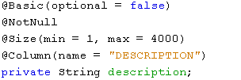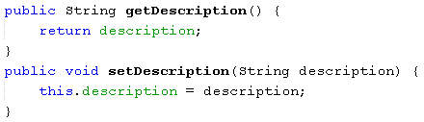

Figure 22: Code Snippet for declaration of a field and its setter and getter methods

There are two ways to transfer information from the entity classes to the database tables. The first one is with the use of XML mapping file and the second is with the use of Hibernate Annotations. We have decided to use the later. The Hibernate Annotations provide a better understanding of the table structure and entity classes simultaneously during the development. There are 2 things that are necessary to use the Hibernate Annotations. The first being the need for JDK version 5.0 or higher and second is the Hibernate 3.x annotations distribution package.

To connect the entity class to the table the annotation @Table is being used above the class. This annotation provides some additional attributes such as:

* Override the name of the table
* Override the catalogue of the table
* Override the schema of the table
* Enforce unique constraints on columns

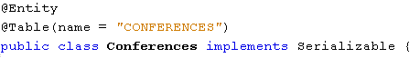

Figure 23: Code Snippet for connecting the entity class to the database table.

The @Entity annotation (see figure 23) marks the class as a persistence class and must have a no-argument constructor, fields that represent the columns of the database table and the appropriate getters and setters.

After connecting the name of the class to the name of the table we need to connect every field in the class to the desired column from the table. This is achieved through the use of the @Column annotation (see figure 22). This annotation is used to specify details about the column. Some of the most commonly used attributes are:

* Name – explicitly specify the name of the column.
* Length – explicitly specify the size of a column value (used mostly for strings).
* Nullable – allows a column to be marked as NOT NULL.
* Unique – allows a column to be marked as containing only unique values.

Hibernate offers a large variety of annotations. The most useful ones are the annotation that offers validation:

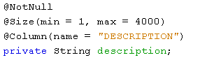

Figure 24: Code Snippet for annotations that offer validation.

On Figure 24 can be seen two validations. These validations are on the application level – they are faster than the database validations. The first two annotations in figure 24 validate the field before a query to the database is made. The first validation checks if the field has a value of null (i.e. its empty). The second validation checks if the size of the field is between one and four thousand.

As every table has a primary key (it can also have more than one), that primary key also should be noted as such in the entity class. The annotation that represents that a field (column) is a primary key is @Id.

To create a relationship between the persistent classes hibernate uses 3 different degrees of relationship annotations:

* @ManyToOne / @OneToMany - one of the most commonly used relationships. We use one of those depending on the perspective we are looking at the relationship. An Object can be associated with multiple objects.
* @OneToOne – similar to @ManyToOne but the column will be set as a unique.
* @ManyToMany – usually implemented with a Set Collection.

The annotation @JoinTable indicates that there will be an interaction with another table. To further develop the relationship between the tables the @JoinColumns annotations can be used. The name attribute holds the foreign key identifier for the relationship – specifies the column name in the join table. The referenceColumnName attribute holds the name of the primary key identifier for this relationship [13] [14].

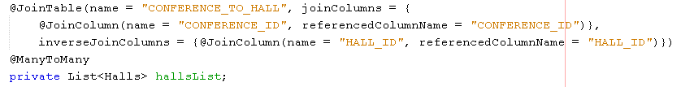

Figure 25: Example for joining tables with Hibernate

## Controller Layer

The Controller is the connection between the model layer and the view layer. Its job is to handle the requests from the users. The controller is responsible for fetching or processing data from the model and sending it to the view layer to be rendered. All of that is being done by the following methods:

* Show – this method is being called by the action “templatesBuilder”. It gets all of the templates in the database. If the return value is success the JSP page corresponding to the management of the templates is being opened. The method uses the help of another method – getAllTemplates.
* saveAsTemplate – this method is being called by the "templatesBuilderDo" action which is connected to the save as template button in the view layer. As the name suggests the method saves the current template. If the current template is a draft template, the method removes the draft status from the information in the database for the template and save it as a ready to be used template. If the current template is a newly written template – the method saves the template in the database. This method also uses other methods: checkIsTemplateExisting, deleteMailTemplate, insertMailTemplate and updateMailTemplate.
* saveAsDraft – this method is being called by the “templatesSaveAsDraft” action. This action is being used by the “save as draft” button in the view layer. It saves the current template as a draft template. If the current template is also a draft template – the method updates the current draft template. This method uses two other methods – insertMailTemplate and updateMailTemplate.
* Delete – this method is called by the “templatesBuilderDelete” action. This action is connected to the “delete” button in the view layer. The method as the name suggests deletes the current template with the help of the deleteMailTemplate method.
* getAllTemplates – this method is being called with the “getAllTemplates” action. If the return value is success, the action returns a string result with all of the templates in the database. One of the places that this action is being used is to populate the list of templates in the view layer. This method uses also the method getAllTemplates.

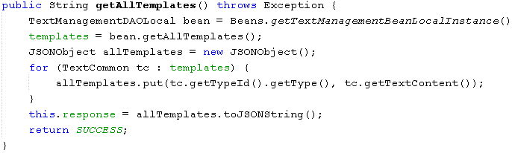 Figure 26: Code Snippet of the method that gets all of the templates in the DB and returns them as a string.

* insertMailTemplate – this method is directly communication with the database and inserting the new templates in the database. It takes 2 inputs – the content of the template and the name of the template. In the method there are validations if the input parameters are correct.
* deleteMailTemplate – as the name suggests this method communicates with the database and deletes the template with the same content and name as the input parameter of the method.
* updateMailTemplate – This method updates the content of the templates.
* getAllTemplates – this method communicates with the database and returns a list with all of the templates in the database. The method returns a list of the templates.
* checkIsTemplateExisting – this method searches through the database if a template with the same name already exists. The input parameter is a string and the return type is either true or false.

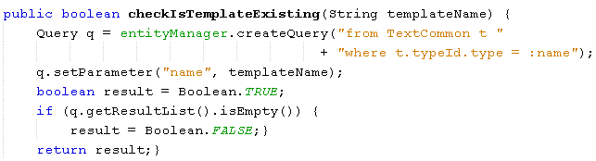

Figure 27: Code Snippet of the method that checks the DB if a template already exists.

* getTemplateText – this method gets the content of the template. As an input parameter it takes the id of the text. The result of the method is a string.

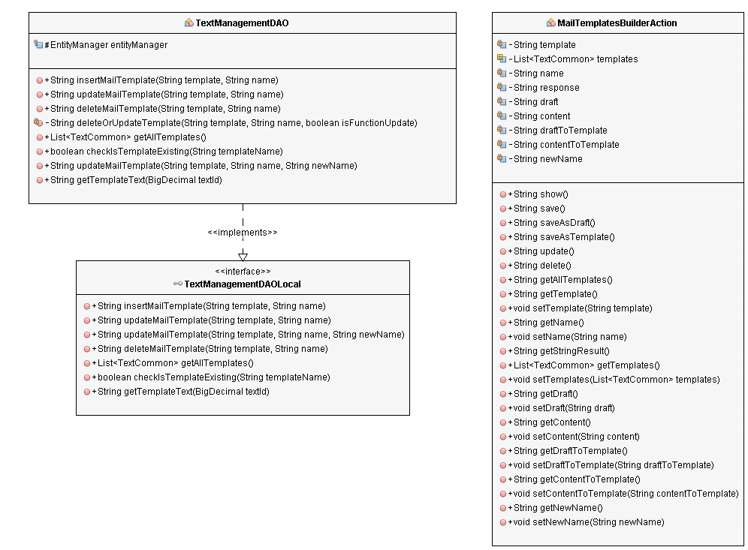

Figure 28: Class Diagram

## Additional use of the email templates

Except for creating a personalized content for emails the email templates module allows the administrator to also manage the content of the auto generated emails that the system sends in the event of registration to the site, approval or rejection to an Event, forgotten password of the user account. The algorithm for all of these auto generated messages is basically the same (with small changes) for all of the messages, so a detailed explanation of only one will be given. The following flow chart diagram is the representation of the general algorithm for content changes.

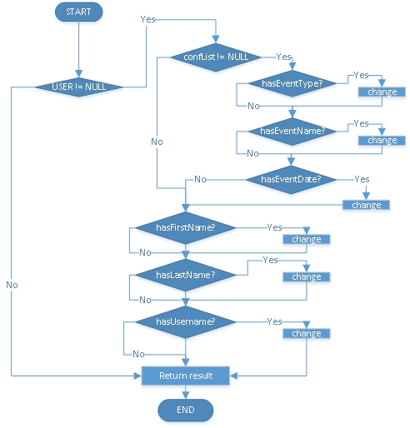

Figure 28: Flow Chart Diagram representing the algorithm for changing the content of auto generated emails.

The algorithm shown in figure 28 represents the flow of the processes when a message is being handled and the keywords in the content are being replaced with real data. In general the algorithm makes various verifications in the content of the messages and based on the result of the verifications, the algorithm makes changes to the content. As the messages have to be personalized to every user to whom they are being sent to, the first thing that has to be checked is if the user to whom the email is being send to is corresponding to an entity in the database table that is representing the users. If there is no such entity the algorithm ends cannot continue to the inability to perform real data replacement of the keywords. If there is such entity the algorithm can extract the necessary data to make changes in the content of the messages. The next verification that the algorithm needs to make is to check if the user is registered for any of the events. If he/she is registered for an event the algorithm continues with the changes concerning the information about the event. The content of the message is being scanned for any of the keywords concerning the events and if such a key word is found it is replaced with the correct information from the database (see figure 29).

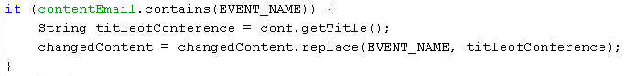

Figure 29: Code Snippet for replacing content in a message.

If the user isn’t registered for any events the algorithm can’t replace information for the event, so it skips to the part where the information about the user is being replaced. The replacement here happens in the same way as the information about the events. If a keyword concerning the user information is being found, it is replaced with the correct information stored in the database.

## User guide for the module

The purpose of this section is to show how the email templates module functions. Being a module of another system, the email templates module has been integrated in the administration panel of the site. The following figure represents the module when opened through the administration panel:

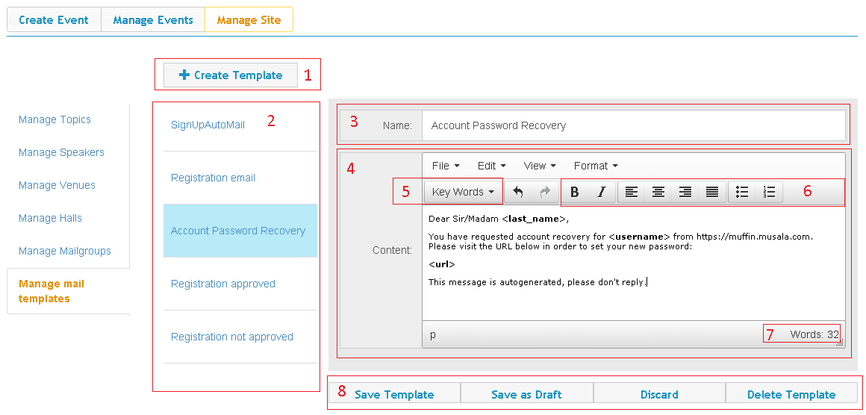

Figure 30: Email Templates Module opened through the administration panel

On the figure, all of the important functionalities are marked with a number:

1. Create template button
2. List of existing template
3. Field for the name of the template
4. Field containing the content of the template
5. A drop-down menu for key words
6. Button-like functionalities for formatting the content
7. Words counter
8. Buttons for saving as template / draft, discarding the content and deleting the template.

On figure 31 can be seen the two variations of the confirmation of admin actions:

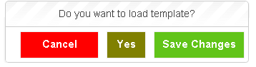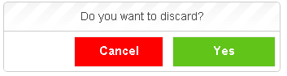

Figure 31: Confirmation boxes

The two figures above show the confirmation boxes when there are changes on the current template (the one to the left) and there is a need to be able to save the changes from the confirmation box. The one to the right shows when there is no need for a save functionality in the confirmation button.

There are two more kinds of pop-ups. They display if there is an error while trying to complete an action and if the action is completed:

C:\Users\lyubomir.hristozov\Desktop\Diploma\Snimki za diplomna\userGuide\5.PNGC:\Users\lyubomir.hristozov\Desktop\Diploma\Snimki za diplomna\userGuide\6.PNG

Figure 32: Pop-ups with error or success messages

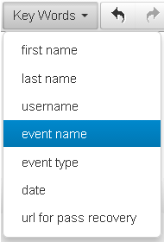

Figure 33: Drop-down menu with key words

When the administrator clicks on the drop-down menu (see № 5 from figure 30) it expands and shows all of the key words that are available. When a key word is selected it is appended to the text where the cursor of the content form is located.

# Conclusion

This section has the goal to analyze the development process and draw conclusions about the results:

## Summary of the results

The goal of the bachelor thesis is the creation of an easy to use module that helps the administrators to create personalized email templates. This goal has been achieved through the completion of three main tasks:

* To achieve the creation of the module, a place to store the information about every template is needed. That is done by a database. Several new tables has been created and added to the already existing ones of the system in which the email template module is integrated.
* The module interacts directly to the DB, allowing dynamically to change the content of already existing templates or to create new templates with various key words.
* The user interface of the email template module has been kept as cleaner and simpler as it can be so the use of the module to be easy and intuitive.

## Ideas for future research and development

The module can be further developed to help the administrators of the site to create better email templates. One of the new functionalities that can be added is the ability the administrator to create his own key words that correspond to some meaning in the data base. Without such functionality the administrator has a limited number of keywords that may prove insufficient. Another functionality that can be useful is the autocomplete of key words inside the content i.e. the administrator doesn’t need to choose a key word from the drop-down menu but simply to start typing the key word and it will auto complete. The last idea is the creation of a live preview of the template – when the administrator creates the template, he or she should be able to see how the email with the template will look like.

# Literary sources

1. <http://www.tensionsoftware.com/osx/automailer/>
2. <http://emailmarketing.comm100.com/features.aspx>
3. Mandala, R., JSP, <http://java-brain.blogspot.com/2011/10/jsp.html> May 7, 2006
4. JavaServer Pages Overview, <http://www.oracle.com/technetwork/java/overview-138580.html>
5. Java Platform, Enterprise Edition (Java EE), <http://www.oracle.com/technetwork/java/javaee/overview/index.html>
6. Struts 2 Architecture and Flow, [http://www.javatpoint.com/struts-2-architecture-and-flow#](http://www.javatpoint.com/struts-2-architecture-and-flow)
7. Struts 2 Architecture, <http://www.tutorialspoint.com/struts_2/struts_architecture.htm>
8. CSS3, <https://developer.mozilla.org/en/docs/Web/CSS/CSS3>
9. Bootstrap Get Started, <http://www.w3schools.com/bootstrap/bootstrap_get_started.asp>
10. JavaScript, <https://developer.mozilla.org/en-US/docs/Web/JavaScript>
11. Hibernate ORM, <http://hibernate.org/orm/>
12. Application Server 8 Developer’s Guide, Chapter 3. Assembling and Deploying J2EE Applications, <http://docs.oracle.com/cd/E19253-01/817-6087/dgdeploy.html>
13. Hibernate - Persistent Class, <http://www.tutorialspoint.com/hibernate/hibernate_persistent_classes.htm>
14. Bernard, E., Chapter 2. Mapping Entities, <https://docs.jboss.org/hibernate/annotations/3.5/reference/en/html/entity.html>, September 15, 2010
15. Dalling, T., Model View Controller Explained, <http://www.tomdalling.com/blog/software-design/model-view-controller-explained/> May 31, 2009
16. Design Patterns MVC Pattern, <http://www.tutorialspoint.com/design_pattern/mvc_pattern.htm>
17. jQuery – Overview, <http://www.tutorialspoint.com/jquery/jquery-overview.htm>

# Attachments

MailTemplatesBuilderAction.java

package com.muffin.admin.actions;

import com.muffin.entities.TextCommon;

import com.muffin.globals.Beans;

import com.muffin.local.text.management.TextManagementDAOLocal;

import com.muffin.results.StringResultInterface;

import static com.opensymphony.xwork2.Action.INPUT;

import static com.opensymphony.xwork2.Action.SUCCESS;

import com.opensymphony.xwork2.ActionSupport;

import com.opensymphony.xwork2.validator.annotations.RequiredStringValidator;

import java.util.List;

import org.apache.struts2.convention.annotation.Action;

import org.apache.struts2.convention.annotation.InterceptorRef;

import org.apache.struts2.convention.annotation.Namespace;

import org.apache.struts2.convention.annotation.Result;

import org.apache.struts2.interceptor.validation.SkipValidation;

import org.json.simple.JSONObject;

@Namespace("/")

@InterceptorRef("adminAuthenticationStack")

public class MailTemplatesBuilderAction extends ActionSupport implements StringResultInterface {

private String template;

List<TextCommon> templates;

private String name;

private String response;

private String draft;

private String content;

private String draftToTemplate;

private String contentToTemplate;

private String newName;

@Action(value = "templatesBuilder", results = {

@Result(name = SUCCESS, location = "adminPages/manageTemplate.jsp")

})

@SkipValidation

public String show() throws Exception {

TextManagementDAOLocal bean = Beans.getTextManagementBeanLocalInstance();

templates = bean.getAllTemplates();

return SUCCESS;

}

@Action(value = "templatesBuilderDo", results = {

@Result(name = SUCCESS, type = "stringResult"),

@Result(name = INPUT, location = "adminPages/mailTemplatesBuilder.jsp")

})

public String save() throws Exception {

TextManagementDAOLocal bean = Beans.getTextManagementBeanLocalInstance();

this.response = bean.insertMailTemplate(template, name);

return SUCCESS;

}

// save as draft

@Action(value = "templatesSaveAsDraft", results = {

@Result(name = SUCCESS, type = "stringResult"),

@Result(name = INPUT, location = "adminPages/mailTemplatesBuilder.jsp")

})

public String saveAsDraft() throws Exception {

TextManagementDAOLocal bean = Beans.getTextManagementBeanLocalInstance();

if (name.contains("draft")) {

draft = name.replaceAll("- draft", "");

draft = draft + "- draft";

content = template;

} else {

draft = name + "- draft";

content = template;

}

if (!bean.checkIsTemplateExisting(draft)) {

this.response = bean.insertMailTemplate(content, draft);

} else {

this.response = bean.updateMailTemplate(content, draft);

}

return SUCCESS;

}

// save as template

@Action(value = "saveAsTemplate", results = {

@Result(name = SUCCESS, type = "stringResult"),

@Result(name = INPUT, location = "adminPages/mailTemplatesBuilder.jsp")

})

public String saveAsTemplate() throws Exception {

TextManagementDAOLocal bean = Beans.getTextManagementBeanLocalInstance();

draft = name;

if (template.equals("")) {

content = " ";

} else {

content = template;

}

if (bean.checkIsTemplateExisting(draft)) {

if (name.contains("draft")) {

draftToTemplate = name.replaceAll("- draft", "");

if (template.equals("")) {

contentToTemplate = " ";

} else {

contentToTemplate = template;

}

this.response = bean.deleteMailTemplate(content, draftToTemplate);

this.response = bean.insertMailTemplate(contentToTemplate, draftToTemplate);

this.response = bean.deleteMailTemplate(content, draft);

} else {

this.response = bean.updateMailTemplate(content, draft);

}

} else {

this.response = bean.insertMailTemplate(content, draft);

}

return SUCCESS;

}

@Action(value = "templatesBuilderUpdate", results = {

@Result(name = SUCCESS, type = "stringResult"),

@Result(name = INPUT, location = "adminPages/mailTemplatesBuilder.jsp")

})

public String update() throws Exception {

TextManagementDAOLocal bean = Beans.getTextManagementBeanLocalInstance();

this.response = bean.updateMailTemplate(template, name, newName);

return SUCCESS;

}

@Action(value = "templatesBuilderDelete", results = {

@Result(name = SUCCESS, type = "stringResult"),

@Result(name = INPUT, location = "adminPages/manageTemplate.jsp")

})

public String delete() throws Exception {

TextManagementDAOLocal bean = Beans.getTextManagementBeanLocalInstance();

this.response = bean.deleteMailTemplate(template, name);

return SUCCESS;

}

@Action(value = "getAllTemplates", results = {

@Result(name = SUCCESS, type = "stringResult")

})

@SkipValidation

public String getAllTemplates() throws Exception {

TextManagementDAOLocal bean = Beans.getTextManagementBeanLocalInstance();

templates = bean.getAllTemplates();

JSONObject allTemplates = new JSONObject();

for (TextCommon tc : templates) {

allTemplates.put(tc.getTypeId().getType(), tc.getTextContent());

}

this.response = allTemplates.toJSONString();

return SUCCESS;

}

public String getTemplate() {

return template;

}

@RequiredStringValidator(key = "error.template.content", message = "")

public void setTemplate(String template) {

this.template = template;

}

public String getName() {

return name;

}

@RequiredStringValidator(key = "error.template.name", message = "")

public void setName(String name) {

this.name = name;

}

@Override

public String getStringResult() {

return this.response;

}

public List<TextCommon> getTemplates() {

return templates;

}

public void setTemplates(List<TextCommon> templates) {

this.templates = templates;

}

public String getDraft() {

return draft;

}

public void setDraft(String draft) {

this.draft = draft;

}

public String getContent() {

return content;

}

public void setContent(String content) {

this.content = content;

}

public String getDraftToTemplate() {

return draftToTemplate;

}

public void setDraftToTemplate(String draftToTemplate) {

this.draftToTemplate = draftToTemplate;

}

public String getContentToTemplate() {

return contentToTemplate;

}

public void setContentToTemplate(String contentToTemplate) {

this.contentToTemplate = contentToTemplate;

}

public String getNewName() {

return newName;

}

public void setNewName(String newName) {

this.newName = newName;

}

}

**TextManagementDAO.java**

@Stateless(name = "TextManagementDAO", mappedName = "TextManagementDAO")

public class TextManagementDAO implements TextManagementDAOLocal {

@PersistenceContext(unitName = "test-ejbPU")

protected EntityManager entityManager;

@Override

public String insertMailTemplate(String template, String name) {

String result = "success";

TextDomain td = getTextDomainBy(GlobalEnums.Domains.EMAIL_TEMPLATE.toString());

if (td == null) {

td = new TextDomain();

td.setName(GlobalEnums.Domains.EMAIL_TEMPLATE.toString());

td = entityManager.merge(td);

}

Query q = entityManager.createQuery("from TextType t where t.type = :type and t.domainId = :domain");

q.setParameter("type", name);

q.setParameter("domain", td);

if (q.getResultList().isEmpty()) {

TextType templateName = new TextType();

templateName.setDomainId(td);

templateName.setType(name);

templateName = entityManager.merge(templateName);

TextCommon tc = new TextCommon();

tc.setDomainId(td);

tc.setTypeId(templateName);

tc.setTextContent(template);

entityManager.merge(tc);

} else {

result = "duplicate";

}

return result;

}

@Override

public String updateMailTemplate(String template, String name) {

return deleteOrUpdateTemplate(template, name, true);

}

@Override

public String deleteMailTemplate(String template, String name) {

return deleteOrUpdateTemplate(template, name, false);

}

private String deleteOrUpdateTemplate(String template, String name, boolean isFunctionUpdate) {

String result = "success";

TextDomain td = getTextDomainBy(GlobalEnums.Domains.EMAIL_TEMPLATE.toString());

Query q = entityManager.createQuery("from TextCommon t where t.typeId.type = :type and t.domainId = :domain");

q.setParameter("type", name);

q.setParameter("domain", td);

List<TextCommon> templatesList = q.getResultList();

if (templatesList.isEmpty()) {

result = "invalid";

} else {

TextCommon templ = templatesList.get(0);

TextType type = templ.getTypeId();

if (isFunctionUpdate) {

templ.setTextContent(template);

type.setType(name);

entityManager.merge(templ);

} else {

entityManager.remove(templ);

entityManager.remove(type);

}

}

return result;

}

@Override

public List<TextCommon> getAllTemplates() {

Query q = entityManager.createQuery("from TextCommon t where t.domainId.name = :name");

q.setParameter("name", GlobalEnums.Domains.EMAIL_TEMPLATE.toString());

List<TextCommon> result = q.getResultList();

return result;

}

@Override

public boolean checkIsTemplateExisting(String templateName) {

Query q = entityManager.createQuery("from TextCommon t "

+ "where t.typeId.type = :name");

q.setParameter("name", templateName);

boolean result = Boolean.TRUE;

if (q.getResultList().isEmpty()) {

result = Boolean.FALSE;}

return result;}

@Override

public String updateMailTemplate(String template, String name, String newName) {

String result = "success";

TextDomain td = getTextDomainBy(GlobalEnums.Domains.EMAIL_TEMPLATE.toString());

Query q = entityManager.createQuery("from TextCommon t where t.typeId.type = :type and t.domainId = :domain");

q.setParameter("type", name);

q.setParameter("domain", td);

List<TextCommon> templatesList = q.getResultList();

if (templatesList.isEmpty()) {

result = "invalid";

} else {

TextCommon templ = templatesList.get(0);

TextType type = templ.getTypeId();

templ.setTextContent(template);

type.setType(newName);

entityManager.merge(templ);

entityManager.merge(type);

}

return result;

}

@Override

public String getTemplateText(BigDecimal textId) {

Query q = entityManager.createQuery("From TextCommon t where t.textId = :textId ");

q.setParameter("textId", textId);

List<TextCommon> result = q.getResultList();

TextCommon txt = result.get(0);

return result.get(0).getTextContent();

}

}

**ManageTemplate.jsp**

<%@page contentType="text/html" pageEncoding="UTF-8"%>

<%@taglib prefix="s" uri="/struts-tags" %>

<script type="text/javascript" src="<%=request.getContextPath()%>/tinymce/js/tinymce/tinymce.min.js"></script>

<script language="javascript" src="<%=request.getContextPath()%>/noty-2.3.2/js/noty/packaged/jquery.noty.packaged.min.js"></script>

<script language="javascript" src="<%=request.getContextPath()%>/JavaScript/rich-text-init.js"></script>

<script language="javascript" src="<%=request.getContextPath()%>/JavaScript/notyUtils.js"></script>

<script language="javascript" src="<%=request.getContextPath()%>/JavaScript/templatesSelectRefresh.js"></script>

<script language="javascript" src="<%=request.getContextPath()%>/JavaScript/mailTemplatesBuilder.js"></script>

<script language="javascript" src="<%=request.getContextPath()%>/JavaScript/manageTemplate.js"></script>

<!DOCTYPE html>

<div id="test" class=" col-xs-12 main-content-form-style">

<div class="row col-xs-12 add-new-topic-container">

<div class="pull-left">

<button style="width:180px" title="This button will prepare the forms for a new template." style="margin-left: -5px" id="createTemplate" class="btn-create-event btn-add-formater">

<span class="glyphicon glyphicon-plus"></span>

<label>Create Template</label>

</button>

</div>

</div>

<div class="row">

<div class="col-xs-3 add-new-topic-container templates-list">

<div id="templatelist" class="divList col-xs-12 make-me-scrollable">

<s:iterator value="templates" >

<div title="<s:property value='typeId.type' />"

class="templates changeCursorOnMouseOver topic-list-item group">

<label>

<s:property value="typeId.type" />

</label>

</div>

</s:iterator>

</div>

</div>

<div class="col-xs-9 add-new-topic-container">

<div class="panel-body panel-wide ">

<s:hidden id="templateId" name="templateId" />

<s:hidden name="templates" />

<div class="input-group input-group-login">

<span class="input-group-addon addon-admin-short"><s:text name="label.template.name" /></span>

<s:textfield id="templateName" name="name" cssClass="form-control" cssErrorClass="field-error" />

</div>

<div class="input-group input-group-login " >

<span class="input-group-addon addon-admin-short"><s:text name="label.content.email" /></span>

<s:textarea id="contentTemplate" name="contentTemplate" style="width:100%" rows="7" cssClass="form-control" cssErrorClass="field-error" />

</div>

</div>

<div>

<div >

<button id="saveAsTemplate" title="This button will save the changes and make a draft into fully functional template."style ="margin-left: 0px" class="btn-create-event btn-add-formater col-xs-3"

<label>Save Template</label>

</button>

<button id="saveAsDraft" title="This button will save the template as a draft." style ="margin-left: 0px" class="btn-create-event btn-add-formater col-xs-3"

<label>Save as Draft</label>

</button>

<button id="discard" title="This button will discard the information." style ="margin-left: 0px" class="btn-create-event btn-add-formater col-xs-3"

<label>Discard</label>

</button>

<button id="deleteTemplate" title="This button will delete the current template." style ="margin-left: 0px" class="btn-create-event btn-add-formater col-xs-3"

<label>Delete Template</label>

</button>

</div>

</div>

</div>

</div>

</div>

**templatesSelectRefresh.js**

function refreshTemplateGroups() {

$.ajax({

type: 'post',

url: 'getAllTemplates',

dataType: 'html',

success: function(data) {

console.log(data);

window.templatesList = JSON.parse(data);

var $field = $('#templatelist');

$field.empty();

$.each(window.templatesList, function(k, v) {

$div = $(document.createElement('div'));

$div.attr('class', 'templates changeCursorOnMouseOver topic-list-item group');

$div.attr('title', k);

$label = $(document.createElement('label')).val(k).text(k);

$div.append($label);

$field.append($div)

listOfTemplates = JSON.parse(data);

});

}

});

}

function refreshTemplateGroupsSelect() {

$.ajax({

type: 'post',

url: 'getAllTemplates',

dataType: 'html',

success: function(data) {

var properties = [];

window.templatesList = JSON.parse(data);

//console.log(window.templatesList);

var iterator = 1;

$.each(window.templatesList, function(k, v) {

properties.push({label: k, value: iterator});

iterator++;

});

properties.sort(function(a, b) {

if (a.label > b.label) {

return 1;

}

if (a.label < b.label) {

return -1;

}

return 0;

});

$('#mail-templates-select').multiselect('dataprovider', properties);

}

});

}

**manageTemplate.js**

var listOfTemplates;

var oldName;

var currentlySelectedTemplate;

function getTemplateById(listOfTemplates, desiredTemplateId) {

for (var i = 0; i < listOfTemplates.length; i++) {

if (listOfTemplates[i]['templateId'] === desiredTemplateId) {

return listOfTemplates[i];

}

}

}

function areThereAnyChanges() {

// check if:

// -> description was modified;

// -> title was modified;

var m = currentlySelectedTemplate.description;

if (currentlySelectedTemplate.description !== tinymce.get(0).getContent()

|| currentlySelectedTemplate.title !== $("#templateName").val()) {

return true;

}

return false;

}

function selectTemplate(template)

{

template.title = $("#templateName").val();

template.description = tinyMCE.get('contentTemplate').getContent();

}

function loadAndRememberText(template) {

// fills the richbox

$('#templateName').val($(template).attr('title'));

tinymce.get(0).setContent(listOfTemplates[$(template).prop('title')]);

oldName = $('#templateName').val();

selectTemplate(currentlySelectedTemplate);

}

function loadTemplateInfoRichBox() {

if (tinymce.editors.length > 0) {

tinyMCE.execCommand('mceAddEditor', false, "contentTemplate");

tinyMCE.execCommand();

} else {

/* init rich text */

tinymce.init({

selector: "#contentTemplate",

plugins: "wordcount",

toolbar: "mybutton | undo redo | bold italic | alignleft aligncenter alignright alignjustify | bullist numlist | link image ",

setup: function(editor) {

editor.addButton('mybutton', {

type: 'menubutton',

text: 'Key Words',

icon: false,

menu: [

{text: 'first name', onclick: function() {

editor.insertContent("&lt;first_name&gt;");

}},

{text: 'last name', onclick: function() {

editor.insertContent("&lt;last_name&gt;");

}},

{text: 'username', onclick: function() {

editor.insertContent("&lt;username&gt;");

}},

{text: 'event name', onclick: function() {

editor.insertContent("&lt;event_name&gt;");

}},

{text: 'event type', onclick: function() {

editor.insertContent("&lt;event_type&gt;");

}},

{text: 'date', onclick: function() {

editor.insertContent('&lt;date&gt;');

}},

{text: 'url for pass recovery', onclick: function() {

editor.insertContent("&lt;url&gt;");

}}

]

});

}

});

}

}

// noty pop-up for confirming action

function confirmYourAction(text) {

var dfd = $.Deferred();

var msg;

if (text === "delete") {

msg = "Do you want to delete?";

} else if (text === 'save') {

msg = "Do you want to save changes?";

} else if (text === 'discard') {

msg = "Do you want to discard?";

} else if (text === 'draft') {

msg = "Do you want to save as draft?";

} else if (text === 'createNew') {

msg = "Do you want to start new template?";

} else if (text === 'changeTemplate') {

msg = "Do you want to load template?";

}

var n = noty({

text: msg,

type: 'confirm',

dismissQueue: false,

layout: 'center',

theme: 'defaultTheme',

buttons: [

{addClass: 'btn-red', text: 'Cancel', onClick: function($noty) {

$noty.close();

dfd.resolve(false);

}

},

{addClass: 'btn-green', text: 'Yes', onClick: function($noty) {

$noty.close();

dfd.resolve(true);

}

}

]

});

return dfd.promise();

}

function confirmYourActionAndSave(text) {

var dfd = $.Deferred();

var msg;

if (text === "delete") {

msg = "Do you want to delete?";

} else if (text === 'save') {

msg = "Do you want to save changes?";

} else if (text === 'discard') {

msg = "Do you want to discard?";

} else if (text === 'draft') {

msg = "Do you want to save as draft?";

} else if (text === 'createNew') {

msg = "Do you want to start new template?";

} else if (text === 'changeTemplate') {

msg = "Do you want to load template?";

}

var m = noty({

text: msg,

type: 'confirm',

dismissQueue: false,

layout: 'center',

theme: 'defaultTheme',

buttons: [

{addClass: 'btn-red', text: 'Cancel', onClick: function($noty) {

$noty.close();

dfd.resolve(false);

}

},

{addClass: 'btn-green-bland', text: 'Yes', onClick: function($noty) {

$noty.close();

dfd.resolve(true);

}

},

{addClass: 'btn-green ', text: 'Save Changes', onClick: function($noty) {

$noty.close();

var str1 = $('#templateName').val();

var str2 = "draft";

if (str1.indexOf(str2) != -1) {

processTemplate('draft');

refreshTemplateGroups();

dfd.resolve(true);

} else {

processTemplate('asTemplate');

refreshTemplateGroups();

dfd.resolve(true);

}

}

}

]

});

return dfd.promise();

}

function processTemplate(operation) {

var typeOfOperation = "";

var params = new Object();

if (operation === 'save') {

action = 'templatesBuilderDo';

typeOfOperation = "saved";

params['name'] = $("#templateName").val();

} else if (operation === 'update') {

action = 'templatesBuilderUpdate';

typeOfOperation = "updated";

params['newName'] = $('#templateName').val();

params['name'] = oldName;

} else if (operation === 'delete') {

action = 'templatesBuilderDelete';

typeOfOperation = "deleted";

params['name'] = $('#templateName').val();

} else if (operation === 'draft') {

action = 'templatesSaveAsDraft';

typeOfOperation = "saved as draft";

params['name'] = $("#templateName").val();

} else if (operation === 'asTemplate') {

action = 'saveAsTemplate';

typeOfOperation = "saved as template";

params['name'] = $("#templateName").val();

} else if (operation === 'discard') {

action = 'discardTemplateContent';

typeOfOperation = "discard template content";

params['name'] = $("#templateName").val();

}

params['template'] = tinyMCE.activeEditor.getContent();

if (params['name'] !== "") {

notificate("Processing..", "warning", 100000);

$.ajax({

type: 'post',

url: action,

data: params,

dataType: 'html',

success: function(data) {

if (data === 'success') {

notificate("Template " + params['name'] + " " + typeOfOperation + "!", "success");

refreshTemplateGroups();

} else if (data === 'invalid') {

notificate("Template does not exist!", "error");

} else if (data === 'duplicate') {

notificate("Template " + params['name'] + " already exist!", "error");

} else {

notificate("There is something wrong!", "error");

}

setTimeout(function() {

$.noty.closeAll();

}, 5000);

}

});

} else {

notificate("Template name not set!", "error", 3000);

}

}

function deactiveTopicSelectionHighlighting() {

$('.active-topic').removeClass("active-topic");

}

function highlightNewSelectedTopic(htmlSectionElement) {

$(htmlSectionElement).addClass("active-topic");

}

$(document).ready(function() {

window.templatesList = {};

refreshTemplateGroups();

currentlySelectedTemplate = {

title: "",

description: "",

id: ""

};

/* delete button */

$('#deleteTemplate').click(function() {

$.when(confirmYourAction('delete')).done(function(decision) {

if (decision) {

processTemplate('delete');

refreshTemplateGroups();

$('#templateName').val("");

tinyMCE.activeEditor.setContent("");

}

});

});

// create button

$('#createTemplate').click(function() {

$.when(confirmYourActionAndSave('createNew')).done(function(decision) {

if (decision) {

var text = "<p></p>";

tinyMCE.get('contentTemplate').setContent(text);

$('#templateName').val("");

deactiveTopicSelectionHighlighting();

}

});

});

// create as draft button

$('#saveAsDraft').click(function() {

$.when(confirmYourAction('draft')).done(function(decision) {

if (decision) {

processTemplate('draft');

refreshTemplateGroups();

}

});

});

// Save as template button

$('#saveAsTemplate').click(function() {

if (areThereAnyChanges()) {

$.when(confirmYourAction('save')).done(function(decision) {

if (decision) {

var str1 = $('#templateName').val();

var str2 = "- draft";

processTemplate('asTemplate');

if (str1.indexOf(str2) != -1) {

var newTitle = str1.replace(str2, "");

$('#templateName').val(newTitle);

}

selectTemplate(currentlySelectedTemplate);

refreshTemplateGroups();

}

});

} else {

$.when(confirmYourAction('save')).done(function(decision) {

if (decision) {

var str1 = $('#templateName').val();

var str2 = "- draft";

processTemplate('asTemplate');

if (str1.indexOf(str2) != -1) {

var newTitle = str1.replace(str2, "");

$('#templateName').val(newTitle);

}

selectTemplate(currentlySelectedTemplate);

refreshTemplateGroups();

}

});

}

});

// discard button

$('#discard').click(function() {

$.when(confirmYourAction('discard')).done(function(decision) {

if (decision) {

var text = "<p></p>";

tinyMCE.get('contentTemplate').setContent(text);

$('#templateName').val("");

}

});

});

refreshTemplateGroups();

loadTemplateInfoRichBox();

$("#tabs").tabs().addClass("ui-tabs-vertical ui-helper-clearfix");

$("#tabs li").removeClass("ui-corner-top").addClass("ui-corner-left");

$.ajax({

type: 'post',

url: 'getAllTemplates',

dataType: 'html',

success: function(data) {

listOfTemplates = JSON.parse(data);

}

});

// highlights when a template name is clicked

$('#templatelist').on('click', '.templates', function() {

var t = $(this);

if (areThereAnyChanges()) {

if ($('.divList').find('div.active-topic').length !== 0) {

var ar = $("#templateName").val();

$.when(confirmYourActionAndSave('changeTemplate')).done(function(decision) {

if (decision) {

loadAndRememberText(t);

deactiveTopicSelectionHighlighting();

highlightNewSelectedTopic(t);

}

});

}

else {

if ($("#templateName").val() !== "" || tinyMCE.get('contentTemplate').getContent() !== "") {

$.when(confirmYourActionAndSave('changeTemplate')).done(function(decision) {

if (decision) {

loadAndRememberText(t);

highlightNewSelectedTopic(t);

}

});

} else {

loadAndRememberText(t);

deactiveTopicSelectionHighlighting();

highlightNewSelectedTopic(t);

}

}

} else {

loadAndRememberText(t);

deactiveTopicSelectionHighlighting();

highlightNewSelectedTopic(t);

}

});

});