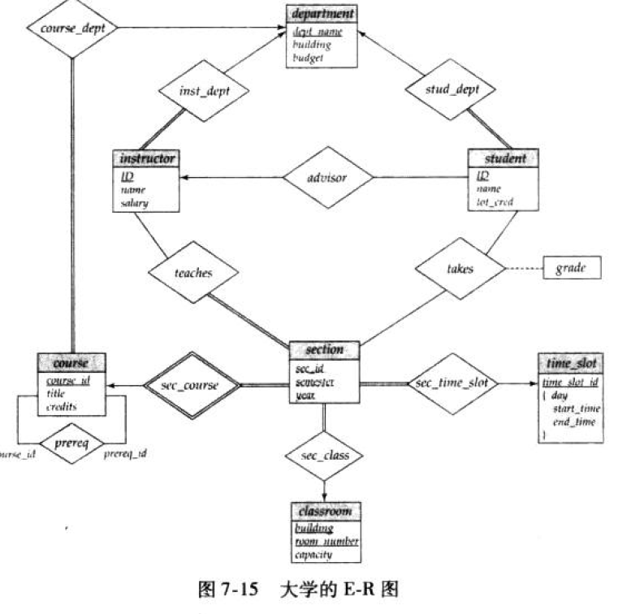

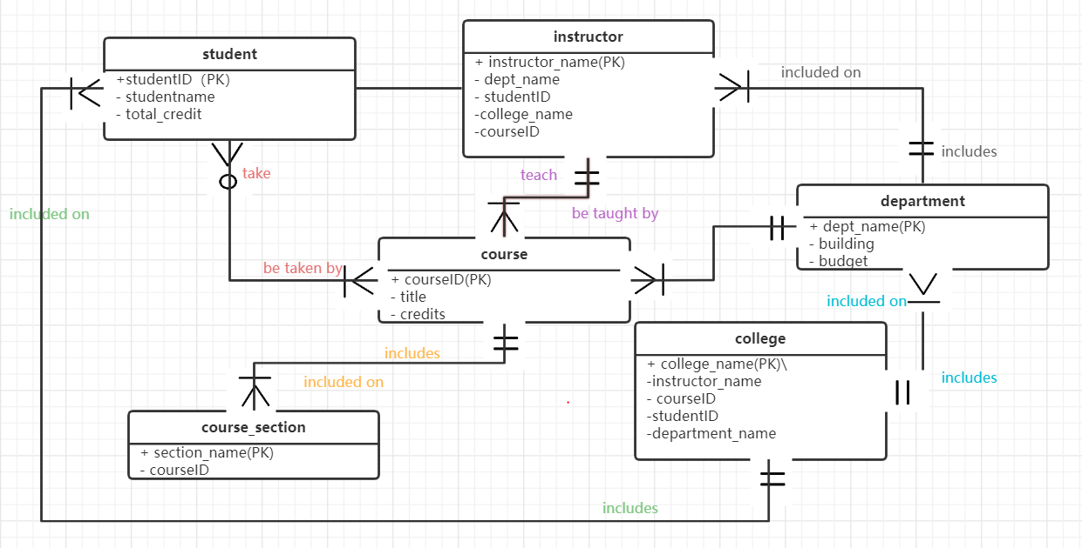Compare my database to the database in the textbook.

1 、

in the future I will follow the principle of drawing a E-R diagram

The E-R diagram includes the following main components:

The two-part rectangle represents the entity set.

The shaded first part of the book contains the names of the entity set, and the second part contains the names of all the attributes of the entity set.

The diamond represents the contact set.

The unsplit rectangle represents the properties of the contact set.

The attributes that make up the primary code are underlined.

Line segments connect a set of entities to a set of associations.

The dashed line connects the association set properties to the association set.

The double line shows the entity's participation in the contact set.

The double diamond represents a symbolic association set connected to a weak entity set (we'll cover both symbolic association sets and weak entity sets in section 7.5.6).

2,

I will use composite attribute more in the future to describe a information clearly.

3,

next time I will use identifying relationship to describe the relation between strong entity with weak entity.