Crawl Balle Rabbit housing data and do analysis
Entry Hyperlink:
http://sh.baletu.com/zhaofang/p2o1a1/?seachId=0&is_rec_house=0&entrance=14&solr_house_cnt=28658

- The following field data is displayed
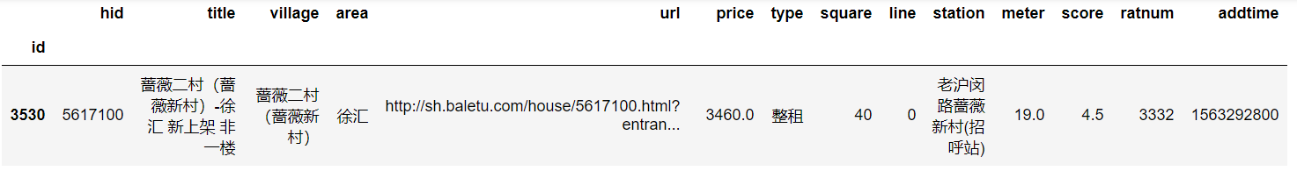
Note: You don't need to crawl all the data, you can do data analysis, because different data analysis results are different. So we give them points for the analysis. (The following figure is for reference)
Obtain the number of housing sources in each area
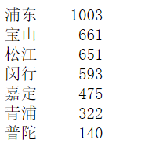
Look at the three most expensive areas on average
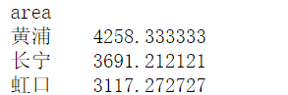

Check the two most expensive residential areas in each area
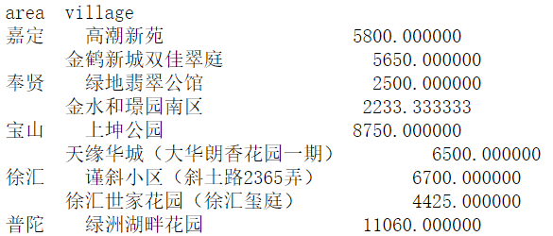

Check the nearest 10 listings in Pudong
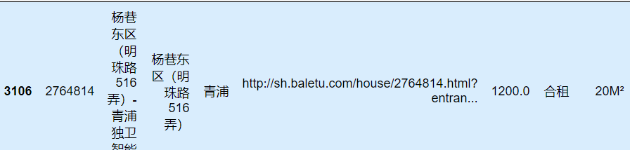

1. Check the three housing sources nearest to each subway (3 housing sources for each line)
2. Check the top 10 most expensive properties per square meter (total price per square meter)
3. Look at the 10 most expensive neighborhoods (based on the average price of each neighborhood)
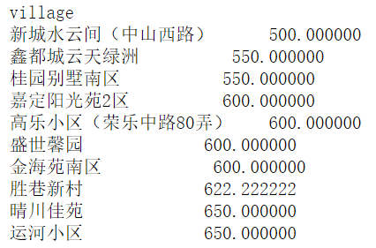
- Search for a 10-20m house in Pudong or Baoshan with a price range of 2000-2500
- Find the houses less than 1000 meters away from the site in the whole rental house, and sort them from near to far
- Arbitrary graph represents: the 10 communities with the most expensive housing prices
- The average house price in each area

