1.Ordinal data values have a meaningful order (ranking) but magnitude between successive values is not known.Nominal data: name without any meaningful order 2.Here, you need to calculate the mean, median and mode. If they are the same, then the distribution is symmetric. Otherwise, it is skewed. Mean: average Median: middle Mode: most frequent appear 3.boxplot: max-q3(upper group median)-median-q1(lower group median)-min4.Missing values: transportation company or accommodation company/prediction by classification(data mining)5. Correlation of attributes: Pearson’s product moment coefficient was covered in class (not yet in 2018). Students may also mention any other test that finds the correlation between numerical attributes.6.Grain of the date mart: The grain of the data mart refers to the level of detail that we store data. Specifically, it refers to the level of details of a single row in the Fact table. In this case, the grain is a Sale of a single package to an account to a particular destination with transportation, accommodation and person information.7. A fact/measure is an additive (and often numeric) value or measurement that is stored in the Fact table. It is mainly used for aggregation and subsequent analytics. In this case study, the profit/sale price is an example of a fact/measure. Others could be the “cost-price” or the “profit-made”.8. Build dimension: In this case, examples are the Flight (Flight number, departure time, arrival time, airplane type, flight company, departure location, destination, …) or Resort (Name, address, phone number, level, facilities, review, price, is_beachfront, is_adultonly, has_golfcourse, has_familyclub…) or dimensions.9. Aggregates (also know as Cubes) are mainly used in order to improve query performance. They are pre-calculated and often implemented as materialized views from queries. Specifically, they involve SUM() and GROUP BY operations. In this case, any one of the following aggregates would potentially speed up performance (based on the frequent queries): a. Monthly Sales b. Seasonal Sales 10. Snowflaking means that we normalize a dimension into two tables, and then link them using foreign keys. For example, we could split the Transportation and accommodation dimension and store details about the flight or resort separately. It is not such a great idea, because it involves the joining of tables and (as shown in class) this is a very expensive database operation. The one place where we would use snowflaking is to avoid “monster” (i.e. very huge) dimensions.11. A surrogate key is an auto-number that is used as a primary key in the data mart. The reason for using this is that we wish to avoid using production keys that has a “meaning”in the operational system. Production keys may be changed by the source system and also even be reused. If this happen, it may cause inconsistencies in our data mart. For example, consider we have a Meet-number that is re-used. This may lead to data from two totally separate Meets being considered as one. Clearly, this will lead to inconsistencies in the data.12.bitmap: Flight cabin level (econ, business, first-class )Customer gender(Boolean) 13.The surrogate key pipeline refers to the data staging steps we take to convert the Fact table from the transactional input data format to the dimensional model. Refer to slide 26 of the Data Staging nodes, as well as the textbook by Kimball et. al.14.Correlation : There are a number of ways to do this. One could use a statistical test such as Pearson’s Coefficient. Alternatively, one could draw a scatter plot and see if there are any strong correlations between the two dimensions. 15. Attribute banding refers to the process of discretizing numeric data into groups that are then useful for decision support. This is also sometimes done to avoid so-called monster dimensions.Examples in this data mart could be to convert the dates of birth of members into age ranges, the exact time of purchase to hourly bands, the exact prices of products into price bands, and so on.16. Symmetric binary: both outcomes equally important .Asymmetric binary: outcomes not equally important 17. Numeric Attribute Types -Numeric Intervals • Measured on a scale of equal-sized units(E.g., temperature in C˚ or F˚ • E.g. calendar dates) Ratios Inherent zero-point • We can speak of values as being an order of magnitude larger than the unit of measurement(e.g., length, counts, money) 18. Discrete vs. Continuous Attributes Discrete-finite or countably infinite set of values.(E.g., postal codes, profession, or the set of words in a collection of documents )Continuous-real numbers (E.g., temperature, height, or weight )19.Attributetypes & tendencies-Categorical: • nominal and binary • Arguably more difficult to assess 20.Measuring the Dispersion of Data: Variance and standard deviation of sample s • Variance: (algebraic, scalable computation)- Standard deviations is the square root of variance s^2-Weuse(n-1)-Bessel’s correction -if population mean unknown • Effectdilutes with large sample 21.Loess (local regression) Curve: Adds a smooth curve to a scatter plot in order to provide better perception of the pattern of dependence • Loess curve is fitted by setting two parameters: a smoothing parameter, and the degree of the polynomials that are fitted by the regression 22.The role of Data Analytics: Strategic: Ad hoc power users***(Direct access queries, reports and data mining), “Push-button” knowledge workers(Standard reports Analytic Applications Dashboards and Scorecards), Operational: standard report consumers(Operation BI)23.Roll up operation: Reduce the dimensions ,Climbing up a concept hierarchy ,Totals only shown for Q1,SQL group by 24.Drill Down operation: Increase the dimensions, Moving down a concept hierarchy, drill down from Quarter 1 to Month to Date –Sales of carrots in Ottawa and Toronto , Different levels of SQL Group By, Where conditions 25.Slice operation : One dimension is selected, Given: the Sales during Quarter 1 for all products, Quarter 1 acts as “a filter”, SQL where conditions.26.Dice operation: More than one dimension –create a subcube ,Give the Sales during Quarter 1 of Butter and Carrots 27.BUC algorithm: Divides dimensions into partitions and facilitates iceberg pruning – If a partition does not satisfy min_sup, its descendants can be pruned • In this example, A is not supported if e.g. min_sup> 9 • E.g. ski-gloves are not popular in Havana. • E.g. ski-gloves are not popular in July, in North America.28.Sampling and Cubes: Stratified sampling for Big Data • Gives approximate answers, that are “good enough” • Speed up query answering• Statistical data –e.g. population data • Sampling bias • Query bias29. Confidence Intervals: Treat points in cube cells as samples ,Compute confidence intervals –mean, standard deviation, t-value ,Return answer in the form of confidence interval ,Indicates quality of query answer ,User selects desired confidence interval ,Example: $50,000 ±$3,000 with 95% confidence.30.Intra-Cuboid Expansion: Choice 1/2: 从横向或者纵向取相邻的两个attributes --Expansion based on nearest age--Expansion to include all levels of education--Expansion to include all occupations (current job)31.Expansion to include all occupations (current job): Careful when combining attributes • Be aware of the problem when using statistical data • Avoid random sampling! • Skew may change over time • Expansion should be verified by domain expert and/or using common sense 32.Learning objectives: Aggregates: Aggregates are a way to speed up frequent queries • May be modelled as a lattice of Cuboids • One Cuboid correspond to One Aggregate • Correspond to somepre-stored “materialized views” (results of aggregated queries)• We aim to design the “optimum set” of aggregates – Answer manyqueries faster – Using reasonabledisk space. 33.What is an aggregate? Data are SUMMED using Concept Hierarchies • Pre-calculated and pre-stored summaries that are stored in the data warehouse • Used for Query Optimization when doing OLAP operations • Aggregates will periodically, dynamically change, since it depends on the frequent queries – Frequent business requests – Statistical distribution of data Data Mart = Base Dim. Model + Aggregate Dim Models 34.Aggregate goals and risks: Key issue: decide on aggregates to materialize/store
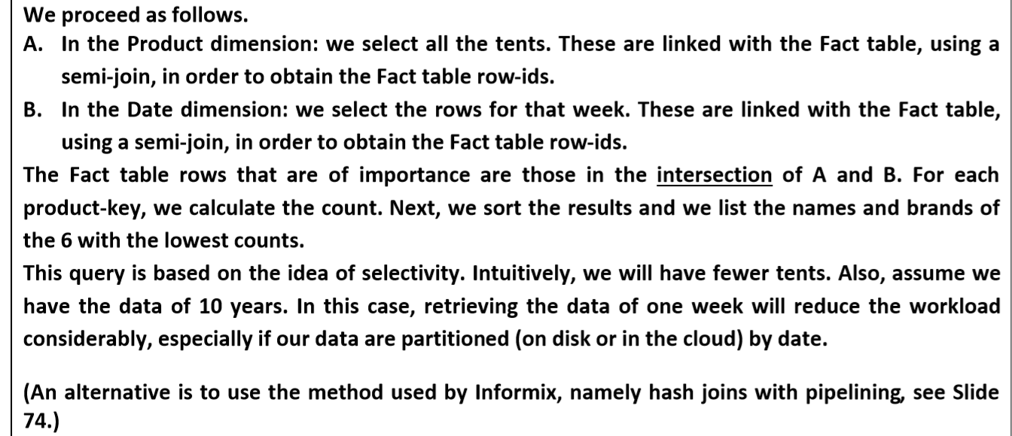
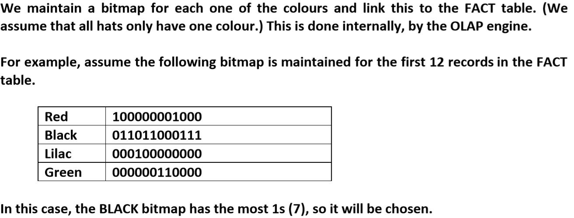
• Dramatic performance gains • Reasonable extra data storage • Transparent to users → aggregate navigation • Benefit all users • Low impact on data staging • Low impact on DBA’s workload 35. Aggregates: A Recipe 1. Identify set of frequent queries 2. Identify concept hierarchies used (in queries in 1) 3. Determine levels in concept hierarchies to be used to speed up the queries (month, year)? 4. Decide on initial set of aggregates 5. If your system allows: a) Implement aggregate strategy and aggregate navigator (e.g. write the code) (or) b) Verify appropriateness of actual aggregates used in OLAP cube engine (if allowed by system) 6. Monitor and adapt 36.Completing the Physical design -- Steps to convert a logical design to a physical design 1. Develop naming and database standards 2. Create physical model 3. Review aggregate table plan 4. Create initial index strategy 5. Create database instance 6. Create storage structure 7. Monitor the usage 37.Handing n-way Joins in Big Data• In memory computations preferred • External sorting often needed • Cluster data with care (avoid having to access different nodes in cloud)38.半连接(semi-join)半连接是指两个表/结果集做JOIN，但是只返回某一个表/结果集中的数据。执行计划中，看到有NESTED LOOPS SEMI/HASH JOIN SEMI 就表示有半连接select department_name from hr.departments dept where department_id IN (select department_id from hr.employeesemp)

