**Supplementary materials for**

**Selecting surrogate species for species-based conservation in the Plateau-Mountains-Basin transition region of China**

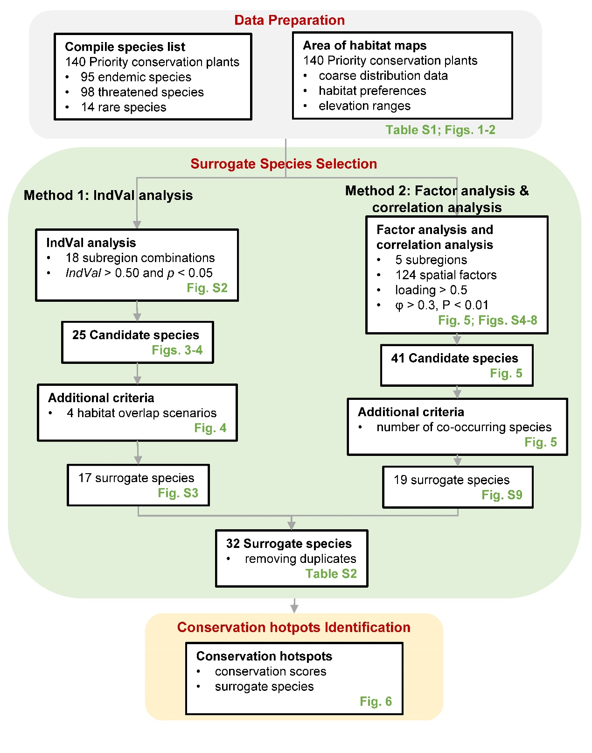

Fig.S1 | Study overview and workflow. IndVal: indicator value.

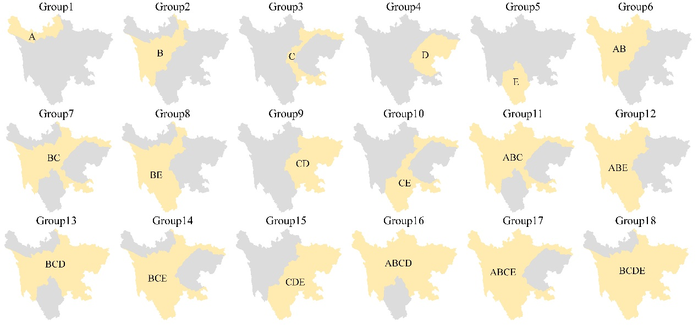

Fig.S2 | Spatial distribution of 18 subregion combinations.

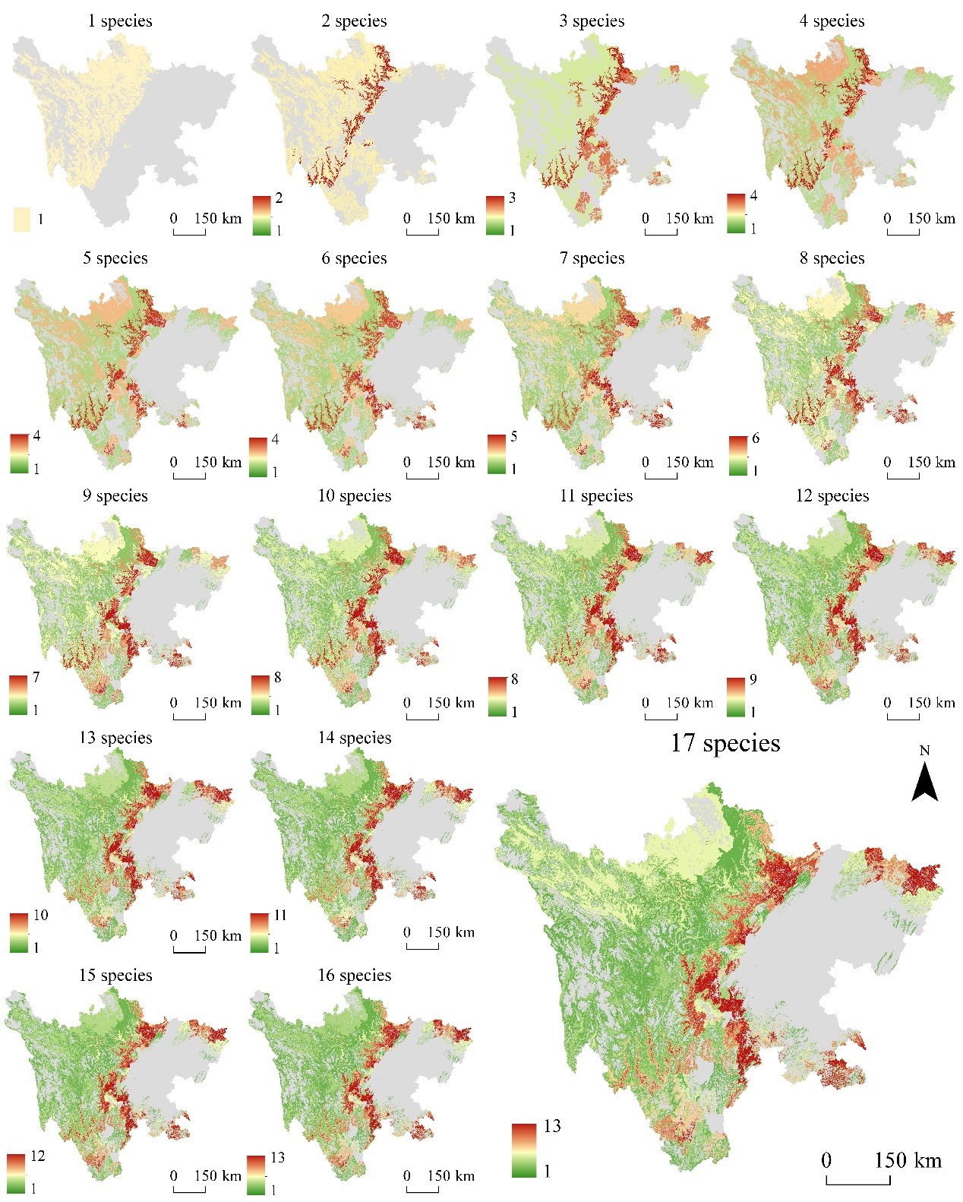

Fig. S3 | Overlapping habitat changes of 17 surrogate species identified by IndVal analysis.

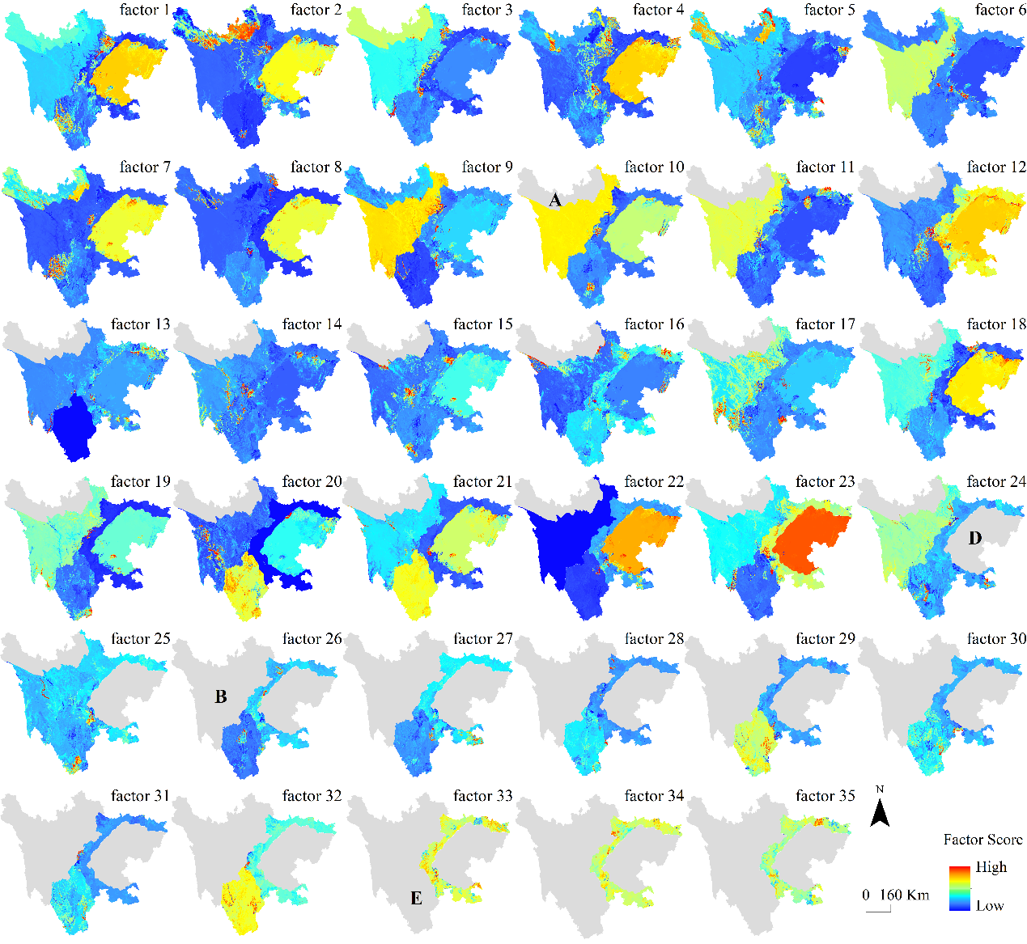

Fig. S4 | The estimated factors after varimax rotation resulted in a total of 124 factors. Among these, 9, 35, 35, 23, and 32 spatial factors were identified in regions A, B, C, D, and E, respectively.

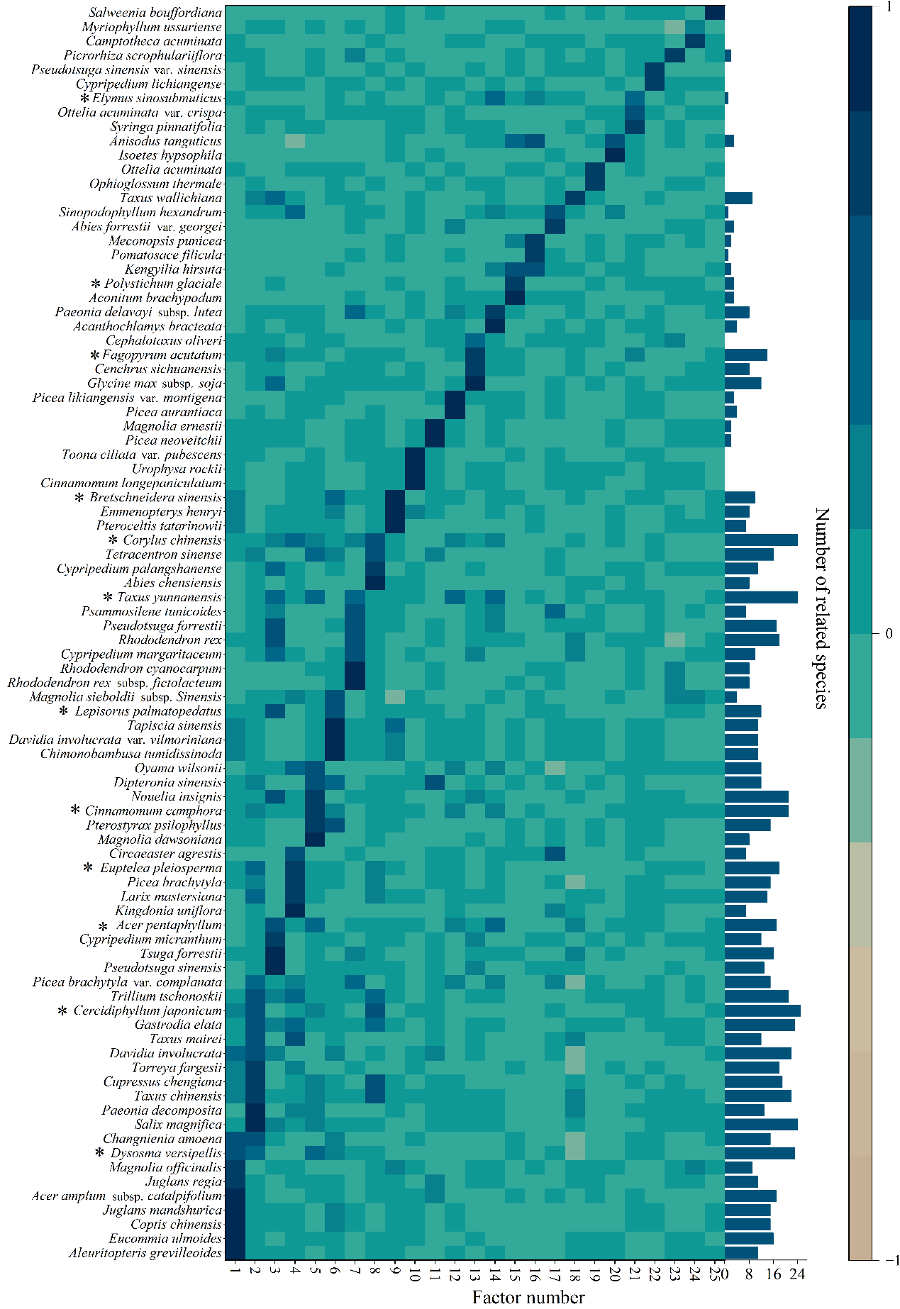

Fig. S5 | The varimax-rotated loadings matrix to select the candidate species in subregion B. The inverted column chart shows the number of co-occurring species for each candidate species, where φ > 0.3 and P < 0.01.

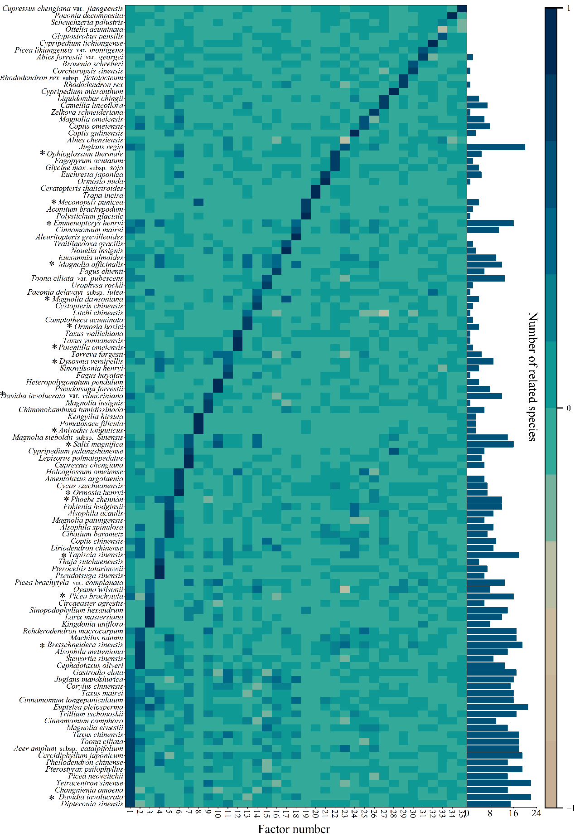

Fig.S6 | The varimax-rotated loadings matrix to select the candidate species in subregion C. The inverted column chart shows the number of co-occurring species for each candidate species, where φ > 0.3 and P < 0.01.

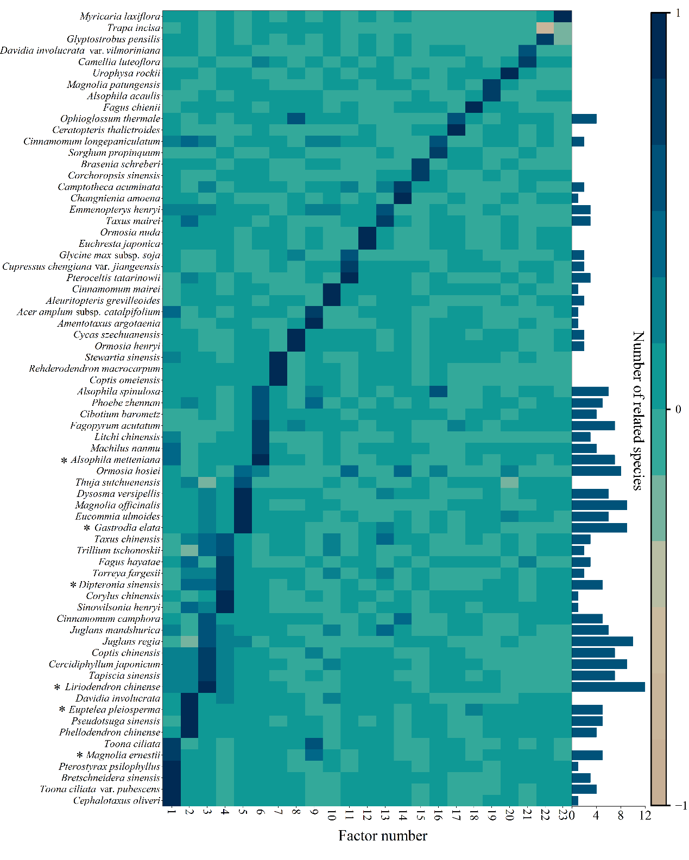

Fig. S7 | The varimax-rotated loadings matrix to select the candidate species in subregion D. The inverted column chart shows the number of co-occurring species for each candidate species, where φ > 0.3 and P < 0.01.

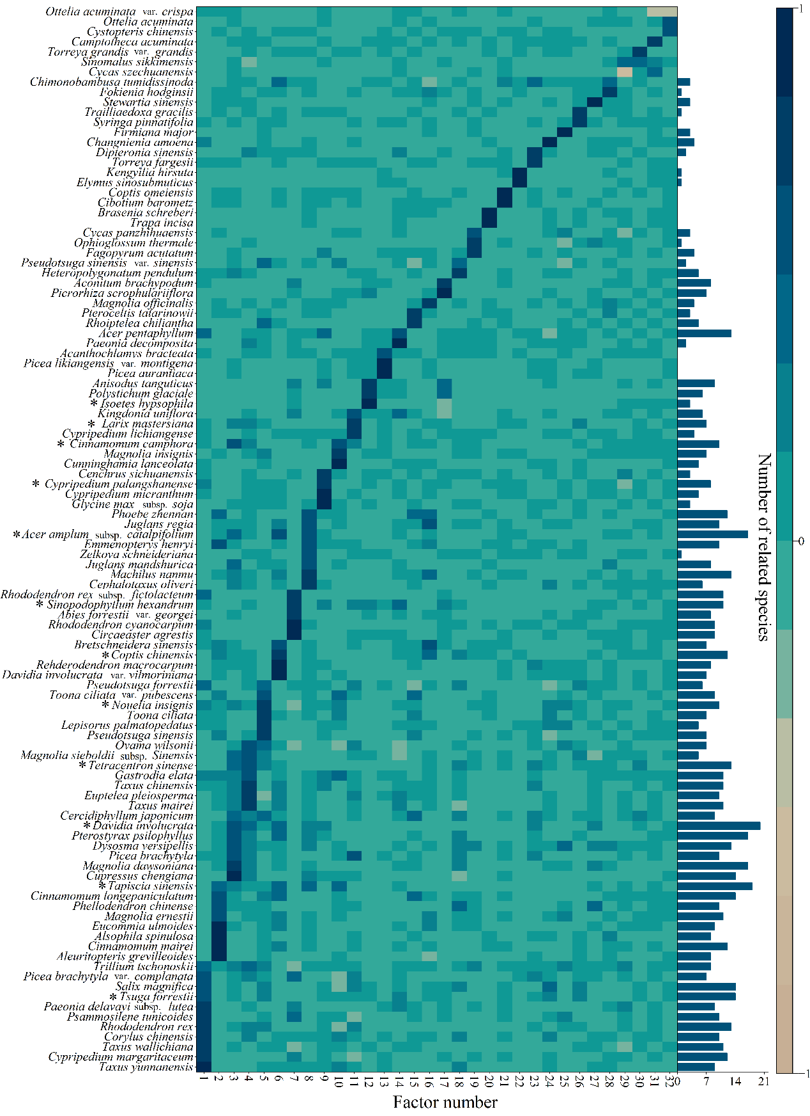

Fig. S8 | The varimax-rotated loadings matrix to select the candidate species in subregion E. The inverted column chart shows the number of co-occurring species for each candidate species, where φ > 0.3 and P < 0.01.

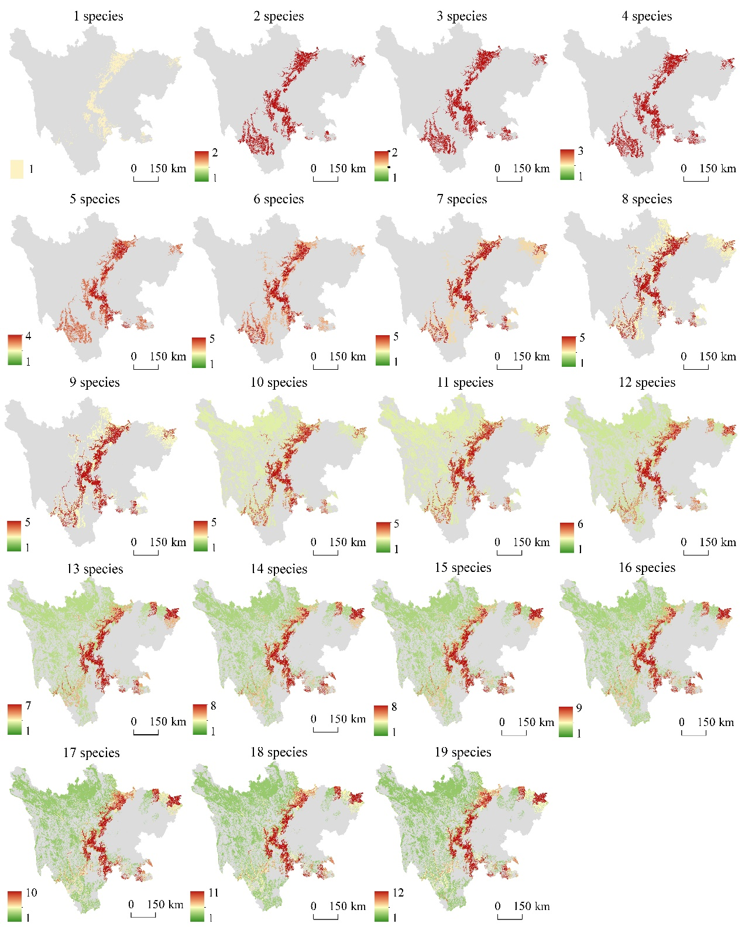

Fig. S9 | Overlapping habitat changes of 17 surrogate species identified by factor analysis.

Table S1. Criteria for assigning priority levels and priority scores

|  |  |  |  |
| --- | --- | --- | --- |
| Evaluation Criteria | Priority level Ⅰ (score=3) | Priority level Ⅱ (score=2) | Priority level Ⅲ (score=1) |
| Endemism and Rarity | Plants with extremely small populations (PSESP) and endemic to the study area | Plants with extremely small populations (PSESP) and endemic to the Hengduan Mountains | Other species |
| Protection Level | Species protected by law (law-protected species) at first level | Law-protected species at second level | Other species |
| Threat Status | Critically endangered (CR) species in the IUCN Red List or China’s Red List | Endangered (EN) species in the IUCN Red List or China’s Red List | Other species |

Table S2. List of 32 surrogate species with their priority scores and priority levels

|  |  |  |  |
| --- | --- | --- | --- |
| Species name | Priority score | Priority level | Method for surrogate identification |
| *Alsophila metteniana* | 3 | III | Factor analysis |
| *Larix mastersiana* | 2 | Ⅱ | Factor analysis |
| *Picea brachytyla* var. *complanata* | 3 | III | IndVal analysis |
| *Taxus chinensis* | 3 | Ⅰ | IndVal analysis |
| *Taxus yunnanensis* | 3 | Ⅰ | Factor analysis |
| *Salix magnifica* | 2 | Ⅱ | Factor analysis |
| *Pteroceltis tatarinowii* | 3 | III | Factor analysis |
| *Fagopyrum acutatum* | 3 | III | Factor analysis |
| *Cercidiphyllum japonicum* | 3 | III | IndVal and Factor analysis |
| *Coptis chinensis* | 3 | III | IndVal analysis |
| *Dysosma versipellis* | 3 | III | Factor analysis |
| *Sinopodophyllum hexandrum* | 3 | III | IndVal analysis |
| *Magnolia dawsoniana* | 2 | Ⅱ | Factor analysis |
| *Magnolia officinalis* | 2 | Ⅱ | IndVal and Factor analysis |
| *Cinnamomum longepaniculatum* | 3 | III | IndVal analysis |
| *Machilus nanmu* | 2 | Ⅱ | IndVal analysis |
| *Phoebe zhennan* | 3 | III | IndVal and Factor analysis |
| *Meconopsis punicea* | 3 | III | IndVal analysis |
| *Bretschneidera sinensis* | 3 | Ⅰ | Factor analysis |
| *Eucommia ulmoides* | 3 | III | IndVal analysis |
| *Potentilla omeiensis* | 3 | Ⅰ | Factor analysis |
| *Ormosia henryi* | 3 | III | Factor analysis |
| *Toona ciliata* | 3 | III | IndVal analysis |
| *Tapiscia sinensis* | 3 | III | Factor analysis |
| *Acer amplum* subsp. *catalpifolium* | 3 | Ⅰ | Factor analysis |
| *Davidia involucrata* | 3 | Ⅰ | Factor analysis |
| *Anisodus tanguticus* | 3 | III | IndVal and Factor analysis |
| *Emmenopterys henryi* | 3 | III | IndVal analysis |
| *Nouelia insignis* | 3 | III | IndVal analysis |
| *Elymus sinosubmuticus* | 3 | III | Factor analysis |
| *Trillium tschonoskii* | 2 | Ⅱ | IndVal analysis |
| *Gastrodia elata* | 3 | III | IndVal analysis |