OPERATIONAL MANUAL

COPY RIGHT
All rights reserved by IC Pro Solution Pvt. Ltd. Reproduction or issue is not permitted without the written permission of IC Pro Solution Pvt. Ltd.

Project Name:

System Line Efficiency (SLE), HCCB
End Customer Name:
HCCB Aranya
Document No:
ICP-OM-PR1680-Aranya
Document Title:
Operational Manual
Prepared by:
IC Pro Solutions Pvt . Ltd.
REVISION HISTORY
Initial Release for Review | 00 | 07-01-2023 | KP | Rajeesh
REVISION DETAILS | REVISION | REV. DATE | PREP. BY | CHECKED | APPROVED

CHANGE DOCUMENT CONTROL
Once IC Pro and HCCB have approved the document, every variation made on the document must be referenced as a change.
Contents
1. Introduction 4
1.1. Scope 4
2. Screen Details 5
2.1. Log in Screen 6
2.2. Dashboard 6
2.2.1. Add Employees 7
2.2.2. Add Shift Executive and Line Operator 7
2.2.3. Add Raw Data 8
2.3. Analysis Screen 9
2.4. Loss Screen 10
2.5. Schedule Screen 10
2.6. Report Screen 11
2.7. First Bottle out Time 12
2.8. NPT, LOG & LBO 13
3. Security 15
4. Appendix 15
4.1. OEE Calculation Process 15

Introduction

Scope

This Operational manual has been developed to specify the functionality and functional Monitoring of the SLE software. The scope of Single Line Efficiency (SLE) System is broad and extends beyond a single machine or production line. It encompasses various aspects of manufacturing and can be applied at different levels within an organization.
- Monitoring Performance: Ensuring that the equipment operates at its optimal speed, which includes measuring actual output against potential output.
- Quality Control: Assessing the quality of the output to identify defects and ensure that only high-quality products are produced.
- Root Cause Analysis: Investigating the underlying causes of inefficiencies, such as low OEE components, to implement effective corrective actions.

Customer : HCCB Aranya
Location : Hindustan Coca-Cola Beverages Pvt. Ltd.(HCCB), Aranya
Process Equipment : SLE System
Project No. : ICP-PR1931

Screen Details
The user interface of the web application includes:
  - Log in Screen
  - Dashboard
  - Summary Report
  - Breakdown

Log in Screen

This system has two types of logins: one for the admin and the other for the operator. The admin has full access to the system, while the operator can only view the dashboard.

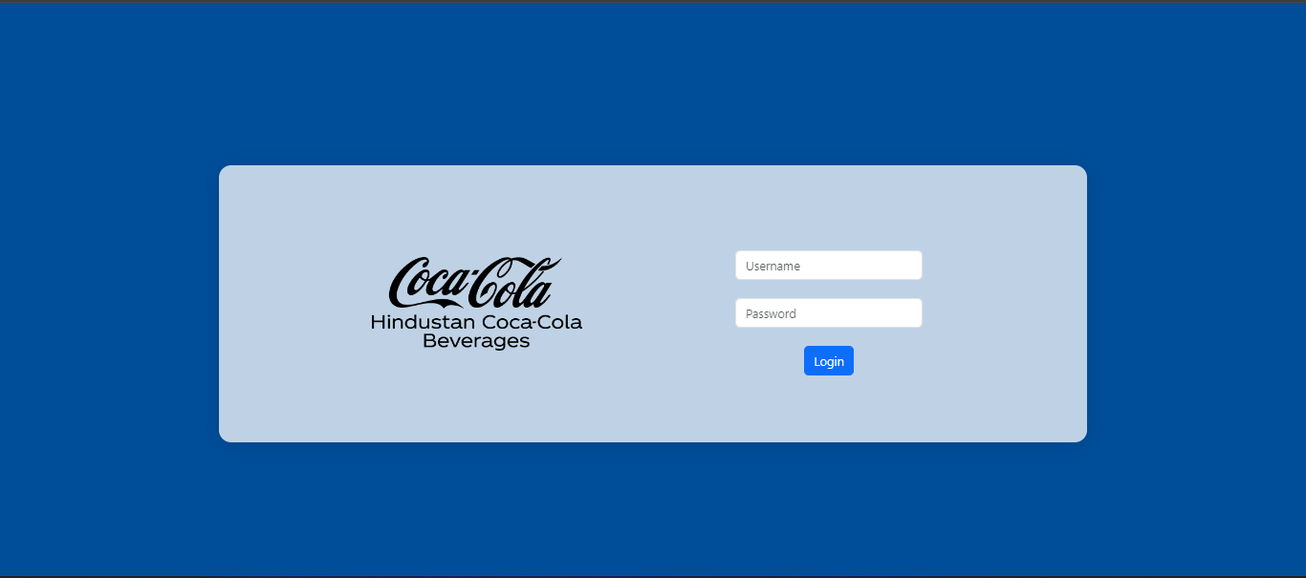

- Admin : Full Access
- Screens : Dashboard, Summary Report, BreakDown
- Credentials : UserName : admin
Password : admin@123#
- Operator : Only view the Dashboard
- Screens : Dashboard
- Credentials : UserName : sleuser
Password : sle@123#

Production mode

Dashboard

This dashboard displays production performance data for a bottling operation, specifically for Shift A, with an SKU of 250ml. Below is a breakdown of its key elements:

Top Section (Summary)
- Shift: A. (current shift)
- SKU: 250ml.
- Date & Time: Friday, 18 October 2024, 11:20:53. (current date and time)
- Speed: 766 BPM (bottles per minute).

Gauges (SLE and AU)
- SLE: System Line Efficiency, which represents how efficiently the system is running based on the target versus actual production rate.
SLE > 80%: Green
70% < SLE ≤ 80%: Yellow
SLE ≤ 70%: Red
- AU: Asset Utilization, a measure of how much the production equipment is being used compared to its potential.
AU > 87%: Green
60% < AU ≤ 87%: Yellow
AU ≤ 60%: Red

Production and Breakdown Time
- Production Time: Indicating how long the production line was operational.
- Breakdown Time: Showing the time the system was down due to failures.
- Available Time: The total time available for production during the past 10 hours.
- Total Cases Count: The number of cases produced during the shift.

SLE Per Hour (Bar Graph)
- The bar graph below the gauges shows the SLE efficiency per hour:
SLE > 80%: Green
70% < SLE ≤ 80%: Yellow
SLE ≤ 70%: Red

Machine Efficiency (Right Panel)
- Shrink Wrapper: 24 CPM (currently showing 24 cases per minute,28 is the maximum count).
- Labeller: 647 BPM.
- Filler: 656 BPM.
- Blowmax: 667 BPM.
These efficiency readings indicate the operational speeds of the various machines in the production line, showing how well each one is performing.

Overall Insights
This dashboard provides a detailed real-time view of production performance, focusing on efficiency, downtime, and machine performance.

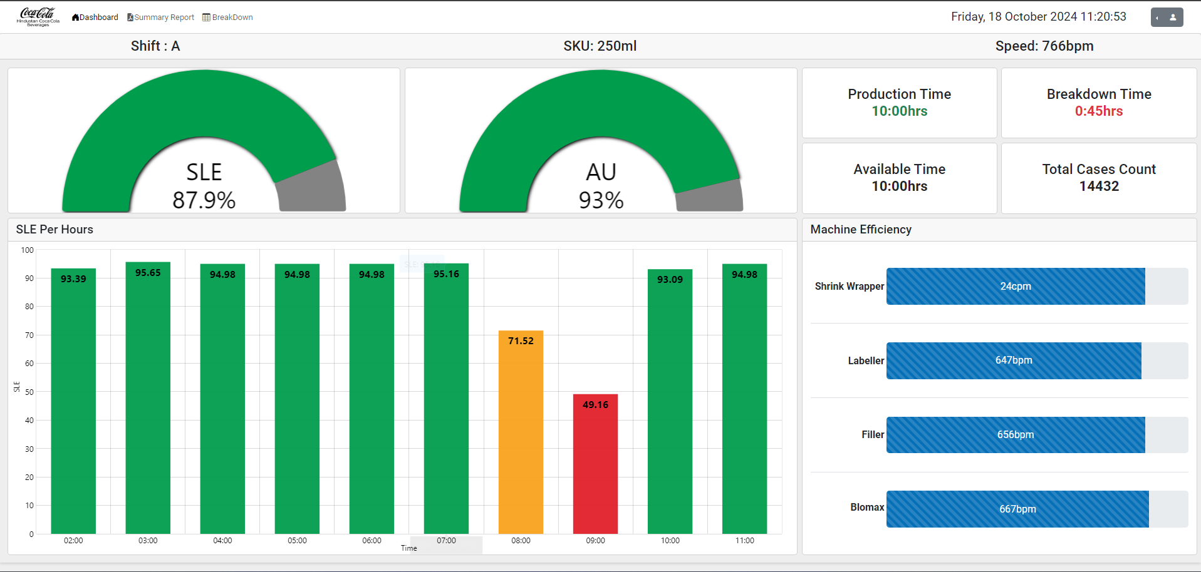

Summary Report
In the Single Line Efficiency Summary Report shown, there are two key filters: one based on shift and another based on date and shift. Here’s a breakdown of the report structure:

Report Based on Shift or date:
We have two filter options like shift and date
When select shift option:
- This report aggregates data for a specific shift over a selected date and shift.
When select date option:
- This view allows users to generate reports for specific date range.

Report Details:
- Plant and Line Details:
  - Plant: HCCB Aranya.
  - Line: ASSP 2.
- Summary:
  - Cases Produced: Number of cases produced during the shift.
  - Production Time: Total hours during which production occurred.
  - Single Line Efficiency (SLE): Efficiency of the production line.
  - Asset Utilization (AU): How much the production assets were utilized.
  - Available Time: Total time available for production.
  - Breakdown Time: Total downtime during the shift.

Breakdown Analysis Section
- This section provides details about equipment breakdown:
  - Equipment: Machines like the Labeller and Shrink Wrapper.
  - Downtime (mins): Time lost due to the breakdown for each piece of equipment (Labeller: 30 minutes, Shrink Wrapper: 15 minutes).
  - Loss (%): The percentage of efficiency loss due to breakdown (Labeller: 5%, Shrink Wrapper: 2.5%).

Key Differences Between Shift and Shift-Date Based Reports:
This report is useful for operations management to track efficiency, pinpoint issues like breakdowns, and analyze equipment performance over time.
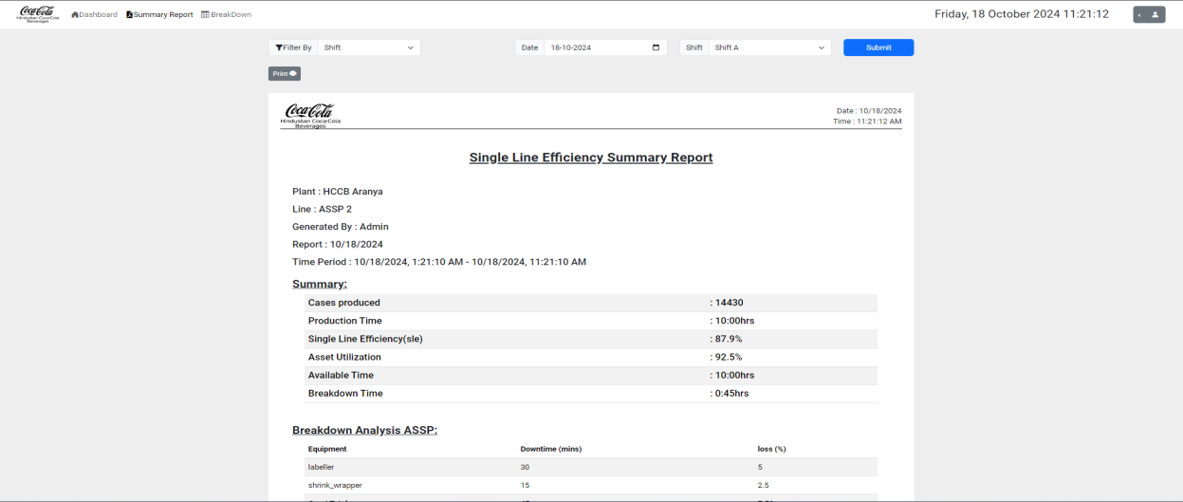
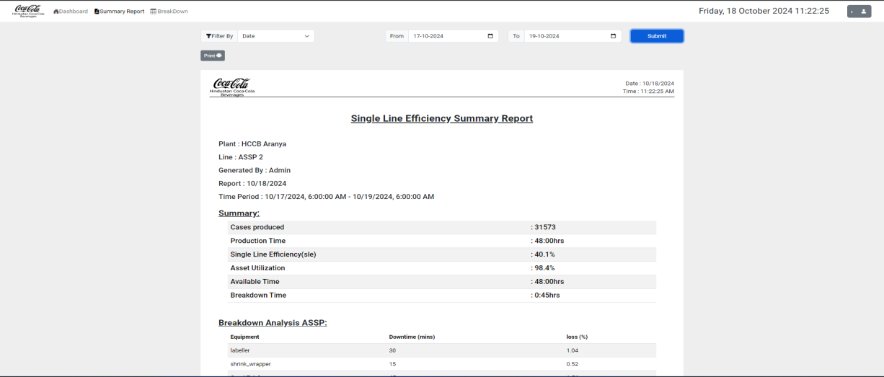

BreakDown
This screen shows the Breakdown Time Logs for equipment in a production line. It tracks when breakdowns occurred, how long they lasted, which equipment was affected, and any remarks related to the issues. Here's a breakdown of the key elements:

Columns Explanation:
- Start:
  - The start time of the breakdown for a piece of equipment.
  - Example: On 18th October 2024 at 7:00 AM, a breakdown started for the shrink wrapper.
- Stop:
  - The time when the breakdown was resolved or stopped.
  - Example: The breakdown for the shrink wrapper ended at 7:15 AM.
- Duration Mins:
  - The total duration of the breakdown in minutes.
  - Example: The shrink wrapper was down for 15 minutes and the labeller was down for 30 minutes.
- Equipment:
  - This column indicates which equipment experienced the breakdown.
  - Example: Shrink Wrapper and Labeller had issues during the selected time frame.
- Remarks:
  - This section provides comments or notes regarding the breakdown cause or issue.
  - Example: The shrink wrapper and labeller both had specific problems, which are noted here.
- Edit:
  - This column allows users to edit the breakdown log entry, such as updating information or fixing an error.

Functionality:
- The top of the screen allows filtering the breakdown logs by date using the From and To fields, letting users select specific periods to analyze.
- The Submit button applies the filter and shows breakdown logs for the specified date range.
This screen is used for monitoring machine downtime, helping identify and resolve issues, and improving equipment efficiency by tracking problems.

Other modes

