**NETWORKING & SYSTEM ADMINISTRATION LAB**

**Name: Libiya Jose**

**Roll No:14**

**Batch:S2 RMCA**

**Date:25/04/22**

**Experiment No.: 7**

**Aim**

Familiarization of Linux Commands.

**Procedure and Output Screenshot**

**1)sudo useradd**

useradd is a command in Linux that is used to add user accounts to your system.

C:\Users\ACER\Pictures\lab 7.1.png

**2)sudopasswd**

*passwd* command in Linux is used to change the user account passwords.

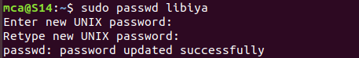

**3)sudo groupadd**

[Groups](https://www.geeksforgeeks.org/groups-in-linux-system-administration/) in Linux refer to the user groups.***groupadd*** command is used to create a new user group.

**C:\Users\ACER\Pictures\lab 7.1.png**

**4)sudo usermode**

Sudo means: Run this command as root. This is required for usermod since usually only root can modify which groups a user belongs to

Usermod is a command that modifies the system configuration for a specific user

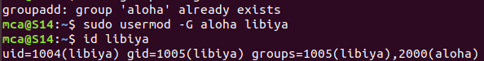

**5)compgen –g**

compgen is a bash built-in command which is used to list all the commands that could be executed in the Linux system

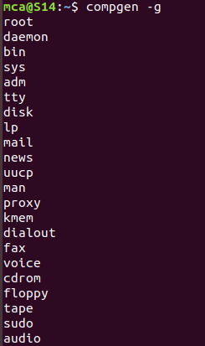

**6)sudo usermod**

**-G** = To add a supplementary groups.

C:\Users\ACER\Pictures\lab 7.1.png

**7)sudo userdel**

The userdel command removes the user account identified by the login parameter.

C:\Users\ACER\Pictures\lab7.3.png

**8)chmod**

the chmod command sets the [permissions](https://www.computerhope.com/jargon/p/permissi.htm) of [files](https://www.computerhope.com/jargon/f/file.htm) or [directories](https://www.computerhope.com/jargon/d/director.htm). 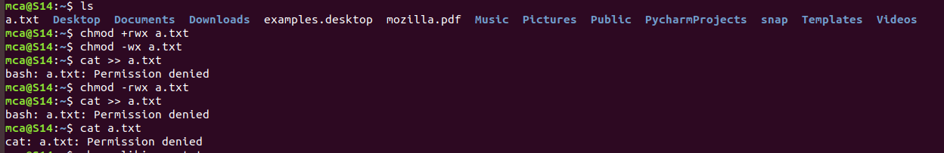

**9)sudo chown**

chown command is used to change the file Owner or group.

**C:\Users\ACER\Pictures\lab 7.4.png**