20MCA136 – OBJECT ORIENTED PROGRAMMING LAB Dept. of Computer Applications

# OBJECT ORIENTED PROGRAMMING LAB

**Name: LIBIYA JOSE**

**Roll No:14**

**Batch:RMCA S2 Date:22-04-2022**

**Experiment No.: 10**

# Aim

**Program to Sort strings Procedure**

import java.util.Arrays; public class StringSort

{

public static void main(String args[])

{

String [] names={"Libiya","Sree","Athira"}; System.out.println("array names:"+Arrays.toString(names));

Arrays.sort(names);

System.out.println("sorted array names:"+Arrays.toString(names));

}

}

# Output Screenshot

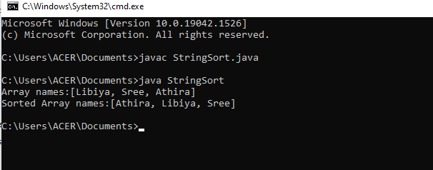

Amal Jyothi College of Engineering, Kanjirappally