Your task is to build a simple “Stopwatch & Countdown Timer” web app that matches the layout shown in the reference image.
A main interfaz will show the “Stopwatch” and “Countdown” options as show below:
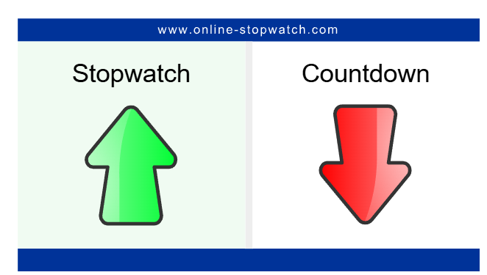
If the Stopwatch button is selected then a fully functional stopwatch will be displayed as show bellow
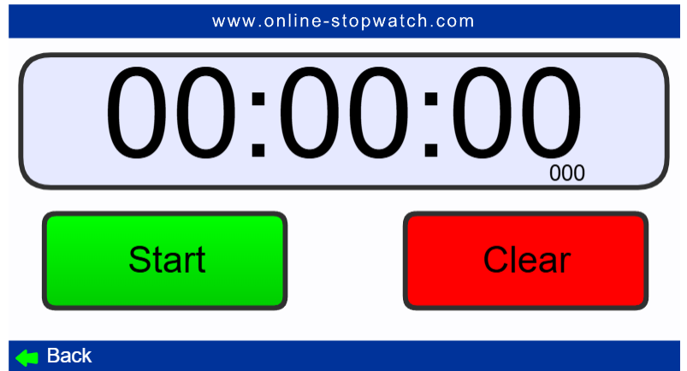
if the Countdown option is selected instead then a fully functional Countdown Cronometer will be displayed as shown bellow:
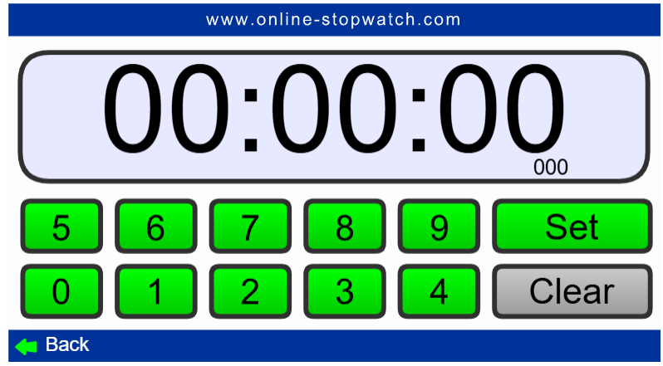

Follow these specific, granular requirements:
- Core Functionality
  - Stopwatch Mode
    - Start, Pause, Resume, Reset
    - Record and display lap times in a scrollable list
    - Millisecond accuracy (hh:mm:ss:ms)
  - Countdown Mode
    - User‐input duration (hours/minutes/seconds) via form controls
    - Start, Pause, Resume, Reset
    - Audible alarm + visual flash when reaching zero
  - Mode Switch
    - Toggle between Stopwatch and Countdown without page reload
    - Preserve current state when switching back
- User Interface
  - Replica of provided reference image: centered timer display, bold digital font, contrasting Start/Stop buttons
  - Responsive layout: full-width on mobile, fixed card on desktop
  - Accessible labels, keyboard controls (Enter to Start/Stop, Esc to Reset)
  - Dark and Light theme toggle
- Architecture & Best Practices
  - Apply SOLID principles: single-responsibility modules, clear interfaces
  - Organize code in ES6 modules (Timer, UIController, AppController)
  - Write unit tests using TDD with Jest: cover all timer methods, UI updates, edge cases
  - Use build tooling (npm scripts, Babel, Webpack/Rollup) for transpilation and bundling
  - Linting and formatting (ESLint + Prettier) with consistent rules
- Technologies & Frameworks
  - Vanilla JavaScript (ES6+) or lightweight framework (e.g. Preact) only if justified
  - CSS: Flexbox/Grid and custom properties (no heavy CSS libraries)
- Deliverables
  - index.html file
  - script.js file
  - style.css file
  - README.md with setup, usage

This is the directory structure. Produce the same structure as in the image.

