
KAMPALA INTERNATIONAL UNIVERSITY

FINAL YEAR PROJECT REPORT

EcoTrace: An E-Waste Collection, Tracking And Rewards System

GROUP F
STUDENT NAME | REGISTRATTION NUMBER
KATEME MARTHA | 2024-04-26432
KYOTANABONA BARBRA | 2024-04-26381
TUSIME DAPHINE | 2024-04-26110

NOVEMBER 2026

DECLARATION
We, the undersigned students listed on the title page, declare that this report is submitted as our project work. Sources consulted have been acknowledged in the reference list. The report distinguishes the software tests that were run from field research and participant evaluation for which no completed records were supplied. This declaration is provided for review and signature; it is not evidence of approval or authorship until completed by the students.
Student Name: _____________________________________________
Student signatures: ______________________________________________
Date: ______________________________

Student Name: _____________________________________________
Student signatures: ______________________________________________
Date: ______________________________

Student Name: _____________________________________________
Student signatures: ______________________________________________
Date: _____________________________
APPROVAL
Supervisor approval is recorded only after review of the completed final report. The signature and date below remain for completion by the supervisor.
Supervisor
Name of Supervisor: Dr. Chukwwemeka Odi Agwu

Signature: ______________________________________________
Date: ______________________________
Contact: 0754319899

ABSTRACT
EcoTrace was developed to support a traceable route for electronic waste from item registration through collection and recycler processing. This report describes the study context, reviewed evidence, planned research methods, implemented role-based web system and available validation results. The software provides consumer, collector, recycler and administrator workflows, with request status events, configured reward and carbon factors, processing records, certificates and administrative summaries.
The local browser evaluation used Chromium, a Vite web client, a Django REST API and an isolated SQLite test database with synthetic role accounts. Three browser tests passed through the tested role workflow, while the recorded Django suite contained 57 passing tests; frontend build and Django configuration checks also passed. In one synthetic scenario, a two-unit pickup reached PROCESSED and displayed a 5,000-point credit and a 5.0 kg CO₂ estimate. These were application outputs from test data, not measured material recovery or emissions reduction.
The research instruments and planned sample were available, but no completed survey dataset, interview transcripts, participant usability records, ethics/permission evidence or production deployment record was supplied. Consequently, the report does not claim achieved recruitment, Kansanga prevalence, participant acceptance, adoption, policy compliance or environmental impact. It concludes only that the evaluated local build supported the tested software workflow; field validation and operational verification remain necessary.
Keywords: e-waste; traceability; collection workflow; recycling; role-based system; software validation; Kansanga.

TABLE OF CONTENTS
CHAPTER ONE: INTRODUCTION 9
1.1 Background to the study 10
1.2 Problem Statement 17
1.3 Main Objective 18
1.4 Specific Objectives 18
1.5 Research Questions 18
1.6 Scope of the Study 19
1.7 Significance of the study 20
1.8 Organization of the report 21
CHAPTER TWO: LITERATURE REVIEW 22
2.1 Introduction 22
2.2 Literature on the topic 23
2.2.1 Nuwematsiko et al. (2021) 23
2.2.2 Sonny, Mlay, Nyero and Oren (2023) 23
2.2.3 Nyeko et al. (2022a) 23
2.2.4 Nyeko et al. (2022b) 24
2.2.5 Nyeko et al. (2022c) 24
2.2.6 Wanjohi Mutahi (2018) 24
2.2.7 NITA-U (2024) 25
2.2.8 Koka (2017) 25
2.2.9 Deche (2020) 25
2.2.10 Ngethe (2021) 25
2.2.11 Kabera, Nishimwe and Mukurarinda (2023) 26
2.2.12 Twagirayezu et al. (2023) 26
2.2.13 Baldé et al. (2024) 26
2.2.14 Tanzania Communications Regulatory Authority (2012) 27
2.2.15 Summary of the Reviewed Literature 27
2.3 Methods and state of the art 28
2.4 Theoretical review 28
2.5 Empirical review synthesis 28
2.6 Research gap 29
2.6.1 No integrated collection-to-tracking workflow 29
2.6.2 Weak item-level traceability 29
CHAPTER THREE: RESEARCH DESIGN AND METHODOLOGY 32
3.0 Introduction 32
3.1 Research Design 33
3.2 Research Approach 35
3.3 Target Population 36
3.4 Sampling Technique and Sample Size 36
3.5 Data Collection 38
3.6 Data Analysis 39
3.7 Design Tools 40
3.8 System Requirements 42
3.8.1 Functional Requirements 43
3.8.2 Non-Functional Requirements 44
3.9 System design 45
3.9.1 System architecture 45
3.9.2 Actor and use-case model 47
3.9.3 Request activity model 48
3.9.4 Request interaction sequence 49
3.9.5 Entity and data relationship model 50
3.10 Choice of Programming Languages 50
3.11 System Implementation 52
3.12 Ethical Considerations 54
CHAPTER FOUR: IMPLEMENTATION AND RESULTS 56
4.1 Introduction 56
4.2 Research findings 56
4.3 System development and implementation 56
4.3.1 Roles and core functions 56
4.3.2 Main disposal workflow 57
4.3.3 Data and reporting behavior 57
4.4 System testing and validation 58
4.5 Discussion of results 59
4.6 Tables and figures 59
CHAPTER FIVE: CONCLUSION, DISCUSSION AND RECOMMENDATIONS 67
5.1 Summary of objective achievement 67
5.2 Conclusion 67
5.3 Limitations 68
5.4 Recommendations and way forward 68
5.5 Contribution to knowledge 69
5.6 Areas for further research 70
REFERENCES 89
APPENDIX A: EVIDENCE AND COMPLETION REGISTER 74
APPENDIX B: REQUIREMENTS TRACEABILITY MATRIX 75
APPENDIX C: USER AND OPERATOR WORKFLOW NOTES 78
APPENDIX D: DETAILED SOFTWARE TEST CASE REGISTER 79
APPENDIX E: RESEARCH INSTRUMENTS 86
APPENDIX F: SELECTED IMPLEMENTATION AND TEST EXCERPTS 95
APPENDIX G: EXTENDED SYSTEM ACCEPTANCE-TEST PLAN 101
APPENDIX H: SYSTEM DATA DICTIONARY AND RECORD RELATIONSHIPS 103
APPENDIX I: ORIGINAL PROPOSAL BASELINE AND EVIDENCE BOUNDARY 106

LIST OF TABLES
Table 1.1. Conceptual influences on e-waste management and their relationships. 13
Table 4.1. Research questions and primary-evidence status. 56
Table 4.2. Role functions observed in the local web build. 57
Table 4.3. Executed validation results and boundaries. 58
Table 5.1. Objective achievement based on available evidence. 67
Table 5.2. Limitations and their effect. 68
Table 5.3. Practical way-forward actions for the Kansanga pilot. 68
Table A.1. Evidence register. 74
Table B.1. Functional requirements traceability. 75
Table B.2. Non-functional requirements and evidence. 77
Table C.1. Role actions and observed outputs. 78
Table C.2. Status transitions and evidence. 78
Table D.1. Browser end-to-end tests. 79
Table D.2. Validation commands and outcomes. 79
Table D.3. Backend test-method inventory: 41 core and 16 waste methods. 80
Table E.1. Household, business and institution questionnaire: respondent profile, practices, awareness, digital readiness and service preferences. 86
Table E.6. Draft participant information and consent points; approval details were not supplied. 94
Table G.1. Acceptance scenarios, criteria and evidence state. 101
Table H.1. Main application data dictionary derived from source models. 103
Table H.2. Principal data relationships. 105
Table I.1. Proposal targets and evidence status. 106

LIST OF FIGURES
Figure 3.1: Agile design framework for the E-Waste Management System 34
Figure 3.2: Iterative build–test–reflect loop of the pragmatic Agile inquiry 34
Figure 3.3: Overall research design framework of the study 35
Figure 3.8: Layered architecture of the E-Waste Management System 45
Figure 3.11. Role-based use cases in the EcoTrace system. Source: author-created from the role routes, API permissions and requirement matrix in Appendix B. 47
Figure 3.12. Request lifecycle and decision points. Source: author-created from the implemented request transition map and Appendix C; branch coverage is stated in Chapter Four. 48
Figure 3.13. Request processing and reporting sequence across system roles and components. Source: author-created from the tested local workflow and Appendix F. 49
Figure 3.14. Core EcoTrace data relationships. Source: author-created from the working-tree models and Appendix H. 50
Figure 3.15: Sprint roadmap for realization of the E-Waste Management System 52
Figure 4.1. Consumer dashboard in the evaluated local web build (synthetic account; identifying account text redacted). 60
Figure 4.2. Collector dashboard in the evaluated local web build (synthetic account; identifying account text redacted). 61
Figure 4.3. Recycler dashboard in the evaluated local web build (synthetic account; identifying account text redacted). 62
Figure 4.4. Administrator reports in the evaluated local web build (synthetic data; identifying account text redacted). 63
Figure 4.5. Recycler processed-consignment detail with receipt, status timeline, certificate, and reward result in the evaluated local web build (synthetic values; identifying account text redacted). 64
Figure 4.6. Consumer certificate view after the synthetic request was processed in the evaluated local web build. 65
Figure 4.7. Consumer wallet in the evaluated local web build after the synthetic workflow; displayed rewards are test data. 66

LIST OF ABBREVIATIONS
Abbreviation | Meaning
API | Application Programming Interface
CO₂e | Carbon dioxide equivalent
Django REST | Django REST Framework
EPR | Extended Producer Responsibility
ICT | Information and Communications Technology
NEMA | National Environment Management Authority
NITA-U | National Information Technology Authority–Uganda
RQ | Research question
SUS | System Usability Scale
UAT | User Acceptance Testing
UI | User interface
UML | Unified Modeling Language
WEEE | Waste electrical and electronic equipment
SQLite | Lightweight relational database used for the isolated local browser test

CHAPTER ONE: INTRODUCTION
Electronic devices now sit at the center of daily life, and they leave a growing trail of waste behind them. In 2022 the world generated 62 million tonnes of e-waste, yet only 22.3 percent was documented as formally collected and recycled (ITU, Global E-waste Monitor 2024). The concern is not only the volume. E-waste holds valuable metals alongside hazardous substances such as lead and mercury, and these become a risk to people and the environment when the waste is burned, dismantled by hand or dumped. Africa produces the least e-waste per person of any region, but it formally recycled less than 1 percent of what it generated in 2022, so the burden falls on informal systems that work with little protection. East Africa offers some evidence that another path is possible, since facilities such as Kenya's WEEE Centre in Nairobi and Rwanda's Enviroserve in Kigali show that formal recycling can operate in the region. Uganda's framework is still developing under the National Environment Act, 2019 and the National Environment (Waste Management) Regulations, 2020, and it has no fully operational Extended Producer Responsibility scheme or dedicated e-waste facility. In Kampala, solid waste is handled by the Kampala Capital City Authority (KCCA), which has no separate e-waste stream, so old phones, computers and appliances are likely to be burned, dismantled in backyards or thrown into general waste. This is a working assumption, because little is documented about what happens in specific neighborhoods such as Kansanga, a mixed residential and commercial area in Makindye Division, Kampala. Without that evidence, local authorities and policymakers cannot design practical interventions. This study therefore examines how e-waste is generated, handled and disposed off in Kansanga, with the aim of adding neighborhood-level evidence to a debate that is usually conducted in global and national terms, and of offering the KCCA, the National Environment Management Authority (NEMA) and local residents a clearer basis for action.

1.1 Background to the study
1.1.1 Conceptual Perspective
Electronic waste (e-waste) is any discarded electrical or electronic device: phones, laptops, batteries, televisions, cables and their parts. It is difficult to manage because it holds both valuable materials (copper, gold, aluminium, rare earths) and hazardous ones (lead, mercury, cadmium, brominated flame retardants). Reuse, recycling and safe disposal therefore need to be organized, not left to change. EcoTrace is a web and mobile platform that connects people who hold e-waste (households and companies) to certified collectors, tracks every item from the owner's home to the recycling center, and rewards responsible disposal through a wallet and a disposal certificate. The key concept is traceability: each item has a recorded source, custody chain and final disposal record.
1.1.1.2 Conceptual framework
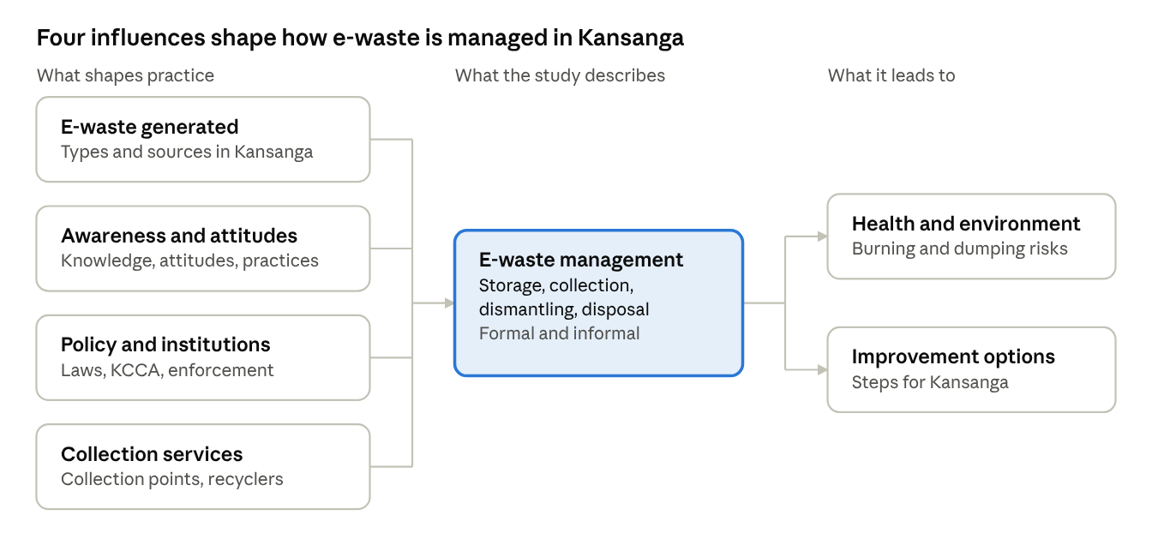
The framework reads from left to right. Four influences, namely the e-waste generated, awareness and attitudes, policy and institutions, and collection services, act together on one central process, e-waste management in Kansanga. The way e-waste is managed then leads to two outcomes: the risk to health and the environment, and the options that are realistic for improvement. The sections below describe each link and the interactions among the variables.

The four influences
E-waste generated. This variable describes the types and sources of e-waste in Kansanga, such as phones, computers, batteries and appliances from households, shops and repair stalls. It determines how much material has to be managed and how much of it is hazardous, because lead, mercury and cadmium call for different handling from copper or aluminium that can be recovered. A larger and more hazardous stream increases the pressure on the other three influences.
Awareness and attitudes. This variable covers what residents and businesses know, how they feel about responsible disposal, and what they actually do. It shapes the decision a person makes when a device stops working: to keep it, sell it to a repairer, pass it on, throw it away, burn it, or hand it to a collector. Attitude alone is not enough, since evidence from Kampala shows that favorable attitudes sit alongside poor knowledge and a habit of storing or selling old devices (Nuwematsiko et al., 2021).
Policy and institutions. This variable covers the laws, the role of the Kampala Capital City Authority and enforcement. The National Environment Act, 2019 and the 2020 Waste Management Regulations set the rules, but KCCA has no separate e-waste stream, so what happens in practice depends on how far the rules are implemented, which earlier work identifies as the main weakness (Wanjohi Mutahi, 2018). Policy decides which routes are lawful and whether the other variables can be backed by enforcement.
Collection services. This variable covers the collection points and recyclers available to the community. It decides whether a formal option exists at all. Where collectors are hard to find, owners are left with informal routes however willing they may be.

Interactions among the influences
The four influences do not act separately. Their effect on practice depends on how they combine.
Awareness and collection services. Awareness leads to proper disposal only where a convenient collector exists. Behavioral evidence shows that people weigh reasons for and against responsible disposal, so knowledge without a route, or a route that nobody knows about, leaves practice unchanged (Nyeko et al., 2022b).
Policy and collection services. Policy and institutions enable or restrict services. Licensing of collectors and producer responsibility can create formal collection capacity, while the absence of effective producer responsibility is reported as a reason collection remains thin (Sonny et al., 2023).
Policy and awareness. Enforcement and public information shape what residents know and what they believe is expected of them, so strong institutions can raise awareness and weak ones leave it to chance.
E-waste generated and collection services. As the volume of e-waste grows, the gap between what is generated and what formal services can absorb widens, and the surplus moves to storage, informal dismantling or burning.

The central process: e-waste management
E-waste management, which includes storage, collection, dismantling and disposal through both formal and informal routes, is where the influences meet. Where awareness is high, services are close at hand, policy is enforced and the stream is understood, more material moves through formal collection and recycling. Where one or more of these is weak, material remains in homes and shops or is burned, dismantled in backyards or dumped with general waste. The practice observed in Kansanga is therefore the combined result of all four influences rather than of any one of them.

The outcomes
Health and environment. The way e-waste is managed determines the risk that follows. Burning and dumping release toxic substances into air, soil and water, while formal handling reduces that exposure and keeps valuable materials in use.
Improvement options. By showing which influence limits proper management most in Kansanga, whether limited knowledge, absent services, weak enforcement or growing volumes, the study identifies realistic steps for improvement. This is the link between the framework and the proposed EcoTrace platform, which addresses the access and traceability weaknesses that the influences expose.

Summary of the interactions
Table 1.1. Conceptual influences on e-waste management and their relationships.
Variable | Role | How it interacts
E-waste generated | Influence | Sets the volume, type and hazard level of the material that has to be managed, and so the scale of demand on collection services and the size of the risk if handling fails.
Awareness and attitudes | Influence | Shapes what owners decide to do with a device they no longer use, but converts into action only where a convenient route exists.
Policy and institutions | Influence | Defines which routes are lawful and enforced, and enables or limits collection services through licensing and producer responsibility.
Collection services | Influence | Decides whether a formal option is physically available, and therefore whether awareness and policy can change practice.
E-waste management | Central process | Receives the combined effect of the four influences and expresses it as storage, collection, dismantling and disposal, through formal and informal routes.
Health and environment | Outcome | Reflects the risk created by the way e-waste is managed, especially burning and dumping.
Improvement options | Outcome | Follow from identifying which influence limits proper management most in Kansanga.

1.1.2 Historical background / perspective
E-waste governance began as a response to toxic waste dumping, well before electronics entered the picture. During the 1980s, tighter environmental rules in industrialized countries made it far cheaper to ship hazardous waste to poorer countries than to treat it at home, and a run of dumping scandals, among them the 1988 Koko case in Nigeria, provoked international outrage. The Basel Convention (1989) was the answer. It set rules for moving hazardous wastes across borders and for how they must be disposed of.
Electronics became the next problem. As computers and mobile phones moved into ordinary homes during the 1990s and 2000s, discarded devices began to pile up, and they contain valuable metals alongside hazardous substances such as lead and mercury. Europe and Asia responded with Extended Producer Responsibility (EPR), which makes producers answerable for collecting and treating their products once consumers are done with them, instead of leaving the cost to municipalities. The idea took shape in Sweden around 1990 and was written into law in places such as Japan (1998) and the European Union (2002).
The numbers show how far practice still trails policy. The world generated 62 billion kg of e-waste in 2022, about 7.8 kg per person and up from 34 billion kg in 2010, yet only 22.3 per cent was documented as formally collected and recycled (ITU, Global E-waste Monitor 2024). Just 81 countries (42 per cent) have an e-waste policy or regulation, short of the ITU's 50 per cent target for 2023. Generation is projected to reach 82 billion kg by 2030, while the documented recycling rate is expected to slip to about 20 per cent.
Africa's hazardous waste history evolved from fighting external dumping via the 1991 Bamako Convention to managing a massive influx of near-end-of-life second-hand electronics, which now constitute over 60 percent of the continent's e-waste. Consequently, despite generating the lowest per capita e-waste globally, Africa formally recycled less than 1 percent of its electronic waste in 2022 compared to Europe's 42.8 percent. This massive regulatory and operational gap has left unprotected informal recyclers to manage the toxic burden entirely on their own.

East Africa is where formal e-waste recycling has been tried most visibly. Kenya's WEEE Centre in Nairobi and Rwanda's Enviroserve facility in Kigali are the two best-known examples, and both show that collecting, dismantling and recycling electronics through formal channels can work in an African city.
Their experience also shows what it takes: a supportive policy framework, and a way of steering discarded equipment into formal channels rather than informal ones. Neither facility has displaced the informal sector.
Uganda's e-waste management relies on general environmental laws—specifically the National Environment Act, 2019 and the 2020 Waste Management Regulations—rather than electronics-specific legislation. This evolving framework still lacks an operational Extended Producer Responsibility (EPR) scheme and a dedicated large-scale recycling facility like Rwanda's. Consequently, in cities like Kampala where KCCA manages solid waste without a separate stream, most electronic waste defaults to hazardous informal burning, backyard dismantling, or open general dumps.
Kansanga, a dense mixed-use neighborhood in Kampala's Makindye Division, serves as the study area due to its high concentration of households, electronics shops, and repair stalls operating without formal e-waste infrastructure. However, the specific unit of analysis—which dictates the study's sampling and data collection instruments—must still be selected from three main candidates: households (to evaluate storage and disposal behavior), repair and resale businesses (to examine aggregation and dismantling), or informal scrap dealers (to investigate recovery and open burning). Because localized data regarding exact waste volumes or burning sites remains unverified, these baseline figures must be established directly through the study's upcoming fieldwork or official KCCA and NEMA records.
1.1.3 Theoretical Perspective
To analyze how electronic waste is managed within Uganda's specific institutional and urban landscape, this study adopts the theoretical lens of Urban Political Ecology (UPE), specifically utilizing the concept of "heterogeneous or hybrid infrastructure." Rather than viewing Kampala’s lack of a formalized municipal e-waste stream as a mere technical or administrative failure by the Kampala Capital City Authority (KCCA), UPE conceptualizes electronic waste as a dynamic "socio-material flow" that links macro-level global economic structures directly to localized urban survival strategies. This flow manifests as a bifurcated system of disposal pathways: a highly constrained formal route tied to state pilot initiatives, and a dominant, decentralized informal route powered by local collectors and repairers.
In an under-resourced neighborhood like Kansanga, the state’s formal regulatory framework exists primarily on paper, creating an institutional void where structural access and infrastructure are missing. UPE shifts the analytical focus toward how individual e-waste generators process this systemic failure internally and structurally. On a behavioral level, an actor's individual attitude, subjective norms, perceived control, and risk awareness shape their ultimate disposal intentions. However, UPE highlights that structural limitations—such as physical distance to formal drop-off facilities—frequently override these personal intentions. As a result, global electronic flows are directly metabolized into local livelihoods via informal handling, backyard dismantling, and open burning, converting environmental risks into economic survival at the direct expense of localized ecological and bodily health.
Theory of Planned Behavior applied to Kansanga
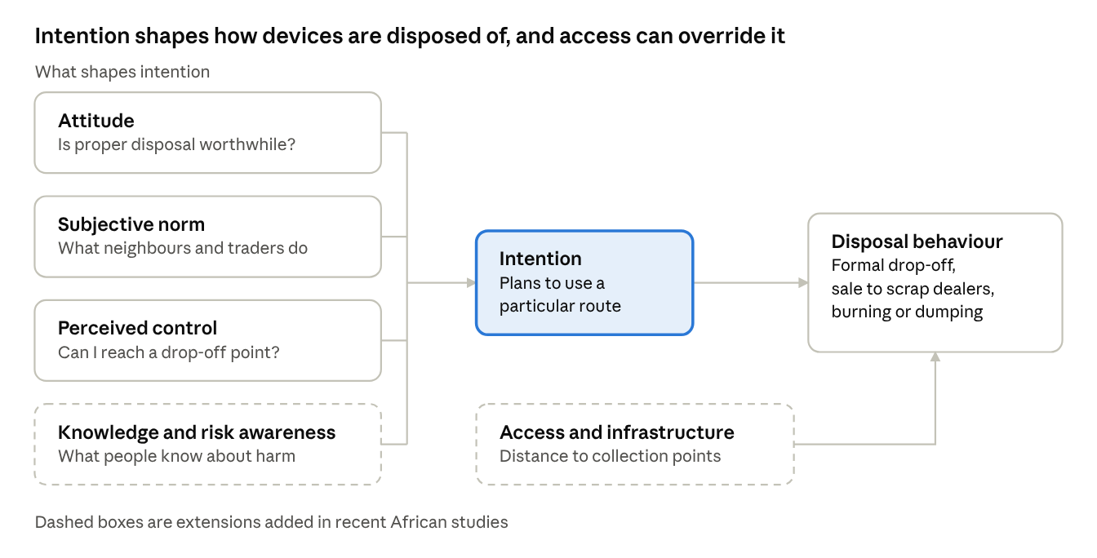

1.2 Problem Statement
Currently, households and companies in Ugandan towns dispose off e-waste informally. owners search for collectors by word of mouth, arrange pickups by phone, and hand items over with no record, while much of the waste is burned, dismantled in backyards or dumped with general refuse. Ideally, e-waste should pass through an organized, traceable chain in which owners can easily reach certified collectors, every item is recorded from its source through collection to final recycling or safe disposal, hazardous materials are handled safely, and responsible disposal is encouraged and verifiable, as envisaged by the National Environment Act, 2019 and the principles of Extended Producer Responsibility. The problem is the absence of an integrated, traceable and incentive-driven e-waste management system: certified collectors are hard to find, nothing verifies what happens to an item after it leaves the owner's hands, recycling centers cannot reliably account for what they receive or where it came from, and there is no incentive to dispose of e-waste properly, so burning and dumping remain the cheapest option. As a result, toxic substances such as lead, mercury and cadmium contaminate air, soil and water and endanger public health, valuable recoverable materials are lost, authorities cannot detect illegal dumping or measure environmental impact, and recyclers and collectors operate without reliable records. This problem is evident in the low share of e-waste that is documented as properly collected and recycled (only about 22% globally in 2022), the prevalence of informal burning and dumping in Ugandan towns, the lack of item-level disposal records at recycling centers, and the absence of data available to regulators. This study therefore proposes EcoTrace, a web and mobile platform that connects e-waste owners to certified collectors by town, tracks each item from the owner's home to the recycling center through a recorded audit trail, and rewards verified responsible disposal with wallet credits and a disposal certificate.
Without a source-to-disposal record, authorities cannot detect illegal dumping or measure environmental impact. This study addresses the absence of an integrated, traceable and incentive-driven e-waste management system.

1.3 Main Objective
The main objective of the study is to connect e-waste owners to certified collectors, tracks e-waste from the point of origin to recycling, and rewards responsible disposal.

1.4 Specific Objectives
To find what e-waste people in Kansanga throw away.
To learn how homes, shops and repair stalls in Kansanga keep old phones and computers, who picks them up, and what finally happens to them after that.
To check what people know about e-waste and how they act.
To study the laws on e-waste in Uganda and the offices in charge of them, such as KCCA and NEMA, and find out how well the rules are followed on the ground in Kampala.
To suggest simple and workable ways of handling e-waste better, beginning here in Kansanga.

1.5 Research Questions
- What kinds of e-waste are thrown out in Kansanga, who throws them out, and roughly how much of it is there overall?
- Where does old e-waste end up here?
- Do people in Kansanga, including residents, shop owners and repairers, know that e-waste can harm health and soil, and does knowing this change what they do with their old devices?
- Which laws and offices cover e-waste in Kampala, and are they followed?
- What could be done, in clear, simple terms, to help residents, businesses and collectors in Kansanga handle e-waste in a safer and cleaner way than they do today?

1.6 Scope of the Study
1.6.1 Geographic scope
The pilot targets a selected Ugandan town, Makindye Division . Kansanga represents a large urban setting with high e-waste volumes, The system is built so that new towns, collectors and recycling centers can be added as data, with no changes to the code.
1.6.2 Content scope
EcoTrace is a role-based web and mobile e-waste management system designed to streamline and audit the entire electronic waste lifecycle in Uganda through user registration and role-based access for households, companies, collectors, and recycling center administrators. The platform enables users to log e-waste details—including item type, quantity, condition, and location—and request pickups that are automatically scheduled and assigned to certified local collectors by town. As items transition through a strictly tracked workflow (REQUESTED, SCHEDULED, COLLECTED, RECYCLED), the system automatically categorizes the material as reusable, recyclable, or hazardous, flagging dangerous components for specialized handling. To ensure complete accountability, EcoTrace maintains a continuous source-to-disposal custody audit trail while simultaneously managing recycling center inventories, generating verifiable disposal certificates, tracking environmental metrics like town-level waste volumes and estimated CO2 savings, and incentivizing safe user participation via a non-negative rewards wallet.

1.6.3 Time scope
The study covers the period needed to establish the baseline situation in Kansanga, to develop the EcoTrace system through successive sprints, and to evaluate the working system with pilot users. It follows the Agile schedule set out in Chapter Three. A baseline sprint at the start gathers stakeholder views and produces the prioritized product backlog. Development then proceeds through four sprints of two weeks each, which together take about eight weeks: authentication, roles and registration; e-waste reporting and pickup requests; the collector workflow, collection transaction and inventory; and the wallet, certificates, reports and notifications. A demonstration and feedback session closes every sprint, and an end-of-study evaluation in the pilot environment follows the last sprint.

Data collection takes place within this period. The baseline questionnaire, interviews and case studies are conducted at the start, while focus groups, System Usability Scale questionnaires and system logs are collected at the end of each sprint. The study period is could not be confirmed because approved start/end dates and fieldwork records were not supplied. Findings therefore describe the situation and the system's performance during this period and are not projected beyond it.
The literature reviewed covers work published between 2012 and 2024, and the global e-waste figures used to frame the problem refer to 2022, the most recent year reported in the Global E-waste Monitor 2024.

1.7 Significance of the study
For e-waste owners, the system eliminates logistical friction by offering households and companies a streamlined platform to report items, schedule pickups, and track disposal progress. This convenient process directly incentivizes proper disposal through wallet rewards and official disposal certificates, which simultaneously helps household’s clear toxic items from their compounds and provides companies with verifiable proof of compliance for environmental audits.
This organized supply chain directly strengthens certified collectors by replacing inefficient search methods with automated, town-based job assignments that reduce wasted trips while building a verifiable digital work history to formalize their businesses. These collected streams feed directly into recycling centres, which gain automated inventory tracking, instant hazard flags for safe workshop handling, and automated reporting tools that drastically cut administrative workloads when applying for green funding and international partnerships.
On a broader structural and regulatory level, EcoTrace operationalizes national environmental policies by providing regulators and government bodies like the National Environment Management Authority (NEMA) with an end-to-end, source-to-disposal audit trail. This immutable digital ledger offers concrete evidence to detect illegal dumping, verify actual recycling rates, and measure performance by town, directly supporting the strict enforcement of the National Environment Act, 2019 and the Waste Management Regulations, 2020.

Consequently, environment and public health sectors see immediate mitigation of open-air burning and illegal dumping, preventing highly toxic heavy metals like lead, mercury, and cadmium from leaching into local air and water tables while quantifying these ecological achievements through real-time, estimated carbon dioxide savings.
As a result, local governments and communities experience cleaner municipal surroundings, reduced cleanup expenditures, and heightened grassroots awareness driven by visible, reward-backed disposal habits.
Furthermore, producers, retailers, and development partners gain access to structured metrics necessary to validate their Extended Producer Responsibility (EPR) compliance and corporate sustainability targets.
Finally, for academia and the researcher, this study establishes a localized, socio-technically grounded blueprint for building secure, traceable, and incentive-based transactional waste management systems within developing nations, while cultivating advanced competencies in secure software engineering, rigorous testing, and structured systems analysis.

1.8 Organization of the report
Chapter One introduces the study. Chapter Two reviews related literature and identifies the research gap. Chapter Three presents the methodology, requirements and design. Chapter Four covers implementation, testing and results. Chapter Five gives conclusions, limitations, recommendations, contribution to knowledge and areas for further study. References and appendices follow.
The benefits described in this section are intended contributions, not measured outcomes. The local software evaluation did not establish adoption, reduced dumping, verified environmental savings, or policy compliance; those claims require field and partner evidence.

CHAPTER TWO: LITERATURE REVIEW

2.1 Introduction
This chapter examines earlier work on the handling of waste electrical and electronic equipment (e-waste): how it is collected, moved, tracked, recycled and finally disposed of, and how information technology has been brought into these activities. Seven of the fourteen sources reviewed were produced in Uganda; the remainder come from Kenya, Tanzania and Rwanda, or from global reporting, and are used where Ugandan evidence is limited. For each source the review states who carried out the work, where, with how many participants, by which method, what was proposed or found, what difficulties or limits applied, and what remains unresolved.
E-waste covers discarded phones, computers, televisions, batteries, printers and similar equipment. Careless handling can release toxic substances, while proper handling allows valuable materials to be recovered or devices to be reused. Good management therefore needs more than pickup: items must be sorted, handled safely, recorded, and followed to their final destination.
The studies below shape the EcoTrace E-Waste Collection, Tracking and Rewards System. They show how people currently dispose of devices, where collection breaks down, and which incentives and coordination arrangements are missing. The gaps drawn from them are set out in Section 2.6.

2.2 Literature on the topic

2.2.1 Nuwematsiko et al. (2021)
Nuwematsiko et al. (2021) studied how electronics consumers in Kampala understand and handle e-waste, drawing on 640 adult consumers, 18 key-informant interviews and six focus groups involving 57 consumers, through a cross-sectional mixed-methods design with multistage sampling. They found that about two-thirds of respondents (67.7%) had poor knowledge of e-waste management, although 79.1% held favorable attitudes towards handling it responsibly, and that old devices were mostly sold to repairers, passed on or kept at home. The authors called for wider awareness and accessible collection and disposal points. Their results rely on what respondents said they do rather than on observed behavior , and no digital tool linking owners, collectors and recyclers was built or tested. The study is relevant to EcoTrace because good intentions without a convenient route to disposal is exactly the problem that EcoTrace's booking, tracking and reward features target.

2.2.2 Sonny, Mlay, Nyero and Oren (2023)
Sonny, Mlay, Nyero and Oren (2023) examined the challenges and opportunities in collecting e-waste in Uganda through a questionnaire survey of 423 e-waste collectors and informal recyclers, analysed with partial least squares structural equation modelling. They reported that weak public awareness, thin collection infrastructure and the absence of effective extended producer responsibility, under which producers share responsibility for end-of-life products, hindered collection, while financial incentives were seen as a way to raise participation and easier access to recycling was recommended. A survey of this kind can identify what limits collection but cannot show how an individual device is followed from owner to recycler, and no complete workflow was proposed. The study supports pairing a collection mechanism with a rewards incentive, which is the combination EcoTrace adopts.

2.2.3 Nyeko et al. (2022a)
Nyeko et al. (2022a) took a stakeholder perspective on sustainable e-waste management in ten Ugandan cities, issuing 410 questionnaires to government employees in waste-related roles, of which 346 (about 84.4%) were usable, and analysing them with descriptive statistics and PLS-SEM. They concluded that sustainable e-waste management depends on cooperation among government bodies, environmental agencies and waste handlers, and proposed a conceptual framework that accounted for roughly 48.5% of the variation in sustainability outcomes. Because the respondents were officials, households and informal collectors are not represented, and the output was a framework rather than a working system with item records. The study treats e-waste as a coordination problem, which a shared digital workflow for owners, collectors and recycling staff can support.

2.2.4 Nyeko et al. (2022b)
Nyeko et al. (2022b) investigated the drivers and inhibitors of e-waste collection and disposal behavior using the same ten Ugandan cities and the same 346 employees as the previous study, so the two papers count as related rather than independent evidence. Applying Behavioral Reasoning Theory within a PLS-SEM analysis to separate reasons for and against responsible disposal, they showed that behavior is shaped by both motivators and barriers, and that assuming people will act simply because disposal is environmentally beneficial is unrealistic. The study measured intentions, and intending to dispose responsibly is different from completing a collection and confirming that it reached a recycler. For EcoTrace, easy booking, status updates and rewards may lower the effort of disposal, but whether they actually change behavior must be tested rather than assumed.

2.2.5 Nyeko et al. (2022c)
Nyeko et al. (2022c) carried out a systematic literature review of the impact of electrical and electronic waste on human health and the environment in Uganda and Sub-Saharan Africa, structuring the identification and synthesis of published studies so that no human participants were involved. The review concluded that toxic substances and unsafe recycling practices threaten health and ecosystems, and that Uganda's e-waste had received less attention than other waste streams despite existing policies. A review of this kind cannot test a tool or measure how rewards affect behavior . It nonetheless shows why EcoTrace flags hazardous items for safe handling instead of treating them as ordinary scrap.

2.2.6 Wanjohi Mutahi (2018)
Wanjohi Mutahi (2018) studied the implementation of Uganda's e-waste policy using questionnaires and interview guides administered to 125 respondents from bodies such as the National Environment Management Authority, the Ministry of ICT, the Ministry of Water and Environment, district environment offices and NITA-U. The central issue identified was the distance between having a policy and putting it into practice, which was affected by capacity, coordination, funding and awareness, and the author proposed an implementation framework in response. The work was institutional and policy-focused and did not build item-level tracking or user rewards. Digital records such as those EcoTrace keeps could support monitoring by authorised bodies, although EcoTrace cannot replace regulation or guarantee legal compliance.

2.2.7 NITA-U (2024)
The National Information Technology Authority-Uganda (NITA-U, 2024) conducted a national baseline survey on waste from electrical and electronic equipment, covering hospitals, universities, businesses, repairers, manufacturers, importers, retailers, telecom operators, local and central government and e-waste handlers, although the published summary does not give a total respondent count. Combining document and data review, key-informant consultation through focus groups and a nationally representative survey, it established a national picture of e-waste volumes, practices, awareness and existing initiatives, and showed that organizations as well as households produce e-waste. A baseline describes the current situation, however, and does not show whether a live platform can maintain a continuous audit trail. EcoTrace's operational records could therefore complement such baselines at the level of individual collections.

2.2.8 Koka (2017)
Koka (2017) assessed the factors leading to poor electronic waste management in Arusha City, Tanzania, by surveying 120 respondents split evenly between institutions, electronics artisans and household members, and examining policy, technology, human and financial resources, and public education. The study found that poor management stems from several interacting factors and that the problem spans use, repair, collection and disposal. Because the context is Tanzanian, the findings cannot be applied directly to Uganda, and no digital collection system was developed. The study suggests that digital coordination must run alongside physical recycling capacity and trained people if it is to work.

2.2.9 Deche (2020)
Deche (2020) examined the factors that influence an ICT framework for a circular e-waste economy among 384 households with small electronic devices in Nairobi County, selected by stratified probability sampling and studied through a descriptive survey of socioeconomic characteristics, consumer behavior , information access and ICT infrastructure. The study considered how ICT could support a circular economy built on repair, reuse, refurbishment and recycling, but its focus was on the factors shaping such a framework rather than on a working system that verifies final recycling. It argues for going beyond information-sharing to bookings, tracking and recorded outcomes, with a simple, mobile-friendly design for ordinary households, which is the direction EcoTrace takes.

2.2.10 Ngethe (2021)
Ngethe (2021) undertook a critical literature review of the influence of e-waste management systems in Kenya, reviewing empirical studies to extract themes and knowledge gaps, so that no participants were involved. The review found existing management approaches inadequate and noted that importers rarely applied extended producer responsibility. Its conclusions are only as strong as the literature reviewed, and no platform was tested. A tracking system such as EcoTrace could work alongside producer-responsibility schemes, provided that legitimate recycling partners take part.

2.2.11 Kabera, Nishimwe and Mukurarinda (2023)
Kabera, Nishimwe and Mukurarinda (2023) assessed the situation and capacity needs of e-waste management in Kigali and Rwanda's secondary cities, using questionnaires analysed with SPSS and mixing quantitative and qualitative approaches. They found that repair and reuse were common, reported by 38.1% of respondents, alongside concerns about water and air pollution and a need for stronger handling capacity. The study assessed needs and did not build a pickup-coordination or reward system. Its findings support EcoTrace's classification of items as reusable, recyclable or hazardous.

2.2.12 Twagirayezu et al. (2023)
Twagirayezu et al. (2023) conducted a critical review of published work on the growth of electrical and electronic equipment, its health and environmental risks, and management options in Rwanda, involving no participants. They recommended managing e-waste across its whole lifecycle through separation, repair, reuse, recycling, remanufacturing and safe disposal, and stopping its mixing with household rubbish. The review offers no evidence on whether a digital platform improves collection or traceability. EcoTrace turns this lifecycle thinking into a recorded workflow, issuing rewards and certificates only after a verified outcome.

2.2.13 Baldé et al. (2024)
Baldé et al. (2024), in the Global E-waste Monitor 2024 compiled by ITU and UNITAR with partners, synthesised country-level statistics from around the world using standardised reporting frameworks. They reported that around 62 million tonnes of e-waste arose in 2022, of which 22.3% was documented as formally collected and recycled, that generation is outpacing recycling, and that Africa's documented rate was under 1%. The report is a statistical and policy resource rather than a local tool for Ugandan users and recyclers. It highlights the importance of reliable records, although a small pilot such as EcoTrace cannot change national figures.

2.2.14 Tanzania Communications Regulatory Authority (2012)
The Tanzania Communications Regulatory Authority (2012) carried out a regulator-led institutional assessment of e-waste in Tanzania, looking at rising equipment use and its waste implications, although no sample size is stated in the bibliographic details available. The study called for coordination among users, collection services, recyclers and public bodies. It is dated and was written before digital collection platforms existed. EcoTrace responds to the same need for coordination by linking users, collectors and recycling staff through shared records.

2.2.15 Summary of the Reviewed Literature
Across the fourteen sources, e-waste management emerges as a multi-part problem involving consumer behavior, collection infrastructure, institutional coordination, environmental protection, policy delivery and dependable information. Ugandan studies document weak awareness, limited collection capacity, fragmented stakeholder action and policy implementation gaps. Regional work adds evidence on ICT potential, repair and reuse, and institutional capacity.
Methods differ: cross-sectional and questionnaire surveys, statistical modelling, policy studies, literature reviews and institutional or statistical reports. Each answers a different question, and none demonstrates that a digital collection and tracking system has been built and shown to work.
Together they justify investigating whether a platform can make disposal more accessible, document individual items, and support checking of their final handling, alongside physical recycling capacity and stakeholder cooperation.

2.3 Methods and state of the art
The studies reviewed used cross-sectional consumer surveys, questionnaires with collectors and public officials, stakeholder interviews, policy implementation research, literature reviews and national or global monitoring. These methods provide complementary evidence: household surveys describe self-reported knowledge and practice; stakeholder studies examine institutional coordination; policy reviews identify implementation constraints; and monitoring reports estimate documented national or global flows. They do not have interchangeable populations or measures, so their percentages should not be pooled as if they described one sample. The two 2022 studies by Nyeko and colleagues that draw on the same ten-city, 346-response dataset are related analyses rather than independent replications (Nyeko et al., 2022a, 2022b). The national NITA-U baseline and Global E-waste Monitor add broader context but cannot substitute for Kansanga-specific responses (NITA-U, 2024; Baldé et al., 2024).
Within the literature reviewed here, digital approaches were discussed mainly as possible information and coordination supports rather than demonstrated end-to-end local services. Deche (2020) considered ICT within a circular-economy framework, while Ngethe (2021) reviewed management-system influences; neither provides a browser-tested EcoTrace-equivalent workflow in the evidence summarized in this report. For a useful digital service, the technology must connect a user-facing disposal request to eligible collection, a recorded custody history, facility receipt and a defensible terminal outcome. A screen that records pickup alone would not establish responsible downstream handling. Digital traceability also depends on operational partners, accurate records, access to collection services and privacy safeguards; software cannot create authorized recycling capacity by itself.

2.4 Theoretical review
The Theory of Planned Behavior (TPB) explains intention through attitudes toward a behavior, subjective norms and perceived behavioral control (Ajzen, 1991). In this study, attitudes relate to whether residents view safe e-waste handling as worthwhile; subjective norms concern perceived expectations from family, businesses, community leaders and institutions; and perceived control concerns whether people can access a convenient, trusted collection route. EcoTrace was designed to support perceived control through item logging, request tracking and disposal-route information. Status visibility and a certificate could make the process more understandable, while configured rewards may provide an additional incentive. These are design links to theoretical constructs, not evidence that the constructs changed.
TPB has limits for this setting. Intention does not guarantee action when collection is distant, transport costs are high, devices retain resale value, or formal services are unavailable. The intention–behavior gap means that usability, local service capacity, trust and affordability must be considered alongside attitudes. Nyeko et al. (2022b) also discuss behavioral reasons for and against responsible disposal, which helps frame practical barriers and motivators alongside TPB. No completed questionnaire or interview data were supplied to measure these constructs in Kansanga; the theory therefore informed the requirements and interpretation framework, not a tested causal explanation.

2.5 Empirical review synthesis
The empirical evidence is strongest at Kampala, national and multi-city scales, with additional studies from Kenya, Tanzania and Rwanda. Nuwematsiko et al. (2021) combined consumer surveys with interviews and focus groups in Kampala; Sonny et al. (2023) examined collectors and informal recyclers; and Nyeko et al. (2022a, 2022b) analyzed stakeholder responses across ten Ugandan cities. Together, these studies show why consumer attitudes, collection access, incentives and institutional coordination need to be considered together. Their populations and methods differ, and the two Nyeko papers share a response base, so they should not be counted as separate independent samples.
The regional studies by Koka (2017), Deche (2020), Kabera et al. (2023) and Twagirayezu et al. (2023) add evidence about interacting social, infrastructure and policy conditions, circular-economy options, repair/reuse and capacity. The Global E-waste Monitor gives an international benchmark, while the TCRA report provides older neighboring-country context. These sources identify plausible local questions; they do not supply a Kansanga respondent profile or establish current local prevalence. Differences in year, geography, sampling and outcome definitions limit direct comparison. The present report therefore treats the reviewed findings as context and keeps the software test results separate from field research.

2.6 Research gap
Of the eight practical gaps the literature leaves open, three are carried forward here because they are the most central to the study and the others largely follow from them. They are the absence of an integrated workflow, the lack of item-level traceability, and rewards that are not tied to verified recycling. Together they describe the chain EcoTrace sets out to build: owners reach collectors through one process, each item is recorded from source to outcome, and responsible disposal is rewarded only once it is verified.

2.6.1 No integrated collection-to-tracking workflow
Nuwematsiko et al. (2021) and Sonny et al. (2023) describe how people dispose of devices and what obstructs collection, but neither presents a single process linking owners, collectors and recycling centres. Nyeko et al. (2022a) likewise treat the problem as one of coordination among institutions, yet stop at a conceptual framework. Owners therefore still search for collectors informally, and the actors in the chain work from separate, unconnected records.
Why it matters: this is the foundation gap, because every other function depends on a shared workflow. EcoTrace addresses it by bringing collection requests, collector assignment and status updates into one system.

2.6.2 Weak item-level traceability
The studies stress proper collection and recycling, yet recording a pickup does not prove that an item reached a suitable facility. What is missing is a record tying each item to its source, custody history and final outcome. This is also the weakness that the regulatory work of Wanjohi Mutahi (2018) and the baselines of NITA-U (2024) and Baldé et al. (2024) leave open, since none of them follows individual items.
Why it matters: without such a record, authorities cannot detect illegal dumping or measure environmental impact. EcoTrace keeps item-level records and treats a collection as complete only once a disposal outcome is entered. Accuracy would still depend on honest reporting and verification by partners.

2.2.3 Rewards not tied to verified recycling
Sonny et al. (2023) point to incentives as an opportunity, and Nuwematsiko et al. (2021) show that good attitudes do not guarantee proper disposal. Nyeko et al. (2022b) add that behavior depends on both motivators and barriers. None of these studies tests rewards that are linked to confirmed recycling, so it is unknown whether an incentive tied to verification changes what people do.
Why it matters: burning and dumping remain the cheapest option unless proper disposal is made worthwhile. EcoTrace credits a rewards wallet only after disposal is recorded and verified, and its real effect on behavior must be measured during testing.

CHAPTER THREE: RESEARCH DESIGN AND METHODOLOGY

3.0 Introduction
This chapter explains how the study was designed and carried out. It describes the philosophy and design that guide the work, the approach used to gather and interpret evidence, the people from whom the evidence is drawn, and the way the EcoTrace E-Waste Collection, Tracking and Rewards System is specified, designed, built and tested. The aim is to show that each choice follows from the problem set out in Chapter One and from the gaps identified in Chapter Two, so that another researcher could understand and repeat the process.
The study rests on a pragmatic research philosophy, which values research for its practical usefulness in solving real problems, and it adopts an Agile research design in which the system is built, tested and refined in short two-week sprints with stakeholders involved throughout. A mixed-methods approach is used, combining qualitative feedback from interviews, focus groups and case studies with quantitative data from questionnaires, System Usability Scale scores and system logs. The evidence is drawn from the target population of 27,676 stakeholders in Kansanga, Kampala, from which a minimum sample of 395 respondents is determined using Slovin's formula, supported by a purposive panel of experts in waste collection and recycling.
The chapter proceeds as follows. Section 3.1 presents the research design and Section 3.2 the research approach. Section 3.3 defines the target population, Section 3.4 explains the sampling technique and sample size, and Sections 3.5 and 3.6 describe how data are collected and analysed. Sections 3.7 to 3.10 cover the design tools, system requirements, system design and choice of programming languages, Section 3.11 describes implementation and verification, and Section 3.12 sets out the ethical considerations that protect participants throughout.

3.1 Research Design
This study is grounded in a pragmatic research philosophy, which posits that the value of research lies in its practical application and capability to solve complex, real-world problems. To address the systemic challenges of electronic waste tracking, collection, and processing, this study utilizes an exclusively Agile research design. The philosophical foundation of an Agile approach centers on iterative discovery, adaptive planning, and immediate empirical validation. Rather than treating software engineering as a detached, theoretical exercise, this approach views the development of the E-Waste Management System as an evolving inquiry where knowledge is generated through the continuous loop of building, testing, and reflecting. By embedding stakeholders directly into the developmental lifecycle, the research ensures that the resulting digital artifact remains highly relevant, socially acceptable, and technically optimized to navigate the fluid dynamics of environmental waste management within a densely populated urban setting.
The selection of an exclusively Agile research design over traditional linear models is justified by the volatile and multi-layered nature of the e-waste ecosystem. Traditional software development frameworks assume that all system requirements can be completely known and fixed at the start of a project. However, an e-waste system involves diverse user groups, including casual consumers, municipal collection authorities, and commercial recycling vendors, all of whom have conflicting operational needs and varying levels of technical literacy. An Agile design accommodates this complexity by allowing the research parameters to evolve as deeper insights are uncovered during development. It mitigates the risk of project failure by preventing the over-engineering of features that users might find impractical in real-world settings. Furthermore, Agile facilitates continuous risk management, as technical bottlenecks, data sync errors, or usability barriers are discovered and corrected early in short cycles rather than at the very end of the research timeline. This flexible structure ensures the final system is built on validated user behavior rather than static, unverified assumptions.
The Agile design framework adopted for the research solution is illustrated in Figure 3.1. Stakeholder consultation feeds a baseline sprint that produces a prioritized product backlog. Each fixed-length sprint of two weeks then moves through sprint planning, a micro-lifecycle of requirements analysis, architectural sketching, coding and verification, a working increment, a demonstration to a pilot group, and the capture and analysis of feedback, after which the backlog is refined for the next sprint. The continuous build, test, and reflect loop that drives this cycle and generates knowledge from every increment is shown in Figure 3.2.
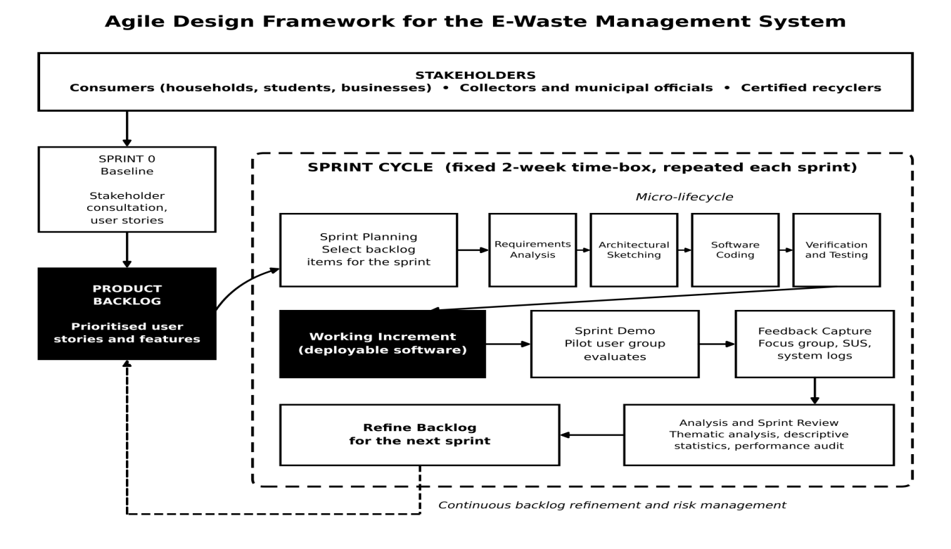
Figure 3.1: Agile design framework for the E-Waste Management System
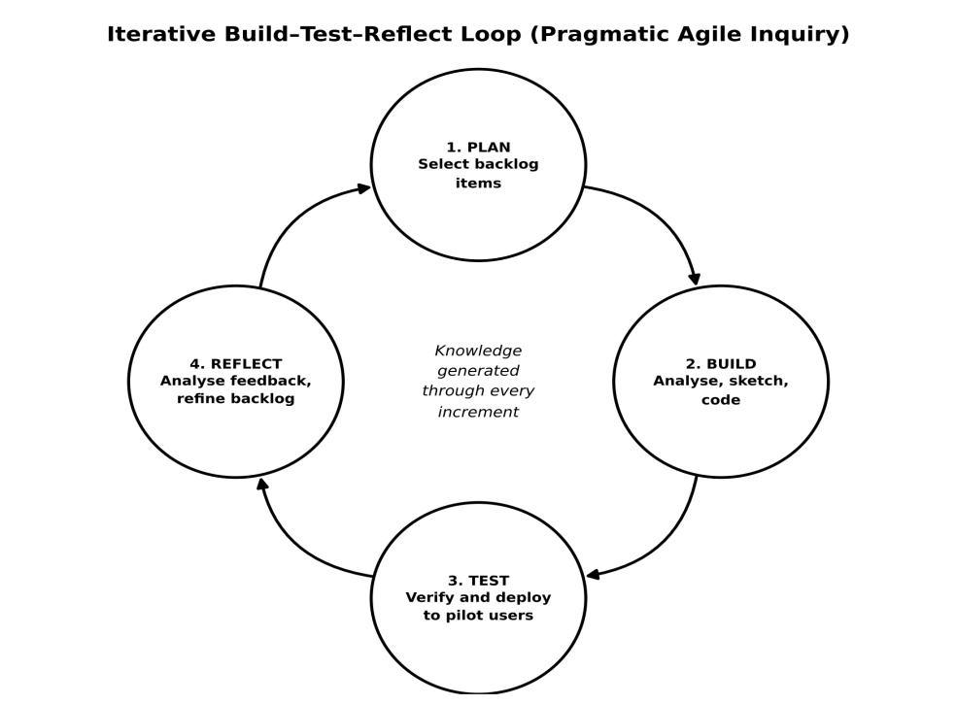
Figure 3.2: Iterative build–test–reflect loop of the pragmatic Agile inquiry

3.2 Research Approach
The study adopts an empirical, development-based qualitative and quantitative approach embedded entirely within the Agile engineering framework. The overall research design relies on inductive inquiry during the early development stages to capture user expectations, shifting toward a deductive, experimental approach during system testing and verification. By utilizing a mixed-methods research approach, the study collects qualitative feedback during sprint reviews to understand user behavior and satisfaction, while simultaneously logging quantitative system telemetry, transaction success rates, and processing latency. This ensures that the system is evaluated not just on its technical performance, but also on its practical human utility and adoption potential within the target ecosystem.
Figure 3.3 summarizes how the research philosophy, design, approach, population and sampling, data collection, and data analysis components of this chapter connect to one another, and how feedback from each sprint flows back into the design to refine the next cycle.
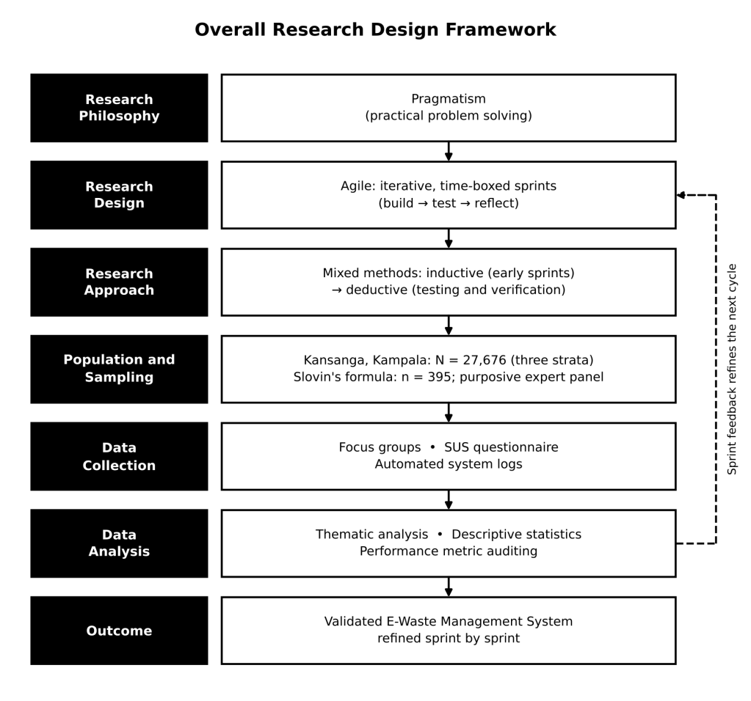
Figure 3.3: Overall research design framework of the study

3.3 Target Population
The target population for this study comprises the complete network of stakeholders involved in the local electronic waste lifecycle within Kansanga, Kampala, which has a total target population of 27,676 (N = 27,676). This specific urban area provides a unique socio-economic mix, characterized by a high concentration of student populations from major higher-learning institutions, diverse commercial retail businesses along the main transport corridors, and varied residential zones. This population is divided into three distinct strata to ensure comprehensive system coverage. The first stratum consists of residential households, business owners, and institutional electronics consumers in Kansanga who generate e-waste and require reliable disposal channels. The second stratum encompasses local division waste management officials, independent scrap collectors, and informal logistics operators working within the Makindye Division network. The third stratum includes the administrative and technical personnel operating certified electronic recycling facilities and scrap-refining plants that service the wider Kampala metropolitan region.

3.4 Sampling Technique and Sample Size
The proposal specified a combined sampling design for the strata shown in Figure 3.4. It planned to calculate the consumer sample using Slovin’s formula and to recruit household, student and business respondents through convenience sampling. It also proposed purposive interviews with waste-management officials, collectors, logistics operators and recycling-facility staff, with the expert panel size guided by participant availability and thematic saturation. These were planned methods; completed recruitment and interview records were not supplied.

Slovin's formula estimates the minimum sample size required to represent a finite population when the distribution of the population is not known in advance. It states that the sample size n equals the population size N divided by one plus the product of N and the square of the margin of error e, as expressed below.
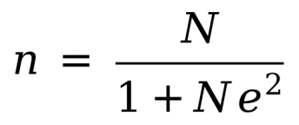
In this study N is the target population of Kansanga, which is 27,676, and e is the margin of error. A margin of error of five percent (e = 0.05), corresponding to a ninety-five percent confidence level, is adopted because it is the conventional standard for social and usability research. Substituting these values into the formula and working through it step by step, the margin of error is first squared to give 0.0025.
The full calculation is shown below.
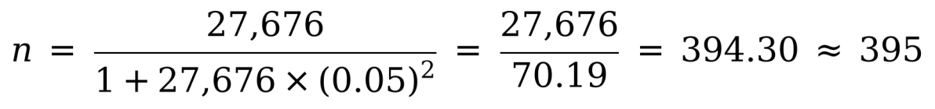
The proposal calculation produced 394.30 and rounded this up to a planned minimum of 395 respondents from the stated target population of 27,676 (about 1.43 percent). This was a sample-size target, not an achieved respondent count; no sampling frame or completed recruitment records were supplied.
The proposal planned to recruit 395 consumer-side respondents and to invite a pilot group of 30 users to review successive software increments. It also planned for purposively selected experts to review the logistics workflow and recycler dashboard. No evidence that these recruitment, demonstration or review activities were completed was supplied. If implemented as planned, convenience and purposive sampling would limit statistical generalization beyond the selected participants and Kansanga context.
The stated population and sample size are planning values, not achieved recruitment. No sampling-frame, invitation, consent, response-count or non-response records were supplied, so the realized sample and response rate cannot be reported.

3.5 Data Collection
Data collection is systematically executed across every iterative sprint using a blend of automated and human-centric instruments, and it draws on four principal methods, namely questionnaires, surveys, interviews, and case studies, which are supported during the sprints by focus groups, a usability scale, and automated system logs. Using several methods allows the weaknesses of one source to be balanced by the strengths of another and supports the mixed-methods approach described in Section 3.2.
Questionnaires are the main instrument for the consumer stratum. A structured questionnaire is administered to the 395 respondents drawn through Slovin's formula and combines closed-ended items, measured on a five-point Likert scale, with a small number of open-ended items. It captures how respondents currently store and dispose of electronic devices, their awareness of e-waste hazards, the channels available to them, their willingness to use a digital platform, and the features they would value most, such as category logging, carbon-offset feedback, and pickup requests.
The proposal planned to pre-test the questionnaire with residents outside the final sample and to administer a digital System Usability Scale after sprint reviews. No pre-test record, completed SUS form or score was supplied, so these activities were not reported as completed.
Surveys are the strategy through which the questionnaire reaches the community. The survey is carried out in Kansanga's residential areas, institutions, and commercial corridors, either in person or through a digitally shared link, so that students, households, and business owners all have an opportunity to respond. Treating the survey as a structured, repeatable exercise makes it possible to obtain a broad quantitative picture of current practices and expectations at the baseline sprint and to repeat selected items in later sprints to see whether attitudes and usability perceptions change as the system matures.
Interviews are used with the purposively selected experts from the second and third strata, including division waste management officials, independent scrap collectors, logistics operators, and the administrative and technical staff of certified recycling facilities. Semi-structured interviews are preferred because a prepared guide keeps the conversation focused on collection routes, volumes, handling and safety practices, regulatory expectations, and the data a recycler needs on arrival of a consignment, while still leaving room for the participant to raise issues the researcher had not anticipated. These interviews are held at the requirements stage to shape the product backlog and again during sprint reviews so that the experts can evaluate the logistics workflow and the recycler dashboard directly. With the participant's consent they are audio-recorded and transcribed for analysis.
Case studies provide an in-depth, real-world view of how e-waste currently moves through the Kansanga and wider Kampala network. A small number of cases, such as one established collection route and one certified recycling facility, are studied through observation of the workflow, review of the records those actors keep, and informal conversations with the people involved. The cases show where information is lost, where delays occur, and which steps could realistically be supported by software, and they are used to test whether the designed workflow matches actual practice. Finally, technical data collection is automated directly within the system architecture through logging frameworks that record transaction error rates, form validation failures, response latencies, and database execution speeds during active user simulations, while open-ended focus groups held in Kansanga at the end of each sprint review capture the qualitative reactions of the pilot users.
The questionnaire, interview and focus-group materials are retained in Appendix E as instruments. Their inclusion documents the planned method; it does not show that they were administered. No completed forms, interview transcripts, focus-group notes or participant consent records were supplied.

3.6 Data Analysis
The analysis of the gathered data follows distinct pathways that run parallel to the sprint schedule to allow for immediate software optimization, as shown in Figure 3.5. Qualitative data obtained from interviews, focus groups, and stakeholder review sessions undergoes thematic analysis, in which transcripts and feedback notes are read repeatedly, coded, grouped into themes, and reviewed to identify recurring pain points, feature requests, and navigation bottlenecks. Data from the case studies are analyzed by comparing the observed workflow with the designed workflow and by looking for patterns that recur across the cases.
Quantitative data from the survey questionnaires are cleaned, coded, and entered into a spreadsheet or statistical package and analyzed using descriptive statistics, including frequencies, percentages, and mean scores, to describe current disposal practices and feature preferences. Responses to the System Usability Scale are converted into a single score for each participant by subtracting one from the score of each odd-numbered item, subtracting the score of each even-numbered item from five, adding the results, and multiplying the total by 2.5. The mean usability score and its frequency distribution are then calculated and compared across sprints, with the widely used benchmark average of about 68 serving as a reference point. Finally, the technical system logs are subjected to performance metric auditing, where statistical variations in error rates and system latency are calculated to pinpoint architectural weaknesses. Findings from the different sources are compared with one another through triangulation, and all analyzed data directly inform the development priorities of the subsequent sprint.
The proposed analysis describes how collected data would be summarized and coded. Because no field dataset or transcripts were supplied, no descriptive statistics, thematic coding, missing-response analysis or participant-based usability score is reported as completed.

3.7 Design Tools
The system is modelled before and during coding using the Unified Modelling Language, flowcharts, and data modelling notations, because visual models give the researcher, the developers, and the stakeholders a common and unambiguous way to discuss what is being built. Diagrams are drawn with general-purpose diagramming software such as draw.io or Lucid chart, and interface wireframes are prototyped with a design tool such as Figma, so that each sprint begins with a model that can be reviewed by users before any code is written. Because the work is Agile, the models are kept deliberately light and are revised as the backlog changes, rather than being fixed once at the start.
Use case diagrams capture the system from the point of view of its users. They identify the actors, namely the consumer, the collector, the recycler, and the administrator, and show which functions each actor can perform, which gives the team a shared picture of the scope of the system and helps in deriving user stories.
Class diagrams describe the main entities of the system, their attributes, and the relationships between them, and they guide the structure of the code and the database. Sequence diagrams show how the user interface, the application programming interface, and the database exchange messages over time for important scenarios such as submitting a collection request, while activity diagrams describe the logic and decision points inside a single process, such as how a request is validated and assigned. Together these diagrams move the design from what the system should do to how its parts cooperate to do it.
Flowcharts complement the UML diagrams by presenting the step-by-step logic of a process in a form that non-technical stakeholders such as collectors and municipal officials can follow without training.

3.8 System Requirements
System requirements are gathered from the stakeholder consultations of the baseline sprint, from the interviews and case studies, and from the questionnaire and survey results, and they are written as user stories and placed in the product backlog. Each backlog item is prioritized according to its value to users and its technical risk, so that the features that are essential to a working collection cycle are built first and the features that are desirable but not essential are scheduled later. Because the backlog is refined after every sprint review, the requirements remain open to change as the pilot users and experts react to working software.
From the point of view of users, consumers need a simple way to log the electronic items they wish to dispose of, to understand the environmental benefit of doing so, and to request collection or find a drop-off point without needing a high level of technical skill. Collectors and logistics operators need a clear list of assigned pickups and a quick way to update the status of each one, while recyclers need advance information about the type and quantity of material arriving and a means of recording what was received and processed. Municipal officials and system administrators need to manage user accounts and to obtain summary reports on volumes collected and recycled.
On the technical side, the system runs as a web application that is accessible from smartphones, tablets, and ordinary computers through a modern browser, with a layout that remains usable on small screens and on slow or intermittent mobile connections, since most users in the study area are expected to rely on mobile data. The server side requires a hosted Linux environment with a web server, an application runtime, and a relational database, and a modest cloud-hosted virtual server with at least two virtual processors and four gigabytes of memory is expected to be sufficient for the pilot load. The development environment requires laptop computers with a code editor, a version control system, a local database for testing, and an API testing tool, together with reliable internet access for collaboration, package installation, and deployment.

3.8.1 Functional Requirements
The functional requirements describe what the system must do:
- User registration and login: Anyone who wants to use the system can sign up with a phone number and a password, then log in again later from any phone or computer.
- Role-based access: Each person sees only what their role allows.
- E-waste logging: A consumer logs every old device or part by choosing its category and type and entering how many there are, so that nothing is left out when the pickup is arranged.
- Carbon-offset estimation: It shows the estimated carbon saved.
- Collection request: When a consumer wants an item taken away, they send a pickup request from the system; if they would rather drop it off, the system shows advice and the nearest drop-off point instead.
- Assignment and scheduling: Each request goes to a certified collector in the same town.
- Collector task management: A collector can open a list of the pickups given to them, mark each one as collected when the job is done, and see which ones are still waiting.
- Status notifications: Consumers get a message whenever the status of their request changes.
- Recycler control dashboard: Staff at the recycling centre use one screen to see which consignments are on the way, then record what arrived and how each item was processed.
- Account management: Administrators can add, edit or remove users.
- Reporting: Administrators can ask for a report that shows how much e-waste was collected, how much was recycled, and how much carbon was saved, for any town or chosen period.

3.8.2 Non-Functional Requirements
The non-functional requirements describe how well the system must perform its functions:
- Security (passwords): Passwords are stored only in hashed form.
- Security (communication): Anything sent between a user's device and the system travels in encrypted form, so that nobody on the network can read it on the way.
- Security (access control): Roles decide who can open each function.
- Performance (response time): On a normal day with the expected number of pilot users, a page or action should finish loading or saving in about three seconds, not longer.
- Performance (lightweight design): It runs on cheap phones.
- Usability: A first-time user, even one with little computer experience, should be able to log an item and ask for a pickup without help, and the system should reach a System Usability Scale score of at least about 68.
- Reliability and availability: Daily backups protect the records after a crash.
- Data integrity: If a request, the items in it and the recycling record are ever saved at different times, the system must make sure they still agree with one another.
- Maintainability: Code is split into small parts.
- Legal compliance: Everything the system does with names, phone numbers and locations must follow the Data Protection and Privacy Act of Uganda, and only the data the service really needs may be kept.

3.9 System design

3.9.1 System architecture
The system is designed as a three-layer architecture, shown in Figure 3.8, so that the interface, the business logic, and the data can be developed, tested, and changed independently. The presentation layer provides a browser-based interface tailored to each of the four user roles. It communicates with the application layer through a REST application programming interface, which holds the business logic, including authentication and access control, e-waste logging and the carbon-offset calculation, collection scheduling and tracking, and notification and reporting. The application layer in turn reads and writes the data layer, which consists of the relational database, activity and error logs that feed the performance analysis described in Section 3.6, and scheduled backups.
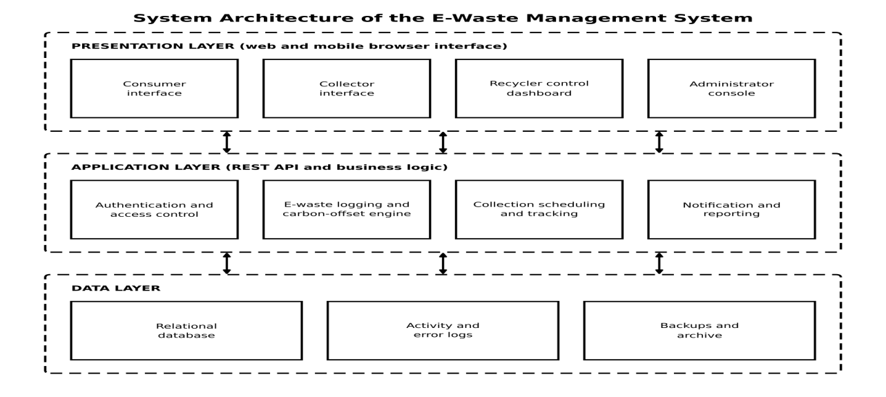
Figure 3.8: Layered architecture of the E-Waste Management System
The requirement statements above describe the intended target, while the evaluated build is documented separately in Chapter Four and Appendix B. In particular, the local browser run verified a same-town collector claim flow; it did not establish automatic assignment to a certified collector. The performance, usability-score, encrypted-deployment, backup, mobile-device and production-availability targets were not measured in the supplied test evidence. The following design models summarize the implemented role and data relationships and should be read with those verification limits.

3.9.2 Actor and use-case model
The use-case view separates consumer, collector, recycler and administrator responsibilities. Consumers record items, request or locate disposal routes and follow the request outcome; collectors claim eligible work and record custody steps; recyclers record receipt and processing or rejection; administrators manage operational records and review reports. The diagram represents implemented system functions at role level, not proof that each function received complete end-to-end browser coverage.
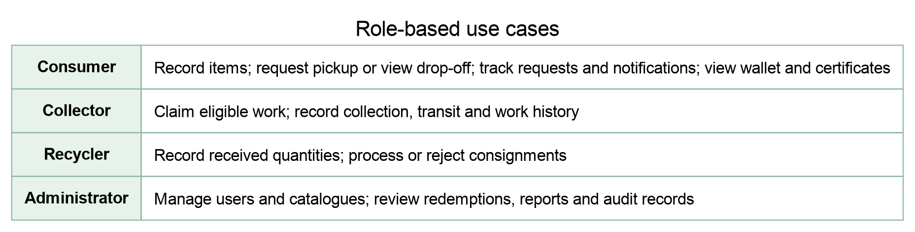
Figure 3.11. Role-based use cases in the EcoTrace system. Source: author-created from the role routes, API permissions and requirement matrix in Appendix B.
3.9.3 Request activity model
The activity model follows the request states documented in the status-transition matrix in Appendix C. A processed request can trigger configured reward credit and a certificate; a rejected request is recorded as a separate outcome. The solid pickup path through processing was exercised with synthetic data. The drop-off branch and rejection branch are shown as supported/design paths but were not covered by the final browser scenario.
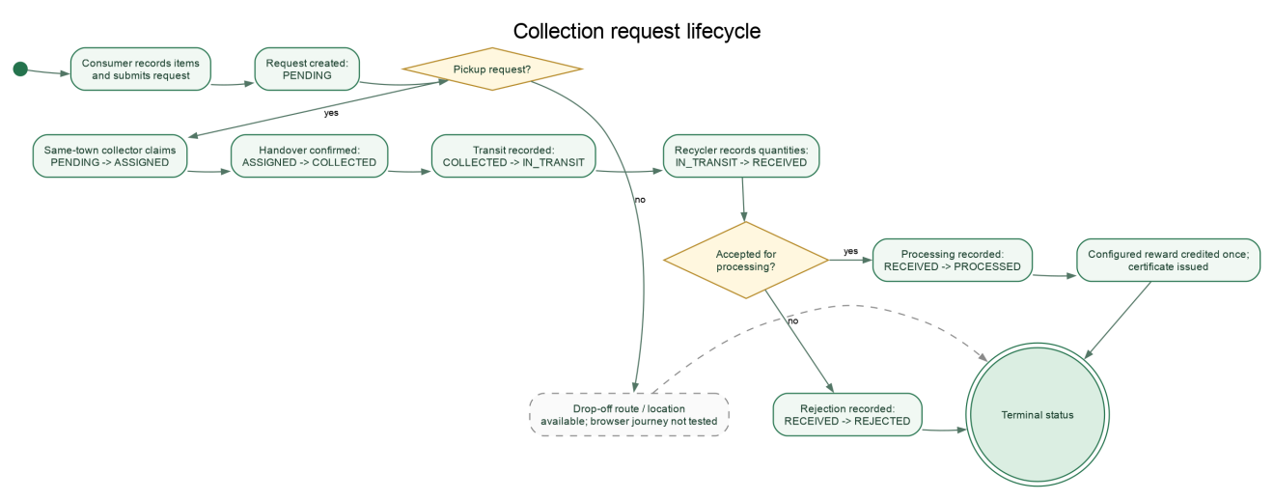
Figure 3.12. Request lifecycle and decision points. Source: author-created from the implemented request transition map and Appendix C; branch coverage is stated in Chapter Four.

3.9.4 Request interaction sequence
This sequence summarizes the browser/API/database responsibilities during request creation, assignment, processing and report retrieval. It is a design-level view grounded in the local test flow and source excerpts in Appendix F; it does not assert production hosting or a physical recycling hand-off.
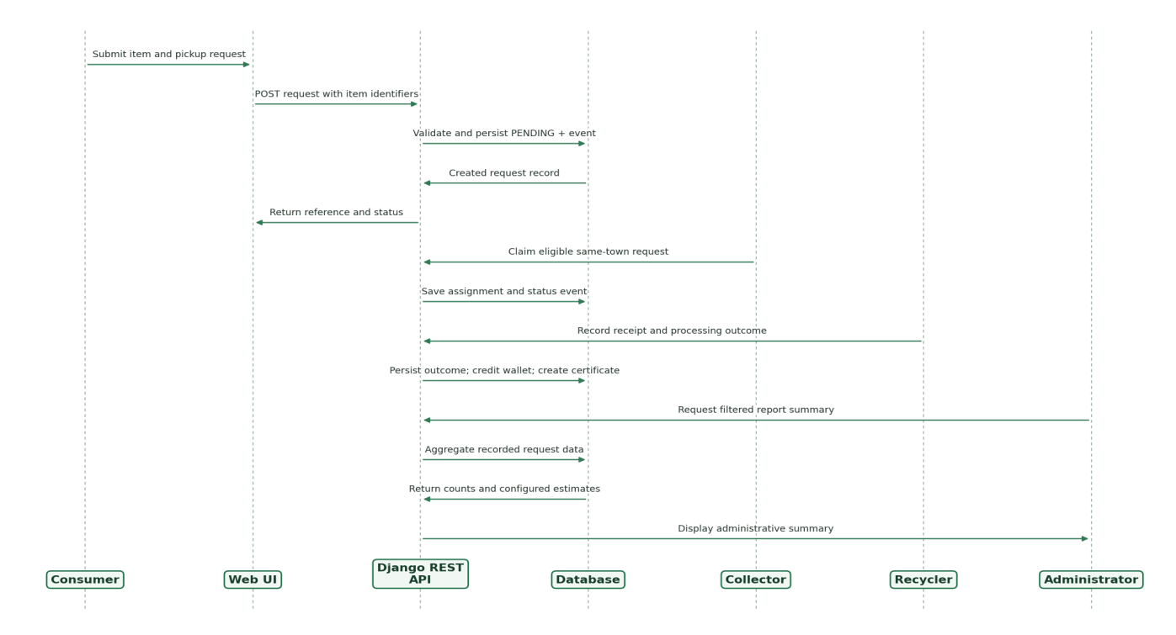
Figure 3.13. Request processing and reporting sequence across system roles and components. Source: author-created from the tested local workflow and Appendix F.
3.9.5 Entity and data relationship model
The data model shows the principal records used to connect users, catalogue items, requests, event history, processing outcomes, certificates and wallet records. Request-to-item is many-to-many; request events preserve status history; processing and certificate records are associated with a request. Configured reward and carbon factors are stored as application values and are not independent measurements. The fuller field-level dictionary and relationship notes are in Appendix H.
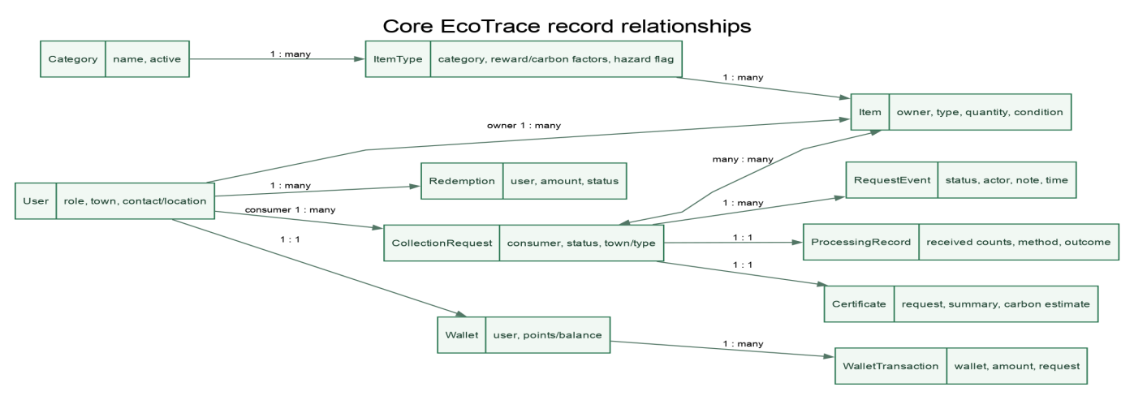
Figure 3.14. Core EcoTrace data relationships. Source: author-created from the working-tree models and Appendix H.

3.10 Choice of Programming Languages
The programming languages and frameworks were chosen against five considerations, namely their suitability for a multi-user web application, their maturity and the size of their developer communities, the security features they provide, their cost, and the ease with which they support short Agile cycles of change and testing. Open-source technologies were preferred because they carry no licensing cost and are widely documented, which suits a research project with limited funding.
The user interface is built with HTML and CSS for structure and styling and with JavaScript, using the React library, for interactivity. React is component-based, so that screens such as the logging form, the collector task list, and the recycler dashboard can be built as reusable pieces and revised independently from sprint to sprint, and it supports responsive layouts that work well on mobile browsers.
The server side is written in Python using the Django framework with the Django REST framework to expose the application programming interface. Python is readable and quick to write, which suits iterative development and the implementation of the carbon-offset estimation logic, while Django supplies built-in user authentication, an administration interface, protection against common attacks such as cross-site request forgery and SQL injection, and an object-relational mapper that connects the code to the database.
Data are stored in a PostgreSQL relational database and accessed through SQL. PostgreSQL is open source, reliable, and strongly consistent in the way it handles transactions, which matters because a collection request and its items must always remain in step, and it can be extended with geographic features if the location of drop-off points and collection routes is later mapped. Git is used for version control so that every sprint's work is tracked, reviewed, and reversible, and automated tests written in Python and JavaScript accompany the code so that regressions are caught early.

3.11 System Implementation
To translate the conceptual requirements into a fully functioning E-Waste Management System, the execution of this study is structured into a sequence of continuous, time-boxed sprints. The lifecycle begins with a foundational baseline sprint dedicated to extracting user stories and establishing a prioritized product backlog from initial stakeholder consultations. Each subsequent sprint runs for a fixed duration of two weeks and executes a micro-lifecycle consisting of immediate requirements analysis, architectural sketching, software coding, and rigorous verification.
During the initial sprints, the research focuses on establishing the core data architecture and user authentication protocols to ensure a secure foundation. As the sprints progress, development transitions to constructing the customer-facing interface, where algorithmic functions for e-waste category logging and carbon-offset estimation are incrementally programmed. The later sprints are dedicated to engineering the logistics infrastructure and the backend recycler control dashboard, enabling real-time coordination between waste generators and processing plants. This progression from the baseline sprint to the integrated system is shown in Figure 3.15.
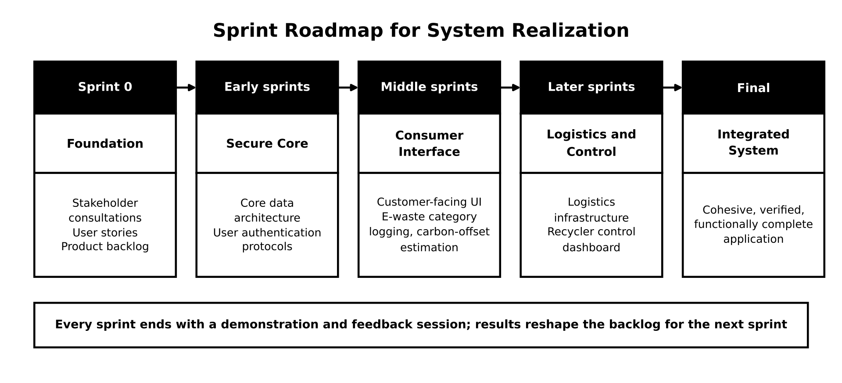
Figure 3.15: Sprint roadmap for realization of the E-Waste Management System

Verification takes place at several levels within every sprint. Individual functions, such as the carbon-offset calculation and the request validation rules, are covered by unit tests, and the interaction between the interface, the application programming interface, and the database is covered by integration tests. Each increment is also checked against the acceptance criteria written into its user stories before it is shown to users, and security checks on authentication and role-based access are repeated whenever those parts of the system change. The code is kept in a version-controlled repository, and each verified increment is deployed to a staging environment that the pilot group can reach.
The development plan proposed a demonstration and feedback session at the end of each sprint. Working increments were intended to be reviewed by a pilot user group for performance, usability and technical integrity, with feedback used to refine the backlog. No sprint attendance, participant feedback, SUS results or pilot deployment record was supplied; the planned cycle was therefore not treated as completed validation.

3.12 Ethical Considerations
The study is conducted in accordance with accepted standards of research ethics. Before data collection begins, approval is sought from the responsible institutional authority, and permission is obtained from the local leaders and the Makindye Division offices through which the community and the waste management officials are reached. Where national requirements apply, the research is registered with the Uganda National Council for Science and Technology, and the study does not proceed with any participant group until these permissions are in place.
Participation is voluntary and based on informed consent. Every participant, whether a survey respondent, an interviewee, or a member of a focus group or the pilot group, is told in clear language what the study is about, what they will be asked to do, how the information will be used, and that they may decline to answer any question or withdraw at any time without penalty. Consent is recorded in writing or, for online questionnaires, by an explicit agreement before the first question, and only adults aged eighteen years and above are recruited. Participants are not offered inducements that could pressure them to take part.
Privacy and confidentiality are protected throughout. Questionnaire responses are anonymized, interview and focus group transcripts are identified by codes rather than names, and findings are reported in aggregate so that no individual can be recognized. This is especially important for informal scrap collectors and logistics operators, whose participation must not expose them to any regulatory or commercial disadvantage. The personal data that the system itself collects, such as names, telephone numbers, and locations, are limited to what the service needs, are handled in line with the Data Protection and Privacy Act of Uganda, and are protected through encrypted communication, hashed passwords, and role-based access. Research data are stored securely, are available only to the researcher and supervisors, and are deleted or anonymized once the study has been completed and the retention period has ended.
The researcher also has a duty to avoid harm and to maintain integrity. Pilot testing of the system does not require participants to dismantle or handle hazardous electronic components, and guidance given through the system encourages safe storage and handling of e-waste. The carbon-offset figures that the system displays are presented honestly as estimates rather than as exact measurements. Finally, the work of other authors is acknowledged through proper citation, data are reported accurately and without selective omission, the limitations of non-probability sampling are openly stated, and the results are reported truthfully whether or not they favor the system that was developed.

CHAPTER FOUR: IMPLEMENTATION AND RESULTS

4.1 Introduction
This chapter reported the implementation evidence available for EcoTrace and kept it separate from field-research findings. The local web application was run with synthetic consumer, collector, recycler and administrator accounts. The role workflow and report screens were exercised in Chromium against a copied SQLite database. No analyzed questionnaire dataset, interview transcripts, participant acceptance results or deployed role credentials were found among the supplied project resources. Software results therefore describe application behavior; they do not represent community responses or measured environmental impact.

4.2 Research findings
The research instruments and proposed sample plan were present, but completed responses and field records were not. The proposal stated a target population of 27,676, a planned minimum consumer sample of 395 and a proposed pilot group of 30. Those values described the plan, not achieved recruitment. No response rate, respondent profile, frequency, percentage or qualitative theme is reported as a study result.
Table 4.1. Research questions and primary-evidence status.
Research question | Evidence required | Status
RQ1: types/sources | Analyzed respondent records with item/source frequencies, units and valid-response denominator. | No completed field dataset or response counts supplied; no prevalence claim made.
RQ2: storage and disposal practices | Counts for storage, sale, reuse, collection and disposal plus coded interview evidence. | No completed responses or interview records supplied; test records were synthetic.
RQ3: awareness/attitudes | Scale responses, missing-response counts and analysis by respondent group. | No administered instrument results supplied; awareness remains unmeasured.
RQ4: policy/service context | Verified policy review and evidence from relevant Kansanga/Kampala stakeholders. | Literature and legislation were cited in Chapter Two; no field compliance review/interviews supplied.
RQ5: system requirements/acceptance | Requirements validation and role-based participant task/UAT evidence. | Local software workflow was tested; no participant UAT, SUS or stakeholder validation supplied.
The Kampala and Uganda literature reviewed in Chapter Two provided context on collection access, handling practices, incentives and stakeholder coordination. It was not substituted for Kansanga responses. The planned population and sample calculations were not presented as people recruited or surveyed.

4.3 System development and implementation

4.3.1 Roles and core functions
The evaluated system was the browser-based React/Vite frontend with a Django REST API. In the local run, the four roles signed in and opened their role-specific pages. The consumer created the tested pickup; the collector claimed and advanced it; the recycler recorded receipt and processing; and the administrator opened reports. This was local synthetic testing, not production deployment.
Table 4.2. Role functions observed in the local web build.
Role | Documented and observed functions
Consumer | Logged items; submitted pickup/drop-off requests; viewed status, notifications/messages, wallet and certificates. The tested path created a pickup and later opened its wallet and certificate.
Collector | Reviewed work and eligible same-town pickups; claimed work; confirmed pickup using a one-time code; advanced collection to transit; viewed work/notification pages.
Recycler | Reviewed incoming consignments; recorded received counts; recorded processing/rejection outcome; viewed request timeline and certificate.
Administrator | Opened reports and navigated requests, users, redemptions, reward settings, categories, audit, drop-offs, maps, notifications and messages. Not every administrative edit was exercised.

4.3.2 Main disposal workflow
The browser test followed one synthetic Kansanga pickup. The consumer logged two used smartphones and created a PENDING request. A same-town collector claimed it, received a one-time verification code, confirmed collection and moved it to transit. The recycler recorded receipt of 2/2 units and processed the consignment. The request reached PROCESSED; the certificate was visible to the consumer and the wallet showed 5,000 points. The report displayed a 5.0 kg CO₂e estimate and UGX 5,000 in reward credits for this synthetic transaction. The carbon value came from configured test factors, not an independent measurement. Cancellation was permitted in PENDING and ASSIGNED before collection.
The test address and accounts were synthetic. Screenshots were sanitized and showed no real user contact details. The test did not establish that physical material was collected or recycled by a real partner.

4.3.3 Data and reporting behavior
Source inspection showed that item records included type/category, quantity, condition, notes and optional image data; item types carried configured reward/carbon factors and a hazard flag. Requests linked items and status events, with optional collection/location details. Recycler records stored expected/received quantities and method. Processing generated a certificate and wallet entry. Administrative summaries grouped requests, units, rewards and estimated carbon by status, town and period. A backend assertion checked that a multi-item request-level carbon snapshot was counted once in a town report.
The carbon and reward values were application calculations, not field measurements. Real-world use would require agreed item factors, reconciled facility records and periodic review of reward policy before those values supported impact claims.

4.4 System testing and validation
The web application was run locally on 10 November 2026. Browser automation used Chromium at 1440 × 1000, a local Vite server and a Django API backed by a fresh copy of an isolated SQLite database. Four synthetic role accounts were used. The repository database and production service were not used.
Table 4.3. Executed validation results and boundaries.
Level | Result | Evidence and limitation
Browser E2E | 3 Playwright tests passed in 127.42 seconds; exit 0. | Consumer item/request; collector claim/code/transit; recycler receipt/process; consumer wallet/certificate; administrator navigation/report.
Role navigation | Consumer 8 routes; collector 7; recycler 5; administrator 12; each home opened. | Local routes and role pages.
Frontend build | `cd web && npm run build` passed; exit 0; Vite 8.3.5. | 10 Nov 2026.
Frontend lint | `cd web && npm run lint` exit 0; 6 warnings remained. | 3 Fast Refresh export warnings, one hook dependency warning, two unused variables.
Django check | `cd backend && ./.venv/bin/python manage.py check` passed. | No system-check issues.
Backend suite | 57 passed in 527.291 seconds; exit 0 on 8 Nov 2026. | 41 core and 16 waste tests; command `./.venv/bin/python manage.py test apps.core.tests apps.waste.tests` from backend.
UAT/production | Not performed. | No participant records or production role credentials supplied.
The first browser attempt used a populated fixture and exposed duplicate item selection and a reward-factor mismatch. A clean isolated database was created with factors aligned to the defined synthetic scenario, and the complete three-test run passed. This was a fixture correction; no production-code change was made to obtain the passing run.

4.5 Discussion of results
The implementation result was a locally functioning role-based workflow linking item entry, pickup custody events, recycler intake, processing, wallet credit and certification. This addressed the traceability gap in the project rationale at a software level. It did not establish that Kansanga residents adopted the service or that local collection increased. Configured rewards and carbon factors provided estimates after recorded processing, but their environmental meaning depended on accurate inputs and verified downstream handling.
The Uganda and Kampala sources reviewed in Chapter Two remained relevant for interpreting future field results. Since no analyzed local survey or interview results were supplied, agreement or difference with that literature could not yet be judged. A Kansanga pilot should include households, shops/repair businesses, collection actors, recycling facilities and relevant authorities; these were evaluation priorities, not reported participants.

4.6 Tables and figures
Figures 4.1–4.7 were captured from the local browser build during the 10 November 2026 synthetic workflow. Account contact values were redacted or replaced with generic role labels. The figures show software screens and seeded test values, not the public deployment or a real material handoff.
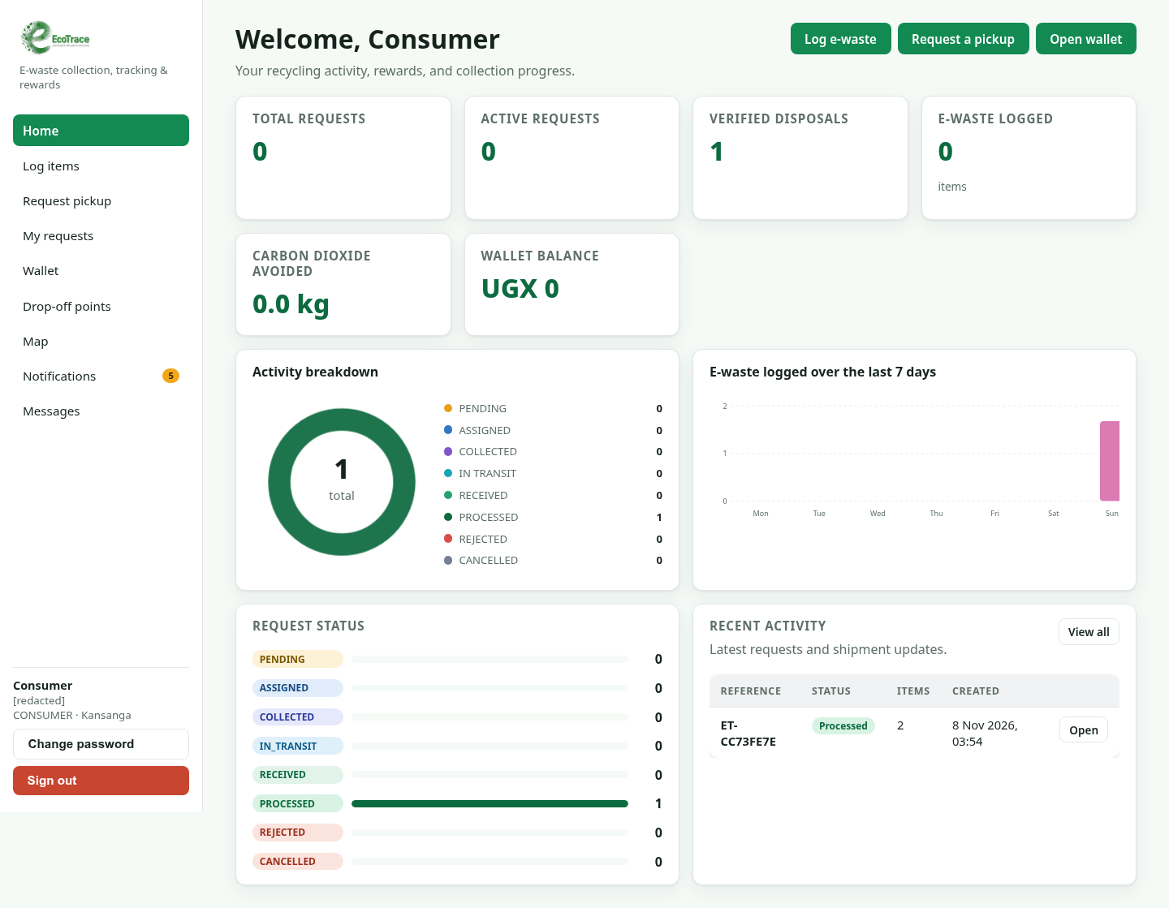
Figure 4.1. Consumer dashboard in the evaluated local web build (synthetic account; identifying account text redacted).
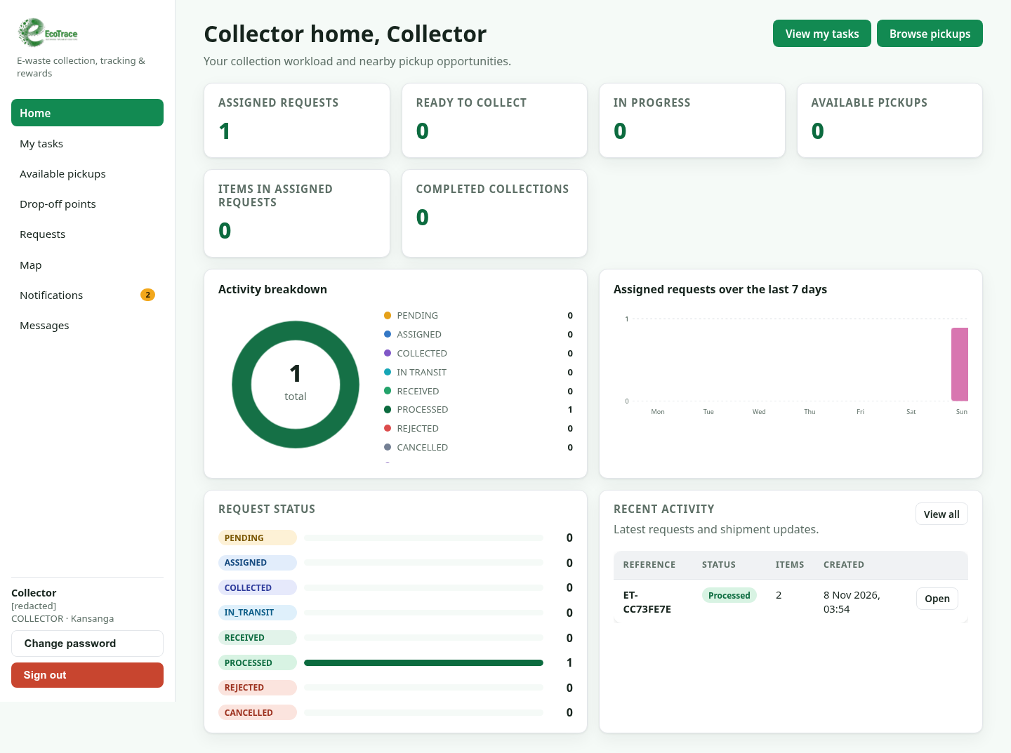
Figure 4.2. Collector dashboard in the evaluated local web build (synthetic account; identifying account text redacted).
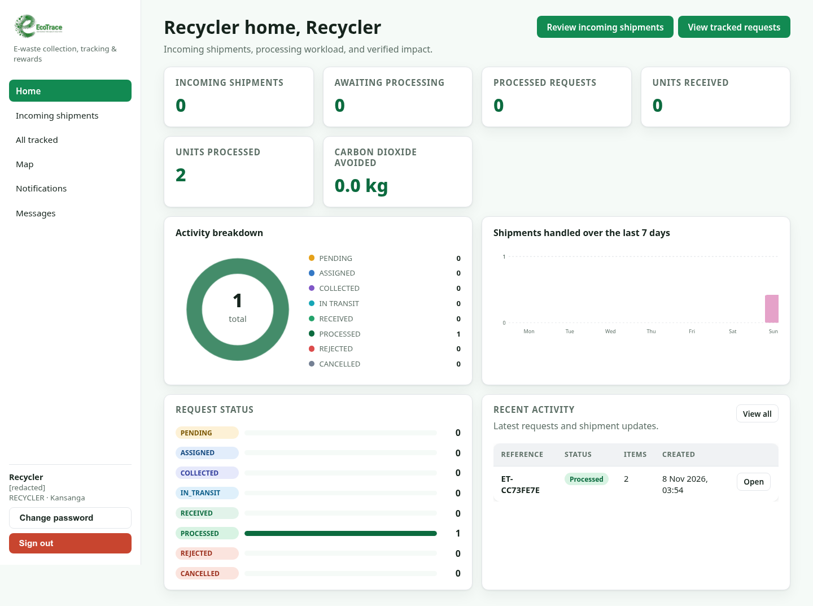
Figure 4.3. Recycler dashboard in the evaluated local web build (synthetic account; identifying account text redacted).
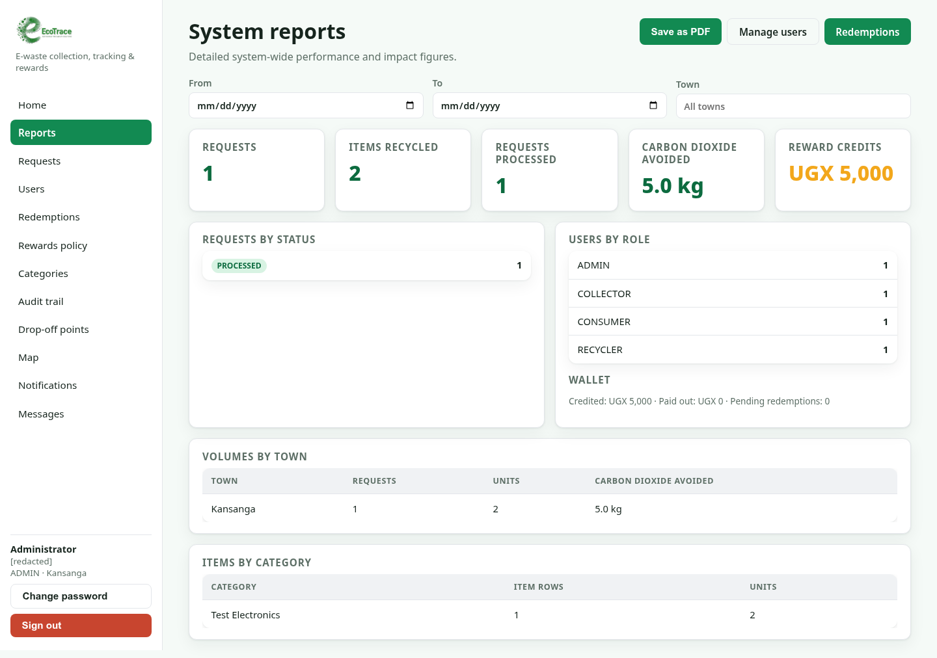
Figure 4.4. Administrator reports in the evaluated local web build (synthetic data; identifying account text redacted).
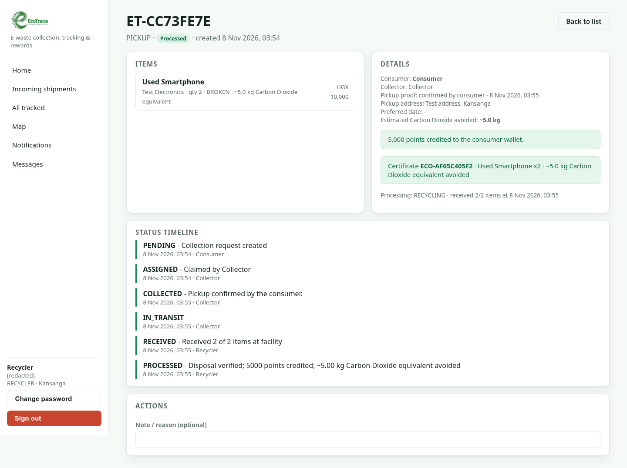
Figure 4.5. Recycler processed-consignment detail with receipt, status timeline, certificate, and reward result in the evaluated local web build (synthetic values; identifying account text redacted).
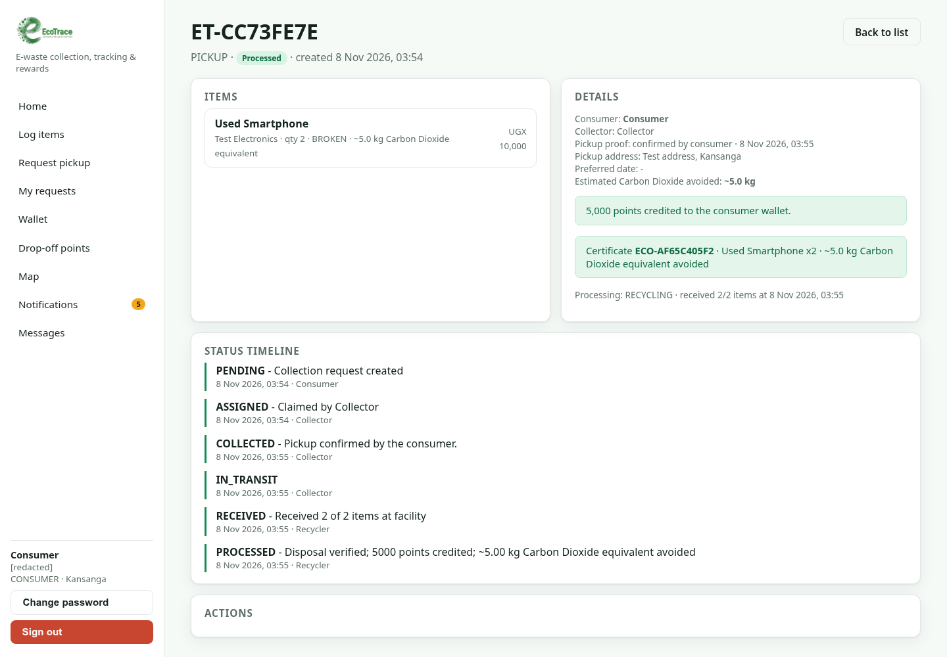
Figure 4.6. Consumer certificate view after the synthetic request was processed in the evaluated local web build.
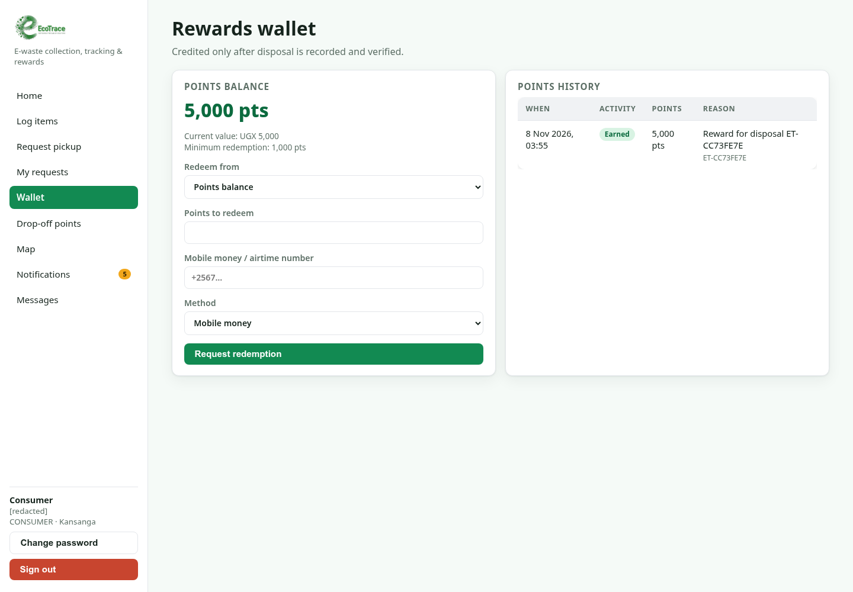
Figure 4.7. Consumer wallet in the evaluated local web build after the synthetic workflow; displayed rewards are test data.

CHAPTER FIVE: CONCLUSION, DISCUSSION AND RECOMMENDATIONS

5.1 Summary of objective achievement
Table 5.1. Objective achievement based on available evidence.
Objective | Evidence needed | Status
Identify e-waste types and sources in Kansanga. | Analyzed questionnaire/interview evidence and denominators. | Not established; field data not supplied.
Describe storage, collection and disposal practices. | Practice counts and qualitative themes. | Not established; no participant responses/transcripts supplied.
Assess awareness and attitudes. | Completed scale responses and analysis. | Not established; instrument was present, responses were not.
Review Uganda policy and responsible institutions. | Cited documents and completed stakeholder/compliance evidence. | Literature/law references present; no completed field review supplied.
Recommend practical improvements for Kansanga. | Synthesis of verified local evidence and stakeholder needs. | Preliminary, evidence-bounded recommendations given; field validation remained outstanding.
Build and evaluate EcoTrace. | Working build, tested workflow and participant evaluation. | Local web workflow and checks passed; UAT/mobile/production verification not supplied.

5.2 Conclusion
EcoTrace was implemented as a local web system that supported a consumer-to-collector-to-recycler request flow, followed by a certificate, wallet credit and administrator report entry. The final synthetic workflow and three browser tests passed; the recorded Django, build and configuration checks were successful. The evidence supported a conclusion that the local workflow operated for the tested scenario. It did not answer the empirical questions about local e-waste types, quantities, practices, awareness, services or stakeholder acceptance. No claim was made about adoption, reduced dumping, actual downstream recycling or measured carbon savings.

5.3 Limitations
Table 5.2. Limitations and their effect.
Limitation | Effect on interpretation
Field evidence | No analyzed survey/interview/focus-group/UAT records; planned population and sample were not achieved counts.
Scope and sampling | Kansanga was the proposed scope, but recruitment and sampling-frame records were unavailable.
Environment | Testing used a local working tree and isolated SQLite; production TLS, uptime, backup and load were not tested.
Device/connectivity | Desktop Chromium only; low-cost Android, intermittent data, accessibility and alternative channels were not evaluated.
Impact verification | Carbon values were configured estimates; no physical material flow, facility reconciliation or independent measurement occurred.
Partner/privacy governance | No partner authorization, field consent records, retention schedule or deployment privacy audit was supplied.

5.4 Recommendations and way forward
Priority | Recommended action | Proposed owner | Indicative timing
Complete fieldwork | Secure ethics/local approvals; administer the approved instrument; preserve anonymized data, response flow, missingness and codebook. Report actual recruitment, not n=395 as achieved. | Research team with supervisor and relevant institution | Before any participant recruitment; within an approved study period
Validate local workflows | Review each step with consumers, shops/repair businesses, collectors, recyclers and relevant authorities, including formal and informal actors where appropriate. | Research team with consumer, collector, recycler and local-authority representatives | Before a Kansanga pilot is opened
Pilot safely | Agree with authorized partners how intake and processing will be verified; prepare guidance and escalation for batteries, damaged devices and hazardous items. | Participating collector and authorized recycling partner | Agree procedures before handling pilot consignments
Test local access | Repeat usability checks on common Android devices and constrained data; check plain language, assisted-service options and recovery after lost connection. | Development team with representative local testers | Before public release; repeat after major interface changes
Govern rewards and estimates | Publish conversion rules and factors; record policy changes; reconcile records with facility evidence before reporting impact. | System operator with recycling partner | Agree factors and rules before enabling real rewards; review periodically
Protect personal information | Minimize contact/location data; restrict access; define retention/deletion; use production-grade secrets and HTTPS; review Uganda data-protection obligations. | Data controller and development lead | Before production deployment; review retention and access periodically
Verify release | Record immutable build identifier; rerun backend/browser suites; verify backups/access controls; distinguish deployment evidence from screenshots. | Release lead / system administrator | At each release, with evidence archived for that build
Table 5.3. Practical way-forward actions for the Kansanga pilot.

5.5 Contribution to knowledge
The verified contribution at this stage was a locally exercised role-based workflow connecting item records, custody events, recycler processing, rewards and certificates. The empirical contribution on Kansanga e-waste practices remained pending field data and participant evaluation. The implementation was not evidence that the broader e-waste challenge had been resolved.

5.6 Areas for further research
Future work could examine adoption over time, reconcile system records with independently verified facility intake, assess access for people with limited data or no smartphone, and study how digital traceability could complement authorized recycling and producer-responsibility arrangements. These questions require approved field methods and documented operational evidence.

REFERENCES
Baldé, C. P., Kuehr, R., Yamamoto, T., McDonald, R., D’Angelo, E., Althaf, S., Bel, G., Deubzer, O., Fernandez-Cubillo, E., Forti, V., Gray, V., Herat, S., Honda, S., Iattoni, G., Khetriwal, D. S., Luda di Cortemiglia, V., Lobuntsova, Y., Nnorom, I., Pralat, N., & Wagner, M. (2024). The Global E-waste Monitor 2024. International Telecommunication Union and United Nations Institute for Training and Research. https://www.itu.int/pub/D-GEN-E_WASTE.01-2024
Deche, C. S. (2020). Factors influencing an ICT framework for a circular e-waste economy by households in Nairobi, Kenya [Thesis]. Africa Nazarene University.
Kabera, T., Nishimwe, H., & Mukurarinda, J. (2023). E-waste management in Rwanda: A situational and capacity need assessment. Sustainability, 15(16), Article 12271. https://doi.org/10.3390/su151612271
Koka, R. E. (2017). Assessment of factors leading to poor electronics waste management in Arusha City, Tanzania [Master’s thesis, The Open University of Tanzania].
National Information Technology Authority–Uganda. (2024). Baseline survey on waste from electrical and electronic equipment (WEEE) in Uganda. https://www.nita.go.ug/research-reports/baseline-survey-waste-electrical-and-electronic-equipment-weee-uganda
Ngethe, D. (2021). Influence of electronic waste management systems in Kenya: A critical literature review. Journal of Environment. https://doi.org/10.47941/je.618
Nuwematsiko, R., Oporia, F., Nabirye, J., et al. (2021). Knowledge, perceptions, and practices of electronic waste management among consumers in Kampala, Uganda. Journal of Environmental and Public Health, 2021, Article 3846428. https://doi.org/10.1155/2021/3846428
Nyeko, S. J., Mlay, S., Among, J., & Nyero, A. I. (2022a). Towards a sustainable electronic waste management in Uganda: A stakeholder perspective. African Journal of Environmental Science and Technology, 16(6), 238–251. https://doi.org/10.5897/AJEST2021.3088
Nyeko, S. J., Mlay, S. V., Amerit, B., & Nyero, A. I. (2022b). Drivers and inhibitors of sustainable electronic waste collection and disposal behavior al intentions in a developing country. ORSEA Journal, 11(2).
Nyeko, S. J., Mlay, S. V., Amerit, B., Abima, B., Among, J., Nyero, A. I., Odiya, J., & Ogen, C. (2022c). The impact of electronic-electrical waste on human health and environment: A systematic literature review. Journal of Engineering and Technology Research. https://doi.org/10.5897/JETR2021.0726
Sonny, S. J., Mlay, S. V., Nyero, A. I., & Oren, C. (2023). Waste electrical and electronic equipment collection: Challenges and opportunities in a developing country perspective. Business Management Review, 26(2), 1–19. https://doi.org/10.56279/bmrj.v26i2.1
Tanzania Communications Regulatory Authority, & Coordination Committee on e-Waste Management. (2012). A study on electronic waste management in Tanzania. Tanzania Communications Regulatory Authority.
Twagirayezu, G., Uwimana, A., Kui, H., Birame, C. S., Irumva, O., Nizeyimana, J. C., & Cheng, H. (2023). Towards a sustainable and green approach of electrical and electronic waste management in Rwanda: A critical review. Environmental Science and Pollution Research, 30, 77959–77980. https://doi.org/10.1007/s11356-023-27910-5
Wanjohi Mutahi, C. (2018). A framework for addressing challenges in the implementation of the Uganda e-waste management policy [Master’s dissertation]. Uganda Martyrs University. https://dissertations.umu.ac.ug/xmlui/handle/123456789/1615
Brooke, J. (1996). SUS: A “quick and dirty” usability scale. In P. W. Jordan, B. Thomas, B. A. Weerdmeester, & I. L. McClelland (Eds.), Usability evaluation in industry (pp. 189–194). Taylor & Francis.
PostgreSQL Global Development Group. (2024). PostgreSQL 16 documentation. https://www.postgresql.org/docs/16/
Ajzen, I. (1991). The theory of planned behavior. Organizational Behavior and Human Decision Processes, 50(2), 179–211.
Baldé, C. P., Kuehr, R., Yamamoto, T., McDonald, R., D'Angelo, E., Althaf, S., Bel, G., Deubzer, O., Fernandez-Cubillo, E., Forti, V., Gray, V., Herat, S., Honda, S., Iattoni, G., Khetriwal, D. S., Luda di Cortemiglia, V., Lobuntsova, Y., Nnorom, I., Pralat, N., & Wagner, M. (2024). The Global E-waste Monitor 2024. International Telecommunication Union and United Nations Institute for Training and Research.
Ellen MacArthur Foundation. (2013). Towards the circular economy: Economic and business rationale for an accelerated transition.
Forti, V., Baldé, C. P., Kuehr, R., & Bel, G. (2020). The Global E-waste Monitor 2020. United Nations University, ITU and ISWA.
Lindqvist, T. (2000). Extended producer responsibility in cleaner production (Doctoral dissertation). Lund University, IIIEE.
WEEE Center
Republic of Uganda. (2019). The National Environment Act, 2019.
Republic of Uganda. (2019). The Data Protection and Privacy Act, 2019.
Republic of Uganda. (2020). The National Environment (Waste Management) Regulations, 2020.
Secretariat of the Basel Convention. (1989). Basel Convention on the control of transboundary movements of hazardous wastes and their disposal. United Nations Environment Programme.
Sommerville, I. (2016). Software engineering (10th ed.). Pearson.
Sources
- ITU, The Global E-waste Monitor 2024
- People Daily, Urgent action needed to avert e-waste disaster

APPENDIX A: EVIDENCE AND COMPLETION REGISTER
The register separates proposal material, repository evidence and completed local checks from missing primary research. “Not supplied” means no completed record was found in the report/project resources inspected; it does not imply recruitment took place.
Table A.1. Evidence register.
ID | Evidence area | Available evidence | Status/boundary
A1 | Population/sample plan | N=27,676; planned minimum n=395; proposed pilot group 30. | Plan only; no achieved recruitment records.
A2 | Research instruments | Questionnaire, interview, focus-group, SUS and UAT drafts retained in Appendix E. | Drafts present; responses and analysis not supplied.
A3 | Ethics/permissions | No approval letter, local permission record or consent log found. | Not evidenced; no completed fieldwork claim.
A4 | Source implementation | Django and React/Vite source inspected; code excerpts in Appendix F. | Available; local working tree, not an immutable deployment.
A5 | Browser workflow | 3 Playwright tests passed 10 Nov 2026 on isolated synthetic SQLite. | Four roles; not field UAT.
A6 | Backend tests | 57 core/waste tests passed 8 Nov 2026. | 41 core + 16 waste methods; detailed in Appendix D.
A7 | Build/static checks | Web build and Django check passed; lint exit 0 with six warnings. | 10 Nov 2026 local checkout.
A8 | Screenshots | Seven sanitized web screenshots captured and inserted as Figures 4.1–4.7. | Local synthetic records; not deployed.
A9 | Production/UAT | No production credentials, participant SUS/UAT, load report or actual facility handoff. | Not verified.

APPENDIX B: REQUIREMENTS TRACEABILITY MATRIX
Statuses below distinguish implemented/source evidence from the exact flows exercised. Route presence alone was not treated as full verification or acceptance.
Table B.1. Functional requirements traceability.
ID | Requirement | Implementation anchor | Verification evidence | Status
FR1 | Phone/password registration and login | Django authentication; core auth tests. | Backend suite passed; browser signed in synthetic roles; browser registration not tested. | Partial
FR2 | Role-based access | Backend permissions and role pages. | Four roles navigated; permissions included in backend suite. | Tested scope
FR3 | Item logging | Item form and item model. | Browser created quantity-two smartphone. | Verified
FR4 | Carbon/hazard estimates | Configured factor and item model fields. | Synthetic estimate displayed; no independent impact measurement. | Software behavior
FR5 | Pickup/drop-off | Request type and linked item workflow. | Pickup browser flow passed; drop-off not submitted in browser. | Partial
FR6 | Same-town assignment | Collector claim endpoint. | Same-town claim passed in browser; automated town tests included. | Verified synthetic case
FR7 | Collection/status updates | Transition map and pickup code. | Code, collection and transit passed. | Verified happy path
FR8 | Status notifications | Notification records/events. | Pickup code used; backend notification tests passed. | Verified flow
FR9 | Recycler receipt/process | Receipt and processing endpoints. | 2/2 received and processed; certificate generated. | Verified
FR10 | Wallet/certificate | Credit guard and certificate model. | 5,000 synthetic points and certificate shown. | Verified synthetic case
FR11 | Admin reporting | Summary endpoint and admin page. | Report showed one request, two units, 5 kg estimate, UGX 5,000. | Verified synthetic report
FR12 | Admin catalogue/account tools | Admin routes and API tests. | Routes visited; every CRUD/edit action not browser tested. | Partial

Table B.2. Non-functional requirements and evidence.
Requirement | Expected behavior | Evidence | Status
Password protection | Passwords hashed by framework. | Auth tests passed; no independent security audit. | Partially checked
Encrypted transport | HTTPS required for deployment. | Local test used localhost HTTP; deployed TLS not verified. | Not verified
Role authorization | Role-specific API/page access. | Four roles and backend permission cases checked. | Partially verified
Response time target | Proposal target about 3 seconds. | No instrumented performance/load test. | Not measured
Low-cost/mobile usability | Responsive web experience. | Desktop browser only; no SUS or Android test. | Not verified
Backups/recovery | Daily backup expectation. | No backup/restore test evidence. | Not verified
Data integrity | Consistent request, processing and reward data. | Transactions and assertions inspected; suite passed 8 Nov. | Partially verified
Privacy/legal | Minimize/secure personal data. | Screenshots redacted; no deployment compliance audit. | Not verified

APPENDIX C: USER AND OPERATOR WORKFLOW NOTES
Pickup was exercised end-to-end. Drop-off, rejection, cancellation, redemptions and partner handoffs were not part of the 10 November browser journey; they are marked accordingly rather than described as observed results.
Table C.1. Role actions and observed outputs.
Role | Action | System response/evidence
Consumer | Logged item, selected item, chose pickup, entered synthetic address and submitted. | PENDING request; later viewed status, notification, wallet and certificate.
Collector | Opened eligible work, claimed same-town request, used one-time code and advanced status. | ASSIGNED → COLLECTED → IN_TRANSIT.
Recycler | Opened incoming work, recorded 2/2 received and selected recycling. | RECEIVED → PROCESSED; processing record/certificate visible.
Administrator | Opened reports and navigated user, redemption, settings, category, audit and operating pages. | Report reflected synthetic request; route navigation did not prove every admin action.

Table C.2. Status transitions and evidence.
Current | Allowed next | Meaning | Coverage
PENDING | ASSIGNED or CANCELLED | Collector claim; consumer cancellation before collection. | Assignment tested; cancellation not browser-tested.
ASSIGNED | COLLECTED, PENDING or CANCELLED | Confirm pickup; release returns to queue; cancellation before collection. | Collection tested; release/cancel not tested.
COLLECTED | IN_TRANSIT | Collector sends consignment to facility. | Tested.
IN_TRANSIT | RECEIVED | Recycler records facility intake. | 2/2 receipt tested.
RECEIVED | PROCESSED or REJECTED | Recycler records outcome/method. | Processed tested; rejection not browser-tested.
PROCESSED / REJECTED / CANCELLED | Terminal | No later status transition. | Processed terminal state tested.
The town check and hashed one-time pickup verification provided application-level controls; they did not independently verify identity, physical condition or recovered material. A pilot would need procedures for partial receipts, discrepancies, damaged items and safe storage.

APPENDIX D: DETAILED SOFTWARE TEST CASE REGISTER
The 8 November backend result and 10 November browser rerun were separate runs. Automated backend test success did not constitute participant acceptance. The method inventory below records the methods included in the 57-test run.
Table D.1. Browser end-to-end tests.
ID | Role | Actions | Observed result | Outcome
WEB-01 | Consumer | Log quantity-two item, navigate consumer pages, submit pickup. | Pending request and request ID were visible. | PASS 10 Nov
WEB-02 | Collector | Claim same-town pickup, read one-time code, confirm pickup and transit. | Status reached IN_TRANSIT. | PASS 10 Nov
WEB-03 | Recycler/consumer/admin | Receive/process; consumer wallet/certificate; admin route/report review. | PROCESSED; certificate visible; 5,000 points and report visible. | PASS 10 Nov

Table D.2. Validation commands and outcomes.
Layer | Command/activity | Result | Date
Backend | `cd backend && ./.venv/bin/python manage.py test apps.core.tests apps.waste.tests` | 57 passed, 0 failed, 527.291 s. | 8 Nov 2026
Browser | `python -m pytest -q test_01_consumer.py test_02_collector.py test_03_recycler_admin.py` | 3 passed, 0 failed, 127.42 s; exit 0. | 10 Nov 2026
Build | `cd web && npm run build` | Passed; Vite 8.3.5. | 10 Nov 2026
Lint | `cd web && npm run lint` | Exit 0; six warnings listed in 4.4. | 10 Nov 2026
Django check | `cd backend && ./.venv/bin/python manage.py check` | Passed; no system-check issues. | 10 Nov 2026
Participant UAT/production | Not run. | No participants/credentials supplied. | Unavailable
A stale fixture caused the first browser attempt to encounter an already logged item and a reward-factor mismatch. A fresh isolated database corrected the test setup; the final run passed all three browser cases without production-code changes.
Table D.3. Backend test-method inventory: 41 core and 16 waste methods.
ID | Suite | Test method | Source line | Result
API-01 | CORE | notification includes linked request id | backend/apps/core/tests.py:42 | Passed 8 Nov 2026
API-02 | CORE | notification can be deleted only by its owner | backend/apps/core/tests.py:56 | Passed 8 Nov 2026
API-03 | CORE | user can delete their notification | backend/apps/core/tests.py:67 | Passed 8 Nov 2026
API-04 | CORE | clear notifications deletes only current users notifications | backend/apps/core/tests.py:78 | Passed 8 Nov 2026
API-05 | CORE | admin can sign in through admin endpoint | backend/apps/core/tests.py:108 | Passed 8 Nov 2026
API-06 | CORE | non admin is rejected even when claiming admin role | backend/apps/core/tests.py:128 | Passed 8 Nov 2026
API-07 | CORE | invalid credential types are rejected | backend/apps/core/tests.py:142 | Passed 8 Nov 2026
API-08 | CORE | admin api rejects unauthenticated and non admin users | backend/apps/core/tests.py:152 | Passed 8 Nov 2026
API-09 | CORE | write activity is recorded and admin can search audit log | backend/apps/core/tests.py:158 | Passed 8 Nov 2026
API-10 | CORE | hierarchy messages notify recipients without exposing private contact data | backend/apps/core/tests.py:212 | Passed 8 Nov 2026
API-11 | CORE | creates admin once without resetting existing password | backend/apps/core/tests.py:261 | Passed 8 Nov 2026
API-12 | CORE | refuses to promote an existing non admin | backend/apps/core/tests.py:283 | Passed 8 Nov 2026
API-13 | CORE | reactivates a disabled administrator | backend/apps/core/tests.py:305 | Passed 8 Nov 2026
API-14 | CORE | requires confirmation | backend/apps/core/tests.py:373 | Passed 8 Nov 2026
API-15 | CORE | empties database and first run creates the admin | backend/apps/core/tests.py:387 | Passed 8 Nov 2026
API-16 | CORE | rejects an incorrect current password | backend/apps/core/tests.py:425 | Passed 8 Nov 2026
API-17 | CORE | changes password and burns pending reset codes | backend/apps/core/tests.py:440 | Passed 8 Nov 2026
API-18 | CORE | requires authentication | backend/apps/core/tests.py:458 | Passed 8 Nov 2026
API-19 | CORE | request opens a reset and notifies the administrator | backend/apps/core/tests.py:502 | Passed 8 Nov 2026
API-20 | CORE | reply is identical for known and unknown numbers | backend/apps/core/tests.py:513 | Passed 8 Nov 2026
API-21 | CORE | administrator can read the active code | backend/apps/core/tests.py:522 | Passed 8 Nov 2026
API-22 | CORE | non administrators cannot list reset requests | backend/apps/core/tests.py:537 | Passed 8 Nov 2026
API-23 | CORE | valid code sets a new password and signs the user in | backend/apps/core/tests.py:546 | Passed 8 Nov 2026
API-24 | CORE | wrong code is rejected | backend/apps/core/tests.py:565 | Passed 8 Nov 2026
API-25 | CORE | expired code is rejected and hidden from the administrator | backend/apps/core/tests.py:579 | Passed 8 Nov 2026
API-26 | CORE | a code can only be used once | backend/apps/core/tests.py:600 | Passed 8 Nov 2026
API-27 | CORE | new requests replace older codes | backend/apps/core/tests.py:612 | Passed 8 Nov 2026
API-28 | CORE | admin can delete a user and their records | backend/apps/core/tests.py:634 | Passed 8 Nov 2026
API-29 | CORE | admin cannot delete their own account | backend/apps/core/tests.py:648 | Passed 8 Nov 2026
API-30 | CORE | non administrators cannot delete users | backend/apps/core/tests.py:654 | Passed 8 Nov 2026
API-31 | CORE | sole administrator cannot be disabled | backend/apps/core/tests.py:680 | Passed 8 Nov 2026
API-32 | CORE | administrator can be disabled when another one is active | backend/apps/core/tests.py:690 | Passed 8 Nov 2026
API-33 | CORE | only active administrator cannot be deleted | backend/apps/core/tests.py:712 | Passed 8 Nov 2026
API-34 | CORE | administrator can be deleted when another one remains | backend/apps/core/tests.py:730 | Passed 8 Nov 2026
API-35 | CORE | sole administrator cannot be disabled through update | backend/apps/core/tests.py:743 | Passed 8 Nov 2026
API-36 | CORE | sole administrator cannot be demoted through update | backend/apps/core/tests.py:755 | Passed 8 Nov 2026
API-37 | CORE | administrator can be updated when another one is active | backend/apps/core/tests.py:767 | Passed 8 Nov 2026
API-38 | CORE | change form cannot disable the sole administrator | backend/apps/core/tests.py:827 | Passed 8 Nov 2026
API-39 | CORE | change form disables an administrator when another exists | backend/apps/core/tests.py:843 | Passed 8 Nov 2026
API-40 | CORE | delete view cannot remove the sole administrator | backend/apps/core/tests.py:862 | Passed 8 Nov 2026
API-41 | CORE | bulk delete cannot remove the sole administrator | backend/apps/core/tests.py:875 | Passed 8 Nov 2026
API-42 | WASTE | register and login | backend/apps/waste/tests.py:46 | Passed 8 Nov 2026
API-43 | WASTE | pickup request accepts map location without address | backend/apps/waste/tests.py:65 | Passed 8 Nov 2026
API-44 | WASTE | full disposal flow credits wallet | backend/apps/waste/tests.py:97 | Passed 8 Nov 2026
API-45 | WASTE | admin can create categories without providing slug | backend/apps/waste/tests.py:218 | Passed 8 Nov 2026
API-46 | WASTE | consumer cannot process | backend/apps/waste/tests.py:229 | Passed 8 Nov 2026
API-47 | WASTE | role scoped request lists | backend/apps/waste/tests.py:243 | Passed 8 Nov 2026
API-48 | WASTE | redeem flow | backend/apps/waste/tests.py:264 | Passed 8 Nov 2026
API-49 | WASTE | admin reports | backend/apps/waste/tests.py:284 | Passed 8 Nov 2026
API-50 | WASTE | item types expose carbon and hazard flags | backend/apps/waste/tests.py:294 | Passed 8 Nov 2026
API-51 | WASTE | hazardous items are flagged | backend/apps/waste/tests.py:303 | Passed 8 Nov 2026
API-52 | WASTE | available pickups are matched by town | backend/apps/waste/tests.py:337 | Passed 8 Nov 2026
API-53 | WASTE | consumer cannot list all users | backend/apps/waste/tests.py:371 | Passed 8 Nov 2026
API-54 | WASTE | points redeem enforces floor and rejection refunds points | backend/apps/waste/tests.py:379 | Passed 8 Nov 2026
API-55 | WASTE | dropoff processing awards full policy points | backend/apps/waste/tests.py:410 | Passed 8 Nov 2026
API-56 | WASTE | admin can update reward policy | backend/apps/waste/tests.py:431 | Passed 8 Nov 2026
API-57 | WASTE | collector can alert local recyclers of full dropoff | backend/apps/waste/tests.py:457 | Passed 8 Nov 2026

APPENDIX E: RESEARCH INSTRUMENTS
The instruments in this appendix had been prepared for proposed fieldwork. No completed responses, transcripts, focus-group notes, SUS scores or UAT records were supplied. They are tools, not collected results. No project budget was present in the source proposal and none has been invented.

E.1 Household, business and institution questionnaire
The questionnaire was drafted for adult household, business and institutional respondents. A five-point scale was specified for Section C. The source proposal said it had been pre-tested, but no pre-test record or administered version was supplied, so pre-testing was not treated as verified. See the draft consent points in Appendix E.6.
Section A: Respondent profile
Table E.1. Household, business and institution questionnaire: respondent profile, practices, awareness, digital readiness and service preferences.
No. | Question or statement | Response format
A1 | Which best describes you? | Household; business; institution; student; other
A2 | What is your age group? | 18 to 24; 25 to 34; 35 to 44; 45 to 54; 55 and above
A3 | What is your highest level of education? | Primary; secondary; certificate or diploma; degree; postgraduate
A4 | How long have you lived or operated in Kansanga? | Under 1 year; 1 to 3 years; 4 to 6 years; over 6 years

Section B: Current practice
No. | Question or statement | Response format
B1 | Which unused electronic items do you currently have? | Phones; computers; televisions; batteries; chargers and cables; appliances; other (tick all that apply)
B2 | About how many unused items are stored with you? | None; 1 to 3; 4 to 6; 7 or more
B3 | What did you do with the last device you stopped using? | Kept at home; sold to a repairer; given away; sold to a scrap collector; thrown with household rubbish; burned; handed to a collector or recycler; other
B4 | Do you know where a certified e-waste collector operates near you? | Yes; no
B5 | Have you ever been paid for, or paid to dispose of, an old device? | Yes, paid; yes, I paid; no

Section C: Awareness and attitudes
No. | Question or statement | Response format
C1 | Discarded electronics can contain substances that are harmful to health. | Scale 1 to 5
C2 | Burning electronic waste harms the air that I and my neighbors breathe. | Scale 1 to 5
C3 | It is acceptable to throw old devices away with ordinary rubbish. | Scale 1 to 5
C4 | I would dispose of old devices properly if it were convenient. | Scale 1 to 5
C5 | People close to me expect me to dispose of electronic waste responsibly. | Scale 1 to 5
C6 | I know how to find a safe place to dispose of electronic waste. | Scale 1 to 5
C7 | A small reward would make me more likely to use a collector. | Scale 1 to 5

Section D: Digital readiness
No. | Question or statement | Response format
D1 | What type of phone do you mainly use? | Smartphone; feature phone; none
D2 | How often do you use the internet? | Daily; weekly; rarely; never
D3 | Do you use mobile money? | Yes; no
D4 | I am comfortable using a website or app to request a service. | Scale 1 to 5
D5 | How would you prefer to request a pickup? | Website; SMS; USSD; phone call; WhatsApp; other

Section E: Preferences about EcoTrace
No. | Question or statement | Response format
E1 | Rank these features by how useful they would be to you: item logging, pickup request, status tracking, wallet reward, disposal certificate, impact estimate. | Rank 1 to 6
E2 | Which form of reward would you prefer? | Mobile money; airtime; discount; certificate only
E3 | What might stop you from using such a system? | Open answer
E4 | Any other comment? | Open answer
E.2 Interview guide for officials, collectors and recycling staff
The guide had been prepared for interviews with waste-management officials, collectors, logistics operators and recycling-facility staff. No interview log, recording or transcript was supplied. Audio recording would require separate permission.
Table E.2: Interview questions and probes
No. | Question | Probe
1 | Please describe your role in handling electronic waste in the Kansanga and wider Kampala area. | How long, and with which groups of clients?
2 | How does an item reach you, and what happens to it afterwards? | Routes, volumes, delays
3 | What records do you keep about the items you receive or move? | Paper or phone; who sees them
4 | Which items are dangerous to handle, and how do you deal with them? | Protective equipment, storage
5 | What do regulations or local authorities expect of you? | Permits, inspections, reporting
6 | What information would you need before a consignment arrives? | Type, quantity, condition, source
7 | Looking at the EcoTrace workflow, which steps would help you and which would cause difficulty? | Screens, timing, trust

E.3 Focus group discussion guide
The focus-group prompts had been prepared for future user feedback sessions. No completed session, attendance record or coded comments were supplied.
Table E.3: Focus group prompts
No. | Prompt
1 | Tell us about your experience of using this version of the system.
2 | Which screen or step was easiest, and which was hardest?
3 | Was anything unclear in the words or buttons used?
4 | How did the status updates and notifications help or fail to help you?
5 | What would make you trust the records and rewards more?
6 | What should change before the next version?

E.4 System Usability Scale (SUS)
The ten SUS statements and scoring method were included for future evaluation after role-based tasks. No completed responses or SUS score were supplied.
Table E.4: System Usability Scale statements
No. | Statement
1 | I think that I would like to use this system frequently.
2 | I found the system unnecessarily complex.
3 | I thought the system was easy to use.
4 | I think that I would need the support of a technical person to be able to use this system.
5 | I found the various functions in this system were well integrated.
6 | I thought there was too much inconsistency in this system.
7 | I would imagine that most people would learn to use this system very quickly.
8 | I found the system very cumbersome to use.
9 | I felt very confident using the system.
10 | I needed to learn a lot of things before I could get going with this system.

E.5 User acceptance testing form
The UAT form had been prepared for participants after role-specific tasks. No completed form, participant count or acceptance result was supplied.
Table E.5: User acceptance statements
No. | Dimension | Statement
1 | Ease of use | I was able to complete my tasks without help.
2 | Ease of use | The words and buttons on the screens were clear to me.
3 | Ease of use | The system worked well on my phone and connection.
4 | Usefulness | The system saves me time or effort compared with how I did this before.
5 | Usefulness | The status updates told me what I needed to know.
6 | Trust | I believe the records kept about my items are accurate.
7 | Trust | I feel my personal information is handled safely.
8 | Satisfaction | The reward and certificate are worth the effort of using the system.
9 | Satisfaction | I would recommend the system to other people.
10 | Comment | What one change would improve the system most? (open answer)

E.6 Participant information and consent template
This template made the proposed consent process explicit. It was not evidence of institutional ethics approval or of any participant having consented. It would need review against the approved protocol, local permissions, language needs and actual data-handling arrangements before use.
Table E.6. Draft participant information and consent points; approval details were not supplied.
Topic | Participant-facing disclosure
Purpose | Study of e-waste handling and the design of a collection, tracking and rewards system in Kansanga, Kampala.
Voluntary participation | Taking part is voluntary; a participant may decline a question or stop without penalty.
Activities/recording | Questionnaire, interview, focus group or system task as applicable; audio recording only after separate permission.
Privacy | Avoid direct identifiers in analysis/reporting; restrict contact data and follow approved retention/deletion arrangements.
Risks/benefits | Explain foreseeable inconvenience/privacy risks; do not promise unapproved payments or direct benefits.
Contacts/approval | Use verified researcher and institutional ethics contacts; names and approval reference were not supplied.
Consent record | Record consent through the approved process before collecting data; no signed records were supplied.

End of Appendix E instruments.

APPENDIX F: SELECTED IMPLEMENTATION AND TEST EXCERPTS
The excerpts were taken from the checked-out source files at HEAD a32b743. They illustrate selected implementation decisions and tests; complete source remains in the repository. No credentials, real records or secrets are reproduced. The mobile excerpt was a local working-tree change and was not part of the tested web workflow.

F.1 Consumer request submission
The screen formed a request payload from selected item IDs and form state, submitted it, navigated to the returned request and displayed an API error.
Source: web/src/pages/consumer/NewRequestPage.jsx, lines 48–70.
0048 | async function submit(e) {
0049 | e.preventDefault();
0050 | setError("");
0051 | setBusy(true);
0052 | try {
0053 | const body = {
0054 | request_type: form.request_type,
0055 | item_ids: selected,
0056 | pickup_address: form.pickup_address,
0057 | consumer_note: form.consumer_note,
0058 | preferred_date: form.preferred_date || null,
0059 | };
0060 | if (form.request_type === "DROPOFF") body.dropoff_point = Number(form.dropoff_point);
0061 | const created = await api("/requests/", { method: "POST", body });
0062 | navigate(`/requests/${created.id}`);
0063 | } catch (err) {
0064 | setError(
0065 | err.data && typeof err.data === "object"
0066 | ? Object.values(err.data).flat().join(" ")
0067 | : err.message
0068 | );
0069 | setBusy(false);
0070 | }

F.2 Item reward, carbon and hazard properties
Model properties scaled configured item-type factors by quantity and combined the type hazard flag with damaged condition. Carbon remained an estimate.
Source: backend/apps/waste/models.py, lines 90–104.
0090 | @property
0091 | def reward_ugx(self):
0092 | return self.item_type.reward_ugx * self.quantity
0093 |
0094 | @property
0095 | def carbon_kg(self):
0096 | return self.item_type.carbon_factor_kg * self.quantity
0097 |
0098 | @property
0099 | def points(self):
0100 | return self.item_type.points_per_item * self.quantity
0101 |
0102 | @property
0103 | def hazardous(self):
0104 | return self.item_type.hazardous or self.condition == self.Condition.DAMAGED

F.3 Allowed request transitions
The map constrained lifecycle changes, allowed cancellation before collection and made processed/rejected/cancelled terminal.
Source: backend/apps/waste/views.py, lines 39–58.
0039 | ALLOWED_TRANSITIONS = {
0040 | CollectionRequest.Status.PENDING: {
0041 | CollectionRequest.Status.ASSIGNED,
0042 | CollectionRequest.Status.CANCELLED,
0043 | },
0044 | CollectionRequest.Status.ASSIGNED: {
0045 | CollectionRequest.Status.COLLECTED,
0046 | CollectionRequest.Status.PENDING,
0047 | CollectionRequest.Status.CANCELLED,
0048 | },
0049 | CollectionRequest.Status.COLLECTED: {CollectionRequest.Status.IN_TRANSIT},
0050 | CollectionRequest.Status.IN_TRANSIT: {CollectionRequest.Status.RECEIVED},
0051 | CollectionRequest.Status.RECEIVED: {
0052 | CollectionRequest.Status.PROCESSED,
0053 | CollectionRequest.Status.REJECTED,
0054 | },
0055 | CollectionRequest.Status.PROCESSED: set(),
0056 | CollectionRequest.Status.REJECTED: set(),
0057 | CollectionRequest.Status.CANCELLED: set(),
0058 | }

F.4 Transition guard and event recording
The helper rejected unlisted transitions; valid updates were saved and recorded as request events.
Source: backend/apps/waste/views.py, lines 396–404.
0396 | def apply_status(self, request_obj, new_status, note, actor):
0397 | if new_status not in ALLOWED_TRANSITIONS.get(request_obj.status, set()):
0398 | return Response(
0399 | {"detail": f"Cannot move from {request_obj.status} to {new_status}."},
0400 | status=status.HTTP_400_BAD_REQUEST,
0401 | )
0402 | request_obj.status = new_status
0403 | request_obj.save(update_fields=["status", "updated_at"])
0404 | add_event(request_obj, new_status, note, actor)

F.5 Same-town collector claim
The claim endpoint required PENDING status, generated and hashed a one-time code, checked town eligibility and assigned the collector.
Source: backend/apps/waste/views.py, lines 429–443.
0429 | if obj.status != CollectionRequest.Status.PENDING:
0430 | return Response(
0431 | {"detail": "Request is no longer available."},
0432 | status=status.HTTP_400_BAD_REQUEST,
0433 | )
0434 | verification_code = None
0435 | if obj.request_type == CollectionRequest.Type.PICKUP:
0436 | verification_code = f"{secrets.randbelow(100_000_000):08d}"
0437 | obj.pickup_verification_hash = make_password(verification_code)
0438 | if obj.consumer.town.casefold() != request.user.town.casefold():
0439 | return Response(
0440 | {"detail": "This pickup is outside your assigned town."},
0441 | status=status.HTTP_403_FORBIDDEN,
0442 | )
0443 | obj.assigned_collector = request.user

F.6 Processing, reward and certificate
Processing calculated totals, marked the request processed, guarded against duplicate reward credit and created a certificate.
Source: backend/apps/waste/views.py, lines 643–675.
0643 | carbon_total = sum((item.carbon_kg for item in obj.items.all()), 0)
0644 | labels = ", ".join(
0645 | sorted({f"{item.item_type.name} x{item.quantity}" for item in obj.items.all()})
0646 | )
0647 | obj.status = CollectionRequest.Status.PROCESSED
0648 | obj.carbon_kg = carbon_total
0649 | if not obj.reward_credited:
0650 | wallet = get_or_create_wallet(obj.consumer)
0651 | if points_total > 0:
0652 | wallet.credit_points(
0653 | points_total,
0654 | f"Reward for disposal {obj.reference}",
0655 | request=obj,
0656 | )
0657 | obj.reward_credited = True
0658 | obj.points_earned = points_total
0659 | obj.save(
0660 | update_fields=[
0661 | "status",
0662 | "reward_credited",
0663 | "points_earned",
0664 | "carbon_kg",
0665 | "updated_at",
0666 | ]
0667 | )
0668 | Certificate.objects.get_or_create(
0669 | request=obj,
0670 | defaults={
0671 | "issued_to": obj.consumer,
0672 | "summary": labels[:255],
0673 | "carbon_kg": carbon_total,
0674 | },
0675 | )

F.7 Processing test assertions
The backend test asserted PROCESSED status, reward credit, certificate presence and request/certificate estimate snapshots.
Source: backend/apps/waste/tests.py, lines 167–179.
0167 | resp = self.client.post(
0168 | f"/api/requests/{req_id}/process/",
0169 | {"method": "RECYCLING"},
0170 | format="json",
0171 | )
0172 | self.assertEqual(resp.status_code, 200, resp.content)
0173 | self.assertEqual(resp.data["status"], "PROCESSED")
0174 | self.assertTrue(resp.data["reward_credited"])
0175 | self.assertIn("certificate", resp.data)
0176 | self.assertIsNotNone(resp.data.get("certificate"))
0177 | # Verified disposal snapshots the carbon estimate onto request + certificate.
0178 | self.assertEqual(float(resp.data["carbon_kg"]), 42.0)
0179 | self.assertEqual(float(resp.data["certificate"]["carbon_kg"]), 42.0)

F.8 Carbon aggregation regression
The multi-item test asserted that a request and its carbon snapshot counted once in town reporting.
Source: backend/apps/waste/tests.py, lines 209–216.
0209 | # Reports must count the request and its carbon exactly once,
0210 | # even though the request has multiple items (join de-duplication).
0211 | self.login(self.admin)
0212 | resp = self.client.get("/api/reports/summary/")
0213 | self.assertEqual(float(resp.data["carbon_saved_kg"]), 42.0)
0214 | kansanga = [r for r in resp.data["by_town"] if r["consumer__town"] == "Kansanga"]
0215 | self.assertEqual(kansanga[0]["requests"], 1)
0216 | self.assertEqual(float(kansanga[0]["carbon_kg"]), 42.0)

F.9 Administrator report retrieval
The admin screen serialized date/town filters into a report query and surfaced report data or errors.
Source: web/src/pages/admin/AdminDashboard.jsx, lines 12–23.
0012 | useEffect(() => {
0013 | const query = new URLSearchParams();
0014 | Object.entries(filters).forEach(([key, value]) => {
0015 | if (value) query.set(key, value);
0016 | });
0017 | api(`/reports/summary/?${query}`)
0018 | .then((report) => {
0019 | setSummary(report);
0020 | setError("");
0021 | })
0022 | .catch((e) => setError(e.message));
0023 | }, [filters]);

F.10 Mobile overflow menu (local-only)
The local mobile change animated the menu icon between vertical ellipsis and close. It was not in the web E2E run; mobile runtime/hot-reload evidence was not available.
Source: mobile/lib/screens/home_shell.dart, lines 213–234.
0213 | Widget _accountActions(AppUser user, bool overflowMenu, bool smallScreen) {
0214 | if (overflowMenu) {
0215 | return PopupMenuButton<String>(
0216 | tooltip: 'Account options',
0217 | icon: AnimatedSwitcher(
0218 | duration: const Duration(milliseconds: 200),
0219 | transitionBuilder: (child, animation) => FadeTransition(
0220 | opacity: animation,
0221 | child: ScaleTransition(
0222 | scale: Tween<double>(begin: 0.6, end: 1.0).animate(
0223 | CurvedAnimation(parent: animation, curve: Curves.easeOut),
0224 | ),
0225 | child: child,
0226 | ),
0227 | ),
0228 | child: Icon(
0229 | _accountMenuOpen ? Icons.close : Icons.more_vert,
0230 | key: ValueKey(_accountMenuOpen),
0231 | ),
0232 | ),
0233 | onOpened: () => setState(() => _accountMenuOpen = true),
0234 | onCanceled: () => setState(() => _accountMenuOpen = false),

APPENDIX G: EXTENDED SYSTEM ACCEPTANCE-TEST PLAN
The local browser cases in Appendix D were executed. The remaining pilot acceptance cases below were not marked passed because no participant UAT or production partner test was supplied. They should use approved synthetic or consented data; demonstration runs should not use real payout destinations.
Table G.1. Acceptance scenarios, criteria and evidence state.
ID | Role | Scenario | Acceptance criterion | Status
G1 | Consumer | Register/sign in and recover account access. | Valid access succeeds; invalid credentials are rejected without account disclosure. | Participant UAT not run.
G2 | Consumer | Log item and submit pickup request. | Item/request persists, starts PENDING and can be read back. | Synthetic browser flow passed; no participant acceptance.
G3 | Consumer | Submit drop-off request and locate point. | Point is attached and instructions are understandable/current. | Route visited; end-to-end drop-off not run.
G4 | Collector | Claim same-town pickup and verify handover. | Eligible claim only; code confirms collection and status updates. | Synthetic same-town code flow passed.
G5 | Collector | Attempt out-of-town claim and wrong code. | Denied safely; state remains valid and message is clear. | No participant test; backend cases cover matching.
G6 | Consumer/collector | Cancel before collection or release assignment. | Only allowed transition succeeds; timeline/notifications remain consistent. | Not browser-tested in this run.
G7 | Recycler | Record complete/partial receipt; process or reject. | Counts/method persist; invalid early processing is rejected. | Complete receipt/process passed; partial/rejection not browser-tested.
G8 | Consumer/admin | Inspect reward/certificate and redemption decision. | Reward credits once; approval is authorized and auditable. | Wallet/certificate passed; participant redemption acceptance not tested.
G9 | Administrator | Filter report by date/town and reconcile counts. | Totals align to source requests without duplicate aggregation. | Report opened; filter reconciliation not independently audited.
G10 | All roles | Use common Android device with constrained data. | Critical tasks remain legible; interrupted requests recover safely. | Not tested.
G11 | Participants | Complete role tasks and SUS/UAT. | Task completion, assistance, errors and SUS use stated denominator/missingness. | Not executed; no participant records.
G12 | Pilot partners | Reconcile authorized consignment with facility records. | Digital receipt/process matches partner evidence; discrepancies documented. | Not executed; no live handoff claimed.

APPENDIX H: SYSTEM DATA DICTIONARY AND RECORD RELATIONSHIPS
This dictionary summarized the main fields found in the Django models. It describes structures, not populated research records. Phone, location, message, verification and payout fields contain sensitive operational data; no real values appear here. Carbon/reward values depend on configured policy and factors.
Table H.1. Main application data dictionary derived from source models.
Model | Fields | Meaning | Handling note
User | phone; full_name; role; town | Sign-in identifier, display name, authorization and service town. | Personal/contact; restrict access.
User | address; latitude; longitude | Optional address and map position. | Sensitive location.
Category | name; slug; icon; is_active | Catalogue grouping and state. | Operational catalogue.
ItemType | category; name; is_active | Category-linked e-waste type. | Operational catalogue.
ItemType | points_per_item; reward_ugx | Configured per-item reward. | Policy; disclose and audit.
ItemType | carbon_factor_kg; hazardous | Configured estimate and hazard flag. | Estimate, not measured impact.
DropOffPoint | name; address; town; coordinates; phone; hours; active | Published drop-off point and optional map/contact details. | Location/contact; keep current.
Item | consumer; item_type; quantity | Owner, catalogue type and number of units. | Personal linkage.
Item | condition; notes; photo; created_at | Condition, optional note/image, creation time. | May reveal personal details.
CollectionRequest | reference; consumer; assigned_collector | Unique reference and linked actors. | Operational identity link.
CollectionRequest | request_type; status; items; dropoff_point | Pickup/drop-off choice, lifecycle and linked items/point. | Operational record.
CollectionRequest | pickup_address; latitude/longitude; preferred_date; note | Collection details and optional location. | Sensitive location/details.
CollectionRequest | reward_credited; points_earned; carbon_kg | Credit guard, points outcome and estimate snapshot. | Financial/estimate; not proof of impact.
CollectionRequest | pickup_verification_hash; pickup_confirmed_at; timestamps | Hashed one-time proof and lifecycle timestamps. | Security-sensitive; never disclose code/hash.
RequestEvent | request; status; note; actor; created_at | Request timeline event and responsible user. | Audit data; note may be sensitive.
ProcessingRecord | request; recycler; expected/received; method; notes; processed_at | Facility intake counts and processing outcome. | Reconcile with partner evidence.
Certificate | request; code; issued_to; summary; carbon_kg; issued_at | One-to-one disposal certificate and estimate snapshot. | Shareable credential; estimate only.
Notification | user; request_id; title/body; read; created_at | In-app status or operational notification. | May contain personal/verification text.
StakeholderMessage | sender; recipient; body; read; created_at | Role-to-role message. | Private communication.
AuditLog | actor; action; method; path; status_code; created_at | Recorded system action and outcome. | Security/operations evidence.
Wallet | user; balance; points_balance; updated_at | One-to-one money and points balances. | Financial account data.
WalletTransaction | wallet; amount; kind; balance_after; reason; request; created_at | UGX credit/debit ledger. | Financial record.
PointTransaction | wallet; points; kind; balance_after; reason; request; created_at | Points credit/debit ledger. | Reward record; prevent duplicate credit.
RewardPolicy | minimum_redemption_points; ugx_per_point; pickup/dropoff_percent; updated_at | Threshold, conversion and route reward percentages. | Policy/configuration.
Redemption | user; amount; points; method; destination; status; handler; times | Payout request, decision and audit details. | Highly sensitive payout/contact data.
Table H.2. Principal data relationships.
Relationship | Cardinality | Implementation meaning
User → Item | One-to-many | A consumer owns logged items.
Category → ItemType | One-to-many | Each type belongs to a catalogue category.
ItemType → Item | One-to-many | Each item refers to a configured type.
Consumer → Request | One-to-many | A consumer can create multiple requests.
Request ↔ Item | Many-to-many | A request contains items; items can be linked to requests.
Request → RequestEvent | One-to-many | Status events form the timeline.
Request → ProcessingRecord | One-to-one | Receipt/processing outcome.
Request → Certificate | One-to-one | Certificate follows processed request.
User → Wallet | One-to-one | Balance and points account.
Wallet → Transactions | One-to-many | Money/points ledger entries.
User → Redemption | One-to-many | A user can request multiple redemptions.

APPENDIX I: ORIGINAL PROPOSAL BASELINE AND EVIDENCE BOUNDARY
Chapters One to Three preserved the original proposal baseline. This appendix mapped its stated scope and targets to the evidence available in the completed software run. Planned figures remained plans unless supported by completed records.
Table I.1. Proposal targets and evidence status.
Element | Original planned scope | Status in this report
Geographic scope | Kansanga, Kampala; wider Makindye/Kampala service context. | Used as synthetic test town/proposed research scope; no field coverage verified.
Target population | N=27,676 in proposal across consumers and e-waste stakeholders. | Proposal value only; sampling frame and achieved recruitment not supplied.
Consumer sample | Planned n=395 from formula and convenience recruitment. | Not achieved-count evidence; no response denominator.
Pilot group | 30 users proposed for iterative demonstrations. | No attendance or completed feedback record supplied.
Expert panel | Purposive interviews with relevant officials/collectors/recyclers. | No completed interview sample, transcripts or saturation record supplied.
Mixed methods | Questionnaire, interviews/focus groups and system evaluation planned. | Instruments present; no analyzed primary data or participant UAT supplied.
System output | Role-based collection, tracking, rewards and reporting. | Local web workflow implemented and tested; no production adoption/impact claim.
Ethics/permissions | Consent, privacy and approval expected before fieldwork. | No approvals/permission records supplied; Appendix E.6 is a draft template only.
For the Kansanga context, practical priorities included access on common smartphones and constrained mobile data, engagement across residents and businesses as well as collection/recycling actors, safe handling guidance for batteries and damaged devices, and transparent handoff records. These were design and evaluation priorities drawn from the stated study scope and reviewed policy context, not measured local behaviors.
No field-response dataset, coded transcripts, completed SUS/UAT records, ethics approval letter or verified facility reconciliation record was identified in the supplied report/project resources. These absences were stated explicitly so later evidence could be added without confusing proposal targets, system estimates or synthetic test records with empirical results.

