**PREVIEW**

**Welcome Screen:**

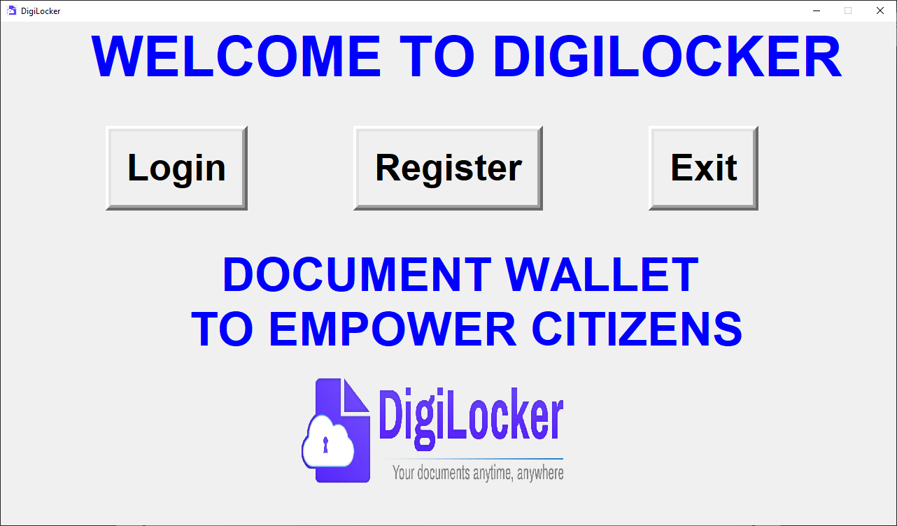

**Registration Screen:**

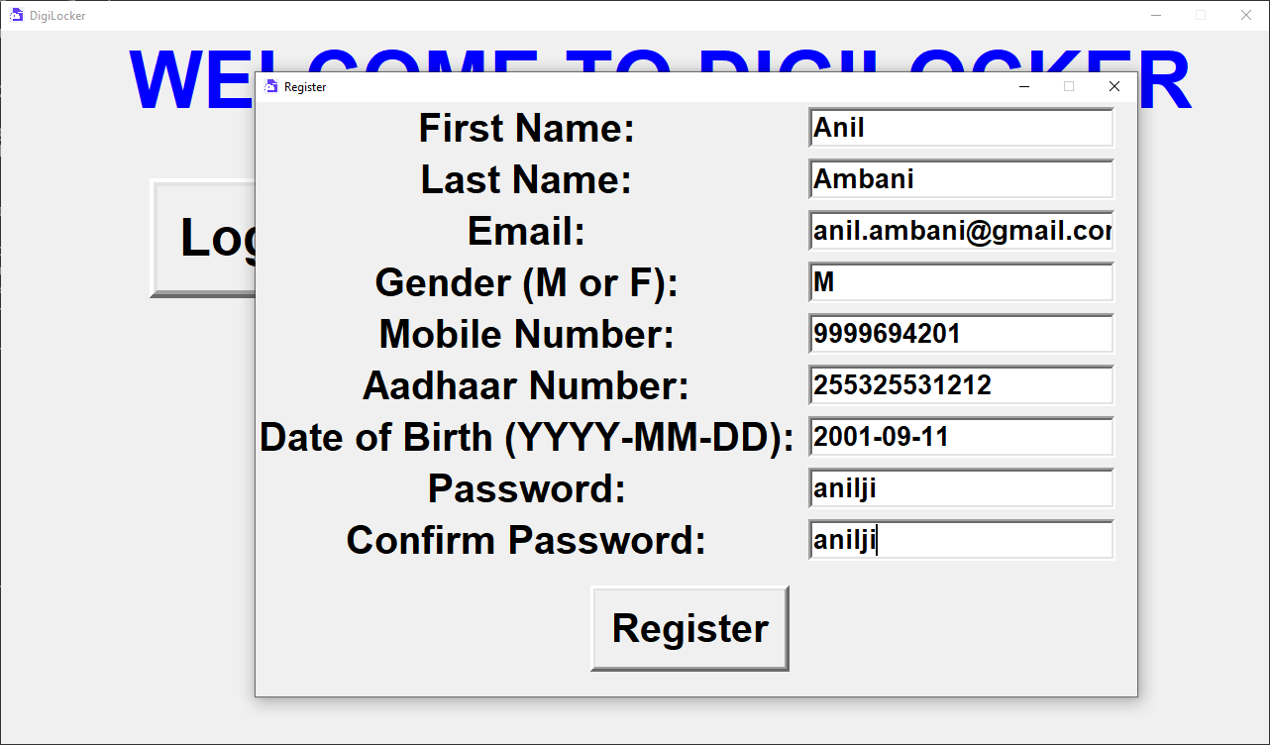

**Error occurs due to empty fields:**

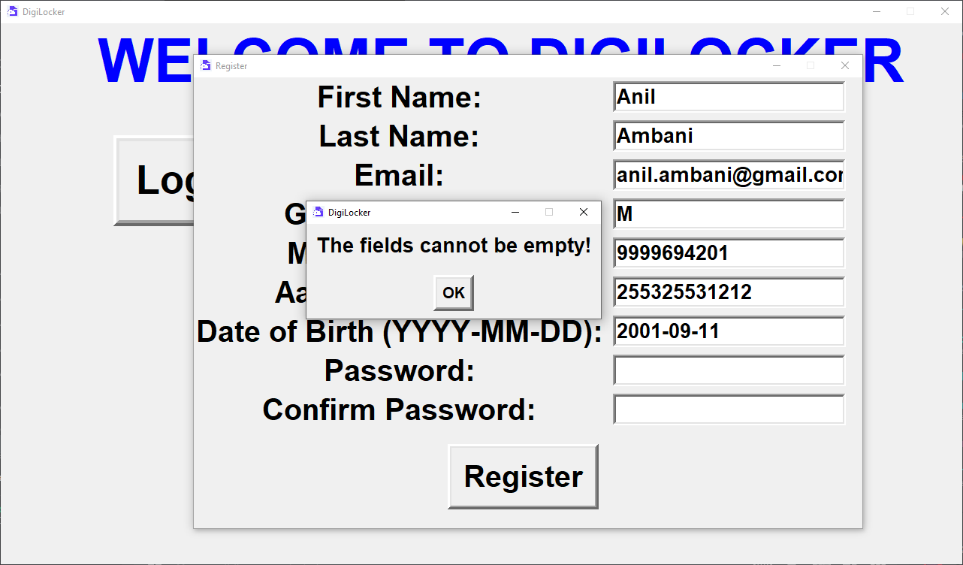

**Successful Registration:**

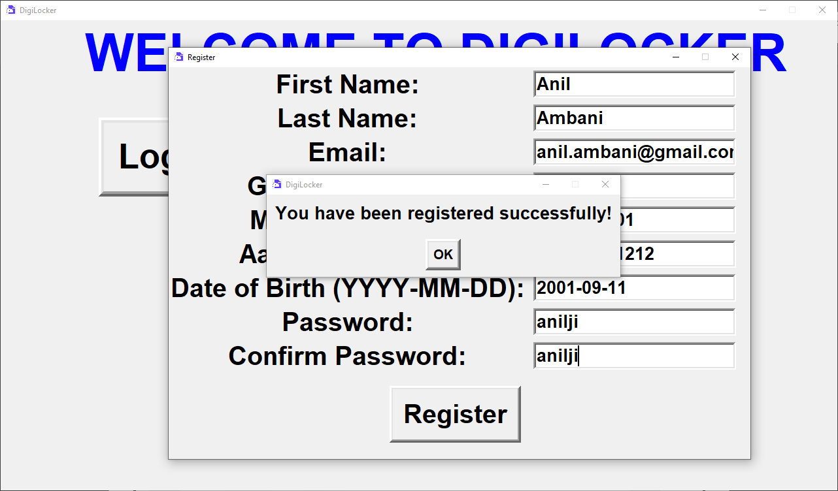

**Login Screen:**

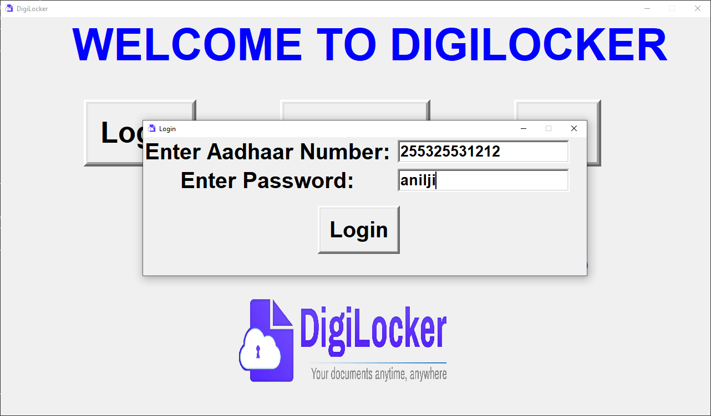

**Error occurs due to invalid credentials:**

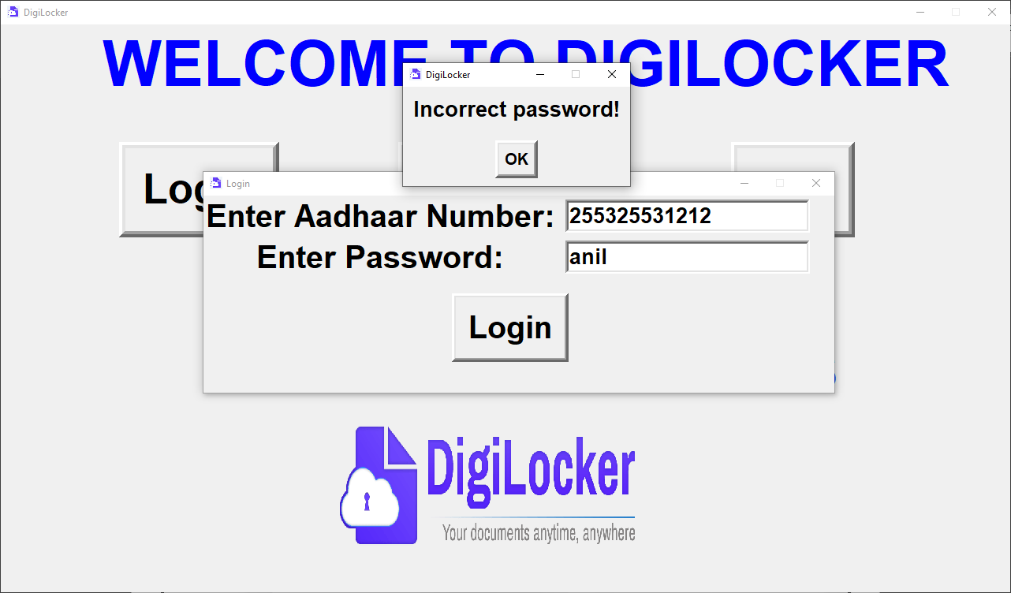

**User screen after successful login:**

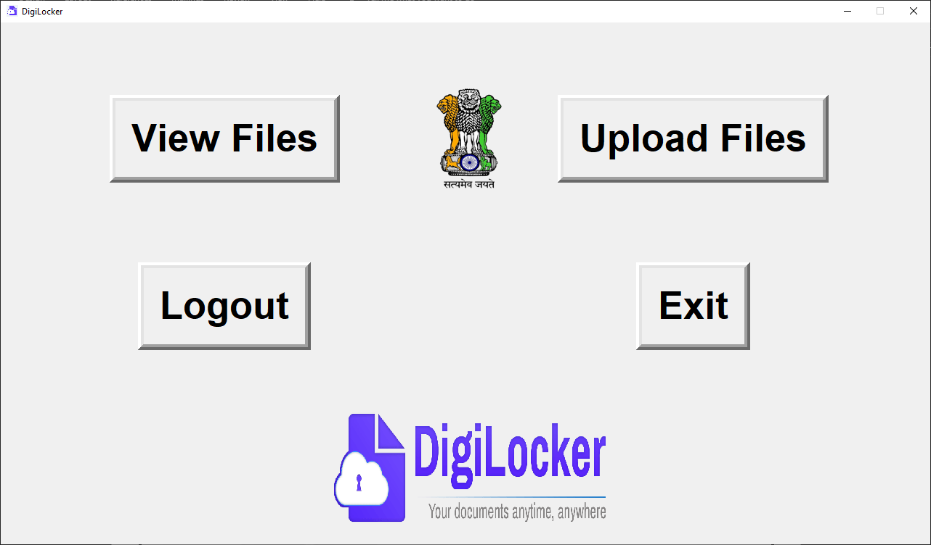

**User Adhaar Card:**

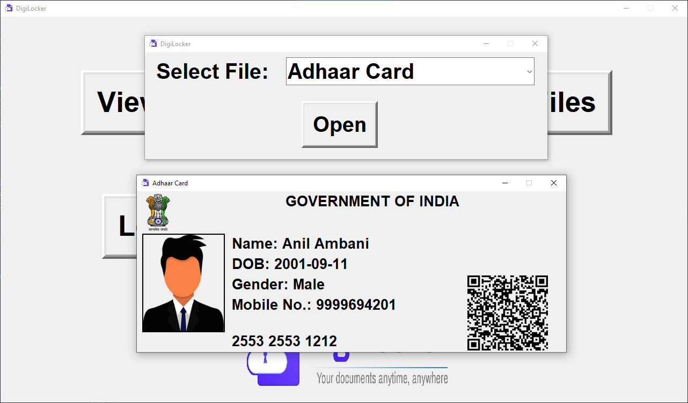

**File Upload Screen:**

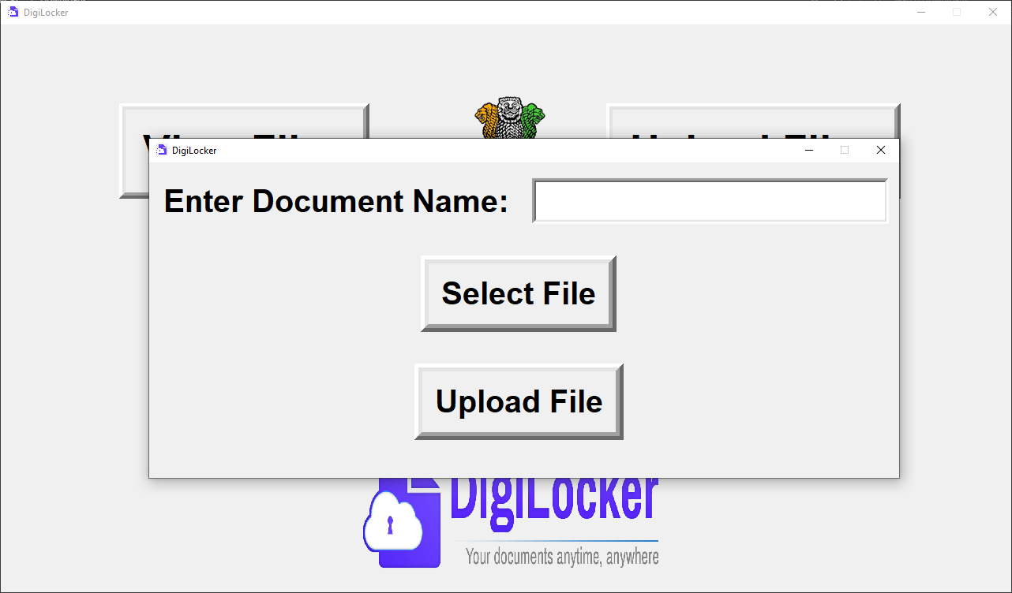

**File Select Dialogue box:**

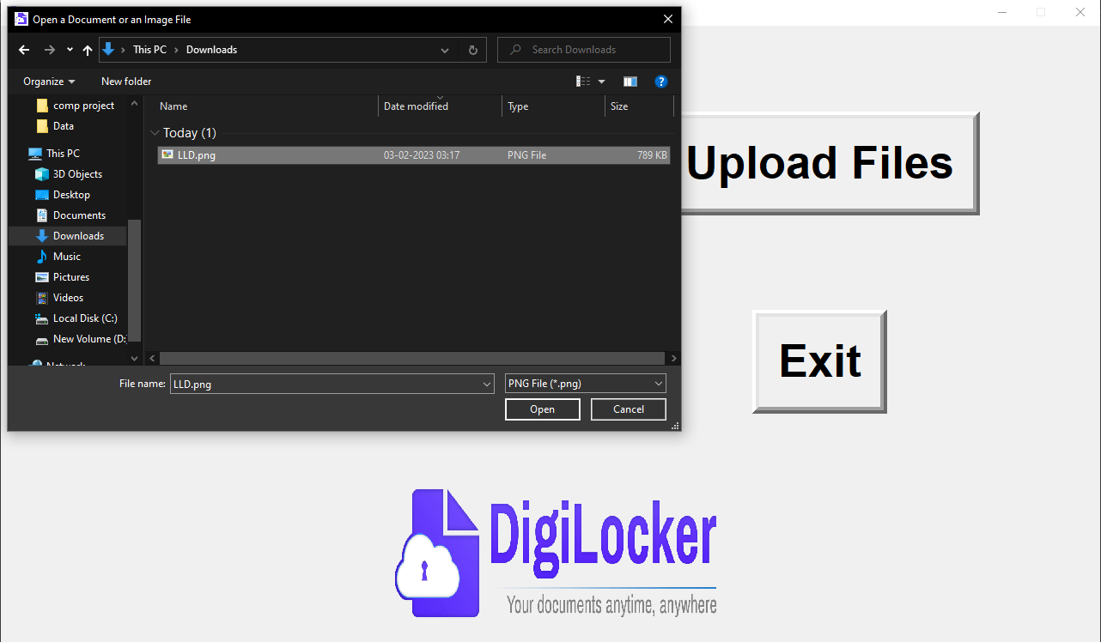

**The uploaded document can be viewed:**

**Image File:**

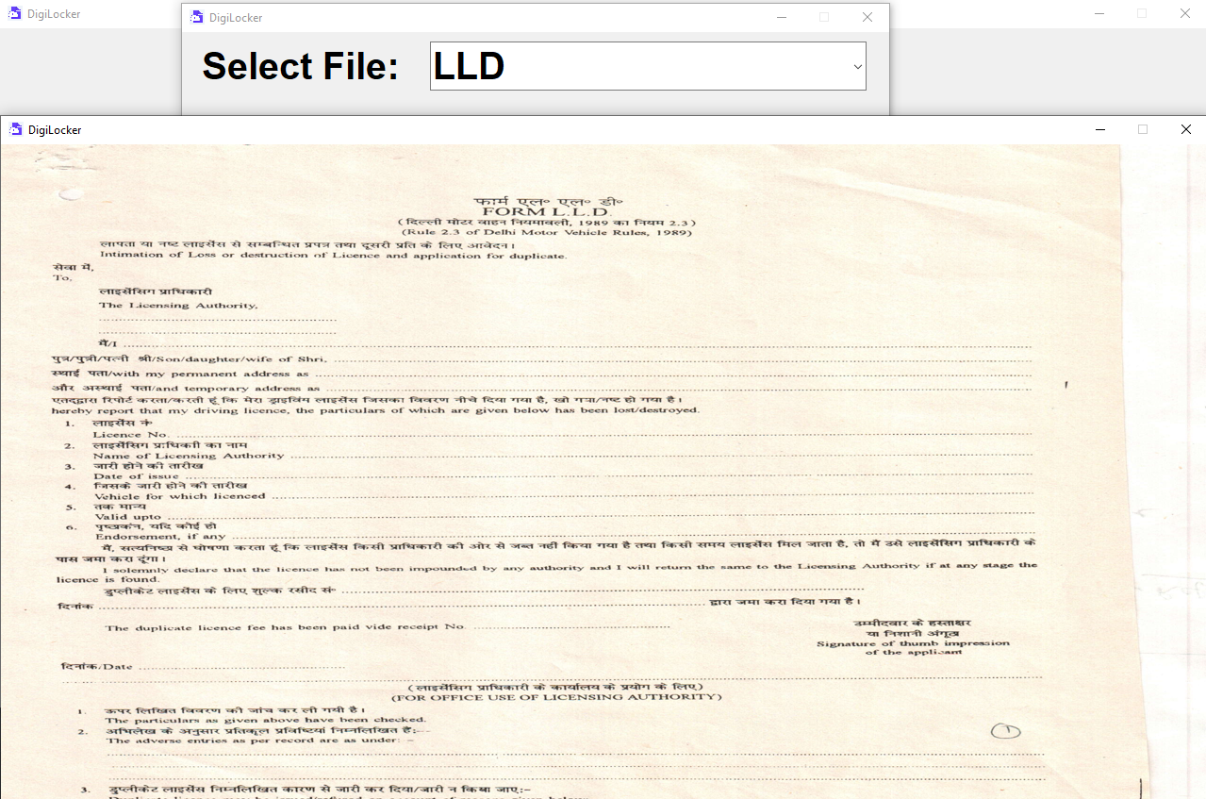

**PDF File:**

