**SMART LIGHTING SYSTEMS**

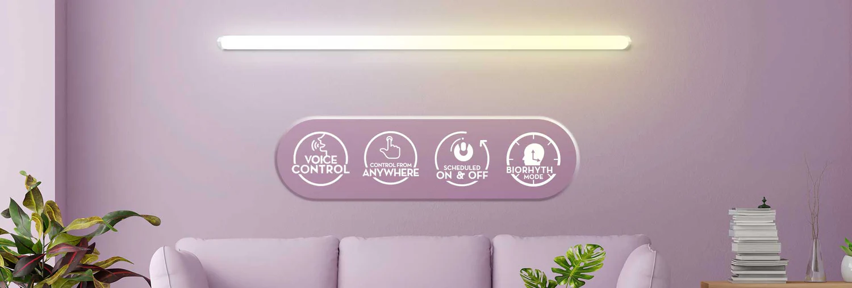

**INTRODUCTION**

**Smart lighting is a system of advanced lighting technology. The lights in a smart lighting system comprise software that connects to an app on your smartphone or other smart devices in your home, allowing you to automate your lights. This way, you can eliminate the need to flip a switch.**

**These smart lighting systems are integrated with a myriad of features including colour changing, scheduled on and off, auto-dimming and essential lighting, among others.** [**Smart lights**](https://www.crompton.co.in/collections/battens-tube-lights/) **can be potentially energy-efficient and cost-effective in the long run.**

**In the evolving landscape of home automation, smart lighting systems have emerged as a cornerstone of modern living. Not only do these systems offer convenience, but they also enhance the aesthetic appeal, security, and energy efficiency of your home. Here’s a deeper look into the top benefits of integrating smart lighting solutions into your living spaces.**

1. Enhanced Convenience:  
   **One of the primary advantages of smart lighting is the convenience it provides. Smart lights can be controlled via smartphone apps, voice commands through assistants like Alexa or Google Home, or even through programmable schedules. Imagine adjusting the brightness, changing colours, or turning lights on and off without ever having to leave your couch or bed. This level of control is particularly beneficial for those with mobility issues or for simply improving the ease of everyday tasks.**
2. Improved Energy Efficiency:  
   **Smart lighting is often more energy-efficient compared to traditional lighting systems.** [**LED smart bulbs,**](https://www.goldmedalindia.com/led/portfolio_page/led-lamp/) **which are commonly used, consume significantly less energy than incandescent or even halogen bulbs. Additionally, the ability to control and automate lighting based on your habits—such as dimming lights during peak energy hours or turning off lights automatically when no one is in the room—helps reduce unnecessary power usage, thereby lowering your electricity bills.**
3. Enhanced Home Security:  
   **Smart lighting can enhance your home’s security by allowing you to simulate occupancy when you’re away. Through app-controlled systems, you can schedule lighting to mimic your usual activity patterns, deterring potential intruders. Additionally, integrating smart lights with other smart home security systems like cameras and motion sensors can improve overall security, alerting you to any unusual activity with triggered lights.**
4. Ambience Creation:  
   **The ability to adjust the brightness and colours of smart bulbs allows you to create the perfect ambiance for any occasion. Whether you’re hosting a dinner party, relaxing in the bath, or reading in your study, you can customize the lighting to suit the mood and activity. This feature is particularly appreciated by those who entertain frequently or who use lighting as an element of interior design.**
5. Health and Wellbeing:  
   **Exposure to different types of light can affect our circadian rhythms, which influence sleep patterns and overall health. Smart lighting can be programmed to mimic natural light patterns, which helps in maintaining a natural circadian rhythm. For instance, brighter, cooler lights during the day can increase alertness and productivity, while warmer, dimmer lights in the evening can signal your body to prepare for sleep.**

**IDEATE:-**

**​The ideation phase focused on translating the real-world requirement of automatic light control into the necessary binary logic for C programming. The core decision was defining the zero (0) and one (1) states: '1' was assigned to the light ON state (to be active after sunset), and '0' was assigned to the light OFF state (active during daylight). This simple, fundamental binary mapping became the foundational conditional logic that drove the entire C program, ensuring the system's output was always a clear, immediate decision.**

**BUILD:-**

#include <stdio.h>

int main() {

int current_hour;

int light_state;

printf("Current time (in 24hr format) :\n");

scanf("%d",&current_hour);

if (current_hour >= 18 || current_hour < 6)

{

light_state = 1;

}

else

{

light_state = 0;

}

printf("•••••••••••••••••••••••••\n");

printf("Light should be : %d\n", light_state);

printf("•••••••••••••••••••••••••");

return 0;

}

**TESTING:-**

**1.Test Case 1**

*Let's have example of input as ‘7’*

Current time (in 24hr format) :

7

•••••••••••••••••••••••••

Light should be : 0

•••••••••••••••••••••••••

[Process completed - press Enter]

**2**.**Test Case 2**

*Let's have example of input as ‘18’*

Current time (in 24hr format) :

18

•••••••••••••••••••••••••

Light should be : 1

•••••••••••••••••••••••••

[Process completed - press Enter]

**3.Test Case 3**

*Let's have example of input as ‘0.01’*

Current time (in 24hr format) :

0.01

•••••••••••••••••••••••••

Light should be : 1

•••••••••••••••••••••••••

[Process completed - press Enter]

**IMPLEMENTATION:-**

**The project is published on Git hub.Which is publicly accessible.**

**CONCLUSION:-**

**This project successfully implemented an automatic light control system using C programming, demonstrating a practical application of the zero or one (binary) output theme. The core objective was to create a system that automatically switches a light ON at sunset and OFF at sunrise.**

THANK YOU!!