WEEK-7

CRICKET APP

In this hands-on lab, you will learn how to:

* Use map() method of ES6
* Apply arrow functions of ES6
* Implement Destructuring features of ES6

## **Prerequisites**

The following is required to complete this hands-on lab:

* Node.js
* NPM
* Visual Studio Code

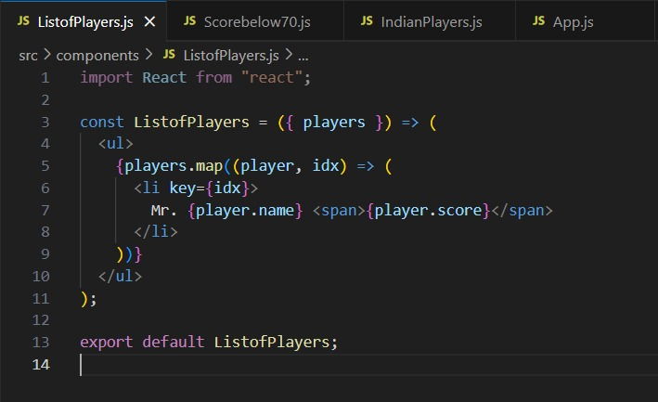

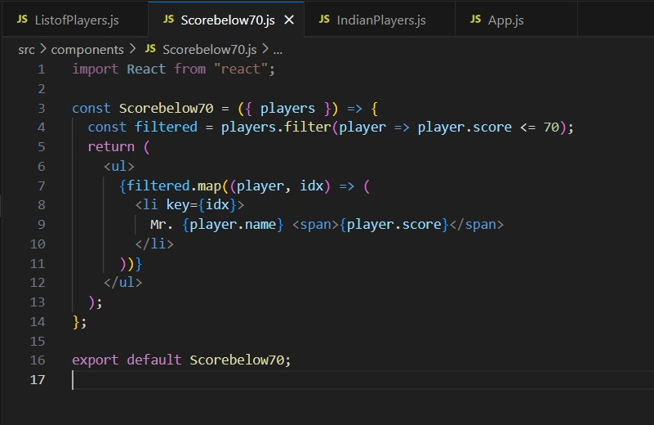

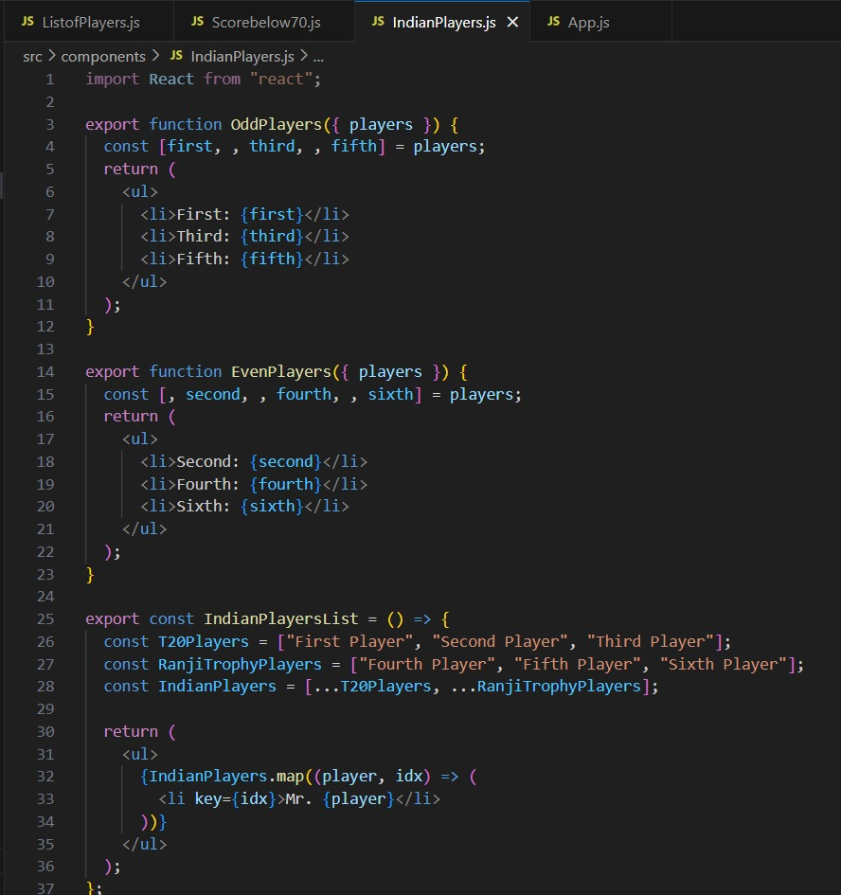

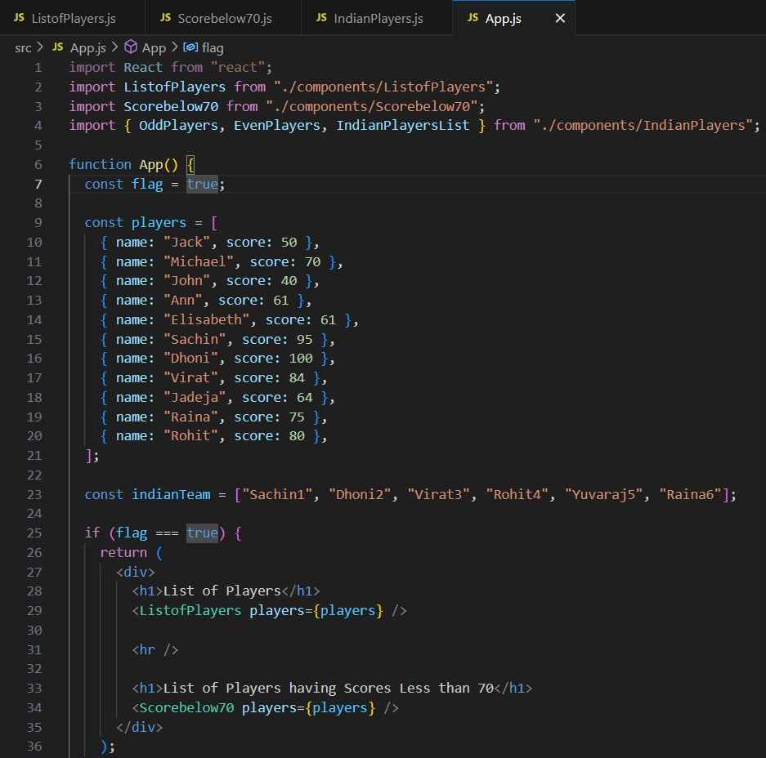

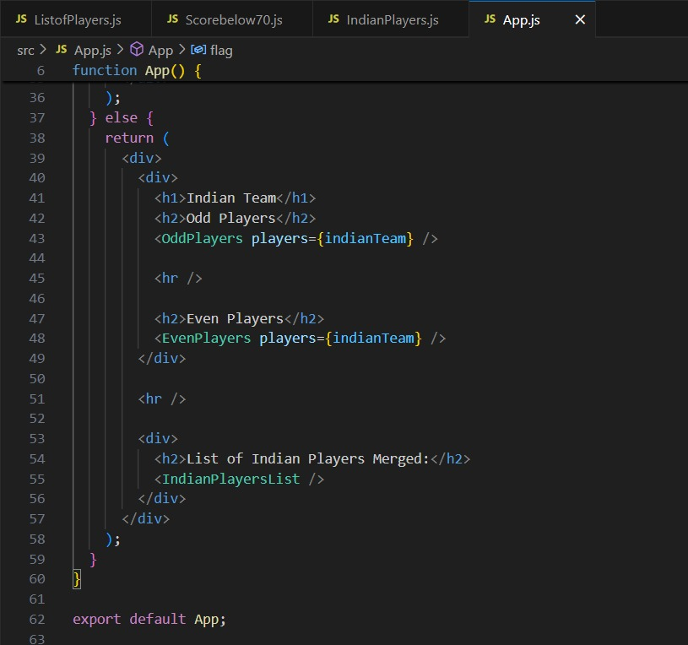

OUTPUT:

