**WEEK-2**

**EXERCISE 1:CONTROL STRUCTURES**

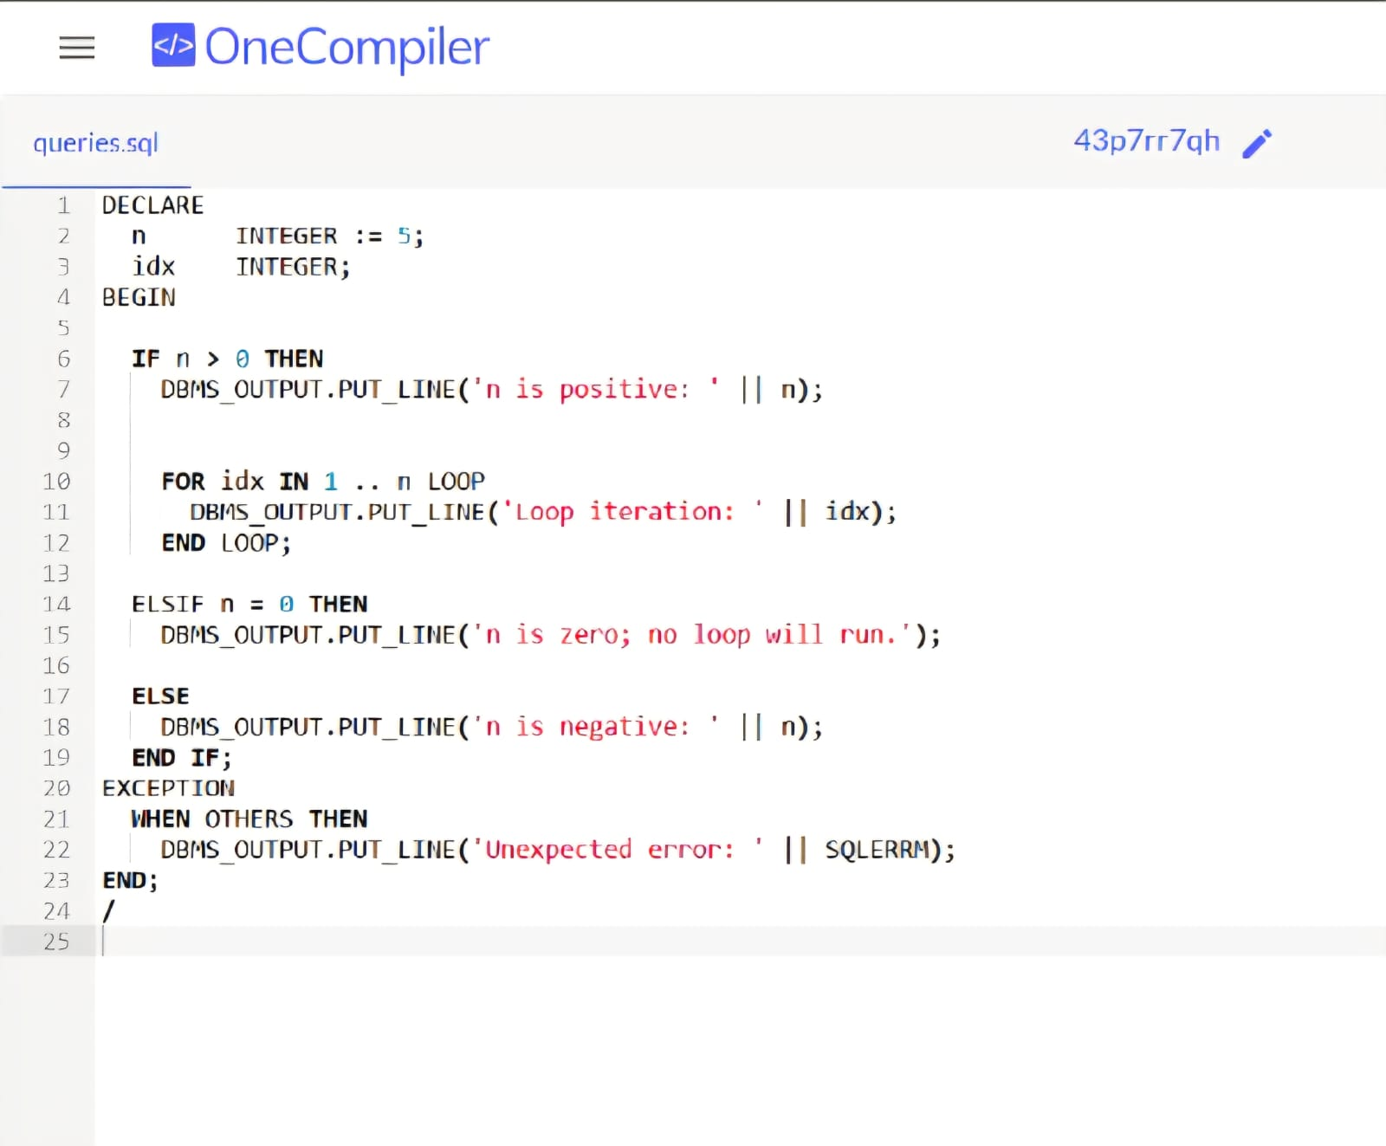

OUTPUT :

