**WEEK-2**

**EXERCISE 3: STORED PROCEDURE**

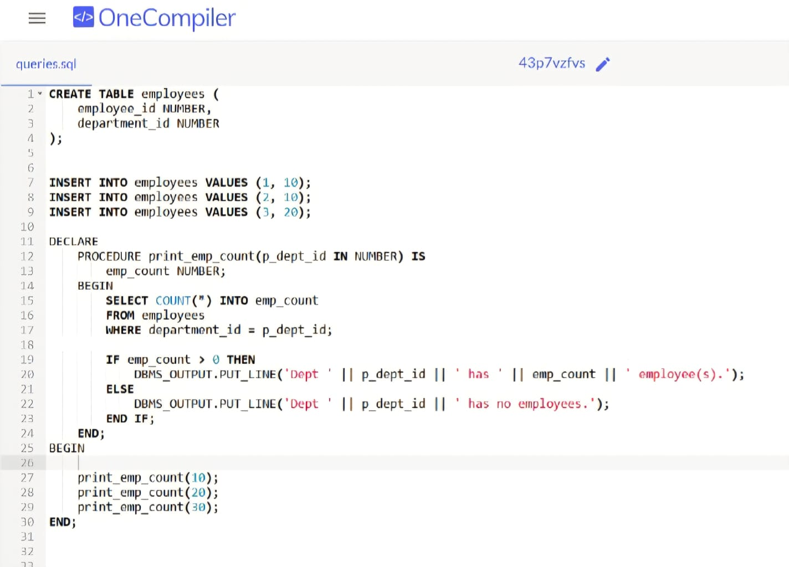

OUTPUT:

