**WEEK-1**

Exercise 2: E-commerce Platform Search Function

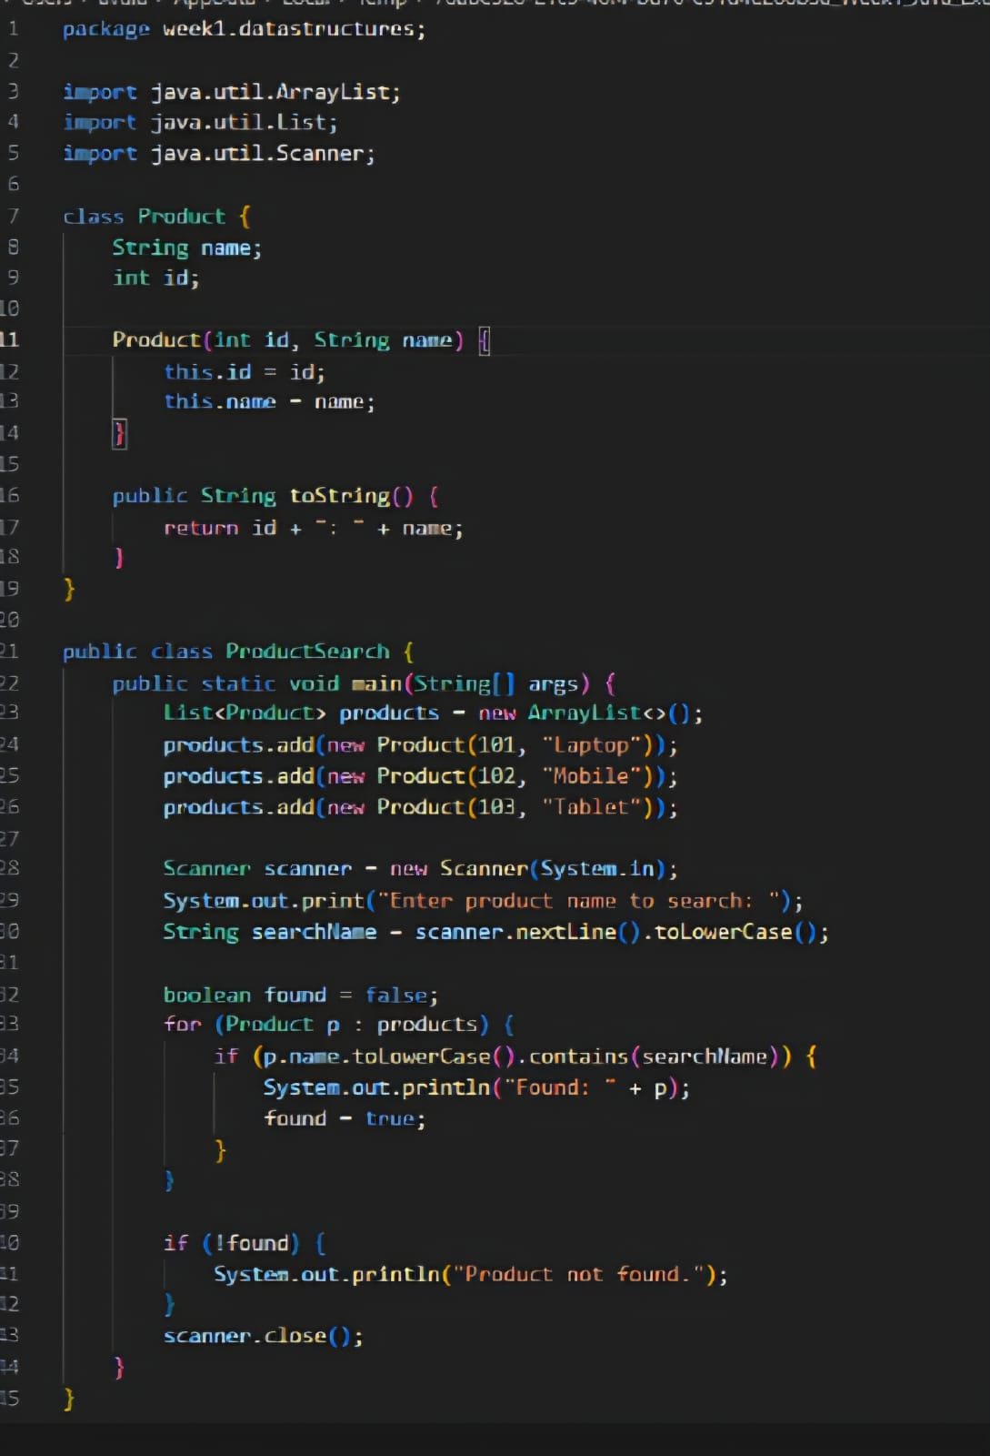

OUTPUT:

