**WEEK-1**

Exercise 7: Financial Forecasting

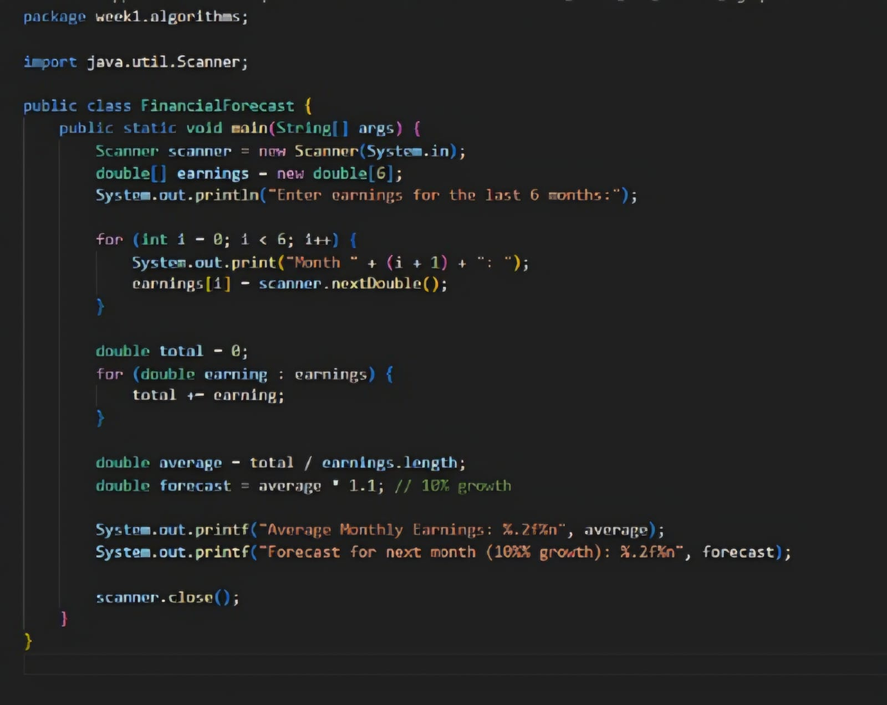

OUTPUT:

