**WEEK-1**

Exercise 1: Implementing the Singleton Pattern

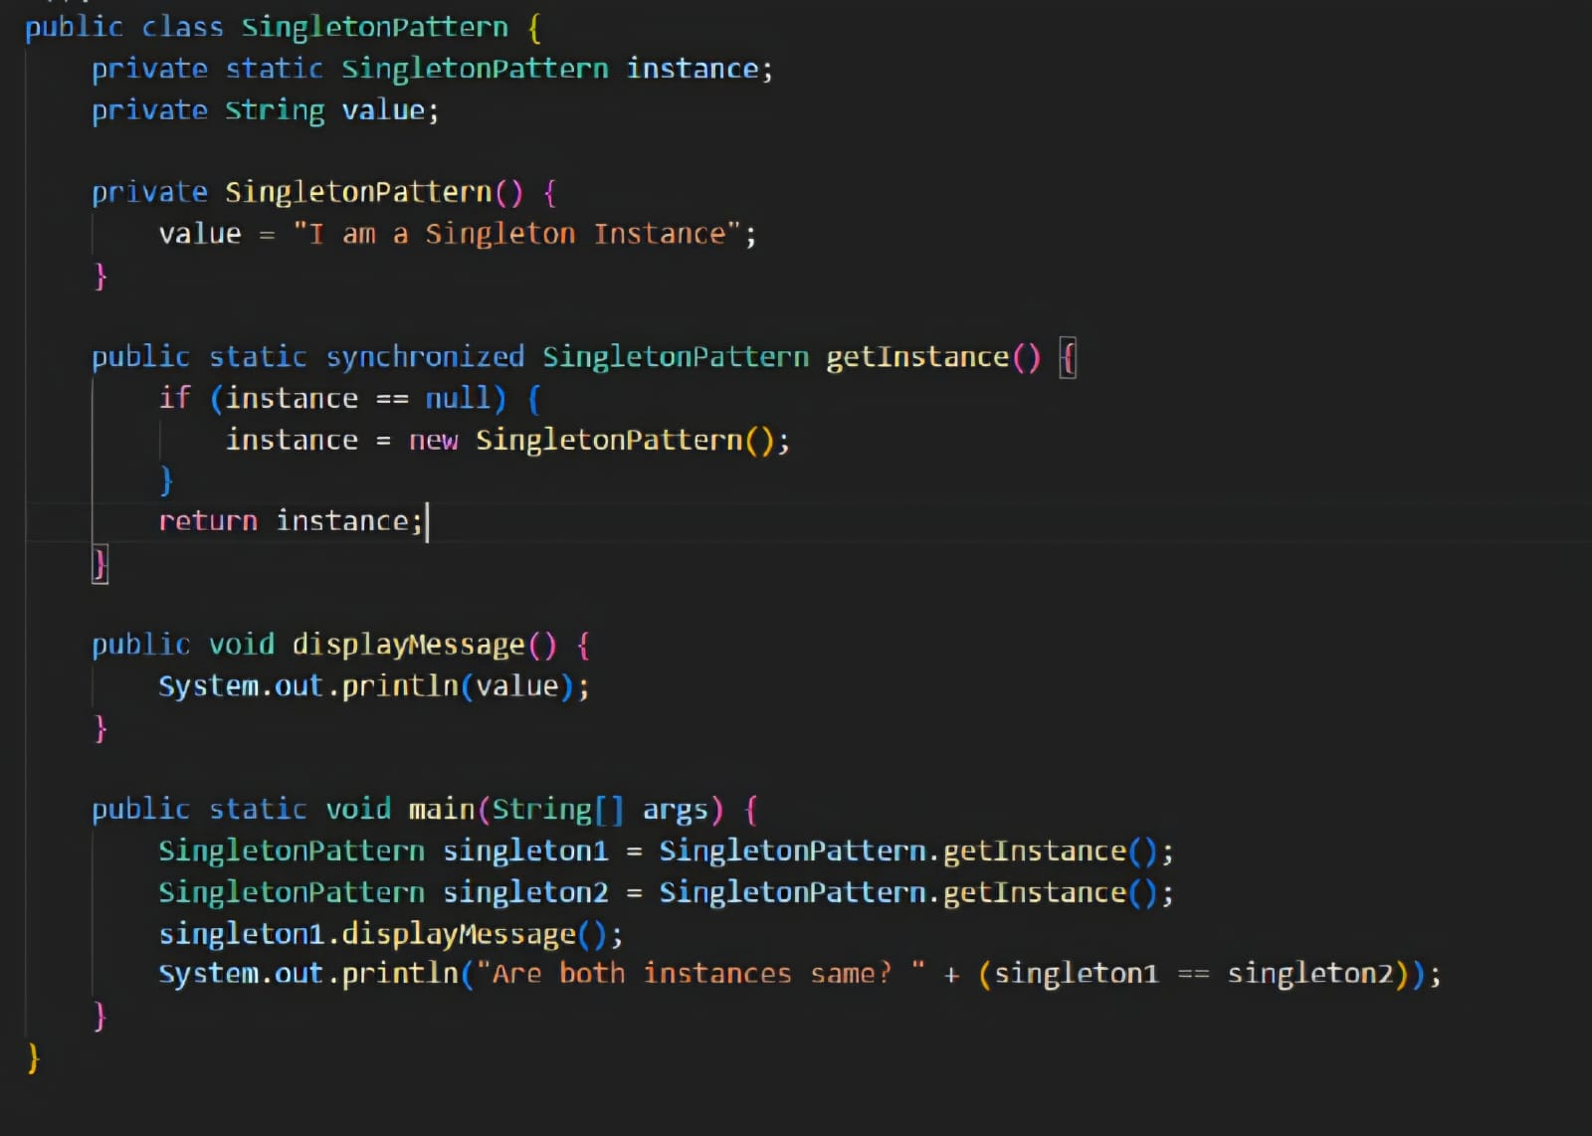

OUTPUT:

