**WEEK-1**

Exercise 2: Implementing the Factory Method Pattern

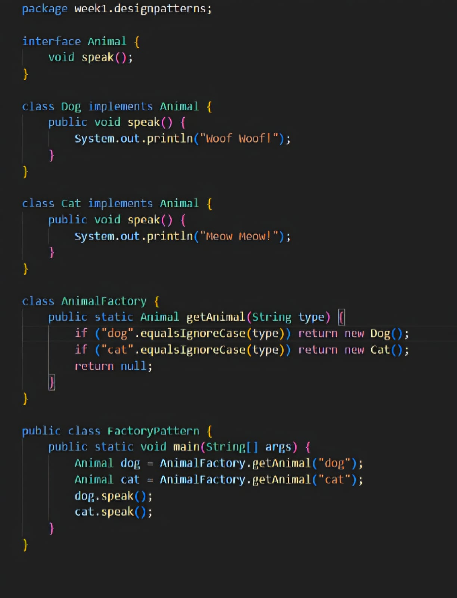

OUTPUT:

