WEEK-3

Spring Data JPA - Quick Example

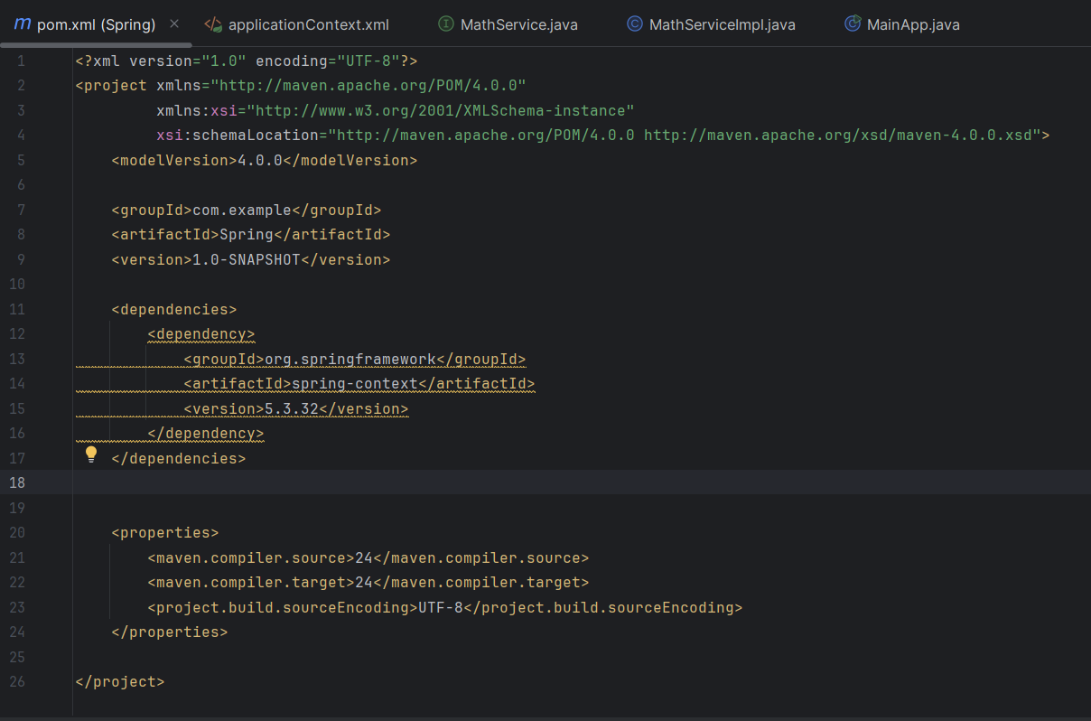

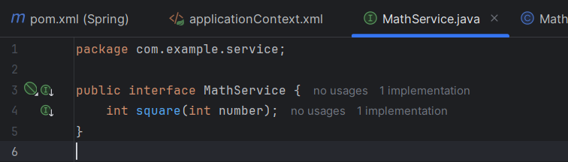

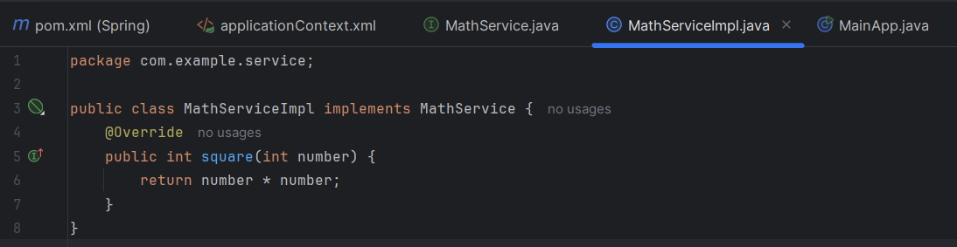

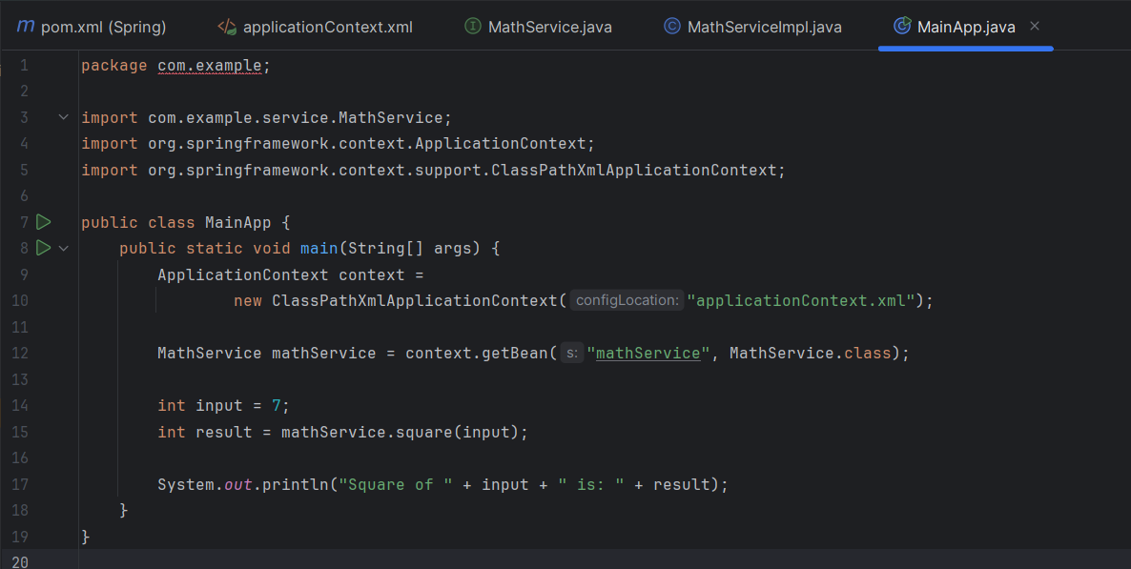

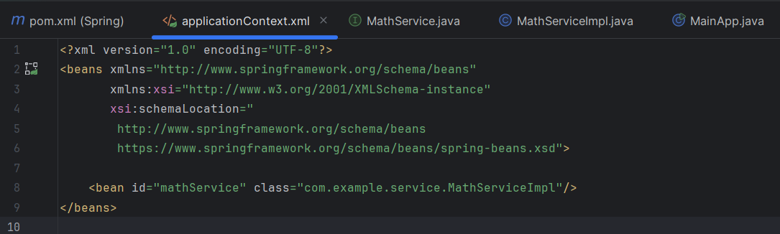

OUTPUT:

