**WEEK-3**

**Difference between JPA, Hibernate and Spring Data JPA**

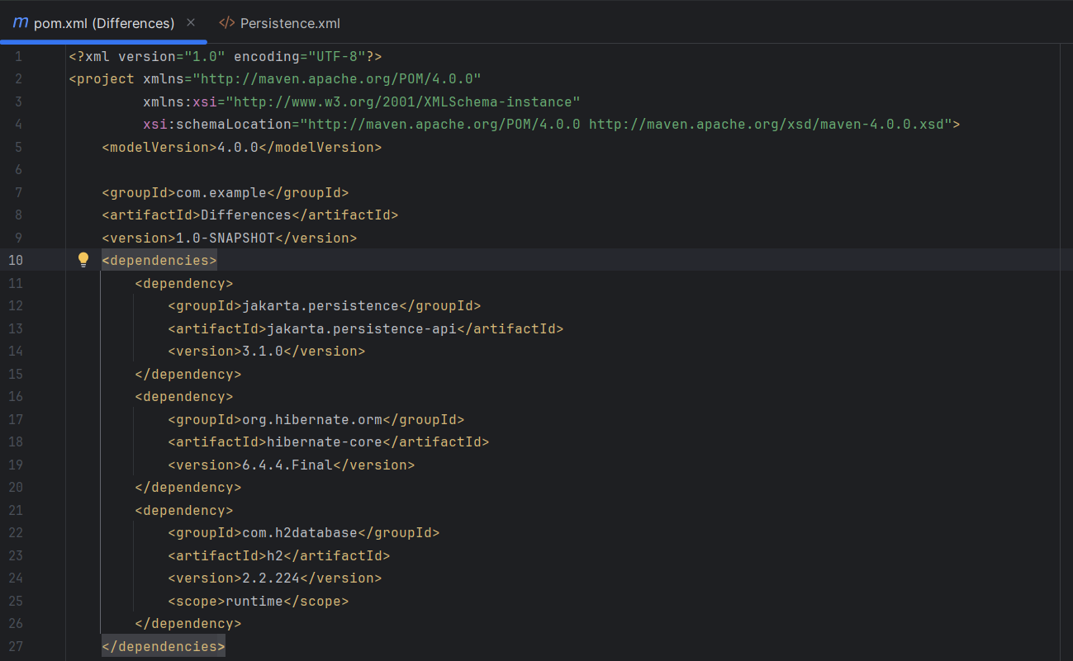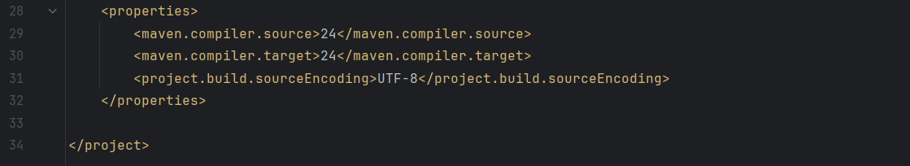

**For JPA Only:**

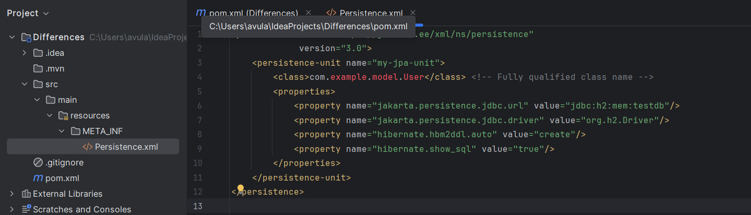

**Hibernate Native (no Spring):**

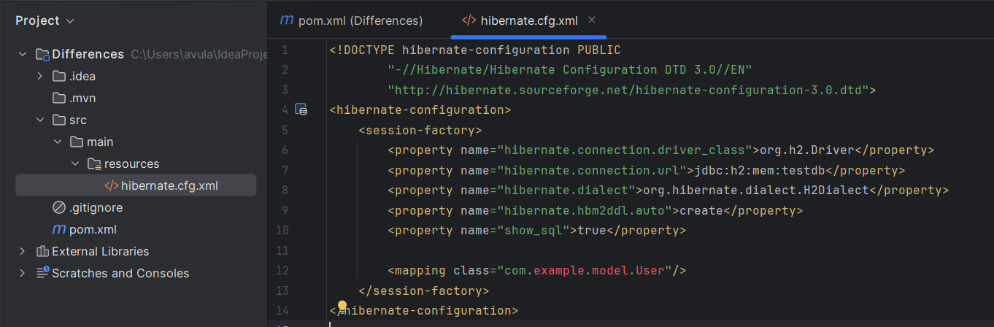

**Spring Data JPA:**

