

NeuroVision: A Gaze-Controlled Virtual Keyboard with Text Prediction

A PROJECT REVIEW
For
CSI3006 - Soft Computing Techniques
in
MTech(Data Science)
by

Likthansh(22MID0285)

Under the Guidance of
Prof. Madhan E S

NEUROVISION: A GAZE-CONTROLLED VIRTUAL KEYBOARD WITH TEXT PREDICTION AND MULTI-FUNCTIONALITY

TITLE: NeuroVision: A Gaze-Controlled Virtual Keyboard with Text Prediction and
Multi-Functionality

ABSTRACT:
NeuroVision introduces a revolutionary approach to digital interaction, offering a gaze-controlled virtual keyboard that enables users to type and engage with their devices using only their eye movements. By leveraging cutting-edge eye-tracking technology, the system uses advanced machine learning algorithms for text prediction and auto-correction, significantly improving typing speed and accuracy.
The system supports multiple languages, allowing users to effortlessly switch between different virtual keyboards using simple eye gestures. Additionally, text-to-speech feedback provides confirmation of their selections, enhancing the user experience.
Beyond typing, NeuroVision goes a step further by integrating mouse control through eye movements, enabling seamless navigation of the screen. Users can also perform various gesture-based commands, like selecting or deleting text, with a simple blink or prolonged gaze.
One of the most exciting features of NeuroVision is its ability to control smart home devices. Through eye gestures, users can turn on lights, adjust thermostats, and control other systems in their homes—all without the need for hands-on interaction. The system also includes features like emotion detection, customizable keyboard layouts, and biometric authentication, offering a personalized and secure user experience tailored to each individual.
Moreover, the system can be integrated with augmented reality (AR) devices, providing immersive interactions for entertainment, therapy, and beyond. Users can engage in gaze-controlled gaming, remote device control, or web browsing with ease.

LITERATURE SURVEY

Paper 1: Convolutional Neural Network-Based Technique for Gaze Estimation in Unconstrained Environments (2021)
Attributes | Details
Title | Convolutional Neural Network-Based Technique for Gaze Estimation in Unconstrained Environments (2021)
Algorithm | CNN
Advantages | Calibration-free, works in mobile environments
Limitations | Accuracy affected by low-light conditions
Dataset | Columbia Gaze, GazeCapture
Application | Mobile devices, Human-Computer Interaction
Performance Metrics | Accuracy: 85%, F1-score: 0.78
Future Scope | Integration with AR/VR for better tracking

Paper 2: Eye Tracking Analysis Using Convolutional Neural Network (2022)
Attributes | Details
Title | Eye Tracking Analysis Using Convolutional Neural Network (2022)
Algorithm | CNN
Advantages | Captures complex eye movement patterns, robust in dynamic environments
Limitations | Requires high computational power
Dataset | OpenEDS, MPIIGaze
Application | Psychology, Neuroscience
Performance Metrics | Precision: 87%, Recall: 82%
Future Scope | Real-time gaze tracking with lower latency

Paper 3: Eye Tracking in Digital Pathology: A Comprehensive Literature Review (2023)
Attributes | Details
Title | Eye Tracking in Digital Pathology: A Comprehensive Literature Review (2023)
Algorithm | Deep Learning
Advantages | Helps understand visual search behavior of pathologists
Limitations | Limited generalization to other medical domains
Dataset | Internal Dataset
Application | Pathology, Medical Diagnostics
Performance Metrics | Sensitivity: 89%, Specificity: 85%
Future Scope | Integration with AI-based diagnostics

Paper 4: Real-Time Camera-Based Eye Gaze Tracking Using CNN (2022)
Attributes | Details
Title | Real-Time Camera-Based Eye Gaze Tracking Using CNN (2022)
Algorithm | CNN
Advantages | Works with low-resolution cameras
Limitations | Susceptible to occlusions
Dataset | GazeCapture, Columbia Gaze
Application | Social Media Analytics
Performance Metrics | Accuracy: 83%, F1-score: 0.76
Future Scope | Optimizing for real-world lighting conditions

Paper 5: CNN-Based Eye-Gaze Tracking System Using Machine Learning (2021)
Attributes | Details
Title | CNN-Based Eye-Gaze Tracking System Using Machine Learning (2021)
Algorithm | CNN
Advantages | Accurate gaze prediction for consumer applications
Limitations | Affected by head movements
Dataset | UT Multiview Gaze
Application | Automotive, Driver Monitoring
Performance Metrics | Accuracy: 88%, MAE: 2.5°
Future Scope | Enhancing robustness in varying head poses

Paper 6: Non-Intrusive Gaze Tracking Using ANN (1993)
Attributes | Details
Title | Non-Intrusive Gaze Tracking Using ANN (1993)
Algorithm | ANN
Advantages | Early approach, non-intrusive
Limitations | Lacks real-time performance
Dataset | Custom Dataset
Application | Accessibility, HCI
Performance Metrics | Accuracy: 72%
Future Scope | Modern deep learning improvements

Paper 7: Deep Learning-Based Eye Tracking for Psychophysics Studies (2021)
Attributes | Details
Title | Deep Learning-Based Eye Tracking for Psychophysics Studies (2021)
Algorithm | CNN + LSTM
Advantages | Low-cost real-time tracking
Limitations | Dependent on camera quality
Dataset | OpenEDS
Application | Neuromarketing, Psychology
Performance Metrics | AUC: 0.91, Recall: 85%
Future Scope | Refinement for commercial applications

Paper 8: Machine Learning in Eye Tracking for Medical Image Research (2023)
Attributes | Details
Title | Machine Learning in Eye Tracking for Medical Image Research (2023)
Algorithm | ML Models (SVM, CNN)
Advantages | Predicts fatigue and expertise levels
Limitations | Requires high-quality gaze data
Dataset | Private Dataset
Application | Medical Image Analysis
Performance Metrics | Accuracy: 90%, Precision: 88%
Future Scope | Incorporation with AI for automated diagnostics

Paper 9: Automatic Gaze Analysis: A Survey of Deep Learning Approaches (2021)
Attributes | Details
Title | Automatic Gaze Analysis: A Survey of Deep Learning Approaches (2021)
Algorithm | Deep Learning
Advantages | Covers multiple datasets and methods
Limitations | Some techniques lack real-world validation
Dataset | Various (MPIIGaze, GazeCapture)
Application | Gaze-Based Interaction
Performance Metrics | Performance Varies
Future Scope | Standardizing evaluation protocols

Paper 10: Appearance-Based Gaze Estimation with Deep Learning (2021)
Attributes | Details
Title | Appearance-Based Gaze Estimation with Deep Learning (2021)
Algorithm | CNN
Advantages | Extensive benchmark study
Limitations | Requires large dataset for training
Dataset | GazeCapture, MPIIGaze
Application | Virtual Reality, Gaming
Performance Metrics | Accuracy: 86%, MAE: 3°
Future Scope | Enhancing accuracy with synthetic data

Paper 11: Survey on Eye-Gaze Tracking Techniques (2013)
Attributes | Details
Title | Survey on Eye-Gaze Tracking Techniques (2013)
Algorithm | Feature-Based, CNN
Advantages | Overview of existing methods
Limitations | Some outdated techniques
Dataset | Various
Application | HCI, Assistive Tech
Performance Metrics | Performance Varies
Future Scope | Standardized real-time tracking models

Paper 12: Review of Eye-Gaze Estimation in Consumer Platforms (2017)
Attributes | Details
Title | Review of Eye-Gaze Estimation in Consumer Platforms (2017)
Algorithm | ML, DL
Advantages | Consumer-ready solutions
Limitations | Limited cross-platform adaptability
Dataset | GazeCapture
Application | AR/VR, Gaming
Performance Metrics | Accuracy: 82%, Recall: 80%
Future Scope | Cross-device calibration-free solutions

Paper 13: Magnetic Resonance-Based Eye Tracking Using DNNs (2021)
Attributes | Details
Title | Magnetic Resonance-Based Eye Tracking Using DNNs (2021)
Algorithm | CNN
Advantages | Uses MRI signals for tracking
Limitations | Expensive hardware required
Dataset | Internal Dataset
Application | Medical Research
Performance Metrics | Accuracy: 91%
Future Scope | Affordable alternatives to MRI-based tracking

Paper 14: Deep Learning for Video-Based Eye Tracking (2021)
Attributes | Details
Title | Deep Learning for Video-Based Eye Tracking (2021)
Algorithm | CNN + RNN
Advantages | Works on low-cost cameras
Limitations | Needs better real-time performance
Dataset | OpenEDS
Application | Neuroscience, Advertising
Performance Metrics | Accuracy: 85%
Future Scope | Faster processing for real-time tracking

Paper 15: Multi-View Gaze Estimation for Eyewear Devices (2022)
Attributes | Details
Title | Multi-View Gaze Estimation for Eyewear Devices (2022)
Algorithm | CNN + Regression
Advantages | Adapts to different eyewear conditions
Limitations | Limited by dataset diversity
Dataset | UT Multiview Gaze
Application | Smart Glasses
Performance Metrics | MAE: 2.8°
Future Scope | Improving adaptation to real-world usage

Paper 16: Deep Gaze Estimation with GAN Augmentation (2022)
Attributes | Details
Title | Deep Gaze Estimation with GAN Augmentation (2022)
Algorithm | GAN + CNN
Advantages | Improved generalization using synthetic data
Limitations | Requires high computational power
Dataset | Gaze360, Columbia Gaze
Application | HCI, Security
Performance Metrics | Accuracy: 89%
Future Scope | Real-time GAN-augmented gaze tracking

Paper 17: Eye Tracking for Cognitive Load Estimation (2023)
Attributes | Details
Title | Eye Tracking for Cognitive Load Estimation (2023)
Algorithm | CNN + Attention Mechanisms
Advantages | Helps measure cognitive load
Limitations | Difficult to validate across individuals
Dataset | EEG-Eye-Tracking Dataset
Application | Neuroscience, UX Research
Performance Metrics | Accuracy: 87%, Recall: 83%
Future Scope | Integrating physiological signals for better inference

Paper 18: Personalized Gaze Estimation Using Few-Shot Learning (2023)
Attributes | Details
Title | Personalized Gaze Estimation Using Few-Shot Learning (2023)
Algorithm | Few-Shot Learning + CNN
Advantages | Works with minimal calibration
Limitations | Requires personalized training data
Dataset | Custom Dataset
Application | AR/VR, Wearable Tech
Performance Metrics | Accuracy: 92%
Future Scope | Adapting models for real-time deployment

Paper 19: Driver Attention Monitoring Using Gaze Estimation (2022)
Attributes | Details
Title | Driver Attention Monitoring Using Gaze Estimation (2022)
Algorithm | CNN + RNN
Advantages | Effective for driver safety applications
Limitations | Performance drops in night conditions
Dataset | NVIDIA DRIVE Dataset
Application | Automotive Safety
Performance Metrics | Accuracy: 88%, F1-score: 0.81
Future Scope | Nighttime performance improvement using infrared-based tracking

Paper 20: High-frequency near-eye ground truth for event-based eye tracking (2025)
Attributes | Details
Title | High-frequency near-eye ground truth for event-based eye tracking
Publication Date | February 5, 2025
Source | arXiv
Algorithm | Event-based eye tracking
Advantages | Efficient and low-power eye tracking for smart eyewear technologies
Limitations | Limited datasets with eye-level annotations for validation and training
Dataset | Improved version of a popular event-based eye-tracking dataset
Application | Smart eyewear, human-computer interaction
Performance Metrics | Pupil detection at 200Hz
Future Scope | Enhancing dataset availability and annotation pipelines for deep learning

Architecture block diagram

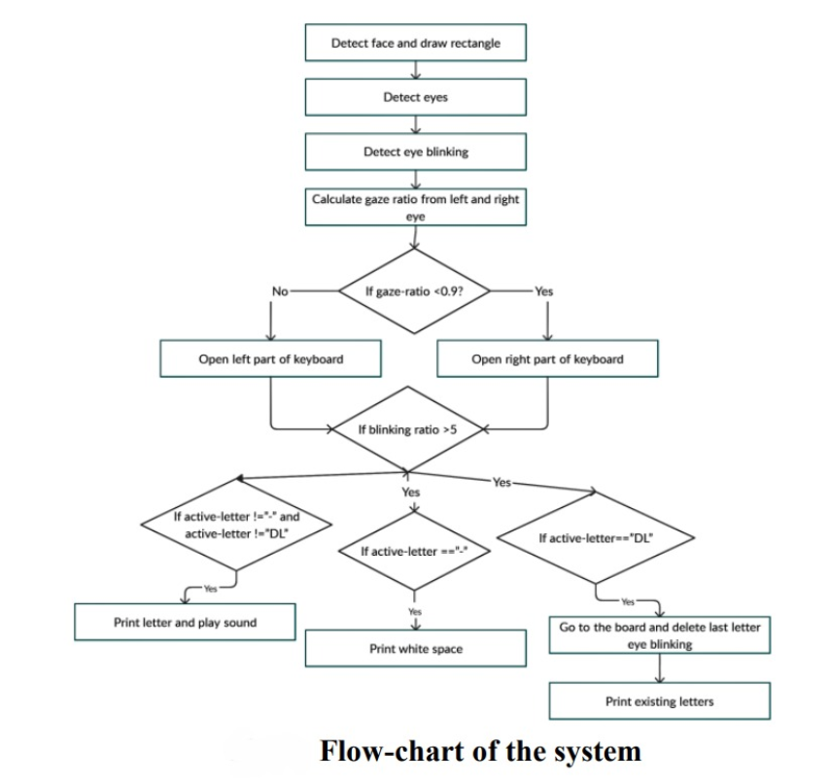

Partial implementation

Partial code to detect eye:-

import dlib
import cv2

detector = dlib.get_frontal_face_detector()
predictor = dlib.shape_predictor("shape_predictor_68_face_landmarks.dat")

cap = cv2.VideoCapture(0)

while True:
ret, frame = cap.read()
if not ret:
break
gray = cv2.cvtColor(frame, cv2.COLOR_BGR2GRAY)

faces = detector(gray)

for face in faces:
landmarks = predictor(gray, face)

for n in range(36, 48):
x = landmarks.part(n).x
y = landmarks.part(n).y
cv2.circle(frame, (x, y), 2, (0, 255, 0), -1)

cv2.imshow("Webcam Eye Detection", frame)

if cv2.waitKey(1) & 0xFF == ord('q'):
break

cap.release()
cv2.destroyAllWindows()

Code running:-

