Clustering Impovements
Andrew Stewart, Aug 14

The usability of many functions are somewhat hindered by the long time that they take to run. For instance, common tasks like plotting results with a mask visualising significant stats after bootstrapping can take several minutes of processing. In this time, LIMO would appear to ‘hang’ and seem unresponsive for minutes. This is despite much of the data having been precomputed at this point, and suggestions that the cluster functions that are done here can be greatly speeded up.

The task becomes to rewrite these cluster functions to speed up execution - and so make this more usable. A first task in this is to write benchmarking functions. This benchmark needs to:
- call relevant functions
- record output for verification purposes
- check current output against previous ‘known good’ output
- interact with the Matlab profiler to parse and save precise timing data.

This function (‘profiling_save_bmark.m’) is now written and works well for these purposes. This saves benchmark data in bmark.mat.

From initial runs of this profiling and benchmarking display_results functions, we used data from CGS1 with 1000 H0 bootstraps. The profiling revealed that there was something of a maze of subfunctions called - from display_results -> limo_stat_values -> local_clustering -> getclustersum x1000 -> ft_findcluster -> bwlabeln x130,000. All this took a total time of 119s. About ⅔ of this time was spent on bwlabeln and checks of ismember in ft_findcluster.

To speed this up, I replaced the local_clustering subfunction with ‘andrews_local_clustering’ for now. In there, I refactored the code essential for these types of calls into fewer subfunctions. Subsequent verification showed that output remained the same, and the benchmark showed that this was a little faster. I then continued with detailed profiling, assessing profiler details and examining what could be done to speed up each function. I found gains could be made in bwlabeln by using ft compiled version preferentially (if it exists in path), reordering how bwlabel was called, using a complied mex version of ismember, and various other changes. This reduces runtime from 119s to 68s.
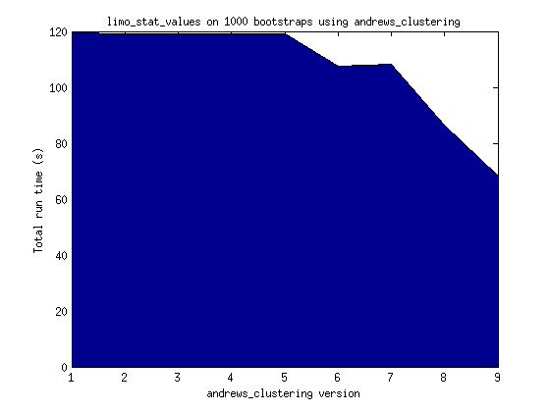
Other cluster functions were also examined to see what could be sped up without dramatic changes to the structure of the code. There is now less of a maze in calling clustering functions from display_results.

