

**МИНИСТЕРСТВО ТРАНСПОРТА РОССИЙСКОЙ ФЕДЕРАЦИИ**

ФЕДЕРАЛЬНОЕ ГОСУДАРСТВЕННОЕ АВТОНОМНОЕ ОБРАЗОВАТЕЛЬНОЕ

УЧРЕЖДЕНИЕ ВЫСШЕГО ОБРАЗОВАНИЯ

**«РОССИЙСКИЙ УНИВЕРСИТЕТ ТРАНСПОРТА»**

**(РУТ (МИИТ)**

**ИНСТИТУТ ТРАНСПОРТНОЙ ТЕХНИКИ И СИСТЕМ УПРАВЛЕНИЯ**

**Лабораторная работа №6**

**по дисциплине** «**Методы программирования**»

«Excel»

**Выполнили:** ст. гр. ТКИ-341

Бузаджи Н.М.

Самохвалова М.Д.

**Проверил:** к.т.н. Сафронов А.И.

**Москва – 2024 г**

1. **Цель работы**

Освоить навыки подключения внешних модулей (библиотек классов) и их использования в разрабатываемых программах; освоить навыки программируемой настройки параметров электронных таблиц Microsoft Office Excel.

## 2. Индивидуальная задача

1. Создать графический пользовательский интерфейс с кнопками: «Выгрузка в Excel», «Заполнение данными», «Предпросмотр».

2. Нажатие на кнопку «Выгрузка в Excel» инициирует запуск на исполнение метода составления электронной таблицы заданной по варианту структуры (обрамление, размеры ячеек, цвета, одноуровневая / многоуровневая «шапка», «чердак», «подвал»).

3. Нажатие на кнопку «Заполнение данными» инициирует запуск на исполнение метода расстановки значений в ячейки из текстового файла. Для вариантов, в схематичной структуре которых присутствуют данные в ячейках таблицы, использовать проиллюстрированные значения, для вариантов, содержащих незаполненные структуры таблиц, необходимо дополнительно продумать возможные наборы данных для заполнения ячеек.

4. Нажатие на кнопку «Предпросмотр» инициирует вызов дочерней экранной формы, содержащей приближенный аналог таблицы, выполненный на базе интерфейсного элемента управления DataGridView. «Предпросмотром» можно пользоваться как до подгрузки данных в табличную структуру, так и после.

## Вариант индивидуального задания

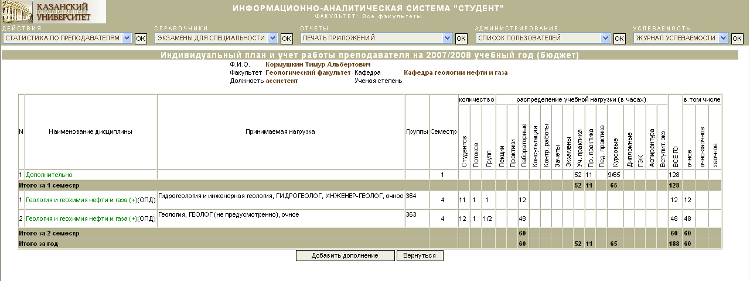

Рисунок 1 – Вариант индивидуального задания

## Диаграммы классов, входящих в состав решения.

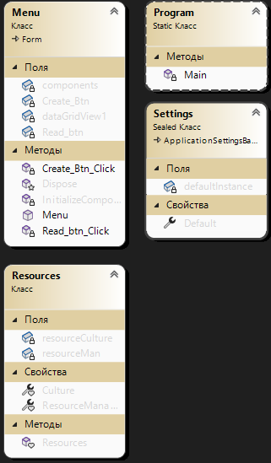

Рисунок 2 – Диаграмма классов

## Сеть Петри

**Легенда:**

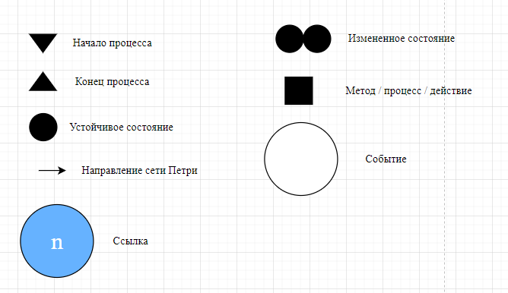

Рисунок 3 – Значение обозначений

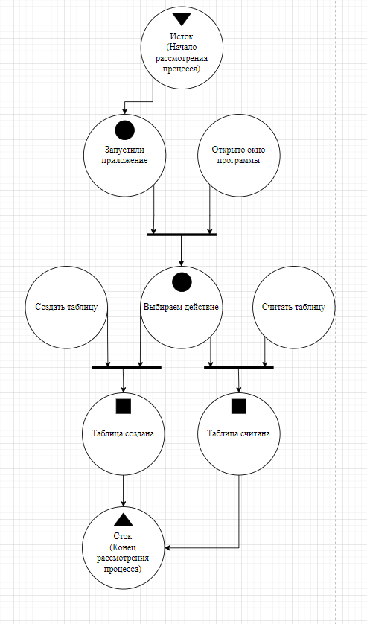

Рисунок 4 – Сеть Петри

## Составление схем алгоритмов методов в составе решения, отмеченных на сети Петри в качестве «эффектов» (метка )

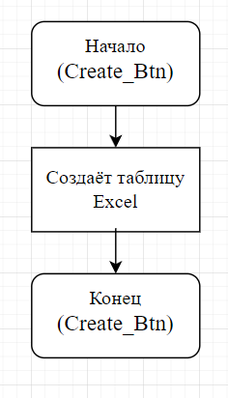

Рисунок 5 – Создаем файл Excel

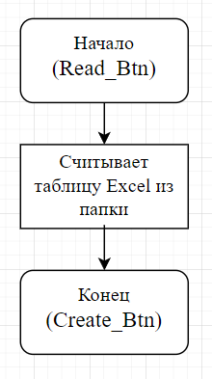

Рисунок 6 – Считывание файла Excel

## Тестовый пример



Рисунок 7 – Первый тестовый пример

## Листинг (код) составленного программного обеспечения

using System;

using System.Data;

using System.Windows.Forms;

using Excel = Microsoft.Office.Interop.Excel;

using System.IO;

using ExcelDataReader;

using Microsoft.Office.Interop.Excel;

using System.Linq;

using OfficeOpenXml.Style;

namespace WindowsFormsApp1

{

public partial class Menu : Form

{

public Menu()

{

InitializeComponent();

}

private void Create_Btn_Click(object sender, EventArgs e)

{

Excel.Application exApp = new Excel.Application();

Excel.Workbook exWorkbook;

Excel.Worksheet exWorksheet;

string path = System.Windows.Forms.Application.StartupPath + "\\NewTable.xlsx";

object misValue = System.Reflection.Missing.Value;

exWorkbook = exApp.Workbooks.Add(misValue);

exWorksheet = (Excel.Worksheet)exWorkbook.Worksheets.get_Item(1);

// Заполнение 1ой строки

exWorksheet.Range["A1:A2"].Merge();

exWorksheet.Range["A1"].VerticalAlignment = Excel.XlVAlign.xlVAlignCenter;

exWorksheet.Range["A1"].HorizontalAlignment = Excel.XlHAlign.xlHAlignCenter;

exWorksheet.Range["A1"].Value = "N";

exWorksheet.Range["A1"].EntireColumn.AutoFit();

exWorksheet.Range["A1"].EntireRow.AutoFit();

exWorksheet.Range["B1:B2"].Merge();

exWorksheet.Range["B1"].VerticalAlignment = Excel.XlVAlign.xlVAlignCenter;

exWorksheet.Range["B1"].HorizontalAlignment = Excel.XlHAlign.xlHAlignCenter;

exWorksheet.Range["B1"].Value = "Наименование дисциплины";

exWorksheet.Range["B1"].EntireColumn.AutoFit();

exWorksheet.Range["B1"].EntireRow.AutoFit();

exWorksheet.Range["C1:C2"].Merge();

exWorksheet.Range["C1"].VerticalAlignment = Excel.XlVAlign.xlVAlignCenter;

exWorksheet.Range["C1"].HorizontalAlignment = Excel.XlHAlign.xlHAlignCenter;

exWorksheet.Range["C1"].Value = "Принимаемая нагрузка";

exWorksheet.Range["C1"].EntireColumn.AutoFit();

exWorksheet.Range["C1"].EntireRow.AutoFit();

exWorksheet.Range["D1:D2"].Merge();

exWorksheet.Range["D1"].VerticalAlignment = Excel.XlVAlign.xlVAlignCenter;

exWorksheet.Range["D1"].HorizontalAlignment = Excel.XlHAlign.xlHAlignCenter;

exWorksheet.Range["D1"].Value = "Группы";

exWorksheet.Range["D1"].EntireColumn.AutoFit();

exWorksheet.Range["D1"].EntireRow.AutoFit();

exWorksheet.Range["E1:E2"].Merge();

exWorksheet.Range["E1"].VerticalAlignment = Excel.XlVAlign.xlVAlignCenter;

exWorksheet.Range["E1"].HorizontalAlignment = Excel.XlHAlign.xlHAlignCenter;

exWorksheet.Range["E1"].Value = "Семестр";

exWorksheet.Range["E1"].EntireColumn.AutoFit();

exWorksheet.Range["E1"].EntireRow.AutoFit();

exWorksheet.Range["F1:H1"].Merge();

exWorksheet.Range["F1"].VerticalAlignment = Excel.XlVAlign.xlVAlignCenter;

exWorksheet.Range["F1"].HorizontalAlignment = Excel.XlHAlign.xlHAlignCenter;

exWorksheet.Range["F1"].Value = "Количество";

exWorksheet.Range["F1"].EntireColumn.AutoFit();

exWorksheet.Range["F1"].EntireRow.AutoFit();

char startColumn = 'F';

char endColumn = 'W';

int i = 0;

for (char column = startColumn; column <= endColumn; column++)

{

string[] words = { "Студенты", "Потоки", "Группы", "Лекции", "Практики", "Лабораторные", "Консультации", "Контр. Работы", "Зачеты", "Экзамены", "Уч. Практика", "Пр. практика", "Пед. Практика", "Курсовые", "Дипломные", "ГЭК", "Аспирантура", "Вступит. Экз." };

string cellAddress = column + "2";

Excel.Range cell = exWorksheet.Range[cellAddress];

cell.Value = words[i];

cell.HorizontalAlignment = Excel.XlHAlign.xlHAlignCenter;

cell.VerticalAlignment = Excel.XlVAlign.xlVAlignBottom;

cell.Orientation = 90;

cell.EntireColumn.AutoFit();

cell.EntireRow.AutoFit();

i++;

}

exWorksheet.Range["I1:W1"].Merge();

exWorksheet.Range["I1"].VerticalAlignment = Excel.XlVAlign.xlVAlignCenter;

exWorksheet.Range["I1"].HorizontalAlignment = Excel.XlHAlign.xlHAlignCenter;

exWorksheet.Range["I1"].Value = "Распределение учебной нагрузки (в часах)";

exWorksheet.Range["I1"].EntireColumn.AutoFit();

exWorksheet.Range["I1"].EntireRow.AutoFit();

exWorksheet.Range["X1:X2"].Merge();

exWorksheet.Range["X1"].VerticalAlignment = Excel.XlVAlign.xlVAlignBottom;

exWorksheet.Range["X1"].HorizontalAlignment = Excel.XlHAlign.xlHAlignCenter;

exWorksheet.Range["X1"].Value = "ВСЕГО";

exWorksheet.Range["X1"].Orientation = 90;

exWorksheet.Range["X1"].EntireColumn.AutoFit();

exWorksheet.Range["X1"].EntireRow.AutoFit();

char startColumn1 = 'Y';

char endColumn1 = 'Z';

int j = 0;

for (char column = startColumn1; column <= endColumn1; column++)

{

string[] words = { "Очное", "Очно-заочное" };

string cellAddress = column + "2";

Excel.Range cell = exWorksheet.Range[cellAddress];

cell.Value = words[j];

cell.HorizontalAlignment = Excel.XlHAlign.xlHAlignCenter;

cell.VerticalAlignment = Excel.XlVAlign.xlVAlignBottom;

cell.Orientation = 90;

cell.EntireColumn.AutoFit();

cell.EntireRow.AutoFit();

j++;

}

exWorksheet.Range["Y1:AA1"].Merge();

exWorksheet.Range["Y1"].VerticalAlignment = Excel.XlVAlign.xlVAlignCenter;

exWorksheet.Range["Y1"].HorizontalAlignment = Excel.XlHAlign.xlHAlignCenter;

exWorksheet.Range["Y1"].Value = "В том числе";

exWorksheet.Range["Y1"].EntireColumn.AutoFit();

exWorksheet.Range["Y1"].EntireRow.AutoFit();

exWorksheet.Range["AA2"].VerticalAlignment = Excel.XlVAlign.xlVAlignBottom;

exWorksheet.Range["AA2"].HorizontalAlignment = Excel.XlHAlign.xlHAlignCenter;

exWorksheet.Range["AA2"].Value = "ЗАОЧНОЕ";

exWorksheet.Range["AA2"].Orientation = 90;

exWorksheet.Range["AA2"].EntireColumn.AutoFit();

exWorksheet.Range["AA2"].EntireRow.AutoFit();

exWorksheet.Range["A3"].VerticalAlignment = Excel.XlVAlign.xlVAlignCenter;

exWorksheet.Range["A3"].HorizontalAlignment = Excel.XlHAlign.xlHAlignCenter;

exWorksheet.Range["A3"].Value = "1";

exWorksheet.Range["A3"].EntireColumn.AutoFit();

exWorksheet.Range["A3"].EntireRow.AutoFit();

exWorksheet.Range["A5"].VerticalAlignment = Excel.XlVAlign.xlVAlignCenter;

exWorksheet.Range["A5"].HorizontalAlignment = Excel.XlHAlign.xlHAlignCenter;

exWorksheet.Range["A5"].Value = "1";

exWorksheet.Range["A5"].EntireColumn.AutoFit();

exWorksheet.Range["A5"].EntireRow.AutoFit();

exWorksheet.Range["A6"].VerticalAlignment = Excel.XlVAlign.xlVAlignCenter;

exWorksheet.Range["A6"].HorizontalAlignment = Excel.XlHAlign.xlHAlignCenter;

exWorksheet.Range["A6"].Value = "2";

exWorksheet.Range["A6"].EntireColumn.AutoFit();

exWorksheet.Range["A6"].EntireRow.AutoFit();

exWorksheet.Range["B3"].VerticalAlignment = Excel.XlVAlign.xlVAlignCenter;

exWorksheet.Range["B3"].HorizontalAlignment = Excel.XlHAlign.xlHAlignLeft;

exWorksheet.Range["B3"].Value = "Дополнительно";

exWorksheet.Cells[3,2].Font.Color = System.Drawing.ColorTranslator.ToOle(System.Drawing.Color.Green);

exWorksheet.Range["B3"].EntireColumn.AutoFit();

exWorksheet.Range["B3"].EntireRow.AutoFit();

exWorksheet.Range["B5"].VerticalAlignment = Excel.XlVAlign.xlVAlignCenter;

exWorksheet.Range["B5"].HorizontalAlignment = Excel.XlHAlign.xlHAlignLeft;

exWorksheet.Range["B5"].Value = "Геология и геохимия нефти и газа(+)(ОПД)";

exWorksheet.Cells[5, 2].Font.Color = System.Drawing.ColorTranslator.ToOle(System.Drawing.Color.Green);

exWorksheet.Range["B5"].EntireColumn.AutoFit();

exWorksheet.Range["B5"].EntireRow.AutoFit();

exWorksheet.Range["B6"].VerticalAlignment = Excel.XlVAlign.xlVAlignCenter;

exWorksheet.Range["B6"].HorizontalAlignment = Excel.XlHAlign.xlHAlignLeft;

exWorksheet.Range["B6"].Value = "Геология и геохимия нефти и газа(+)(ОПД)";

exWorksheet.Cells[6, 2].Font.Color = System.Drawing.ColorTranslator.ToOle(System.Drawing.Color.Green);

exWorksheet.Range["B6"].EntireColumn.AutoFit();

exWorksheet.Range["B6"].EntireRow.AutoFit();

exWorksheet.Range["E3"].VerticalAlignment = Excel.XlVAlign.xlVAlignCenter;

exWorksheet.Range["E3"].HorizontalAlignment = Excel.XlHAlign.xlHAlignCenter;

exWorksheet.Range["E3"].Value = "1";

exWorksheet.Range["E3"].EntireColumn.AutoFit();

exWorksheet.Range["E3"].EntireRow.AutoFit();

exWorksheet.Range["P3"].VerticalAlignment = Excel.XlVAlign.xlVAlignCenter;

exWorksheet.Range["P3"].HorizontalAlignment = Excel.XlHAlign.xlHAlignCenter;

exWorksheet.Range["P3"].Value = "52";

exWorksheet.Range["P3"].EntireColumn.AutoFit();

exWorksheet.Range["P3"].EntireRow.AutoFit();

exWorksheet.Range["Q3"].VerticalAlignment = Excel.XlVAlign.xlVAlignCenter;

exWorksheet.Range["Q3"].HorizontalAlignment = Excel.XlHAlign.xlHAlignCenter;

exWorksheet.Range["Q3"].Value = "11";

exWorksheet.Range["Q3"].EntireColumn.AutoFit();

exWorksheet.Range["Q3"].EntireRow.AutoFit();

exWorksheet.Range["S3"].VerticalAlignment = Excel.XlVAlign.xlVAlignCenter;

exWorksheet.Range["S3"].HorizontalAlignment = Excel.XlHAlign.xlHAlignCenter;

exWorksheet.Range["S3"].Value = "9|65";

exWorksheet.Range["S3"].EntireColumn.AutoFit();

exWorksheet.Range["S3"].EntireRow.AutoFit();

exWorksheet.Range["X3"].VerticalAlignment = Excel.XlVAlign.xlVAlignCenter;

exWorksheet.Range["X3"].HorizontalAlignment = Excel.XlHAlign.xlHAlignCenter;

exWorksheet.Range["X3"].Value = "128";

exWorksheet.Range["X3"].EntireColumn.AutoFit();

exWorksheet.Range["X3"].EntireRow.AutoFit();

exWorksheet.Range["P4"].VerticalAlignment = Excel.XlVAlign.xlVAlignCenter;

exWorksheet.Range["P4"].HorizontalAlignment = Excel.XlHAlign.xlHAlignCenter;

exWorksheet.Range["P4"].Value = "52";

exWorksheet.Range["P4"].EntireColumn.AutoFit();

exWorksheet.Range["P4"].EntireRow.AutoFit();

exWorksheet.Range["Q4"].VerticalAlignment = Excel.XlVAlign.xlVAlignCenter;

exWorksheet.Range["Q4"].HorizontalAlignment = Excel.XlHAlign.xlHAlignCenter;

exWorksheet.Range["Q4"].Value = "11";

exWorksheet.Range["Q4"].EntireColumn.AutoFit();

exWorksheet.Range["Q4"].EntireRow.AutoFit();

exWorksheet.Range["S4"].VerticalAlignment = Excel.XlVAlign.xlVAlignCenter;

exWorksheet.Range["S4"].HorizontalAlignment = Excel.XlHAlign.xlHAlignCenter;

exWorksheet.Range["S4"].Value = "65";

exWorksheet.Range["S4"].EntireColumn.AutoFit();

exWorksheet.Range["S4"].EntireRow.AutoFit();

exWorksheet.Range["X4"].VerticalAlignment = Excel.XlVAlign.xlVAlignCenter;

exWorksheet.Range["X4"].HorizontalAlignment = Excel.XlHAlign.xlHAlignCenter;

exWorksheet.Range["X4"].Value = "128";

exWorksheet.Range["X4"].EntireColumn.AutoFit();

exWorksheet.Range["X4"].EntireRow.AutoFit();

exWorksheet.Range["A4:D4"].Merge();

exWorksheet.Range["A4"].VerticalAlignment = Excel.XlVAlign.xlVAlignCenter;

exWorksheet.Range["A4"].HorizontalAlignment = Excel.XlHAlign.xlHAlignLeft;

exWorksheet.Range["A4"].Value = "Итого за семестр";

exWorksheet.Range["A4"].EntireColumn.AutoFit();

exWorksheet.Range["A4"].EntireRow.AutoFit();

exWorksheet.Range["A7:D7"].Merge();

exWorksheet.Range["A7"].VerticalAlignment = Excel.XlVAlign.xlVAlignCenter;

exWorksheet.Range["A7"].HorizontalAlignment = Excel.XlHAlign.xlHAlignLeft;

exWorksheet.Range["A7"].Value = "Итого за семестр";

exWorksheet.Range["A7"].EntireColumn.AutoFit();

exWorksheet.Range["A7"].EntireRow.AutoFit();

exWorksheet.Range["A8:D8"].Merge();

exWorksheet.Range["A8"].VerticalAlignment = Excel.XlVAlign.xlVAlignCenter;

exWorksheet.Range["A8"].HorizontalAlignment = Excel.XlHAlign.xlHAlignLeft;

exWorksheet.Range["A8"].Value = "Итого за год";

exWorksheet.Range["A8"].EntireColumn.AutoFit();

exWorksheet.Range["A8"].EntireRow.AutoFit();

exWorksheet.Range["C5"].VerticalAlignment = Excel.XlVAlign.xlVAlignCenter;

exWorksheet.Range["C5"].HorizontalAlignment = Excel.XlHAlign.xlHAlignLeft;

exWorksheet.Range["C5"].Value = "Гидрогеология и инженерная геология, ГИДРОГЕОЛОГ, ИНЖЕНЕР-ГЕОЛОГ, очное";

exWorksheet.Range["C5"].EntireColumn.AutoFit();

exWorksheet.Range["C5"].EntireRow.AutoFit();

exWorksheet.Range["C6"].VerticalAlignment = Excel.XlVAlign.xlVAlignCenter;

exWorksheet.Range["C6"].HorizontalAlignment = Excel.XlHAlign.xlHAlignLeft;

exWorksheet.Range["C6"].Value = "Геология, ГЕОЛОГ (не предусмотрено), очное";

exWorksheet.Range["C6"].EntireColumn.AutoFit();

exWorksheet.Range["C6"].EntireRow.AutoFit();

exWorksheet.Range["D5"].VerticalAlignment = Excel.XlVAlign.xlVAlignCenter;

exWorksheet.Range["D5"].HorizontalAlignment = Excel.XlHAlign.xlHAlignLeft;

exWorksheet.Range["D5"].Value = "364";

exWorksheet.Range["D5"].EntireColumn.AutoFit();

exWorksheet.Range["D5"].EntireRow.AutoFit();

exWorksheet.Range["D6"].VerticalAlignment = Excel.XlVAlign.xlVAlignCenter;

exWorksheet.Range["D6"].HorizontalAlignment = Excel.XlHAlign.xlHAlignLeft;

exWorksheet.Range["D6"].Value = "363";

exWorksheet.Range["D6"].EntireColumn.AutoFit();

exWorksheet.Range["D6"].EntireRow.AutoFit();

exWorksheet.Range["E5"].VerticalAlignment = Excel.XlVAlign.xlVAlignCenter;

exWorksheet.Range["E5"].HorizontalAlignment = Excel.XlHAlign.xlHAlignCenter;

exWorksheet.Range["E5"].Value = "4";

exWorksheet.Range["E5"].EntireColumn.AutoFit();

exWorksheet.Range["E5"].EntireRow.AutoFit();

exWorksheet.Range["E6"].VerticalAlignment = Excel.XlVAlign.xlVAlignCenter;

exWorksheet.Range["E6"].HorizontalAlignment = Excel.XlHAlign.xlHAlignCenter;

exWorksheet.Range["E6"].Value = "4";

exWorksheet.Range["E6"].EntireColumn.AutoFit();

exWorksheet.Range["E6"].EntireRow.AutoFit();

exWorksheet.Range["F5"].VerticalAlignment = Excel.XlVAlign.xlVAlignCenter;

exWorksheet.Range["F5"].HorizontalAlignment = Excel.XlHAlign.xlHAlignCenter;

exWorksheet.Range["F5"].Value = "11";

exWorksheet.Range["F5"].EntireColumn.AutoFit();

exWorksheet.Range["F5"].EntireRow.AutoFit();

exWorksheet.Range["F6"].VerticalAlignment = Excel.XlVAlign.xlVAlignCenter;

exWorksheet.Range["F6"].HorizontalAlignment = Excel.XlHAlign.xlHAlignCenter;

exWorksheet.Range["F6"].Value = "12";

exWorksheet.Range["F6"].EntireColumn.AutoFit();

exWorksheet.Range["F6"].EntireRow.AutoFit();

exWorksheet.Range["G5"].VerticalAlignment = Excel.XlVAlign.xlVAlignCenter;

exWorksheet.Range["G5"].HorizontalAlignment = Excel.XlHAlign.xlHAlignCenter;

exWorksheet.Range["G5"].Value = "1";

exWorksheet.Range["G5"].EntireColumn.AutoFit();

exWorksheet.Range["G5"].EntireRow.AutoFit();

exWorksheet.Range["G6"].VerticalAlignment = Excel.XlVAlign.xlVAlignCenter;

exWorksheet.Range["G6"].HorizontalAlignment = Excel.XlHAlign.xlHAlignCenter;

exWorksheet.Range["G6"].Value = "1";

exWorksheet.Range["G6"].EntireColumn.AutoFit();

exWorksheet.Range["G6"].EntireRow.AutoFit();

exWorksheet.Range["H5"].VerticalAlignment = Excel.XlVAlign.xlVAlignCenter;

exWorksheet.Range["H5"].HorizontalAlignment = Excel.XlHAlign.xlHAlignCenter;

exWorksheet.Range["H5"].Value = "1";

exWorksheet.Range["H5"].EntireColumn.AutoFit();

exWorksheet.Range["H5"].EntireRow.AutoFit();

exWorksheet.Range["H6"].VerticalAlignment = Excel.XlVAlign.xlVAlignCenter;

exWorksheet.Range["H6"].HorizontalAlignment = Excel.XlHAlign.xlHAlignCenter;

exWorksheet.Range["H6"].Value = "1|2";

exWorksheet.Range["H6"].EntireColumn.AutoFit();

exWorksheet.Range["H6"].EntireRow.AutoFit();

exWorksheet.Range["K5"].VerticalAlignment = Excel.XlVAlign.xlVAlignCenter;

exWorksheet.Range["K5"].HorizontalAlignment = Excel.XlHAlign.xlHAlignCenter;

exWorksheet.Range["K5"].Value = "12";

exWorksheet.Range["K5"].EntireColumn.AutoFit();

exWorksheet.Range["K5"].EntireRow.AutoFit();

exWorksheet.Range["K6"].VerticalAlignment = Excel.XlVAlign.xlVAlignCenter;

exWorksheet.Range["K6"].HorizontalAlignment = Excel.XlHAlign.xlHAlignCenter;

exWorksheet.Range["K6"].Value = "48";

exWorksheet.Range["K6"].EntireColumn.AutoFit();

exWorksheet.Range["K6"].EntireRow.AutoFit();

exWorksheet.Range["K7"].VerticalAlignment = Excel.XlVAlign.xlVAlignCenter;

exWorksheet.Range["K7"].HorizontalAlignment = Excel.XlHAlign.xlHAlignCenter;

exWorksheet.Range["K7"].Value = "60";

exWorksheet.Range["K7"].EntireColumn.AutoFit();

exWorksheet.Range["K7"].EntireRow.AutoFit();

exWorksheet.Range["K8"].VerticalAlignment = Excel.XlVAlign.xlVAlignCenter;

exWorksheet.Range["K8"].HorizontalAlignment = Excel.XlHAlign.xlHAlignCenter;

exWorksheet.Range["K8"].Value = "60";

exWorksheet.Range["K8"].EntireColumn.AutoFit();

exWorksheet.Range["K8"].EntireRow.AutoFit();

exWorksheet.Range["X5"].VerticalAlignment = Excel.XlVAlign.xlVAlignCenter;

exWorksheet.Range["X5"].HorizontalAlignment = Excel.XlHAlign.xlHAlignCenter;

exWorksheet.Range["X5"].Value = "12";

exWorksheet.Range["X5"].EntireColumn.AutoFit();

exWorksheet.Range["X5"].EntireRow.AutoFit();

exWorksheet.Range["X6"].VerticalAlignment = Excel.XlVAlign.xlVAlignCenter;

exWorksheet.Range["X6"].HorizontalAlignment = Excel.XlHAlign.xlHAlignCenter;

exWorksheet.Range["X6"].Value = "48";

exWorksheet.Range["X6"].EntireColumn.AutoFit();

exWorksheet.Range["X6"].EntireRow.AutoFit();

exWorksheet.Range["X7"].VerticalAlignment = Excel.XlVAlign.xlVAlignCenter;

exWorksheet.Range["X7"].HorizontalAlignment = Excel.XlHAlign.xlHAlignCenter;

exWorksheet.Range["X7"].Value = "60";

exWorksheet.Range["X7"].EntireColumn.AutoFit();

exWorksheet.Range["X7"].EntireRow.AutoFit();

exWorksheet.Range["X8"].VerticalAlignment = Excel.XlVAlign.xlVAlignCenter;

exWorksheet.Range["X8"].HorizontalAlignment = Excel.XlHAlign.xlHAlignCenter;

exWorksheet.Range["X8"].Value = "188";

exWorksheet.Range["X8"].EntireColumn.AutoFit();

exWorksheet.Range["X8"].EntireRow.AutoFit();

exWorksheet.Range["Y5"].VerticalAlignment = Excel.XlVAlign.xlVAlignCenter;

exWorksheet.Range["Y5"].HorizontalAlignment = Excel.XlHAlign.xlHAlignCenter;

exWorksheet.Range["Y5"].Value = "12";

exWorksheet.Range["Y5"].EntireColumn.AutoFit();

exWorksheet.Range["Y5"].EntireRow.AutoFit();

exWorksheet.Range["Y6"].VerticalAlignment = Excel.XlVAlign.xlVAlignCenter;

exWorksheet.Range["Y6"].HorizontalAlignment = Excel.XlHAlign.xlHAlignCenter;

exWorksheet.Range["Y6"].Value = "48";

exWorksheet.Range["Y6"].EntireColumn.AutoFit();

exWorksheet.Range["Y6"].EntireRow.AutoFit();

exWorksheet.Range["Y7"].VerticalAlignment = Excel.XlVAlign.xlVAlignCenter;

exWorksheet.Range["Y7"].HorizontalAlignment = Excel.XlHAlign.xlHAlignCenter;

exWorksheet.Range["Y7"].Value = "60";

exWorksheet.Range["Y7"].EntireColumn.AutoFit();

exWorksheet.Range["Y7"].EntireRow.AutoFit();

exWorksheet.Range["Y8"].VerticalAlignment = Excel.XlVAlign.xlVAlignCenter;

exWorksheet.Range["Y8"].HorizontalAlignment = Excel.XlHAlign.xlHAlignCenter;

exWorksheet.Range["Y8"].Value = "60";

exWorksheet.Range["Y8"].EntireColumn.AutoFit();

exWorksheet.Range["Y8"].EntireRow.AutoFit();

exWorksheet.Range["P8"].VerticalAlignment = Excel.XlVAlign.xlVAlignCenter;

exWorksheet.Range["P8"].HorizontalAlignment = Excel.XlHAlign.xlHAlignCenter;

exWorksheet.Range["P8"].Value = "52";

exWorksheet.Range["P8"].EntireColumn.AutoFit();

exWorksheet.Range["P8"].EntireRow.AutoFit();

exWorksheet.Range["Q8"].VerticalAlignment = Excel.XlVAlign.xlVAlignCenter;

exWorksheet.Range["Q8"].HorizontalAlignment = Excel.XlHAlign.xlHAlignCenter;

exWorksheet.Range["Q8"].Value = "11";

exWorksheet.Range["Q8"].EntireColumn.AutoFit();

exWorksheet.Range["Q8"].EntireRow.AutoFit();

exWorksheet.Range["S8"].VerticalAlignment = Excel.XlVAlign.xlVAlignCenter;

exWorksheet.Range["S8"].HorizontalAlignment = Excel.XlHAlign.xlHAlignCenter;

exWorksheet.Range["S8"].Value = "65";

exWorksheet.Range["S8"].EntireColumn.AutoFit();

exWorksheet.Range["S8"].EntireRow.AutoFit();

exWorksheet.Range["A3", "AA3"].Interior.Color = System.Drawing.ColorTranslator.ToOle(System.Drawing.Color.Orange);

exWorksheet.Range["A7", "AA7"].Interior.Color = System.Drawing.ColorTranslator.ToOle(System.Drawing.Color.Orange);

exWorksheet.Range["A8", "AA8"].Interior.Color = System.Drawing.ColorTranslator.ToOle(System.Drawing.Color.Orange);

Excel.Range Granici = exWorksheet.Range["A1:AA8"];

Granici.Borders.LineStyle = Excel.XlLineStyle.xlContinuous;

exWorkbook.SaveAs(path);

exApp.Visible = true;

}

private void Read_btn_Click(object sender, EventArgs e)

{

OpenFileDialog openFileDialog = new OpenFileDialog();

openFileDialog.Filter = "Excel Files|*.xls;*.xlsx";

if (openFileDialog.ShowDialog() == DialogResult.OK)

{

using (var stream = File.Open(openFileDialog.FileName, FileMode.Open, FileAccess.Read))

{

using (var reader = ExcelReaderFactory.CreateReader(stream))

{

var result = reader.AsDataSet();

// Предполагаем, что файл Excel содержит только один лист

System.Data.DataTable dt = result.Tables[0];

// Устанавливаем DataTable как источник данных для DataGridView

dataGridView1.DataSource = dt;

// Настраиваем отображение данных в DataGridView

for (int i = 0; i < dt.Columns.Count; i++)

{

dataGridView1.Columns[i].HeaderText = dt.Columns[i].ColumnName;

}

}

}

}

}

}

}

## Графический пользовательский интерфейс программного обеспечения и его описание.

## Пользовательский интерфейс:

Создать таблицу – кнопка создания таблицы Excel;

Считать таблицу – кнопка считывания таблицы Excel из папки;

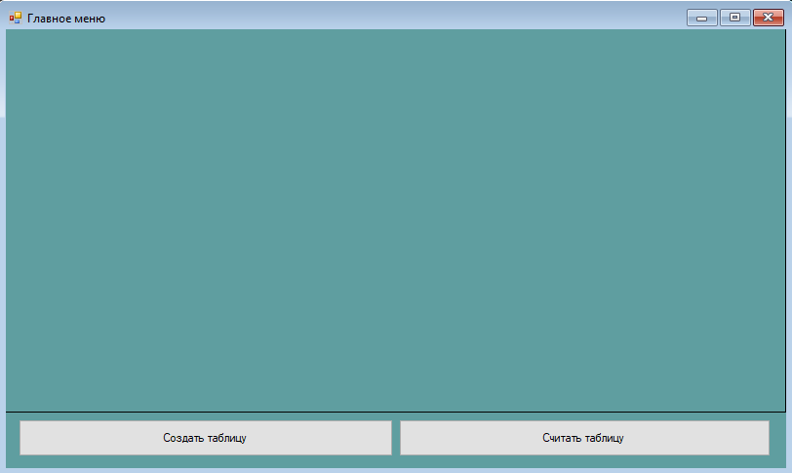

Рисунок 8 – Окно главного меню

## Расчёт тестовых примеров с использованием составленного программного обеспечения.

## 

Рисунок 9 – Результат первого тестового примера

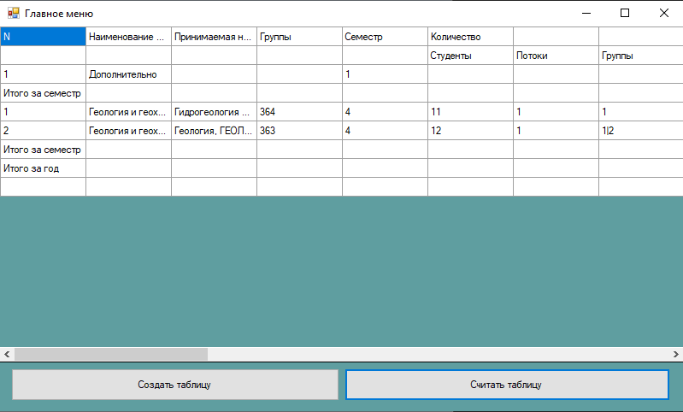

Рисунок 10 – Результат второго тестового примера

1. **Вывод по работе**

В текущей работе были освоены навыки подключения внешних модулей (библиотек классов) и использованы в разработанной программе.

В данной лабораторной работе были освоены следующие навыки:

* создание таблицы с заданным размером;
* заполнение таблицы данными;
* окрашивание диапазона ячеек в определенный цвет;
* окрашивание текста внутри ячейки в определенный цвет;
* объединение ячеек с помощью кода;