Digital image processing: using a computer to change the nature of a digital image

Chap 1 Introduction
§ What is image processing: (M§1.2)
Changing the nature of an image in order to:
1. improve it for human interpretation
2. make it more suitable for machine perception
Humans like images to be sharp, clear, detailed. Machines prefer images to be simple.
Examples of Purpose1:
1. enhancing the edges of an image. An example is shown in Fig.1.1.
2. removing the noise from an image. An example is given in Fig.1.2.Noise may take different forms, each type of noise requires different method.
3. removing motion blur from an image. An example is given in Fig.1.3.
Examples of Purpose1:
Examples of Purpose2:
1. obtaining edges of an image. An example is in Fig.1.4. We can also use edge-detection as a first step to enhance image.
2. removing detail from an image. For counting purpose, we are not interested in detail of an image.
M§1.3 Image aequition and sampling
Sampling should obey the sampling theorem:
a continuous function can be reconstructed from its samples if f_{s}≧2w.(Nyquist criterion.)
Sampling a continuous image(continuous function of 2 variable) requires that we consider the Nyquist criterion.(to produce digital images.)
Examples of correct sampling and undersampling are in Fig.1.8.(Fig.1.8(b) has aliasing.)
M§1.4 Images and digital images
We can consider the gray-level image as being a 2-D function, where function values f(x,y) are brightness(Fig.1.13). f(x,y) can be real-valued, e.g., from 0(white) to 1 (black). The concept of an image as a function is very important.
A digital image differ from a continuous image in that x, y, f(x,y) are all discrete.
For example, in Fig.1.13, 1≦x, y≦256, 0≦f(x,y) ≦255, x, y, f(x,y)Z.
A digital image can be seen as a large array of sampled points from a continuous image. Each point of a digital image is a pixel. Pixels surrounding a given pixel constitute its neighborhood. For example, 3╳3 or 5╳7 neighborhood. (Fig.1.15)
M§1.5 Applications:
1. Medicine: medical image
2. Agriculture: distinguishing good products from bad.
3. Industry: Automatic inspection on a production line.
4. Law enforcement: Fingerprint analysis.
M§1.6 Aspects of image processing
Image-processing algorithm subclasses:
1. Image enhancement: making an image look better
sharpeing an out-of-foucus image
highlighting edges
improving image contrast
removing noise
2. Image restoration: Restore an image from a damage by a known cause, for example, blur caused by linear motion
removing periodic interference
removing optical distortion
3. Image segmentation
finding face in an image
identifying cars in in an image
A given DIP algorithm may be used for both image enhancement or restoration.
M§1.8 Types of digital image
- Binary: Each pixel is just black or white(halftone image)
for example: text, fingerprint
2. Grayscale: Pixel values are from 0(black) to 255(white),which can be represented by 8 bits.( Fig.1.17)
3. True color or red-green-blue(RGB):
Each pixel has RGB values (3╳8=24 bits)
Such an image can be considered as a stack of 3 matrices. ( Fig.1.18)
512╳512 color image:
3╳512╳512╳8 bits0.786 Mb
512╳512 gray image:
512╳512╳8 bits=512╳512 bytes=262144 bytes=0.262 Mb
Video: 30 frame/sec
M§1.10 human image perception
Much of image processing is to make an image better to human being (human visual system).
1. Observed intensities vary as to background. A block of gray will appear darker if placed on a white background. ( Fig.1.20)
2. Visual system tends to undershoot or overshoot around the boundaries.
3. Fig.1.21: continuously varying intensity, but seen as it has edges.
§Important image processing journals:
IEEE Trans. on Image Processing
IEEE Trans. on Circuits and Systems for video technology
IEEE Trans. on Pattern analysis and Machine Intellegence
IEEE Signal Processing Magazine
IET Journal in Image Processing
International Journal of Computer Vision
Pattern Recognition Journal / Letters Signal Processing / Image communication
IEEE International Conference on Image Processing
IEEE Trans. on Multimedia

Chapter 2 Images and Matlab
Digital images can be seen as matrices whose element values are the pixel values.
M§2.1 Grayscale images
>> w=imread(‘wombats.tif’);
imread function reads an image file and return a matrix of all the pixel values.
>> figure:imshow(w):pixval on
(display w as a grayscale image) (Fig.2.1)
M§2.2 RGB images
There are different methods to describe colors, but a standard model is RGB. (Fig.2.2)
RGB is not good to describe colors. There are colors not possible with RGB because they require negative values of RGB.
>> a=imread(‘autumn.tif’);
>> figure:imshow(a):pixval on
>>size(a);
Then a is a 3-dimensional matrix.(multidimensional array)
M§2.4 Data types and conversion
>> w=imread(‘wombats.tif’);
Data type of w is unit8.
>>x=double(w);
Then x is of data type double.(可做運算)
>>imwrite(x);
Write x to a file.
詳例:
>>imwrite(x,map,’filename’,’fmt’)
%write the image x to file ‘filename’ with format ‘fmt’.
For human vision, we like images to be sharp and detailed, which depend on quantization and spatial resolution.

Chapter 3 Image display
M§3.3 Imshow function: c=imread(‘caribou.tif’);
>>cd=double(c);
>>figure,imshow(cd)
because cd is of type double, imshow display 0 as black and 1 as white.
( Fig.3.1, Fig.3.2)
M§3.5 Spatial resolution
(Fig.3.5~Fig.3.7)
Effect of increasing blockiness and pixelization because more serious as resolution decreases.
M§3.6 Quantization and dithering
Quantization is the number of grayscales used to represent an image. Sometimes, we need to represent images with fewer gray scales. This can be done by the uniform quantization (Fig.3.8),
For example,
original value output value
0~63 0
64~127 1
128~191 2
192~255 3
(can be done using floor((x)/64) )
One consequence of uniform quantization false contour, which occur when jumps between consecntive grayscales become larger. (Fig.3.11)
Dithering: Newspaper has only 2 scales of gray(black or white). Images with only 2 tones are halftone image(halftoning). One method of dealing with false contour is adding random values before quantization. That is, for quantization to two grayscales we compare the image to a random matrix.
One standard matrix is:
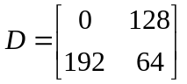
which is repeated until it is as big as the image matrix. Let d(i,j) be the matrix obtained by repeating D. The output pixel is
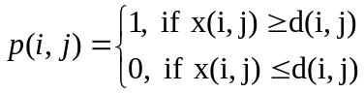
This approach to quantization is dithering.
The matrix D is an example of a dithering matrix.
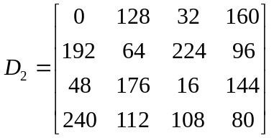
Fig.3.14 are the results.

Error diffusion: A different approach of halftoning. Error diffusion takes into account the error. The idea is to spread out the error over neighboring pixels.
Floyd-Steinberg error diffusion
- 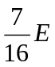
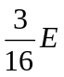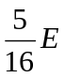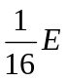
Its algorithm is in page 59. Fig.3.17 is the result.
1. Perform quantization.
2. Calculate the error.
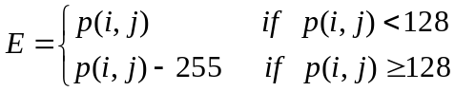
- Diffuse the error.
Other error diffusion schemes: (p.61)
1. Javis-Judic-Ninke
2. Stuki

M§ Chapter 4 Point Processing
M§4.1 Introduction
Image-processing operation transforms gray values of pixels. Image processing operations can be divided into 3 classes based on the required information:
- Transforms
Image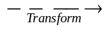Transformed image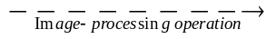Processed transformed image

Processed original image 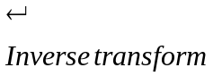
- Neighborhood processing
例如: 用平均值(周圍9點)，取代該pixel value.
- Point operations: A pixel’s gray value is changed according to only its original value. Although point operations are simplest, they are widely used.
M§4.2 Arithmetic Operations:
These operations act by applying a function
y=f(x)
to each pixel in the image. Simple examples are adding, substracting or multiplying a constant: y=xc
y=cx
We have to adjust the output to ensure
0≦f(x) ≦255.
Fig. 4.2 are examples of adding and substracting.
Adding will lighten the image, substracting will darken.
Fig. 4.3 are the resulting image of adding and substracting.
We can also do lightening or darkening by multiplication.
1. Fig. 4.4 are example functions.
2. Fig. 4.5 are example images after multiplication.
觀察:
1. b2 and b3 are both darkening; but b2 loses information.
2. Similarly, b1, b2, b5 are all lightening; but b1, b4 loses information.

Complements: The complement of the images is photographic negative.
Fig. 4.6 is an example of complement: y=255-x.
Complementing part of an image:
Fig. 4.7 includes solarization. (電腦homework)
Computer homework: (solarization)
Do point processing of an image by Fig. 4.7(both figures) (Input image: Lena)
M§4.3 Histogram
Histogram is a graph indicating the number of times each gray level occurs in each image. Histogram can deduce the appearance of an image, for example,
1. In a dark image, gray levels cluster at lower end.
2. In a bright image, gray levels cluster at upper end.
3. In well-contrasted images, gray levels well spread out.
Fig. 4.8 shows an example. In this image, gray levels cluster at center values. It is poor- contrasted.
Given a poorly contrasted image, we can enhance its contrast by spreading out the histogram.
M§4.3.1 Histogram stretching
Assume an image has histogram in Fig. 4.9. Number 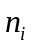of gray levels are in page 72. We can stretch out its histogram by applying a piecewise linear function in Fig. 4.9.
i 5 6 7 8 9
j 2 5 8 11 14
Then contrast of output image improves.
Fig. 4.11 shows effects of a gamma value:
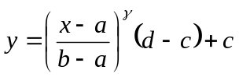
必通過(a,c), (b,d)兩點。
where gamma=1: linear
gamma>1: concave upward
gamma<1: concave downward
Fig. 4.12 is an example with =0.5<1.
M§4.3.2 Histogram equalization
Histogram equalization improves the histogram stretching method. The idea is to change the histogram to one that is uniform. Histogram equalization is important since it provides good results, i.e., good contrasted output image.
Method of histogram equalization:
1. Assume we have gray levels 0,1,2,…,(L-1) in our image.
2. Gray level i occurs times in the image.
3. 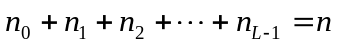 (total pixels)
4. Gray level i 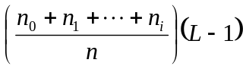.
Example: (page 78) (histogram equalization algorithm)
Example: 1. Fig. 4.19 (Output image contrast greatly increased)
2.Fig. 4.20 (before histogram equalization)
Fig. 4.21 (after histogram equalization)
Why histogram equalization works:
(Consider the continuous image case)
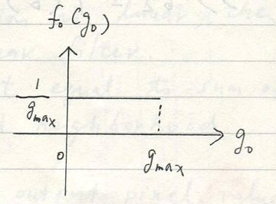
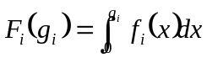
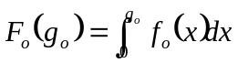
Then 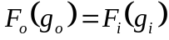
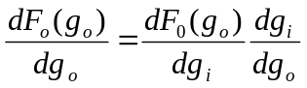
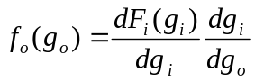
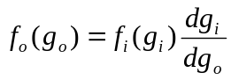
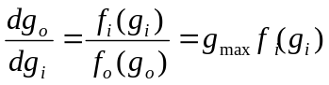
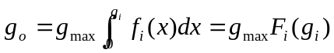
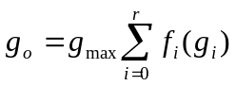
M§4.4 Lookup tables
Point operations can be done by using lookup tables(LUT). With LUT, point operations can be done by replacing pixel p by t_{p} in the LUT.
Example: LUT for y=x/2
p: 0 1 2 3…250 251 252… 255
t_{p:} 0 0 1 1…125 125 126…127
A matlab example:
>> T=floor((0:255)/2)
>>b₂=T(b); %b is the input image.
M§ Chapter 5 Neighborhood Processing
M§5.1 Introduction
Neighborhood processing is a extension of point processing, where a function is applied to neighborhood of each pixel to produce its output.
(Fig. 5.1) The idea is to move a mask (rectangular), (usually with sizes of odd length) or other shape over the given image:
New pixel value=functions of old pixel values in the mask
The combination of mask and function is called a filter. If the function is linear, then the filter is called a linear filter. A linear filter has output equal to sum of products of mask elements and neighborhood elements.
[Example] (page 88) The output pixel value is
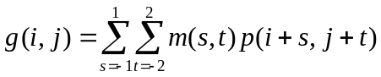
(see also Fig.5.2)
(page 89) Three steps of spatial filtering:
1. Position the mask over the current pixel.
2. Form product of mask and neighborhood elements.
3. Add the products. Repeat for every pixel in the image.
Spatial filtering is equivalent to spatial convolution (2D convolution):
Most filters are rotationally symmetric, so
m(-s,-t)=m(s,t)
For the previous example,
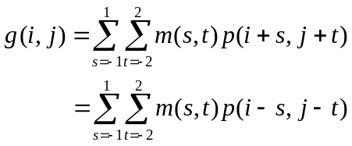
(2D convolution of m and p)
Example: (averaging filter)
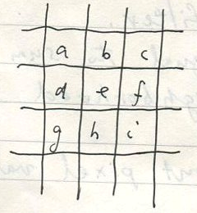
output pixel value 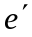:
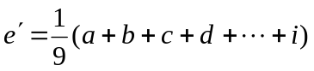
M§5.2 Notation
A linear filter can be simply described as a matrix. For example, the averaging filter can be described by
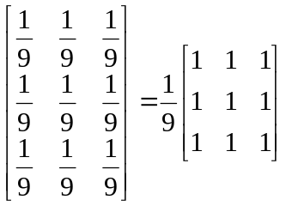
Another example: The filter
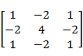
Has output image pixel as
a | b | c
d | e | f
g | h | i
e’ = a-2b+c-2d+4e-2f+g-2h+i

∫5.2.1 : Edegs of the image
There in an obvious problem for filtering:
How to deal with the problem where the mask falls outside the image.(Fig. 5.3)
- Ignore the edges: Then the output image is smaller than the input image.
- Pad with zeors: The output image is of the same size as the original, but may introduce artifacts(dark edges)

∫5.3 : Filtering in matlab:
Filter 2 (filter, image, ‘same’)
Output image size is the same as the input image. (by using zero padding)

An example of averaging filter:
(Fig. 5.4)
- The averaging filter blurs the image.
- The zero padding method results in dark edges of output images.
- The output omages are bad for human vision,but might be good for machine processing.

∫5.3.1: Separable filters
Some 2-D filters can be implemented by successive applications of 2 1-D filter.
For example,

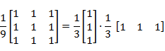

The 3x3 averaging filter can be implemented by first a 3x1 averaging filter and then 1x3 averaging filter. Separablility results in great time savings:
- nxn filter: 乘法, ()加法
- nx1 filter and 1xn filter: 2x(n乘法, (n-1)加法)
Another example: The Lapacian
= 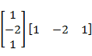.

∫5.4 Frequencies : Low- and High-Pass Filters
- filter 之作用
- how to choose a filter for image-processing
One important notion to answer the above problems in frequencies.
＊frequencies: a measure of the amount by which gray levels change with distance.
(detailed in Chapter 7)
- High-freq. components: large changes in gray levels. (eg: edges,noise)
- Low –frequency components: little changes in gray levels. (eg: background, skin)

Filters:
- High-pass filter: pass high-frequency and reduce low-frequency.
- Low-pass filter: pass low-frequency and reduce high-frequency.

For example, averaging filter is low-pass, because it blurs edges. The filter
Is high-pass for the following reason: (page 98)
- Its sum is zero.
- An image with similar gray values: output tends to 0.

High-pass filters are of particular values in edge detection and edge enhancement.
The result of laplacian filter to an image is shown in Fig. 5.5(a), LOG filter to an image is in Fig5.5(b).

Handle values outside the range 0-255:
- Make negation values positive:
For images with only a few negatives and they are lose to 0.
- Clip values:
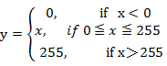
Not suitable for images with pixel values outside 0-255.
- Scaling transformation:
Transform filter output ranges ~ to the range 0~255 by linear transformation (page 100).

∫5.5 Gaussian filters:
Gaussian filters are a class of low-pass filters based on the Gaussian pdf:
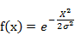
where is the standard deviation(fig 5.7).
Gaussian filters are important because:
- FT of a Gaussian filter is another Gaussian.
- They are rotationally symmetric.
- They are separable.
- Convolution of Gaussian is Gaussian.
2-D Gaussian:
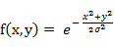
Gaussian filters have blurring effect similar to averageing filters.
Examples of images after Gaussian filters: (Fig.5.9)
↑ => blurring effect ↑
=∞ => averaging filter

∫5.6 Edge sharpening
Spatial filtering can be used to make edges in an image sharper: called edge enhancement, edge crispening, unsharp masking

∫5.6.1 Unsharp masking:
Unsharp masking = original image – k‧(unsharp version of original)
With k < 1. (Fig.5.10)
Fig.5.11 shows an example with k =

Why unsharp masking works: Fig.5.12:
Because a scaled blur is substracted.

In fact, unsharp masking can be implemented by only one filter of the form:

f = 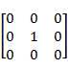 – 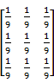
Fig.5.13 is output image of the following unsharpmasking filter:

4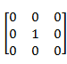 – 3

∫5.6.2 High-Boost filtering
High boost = A(original) – (low-pass)
Where A>1. If A=1, the high-boost filter is the ordinary high-pass filter.
For example :
A – 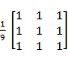 = 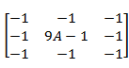
Where 9A-1>8.

Alternative forms of high-boost filters:
- High-boost = A‧original – lowpass
= A‧original – ( 1 – high pass)
= (A-1)‧original + high pass
- w(A-1)=1
w =
high-boost = ‧original – lowpass
- Another version:
‧original – lowpass
With ≦A≦ ( ≦1-A≦ , ≧ )
If A= , this formula becomes
3‧original - 2‧lowpass
(result in Fig.5.14(a))
↖ with sharper edge than the original

∫5.7 Nonlinear filters:
A nonlinear filter is obtained by a nonlinear function of grayscale values in the mask.
Examples include:
- Maximum filter: Its output is max. value in the mask.
- Minimum filter: Output is min. value in the mask

Rank-order filter: Elements under the mask is first ordered, then a particular value is outputted.
Fig5.15: max. and min. filter examples. The output images lose sharpness and are brightened or darkened.
A very important rank-order filter is the median filter, which takes central value of the ordered list. Example:
Ordfilt2 ( c, 5, ones(3,3) )
Other nonlinear filters: (useful for image restoration, Chap 8)
- Geometric mean filter:

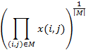
Where M: the filter mask
|M|: mask size
- Alpha-trimmed mean filter:
For example： a. 3x3 mask
b. ≦≦≦…≦
c. the output pixel value:
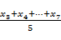 (頭尾各2個不要)
∫5.8 Region of interest(ROI) processing

We may not want to apply a filter to the entire image, but only a small region within it. Reason:
- Computationally expensive. (To save computations)
- Only interested in a small region.
That small region is called region of interest(ROI). Their processing called ROI processiong.
Examples are in Fig.5.18
Chap 7 The fourier transform
∫7.1 Inroductions:
Fourier transform is important because:
- It allows us to perform tasks that other way can not do.
- It is more efficient than spatial filtering.
- Fourier transform allows us to do image processing in frequency domain.
(high-pass or low-pass filterings)

∫7.2 Background
A periodic function can be written as the sum of sines and cosines of different amplitudes and frequencies.
An example: A square wave can be decomposed as (Fig.7.2).
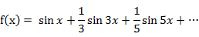

Computer exercise: 畫出 1,2,3,5,7,9項之f(x)
(11,13,15)

The fourier series: If f(x) is a function of period 2T, then its FS is
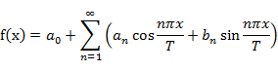
where ＝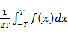
＝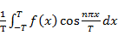 , n=1,2,3…
＝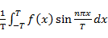 , n=1,2,3…
Complex form of FS:
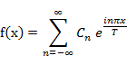
where ＝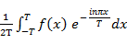

If f(x) is nonperiodic, we have the Fourier transform: (與課本不同)
＝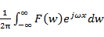
＝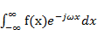
（FT pari）

∫7.3 The 1-D Discrete Fourier Transform
∫7.3.1 Definiton of the 1-D DFT:
Let ,
Be a sequence of length N. We define its DFT to be the sequence:
Where 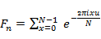
The above equation is similar to that of the Fourier series. This definition can be expressed as a matrix multiplication.
Where F is an NxN matrix given by
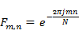 ,0≦m,n≦N-1
F is called the DFT matrix. As an example, the 3x3 DFT matrix is
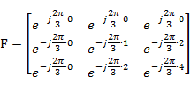
If we define 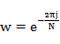
Then the NxN DFT matrix is
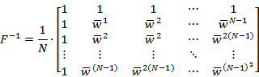
Where 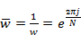
In matlab, we can calculate the forward DFT with fft. There fft stands for fast Fourier transform, which is a fast method to compute DFT.
Example: fft(a’) % a’: a column vector

∫7.4 Properties of 1-D DFT:
Linearity: If with p,q scalars and ,
Then

Shifting:
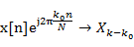
pf: 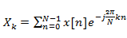
then 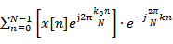
＝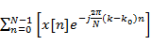
＝
Thus,
Let 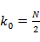 , then
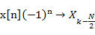

Conjugate symmetry: If x is real and of length N, then its DFT X satisfies
Where is complex conjugate of .
For example, in the example of page 150 with N=8, we have
= ,= ,= ,= ( is real).

Convolution:
Let x and y are vectors of length N.
Their circular convolution is :
where
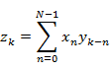
For example, if N=4,

It can be shown that

[Example]
Then
- Compute
- Compute

- Compute
- Compute

Second method to compute circular convolution:
- Elements of x are coefficients of p(u).
Elements of y are coefficients of q(u).
- Form the products
③ Coefficients of to ② are

Circular convolution theorem:
Let x,y be vectors of length N.
If
and 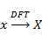
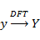
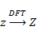
Then ( element by element multiplication of X and Y)

The second method to compute : (more efficient)
1. Compute
2. Compute
3.
4. with IDFT being the inverse DFT.

Because there is FFT (fast algorithm to compute DFT,FFT is fast Fourier transform),
The above method to compute z is much more efficient.

Computation complexity of FFT is , while direct computation of DFT requires computations.
(Comparisons are in Table 7.1)

∫7.5 2-D DFT:
Input and output of 2-D DFT are both matrices. Let
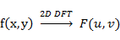
We can also write , or (F and f are matrices of the same size)
Definition of 2-D DFT:
The forward and inverse transforms of an MxN matrix, where x indices from 0 to M-1 and y indices from 0 to N-1, are
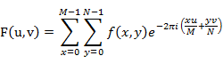

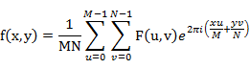

∫7.5.1 Properties of 2-D DFT
Similarity: Forward and inverse transforms are very similar. Thus, the forward algorithm for DFT can be used for both the forward and inverse transforms. Because
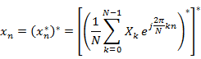
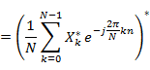
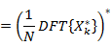

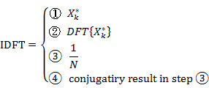

Separability: The 2-D Fourier transform is separable becomes
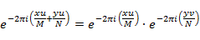
Then the 2-D DFT can be calculated by:
1. First calculate DFT of all rows.
2. then calculate DFT of all columns.

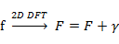
where : the DFT matrix
Linearity:
Let f → F
g → G
Them:
f + g → F+G
kf → kF
This property can be used to remove noise:
Let:
d = f+n
D = F+N
If we can remove N from D in the transform domain, f can be recovered.

Convolution theorem:
Digital convolution (spatial filtering) of an image M with a spatial filter S:
MS
If S is large , computing MS in the spatial domain is very slow. Instead, we can compute MS as follows:

- Obtain S’ by zero padding S. ( S’ is the same size as M)
- From DFT of M and S’ (denoted by F(M) and F(S’ ))
- From element-by-element product
F(M).F(S’)
- MS= ( F(u). F(S’) ).

[Example] Convolve a 512x512 image with a 32x32 filter:
- Spatial domain: (512x512)．(32x32)
- 512 point FFT : 4608 multiplications
3(4608x512x2)+512x512
=14417920 multiplications
(using convolution theorem and 3 2-D FFTs)
The DC coefficient: F(0,0) Iin the DC coefficient:
From (7.4),
F(0,0)==

Conjngate symmetry:
F(u.v)=F(-u+PM, -v+gN)
Z

Displaying transforms:
Let f(x,y)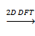 F(u,v).
Them F(u,v) are complex functions.
Since |F(0,0)| in much larger then all other |F(u,v)|, we can not
view |F(u,v)| directing . Instead , we display spectrum of the Fourier.
Transform by showing
Log(1+|F(u,v)|)

7.6 Fourier transforms in Matlab:
fft: 1-D DFT
ifft: 1-D inverse DFT
fft2: 2-D DFT
ifft2 2-D inverse DFT
fftshift: shifts a transform as in fig 7.7
7.7 Fourier transforms of images:
Example 7.7.1: 2-D DFT of a single edge (Fig 7.10)
Example 7.7.2: 2-D DFT of circle (Fig 7.11)
Example 7.7.4: 2-D DFT of a circle (Fig 7.13)

(Because of sharp cutoff of the circle, ringing in the Fourier transform results. )

7.8. Filtering in the frequency domain:
7.8.1 Ideal filtering
Low-pass filtering:
Suppose we have a 2-D DFT matrix F shifted so that DC is in center. We can peform
low-pass filtering by multiplying it using an ideal low-pass matrix, which is
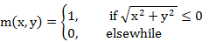

(An example shown in fig 7.13) (with D = 15)
Them the filtered output is :

An image and output of its ideal low-pass filtering are shown in Figs 7.14 and 7.15.
Ringing in Fig.7.15(b) is caused by sharp cutoff of the filter.

- If D => more blurred.
- If D => less blurred. (Fig. 7.16)

High-pass filtering.

High-pass filtering eliminates center values of the DFT and keeps the others.
(Figs. 7.17 7.18)
(If cutoff => edge )
(If cutoff => edge )

7.8.2 Butterworth filtering
Ideal filtering has the disadvantage of introducing
Unwanted artifacts(ringing) to the result We can use a filter with less sharp cutoff to avoid these artifacts. One such choice in the Butterworth filter
Fig 7.19 Ideal LPF and HPF functions
Fig 7.20 Butterworth filter n=2
Fig 7.21 Butterworth filter n=4 (n)

Butterworth filter functions:
LPF : f(x)= 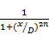

HPF: f(x)= 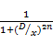

Where n is called order of the filter.
Fig 7.24 Butterworth LPF results (Ringing is absent).

Fig 7.25 Butterworth HPF results.

7.8.3 Gaussian filtering:
Gaussian filters are the smoothest of all filters. (ideal filter and Bufferworth are least and middle)
Fig 7.26Gaussian LPF results.

Fig7.24 Gaussian HPF results.

Chapter 8. Image restoration
8.1 Introduction:
Image restoration removes or reduces degradations that occur in acquisition of the image.

Such degradations include:
- noise.
- Out-of-focus blurring.
- Blurring due to camera motion

Restoration techniques:

- Neighborhood techniques.
- Frequency domain processing.

8.11
A model of image degradation
Degraded image can be modeled as:
(with n(x,y) the additive noise)

g(x,y)=f(x,y) h(x,y)+n(x,y) (8.1)

An example:
if h(x,y) consists a single line of ones , result of f(x,y) h(x,y) is
A motion blur in the direction of the line.

Frequency domain representation of (8.1):

G(i , j)= F( x , y )H( x , y )+N( i , j )

Thus , if we know H and N ,F can be recovered by
F( i , j ) = 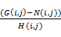 (8.2)

Problems of the approach (8.2):
- N( I , j ) in unknown.
- H( I , j ) may have values close to 0.
8.2 Noise

Usually we know the type of noise on the image, hence we can choose suitable method to reduce it.
Some standard noise forms and their restoration methods will be discussed.

8.2.1 Salt and pepper noise:

Also called impulse noise, shot noise or binary noise. 9t’s randomly scattered white or black pixels over the image.
Salt and pepper noise generation by Matlab:

Imnoise (input_image, ‘salt & pepper ’,0.1);
% add 10% noise (default)

Example: Fig 8.1.

8.2.2 Gaussian noise

White Gaussian noise is white noise that is normally distributed. If image is I and
Gaussian noise is N , then an image with Gaussian noise is

I+N , (AWGN)
( Matlab command
Imnoise(input_image, Gaussian ) % defult mean and variance are 0 and 0.01
An example: Fig 8.2(a)

8.2.3 Speckle noise (multiplicative noise )
Speckle noises are random values multiplicative by pixel values. Hence= also called multiplicative noise. Speckle noise is a major problem in some radar applications

Matlab command: imnoise(input_image, ‘speckle’)
% implemented as I (1+N)
Where N : Gaussian with (u,) =(0,0.04).
An example : Fig 8.2(b)

8.2.4 Periodic noise
Effect of periodic noise is of ears over the image.
An example : Fig 8.3.
Salt and pepper noise , Gaussian , and speckle noise can all be cleaned by
Spatial filtering techniques. Periodic noise iequies the use of frequency domain filtering.

8.3 Cleaning salt and pepper noise:

8.3.1 Low-pass filtering:

Given that salt and pepper noise high-freq. component of an image, low-pass filter can reduce them. AS an example , we can use average filter to reduce them.
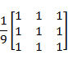
An example: Fig 8.4.
However , the desired image is blurred.

8.3.2 Median filtering:

Median filtering is powerful to remove salt and pepper noise. Median of a set in the middle value when values are sorted.
A median filter is a nonlinear spatial filter, the output value is the median of the values in the mask As example

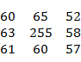 the current pixel 255 is replaced by 60 as the output pixel

Since noisy value (very large or small) is not the median , a noisy value will be replaced with one closer to its surroundings.
Matlab command: medfilt 2(inpur-image,[s1 s2])
%[s1 , s2] gives the size of the mask to be used

An example: Fig 8.5.

more salt and pepper noise: (Fig. 8.6 )

- To remove noise completely, we can try a
Second application of 3x3 median filter. ( Fig 8.7(a))

or2. Apply a 5x5 median filter on the original image. (Fig. 8.7(6))

8.3.3 Rank-order filtering
Median filtering is a special case of rank-order
Filtering. Rank-order filter takes the nth value instead of the median.

In matlab, rank-order filter allows us to choose median of nonrectangular mask.

A mask of a 3x3 cross shape is

The matlab command is
Ordfilt2(input-image,3,[0 10 ;111; 010]);
Another example is a 5x5 cross shape

8.3.4 An outliner method:

Applying median filtering is a slow operation:
Each pixel output needs sorting of at least nine values.
To overcome this problem, cleaning salt and pepper noise by treating noisy pixels as outliers is proposed . Outliers are pixels a significantly different from their neighbors.
The outlier method is :
- choose a threshold D.
- Compare a given pixel p with mean m of it’s eight neighborhood.
- If |p-m|>D, the given pixel is noisy.
- Replace p with in if it’s noisy. Otherwise lease it unchanged.
Mean of a pixel’s eight neighborhood can be generated by the spatial filter:

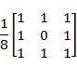

For outlier method, the threshold D must be chosen. Fig8.9 are results of the
Outlier method.

- If D is too small, non-noisy pixels will be classified as noisy and their values
Will be changed to average of neighbors blurring
- If D is too large , little changes will occur in the output.
DIP (Mc Andrew)

8.6 Inverse filtering

From convolution theorem.

Y(I,j)=x(I,j)F(I,j)

Where X, F , Y are DFTs of input , filter and output
If one is given Y and F them DFT of original image X can be recovered by

X(I , j )=

The result of an example is shown in Fig7.17. The trouble is that some elements of the filter are very small. The problem is solved in two ways.

- Apply an LP filter to the division

X(i,j)= 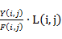 (low-pass filter)

- Use constrained division (let d be a threshold value)

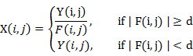

Fig.8.18 are results of the above first method with cutoff 40,60,80,and 100.

Fig8.19 are results of the above second method with various d.

8.6.1 Motion deblurring

The removal of blur caused by motion is a special case of inverse filtering.

Fig.8.20(a) is an original image.
Fig.8.20(b) is motion blur version of (a).
m=f special (‘motion’,7,0 );
bm=imfliter (b,m) % b.original

To deblur ,
m2= zeros(256,256);
m2(1,1:7)=m;
mf= fft2(m2);
bm=ifft2(fft2(bm)./mf)
fftshow(bmi.’abs’)

The result is show in fig 8.21.

( (a): straight division) (b): constrained division )

9.6 Edge detection:

Image edges are useful to

- measure size of objects
- isolate particular objects
- recognize objects

Matlab w??? and to find edges:
Edge(image, method , parameters)

An edge is loosely defined as local discontinuity in the pixel values that exceeds a threshold

9.7 Derivatives and edges

9.7.1 Fundamlntal definitions

Edges types :1.ramp edge (Fig 9.14)
- step edge (ideal edge)

Edges and derivatives are related : Profile function f(x) and it’s derivates f’(x) are ploted in Fig9.14~15 as examples (nonzero f’(x) corresponds to edges)

Since f’(x)=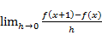 , discrete version of the derivative is:
- f(x+1)-f(x)
- 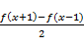
- f(x)- f(x-1)

For 2-D functions , an important expression is the gradient
[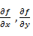]
Which points in the direction of greatest increase of f(x,y). Most edge –detection methods of f(x,y). Most edge-detection methods concerns with finding magnitude of the gradient and theme applying a threshold .

9.7.2 Some edge detection filters:
Using f(x+1)-f(x-1) for derivatives, leaving the scaling out, produced horizontal and vertical filters

[-1 0 1] (horizontal)
and 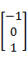 (vertical)

These filters can find vertical and horizontal edge. The resulting edges can be improve by smoothing I the opposite direction by using the filters

and [ 1 1 1]

These result the combined filters for finding vertical and horizontal edges

Px=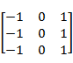 , Py=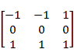

Which are called Prewitt filters for edge detection.

If Px and Py are outputs of Px and Py to any image them magnitude of the gradient is

Or max{|Px|, |Py|} or |Px|+|Py|.

For example ,
Fig 9.17 are outputs of Px and Py respectively (Px and Py produce vertical and horizontal edges)

Fig9.18
creats am image containing all the edges (Fig 9.18(a) gray image
Fig9.18(b) binary)

Matlab command : edge (input-image,’prewitt’) (Fig9.19)

Other edge-finding filters are

- Roberts cross-gradient filters

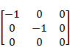 and 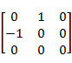

- The Sobel filters.

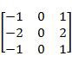 and 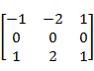

The Sobel filters are similar to Prewitt filters except that Sobel filters use smoothing of the form
[ 1 2 1 ]
Which gives more prominences to central pixel (Examples of Robert and Sobel filters are Fig 9.20)

Of the three filters, Sobel filters general are the best . They provide good edges and perform reasonably well in noise.

9.8: Second derivatives:
9.8.1: The Laplacian:
Another class of edge detection is considering the second derivatives is considering the second derivatives
The Laplacian is defined as
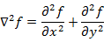

The discrete Laplacian can be implemented by

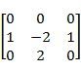+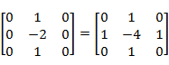

The Laplacian has an advantage over first derivative methods in that it’s an isotropic filter. That is, it is invariant under rotation.
However a major problem with all second derivative filters in that they are very sensitive to noise.

Fig9.21.Second derivatives of an edge

The Laplacian gives double edges (Fig 9.22)

Other Laplacian masks:

1.
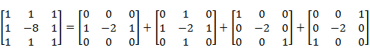
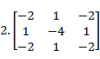(Sums of all edge-finding spatial filter coefficients are zero (HPF) )
- In Matlab , Laplacians of all sorts can be generated by

fspecial (‘laplacian‘,) % defaults to 0 which produces

