Recursion

Key note:

1. Find the relationship between current function and the next function.
2. Find the end condition.

Q1: If a frog can jump 1 step or 2 steps. How many possible ways the frog can jump X steps?

1. Relationship between each step: Assume we have n steps. Totally, there are f(n) possible ways to jump. Each time there are two possible: 1 step or 2 steps.

Case 1, if jump 1 step first, then we will have n-1 steps remaining which is f(n-1) possible ways.

Case 2, if jump 2 step first, then we will have n-2 steps remaining which is f(n-2) possible ways

Therefore: f(n) = f(n-1) +f(n-2)

1. End condition:

When n < 0. There are 0 possible ways to jump, so f(n) = 0 ***(Not count, since we limit n=1, so do not need to worry here.)

When n == 0. There are 0 possible ways to jump, so f(n) = 1 ***(This count, since it is a way to jump)

When n = 1. There are 1 possible way to jump, so f(n) = 1

public int recusion(int a) {  
 if(a <= 0){  
 return 1;  
 }  
 else if(a == 1){  
 return 1;  
 }  
 else{  
 return recusion(a - 1) + recusion(a-2);  
 }  
}

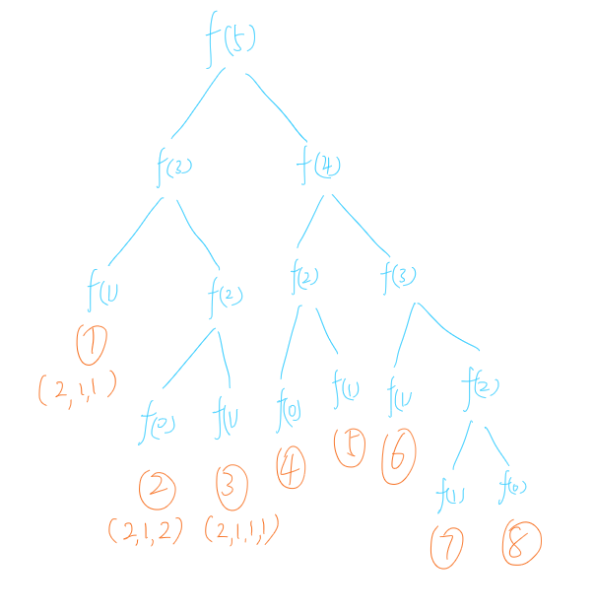

Improvement: The problem here is too many repeated calculations. Expensive!

----------------------------------------------------------------------------------------------------------------------------------------------------------------

Here we can use [**dynamic**](javascript:;) [**programming**](javascript:;)

Key note:

a) Save unique result in a map or other structure. Directly use without calculate again.

In this example, we can save f(4), f(3),f(2) when we first calculate. Therefore we can use anytime without do a repeat calculation.

Map<Integer, Integer> map = new HashMap<>();  
public int dynamic( int a ){  
 if(a <= 0){  
 return 1;  
 }  
 else if(a == 1){  
 return 1;  
 }  
 else{  
 if(map.containsKey(a)){  
 return map.get(a);  
 }  
 else{  
 int val = dynamic(a - 1) + dynamic(a-2);  
 map.put(a,val);  
 return val;  
 }  
 }  
  
}

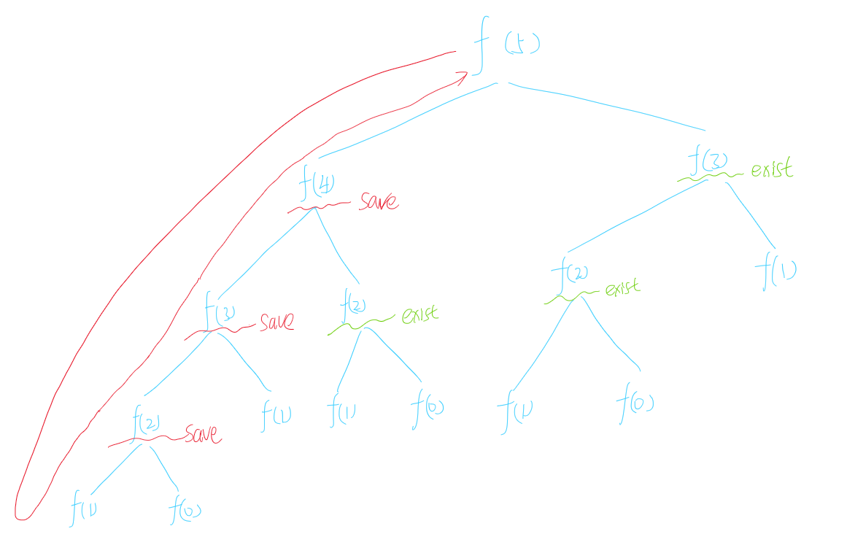

----------------------------------------------------------------------------------------------------------------------------------------------------------------

Q1: If a frog can jump 1 step, 2 steps, 3 steps ····· or X step each times. How many possible ways the frog can jump X steps?

Map<Integer, Integer> map = new HashMap<>();  
public int dynamic( int a ){  
 if(a <= 0){  
 return 1;  
 }  
 else if(a == 1){  
 return 1;  
 }  
 else{  
 if(map.containsKey(a)){  
 return map.get(a);  
 }  
 else{  
 int val = 0;  
 for(int i = 1 ;i<=a; i++){  
 val += dynamic(a - i);  
 }  
 map.put(a,val);  
 return val;  
 }  
 }  
  
}