* Home
* Products
* Cart
* Among Us
* Contact Us
* Terms & Conditions

### "Choose the better parts"

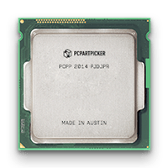Processor

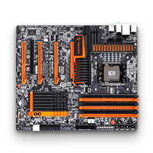Motherboard

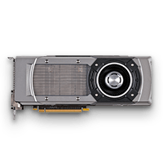Video Card

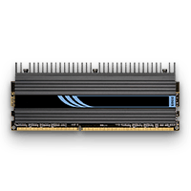Memory

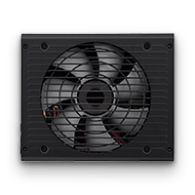Power Supply

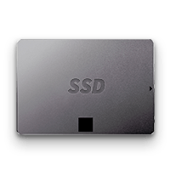Storage

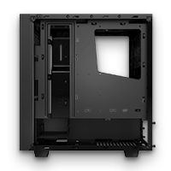Case

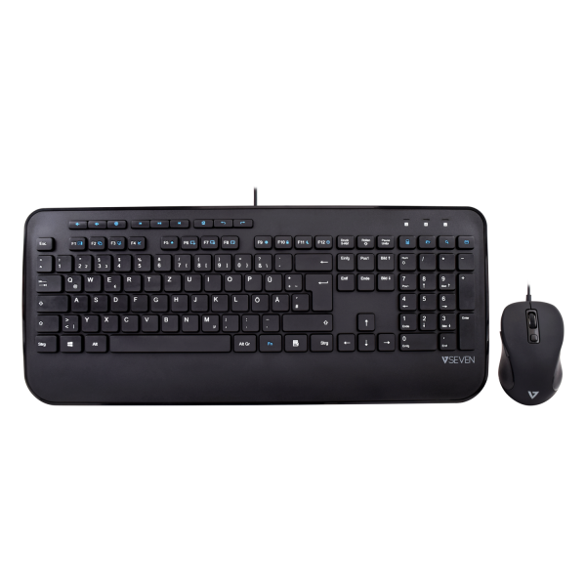Peripherals

## On Sale!

Work in progress...

Work in progress...

Work in progress...

## Best Sellers!

Work in progress...

Work in progress...

Work in progress...

Don Bosco Technical Institute of Makati

Grade 9 - Rinaldi (ICT1) (SY 2021-2022)

©2021 PC Component Department