All nodes in WSN have to communicate with each other securely by sharing authentication keys. In this paper author is proposing concept to generate authentication keys by using location(X and Y coordinates) of nodes. In current WSN three types of nodes will participates Sensor Node, Anchor Node, Cluster Head. All sensor nodes has to aggregate sense data and sent to closer cluster head by using hop by hop communication and then cluster head will transfer data to base station.

To transfer data securely first sensor node discovers all nodes in their ranges and request anchor node to send nonce values and by using that nonce value and their location sensor node will generate authentication keys and share those keys with each other in their ranges.

Using this keys node can detects any type of attack in the network.

Here in this I am simulating two scenarios one with attack and one with detecting that attack. In attack scenario nodes will drop all packets and in other scenario after detecting attack source will not send data.

Simulation screen

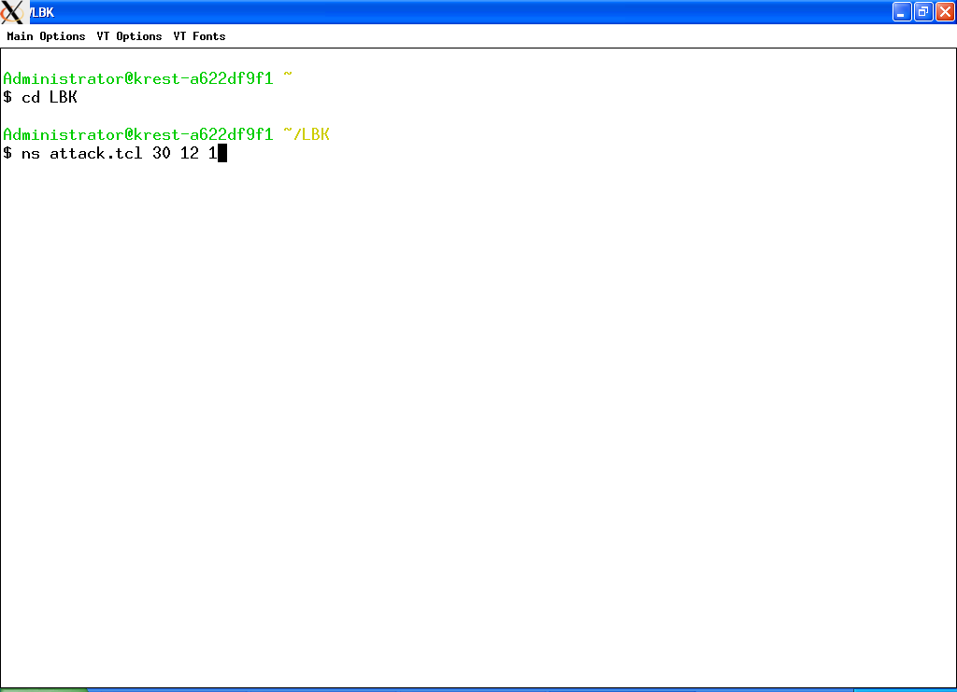

In above screen I am running attack file. In above command ‘attack.tcl’ is the simulation file ad 30 is total no of nodes and 12 is the sending sensor and 1 means it indicate simulation with attack

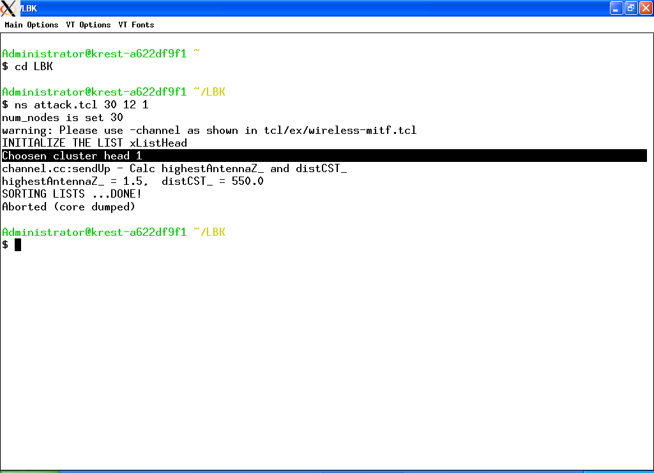

In above screen sending sensor choose cluster head1 to reach base station

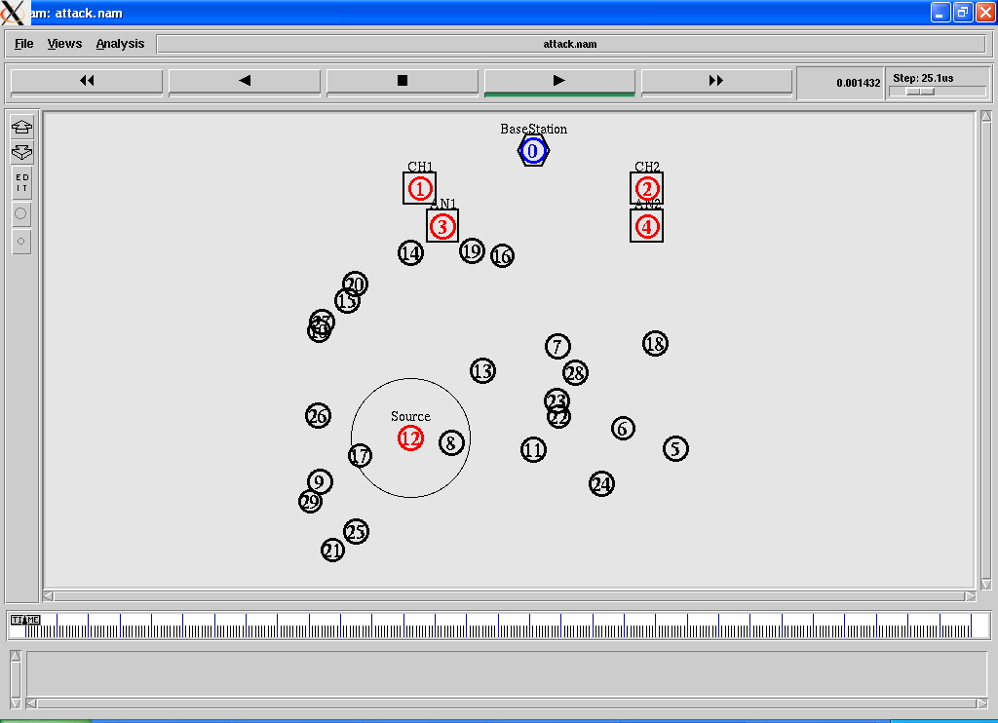

In above screen we can see sensing data starts from sending sensor 12

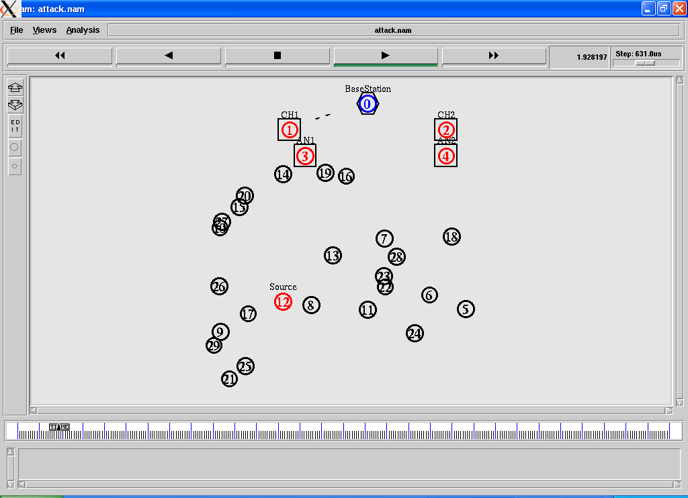

In above screen we can see small line transfer data from CH1 to base station. Now after seeing simulation we can see trace file where network activity recorded

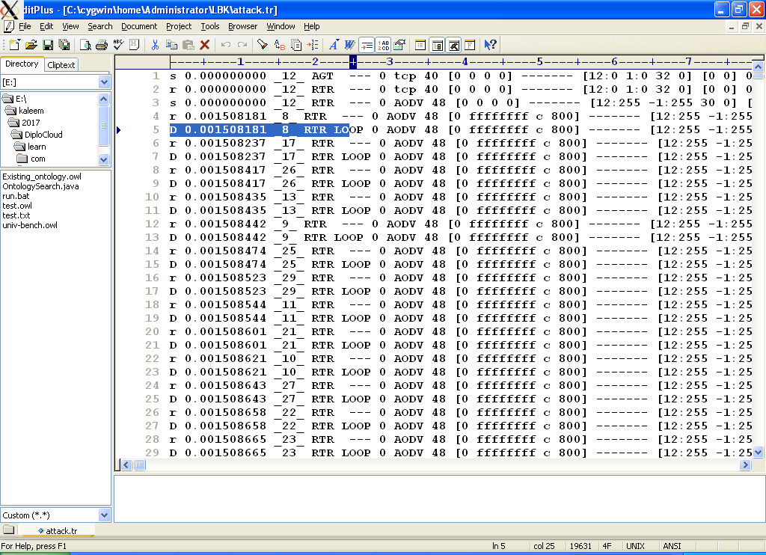

In above trace file we can see continuous drops indicate with alphabet ‘D’ and ‘S’ indicate send and ‘R’ indicate receive of packets.

Now we run detection techniques using authentication keys of LBK Location base

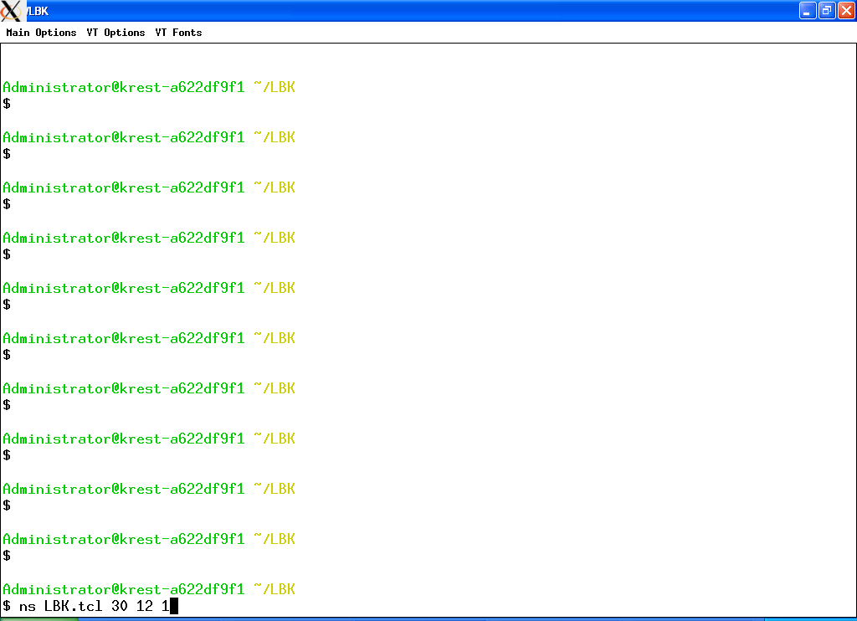

Here in above screen LBK.tcl is the simulation file and 30 total nodes and 12 is the sending sensor and 1 means attack

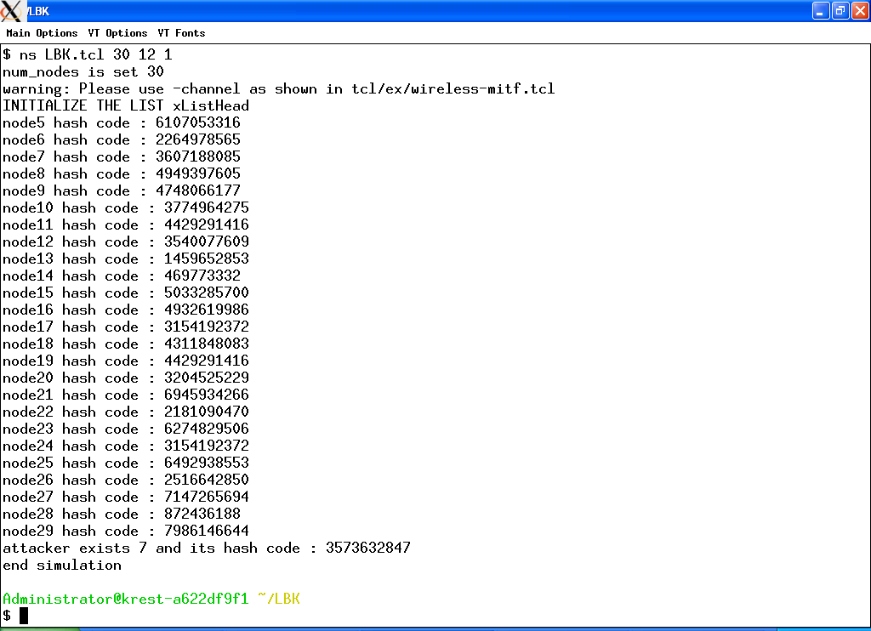

In above screen for all nodes hash code generated with locations. Node 7 becomes neighbor of 12 and its keys mismatch, base on that it consider as attacks

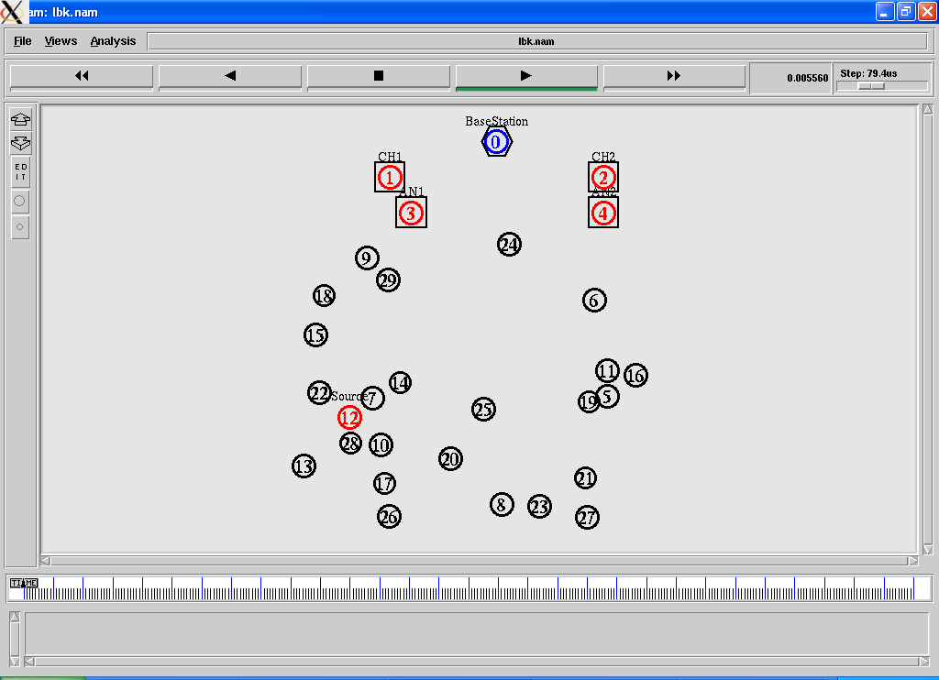

In above screen no activity occurs as source 12 detects attacks.

Now run without attacks

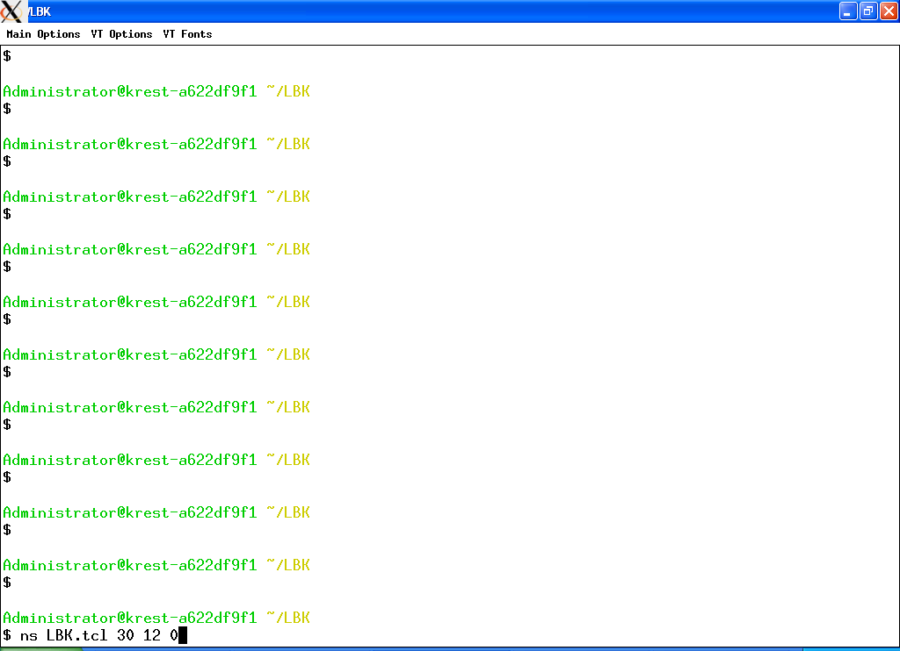

In above screen 0 means no attack

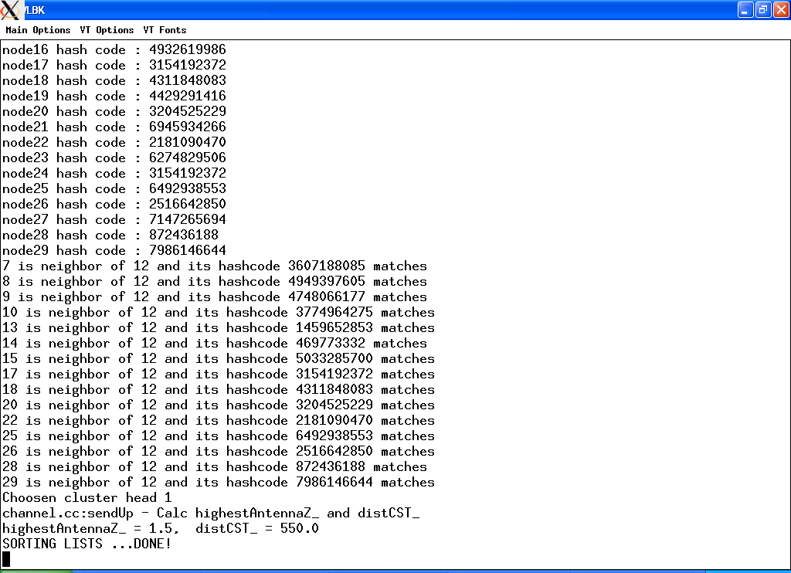

In above screen showing hashcode of all nodes and displaying neighbors of source 12

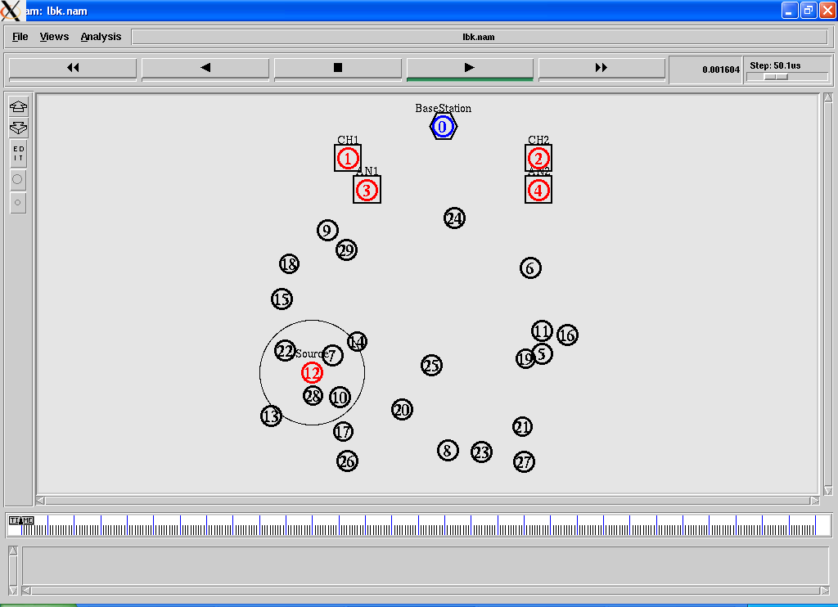

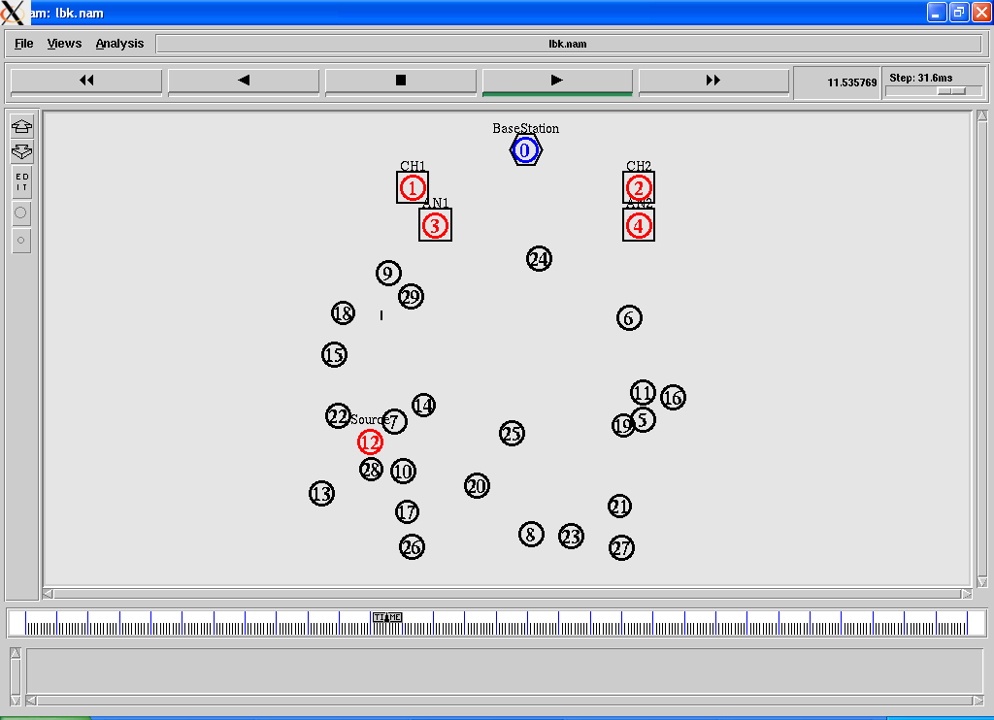

U can see small line going from 12 to 9 which shows data transfer. Here in this simulation trace file we will not find any drops

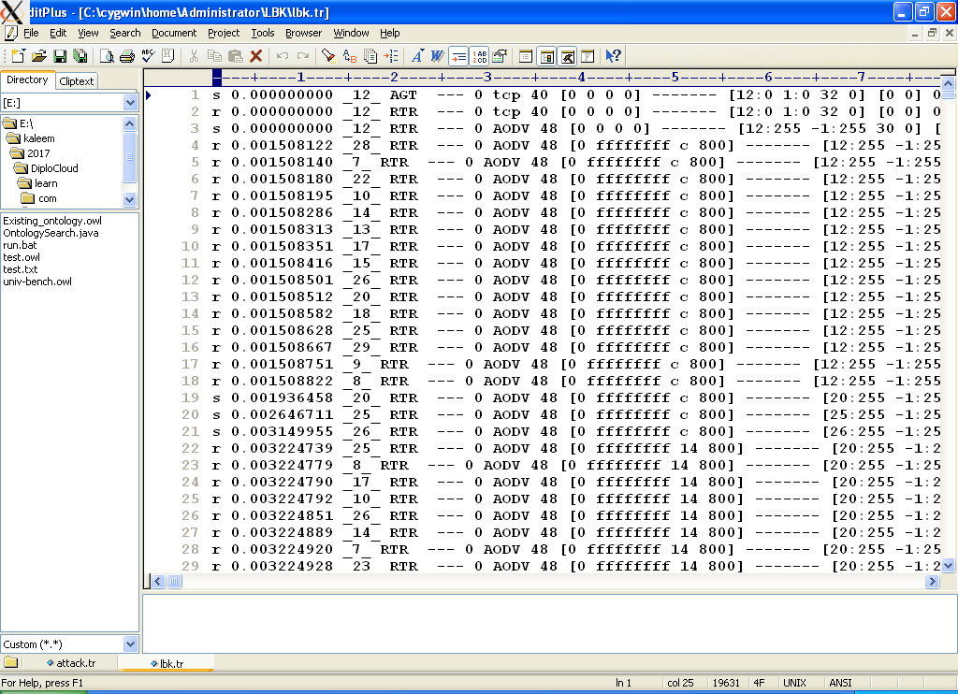

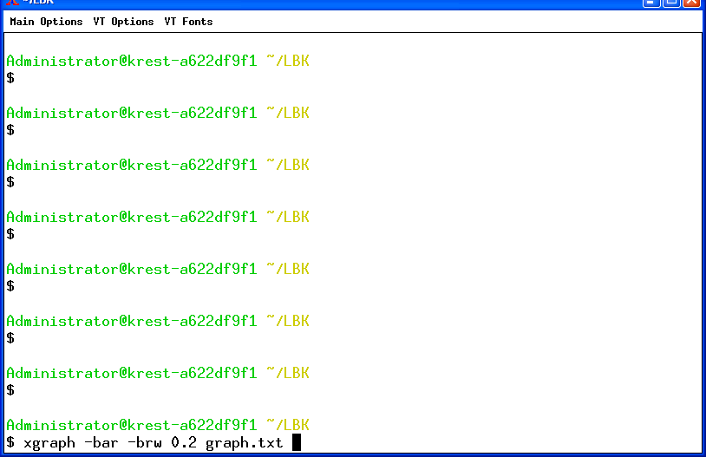

Using above command we are showing graphs which display total no of neighbors found for each sensor

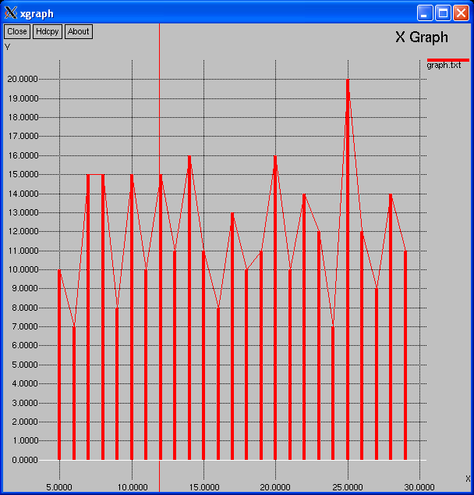

X axis showing node name of each sensor from 1 to 30 and y axis showing neighbor count of each node