Bluestock Mutual Fund Analytics Capstone
Executive Summary
The Bluestock Mutual Fund Analytics Capstone project was developed to analyse mutual fund industry trends, fund performance, investor behaviour, and SIP growth patterns using real-world financial datasets. The project integrates data engineering, analytics, and business intelligence techniques to create a comprehensive analytics platform for mutual fund insights.
The solution follows a complete ETL pipeline that extracts raw mutual fund datasets, transforms and cleans the data using Python, and loads the processed information into a structured SQLite database. Multiple analytical workflows were implemented to evaluate industry growth, fund performance, investor participation, risk-adjusted returns, and market trends.
Exploratory Data Analysis (EDA) was performed to identify key patterns in Assets Under Management (AUM), investor folios, SIP inflows, category-wise fund performance, and investor demographics. Advanced analytics techniques such as Value at Risk (VaR), Conditional Value at Risk (CVaR), Rolling Sharpe Ratio, SIP continuity analysis, investor cohort analysis, and portfolio concentration analysis using the Herfindahl-Hirschman Index (HHI) were also implemented.
Interactive dashboards were developed in Power BI to visualize industry performance, fund metrics, investor analytics, and SIP trends. The dashboards enable stakeholders to explore market behaviour, compare fund categories, monitor risk metrics, and identify investment opportunities through intuitive visualizations.
The project successfully demonstrates end-to-end data engineering, financial analytics, and dashboard development capabilities while providing actionable insights into the Indian mutual fund ecosystem.
Project Objectives
The primary objective of this project is to build a comprehensive Mutual Fund Analytics Platform that provides actionable insights into the Indian mutual fund industry through data engineering, analytics, and business intelligence techniques.
The specific objectives of the project are:
- Design and implement an end-to-end ETL pipeline for mutual fund datasets.
- Build a structured SQLite database for storing cleaned and transformed data.
- Perform Exploratory Data Analysis (EDA) to identify trends in AUM, fund performance, investor participation, and SIP growth.
- Analyse mutual fund performance using return-based and risk-adjusted performance metrics.
- Study investor behaviour through demographic analysis, transaction patterns, and cohort analytics.
- Evaluate market trends and SIP growth patterns across different fund categories.
- Implement advanced risk analytics including Value at Risk (VaR), Conditional Value at Risk (CVaR), Rolling Sharpe Ratio, and portfolio concentration measures.
- Develop interactive Power BI dashboards to enable data-driven decision making and visualization of key insights.
Data Sources
The project utilizes multiple datasets related to the Indian mutual fund industry. These datasets were collected, cleaned, and transformed to support analytical and visualization requirements.
1. Fund Master Data
Contains information about mutual fund schemes including scheme names, fund houses, categories, benchmarks, launch dates, and expense ratios.
2. NAV History Data
Provides historical Net Asset Value (NAV) information for mutual fund schemes. This dataset was used to calculate daily returns, performance metrics, and risk indicators such as VaR, CVaR, and Sharpe Ratio.
3. Investor Transactions Data
Contains investor transaction records including SIP investments, lump-sum investments, redemptions, transaction dates, demographic attributes, and transaction amounts.
4. Portfolio Holdings Data
Includes fund portfolio composition, sector allocations, stock holdings, and weight percentages. This dataset was used for concentration analysis using the Herfindahl-Hirschman Index (HHI).
5. Monthly SIP Inflows Data
Provides monthly SIP account statistics, SIP inflows, assets under management, and year-over-year growth metrics. This dataset was used to analyse SIP trends and industry growth.
6. Industry Folio Count Data
Contains investor folio information across mutual fund categories and fund houses. It was used to study investor participation and category-level growth.
7. Category Inflow Data
Includes category-wise net inflow and outflow statistics that help identify investment preferences and capital movement trends across mutual fund categories.
8. Benchmark Indices Data
Contains benchmark index performance information used for performance comparison and evaluation of mutual fund schemes against market benchmarks.
All datasets were processed through a standardized ETL pipeline to ensure consistency, data quality, and analytical readiness.
ETL Pipeline Design
The project follows a structured Extract, Transform, and Load (ETL) architecture to convert raw mutual fund datasets into analysis-ready information for reporting and visualization.
Extract Phase
Data was collected from multiple mutual fund datasets including scheme master data, NAV history, investor transactions, SIP inflows, portfolio holdings, benchmark indices, and industry statistics. Raw files were stored in the project's data/raw directory.
Transform Phase
Data preprocessing and cleaning were performed using Python and Pandas. The transformation process included:
- Handling missing and duplicate values.
- Standardizing column names and data types.
- Converting date fields into datetime format.
- Creating calculated metrics and derived features.
- Validating data quality and consistency.
- Preparing analytics-ready datasets for reporting.
The transformation scripts generated cleaned datasets stored in the data/processed directory.
Load Phase
The cleaned datasets were loaded into an SQLite database using automated Python scripts. The database acts as a centralized storage layer that supports querying, reporting, and dashboard development.
ETL Workflow:
Raw Data Files
↓
Data Cleaning & Validation (Python)
↓
Feature Engineering & Transformations
↓
Processed CSV Files
↓
SQLite Database
↓
Analytics & Reporting
↓
Power BI Dashboard

Technologies Used:
Component | Technology
Programming Language | Python
Data Processing | Pandas, NumPy
Database | SQLite
Visualization | Power BI
Development Environment | VS Code
Version Control | Git & GitHub
The ETL pipeline ensures that data remains accurate, consistent, and readily available for analytical workflows and dashboard visualization.
Database Schema
The project uses an SQLite database to store cleaned and processed mutual fund datasets. The database consists of multiple tables representing fund information, investor activity, market performance, and portfolio holdings.
Database Tables
Table Name | Description
clean_fund_master | Master information for mutual fund schemes
clean_nav_history | Historical NAV data used for return calculations
clean_scheme_performance | Fund performance metrics including returns,  alpha, beta, Sharpe ratio, and risk grades
clean_benchmark_indices | Benchmark index performance data
clean_aum_by_fund_house | Assets Under Management (AUM) by fund  house
clean_industry_folio_count | Industry folio statistics
clean_monthly_sip_inflows | Monthly SIP inflow trends
clean_investor_transactions | Investor transaction records
clean_portfolio_holdings | Portfolio composition and sector allocation
clean_category_inflows | Category-wise fund inflows
Schema Relationships
- amfi_code acts as the primary linking key across multiple datasets.
- Fund master data provides scheme-level metadata.
- NAV history connects to scheme performance calculations.
- Investor transactions support cohort and SIP continuity analysis.
- Portfolio holdings support concentration and sector analysis.
- Benchmark data is used for performance comparison and risk-adjusted metrics.
Database Design Benefits
The database structure provides:
- Centralized storage for all processed datasets.
- Efficient querying and analysis.
- Reduced data redundancy.
- Consistent integration across analytics modules.
- Seamless connection with Power BI dashboards.
Data Flow
Fund Master Data
↓
NAV History
↓
Performance Metrics
↓
Investor Transactions
↓
Portfolio Holdings
↓
SQLite Database
↓
Analytics & Dashboard Layer

The database schema was designed to support both exploratory analysis and advanced financial analytics while maintaining data consistency across the project.

Exploratory Data Analysis
Exploratory Data Analysis (EDA) was conducted to understand the structure, quality, and distribution of the mutual fund datasets before performing advanced analytics. The analysis focused on identifying trends, patterns, and relationships across fund performance, investor activity, SIP inflows, and portfolio holdings.
Data Quality Assessment
The datasets were examined for:
- Missing values
- Duplicate records
- Data type inconsistencies
- Outliers and anomalies
- Invalid date formats
Data cleaning procedures ensured consistency across all datasets before analysis.
Fund Distribution Analysis
The mutual fund universe consists of schemes across multiple categories including:
- Large Cap
- Mid Cap
- Small Cap
- Flexi Cap
- Hybrid
- Liquid
- Gilt
- Sectoral/Thematic Funds
Equity-oriented funds formed the largest proportion of schemes within the dataset.
Assets Under Management (AUM) Analysis
Analysis of AUM revealed significant concentration among leading fund houses.
Key observations:
- Large fund houses manage a substantial share of industry assets.
- AUM growth trends indicate increasing investor participation.
- Equity-oriented schemes contribute significantly to overall AUM.
NAV Trend Analysis
Historical Net Asset Value (NAV) data was analysed to understand fund growth patterns over time.
Key observations:
- Most equity funds exhibited long-term upward trends.
- Market volatility resulted in short-term fluctuations.
- Large-cap funds demonstrated relatively stable NAV movement compared to small-cap funds.
Investor Demographics Analysis
Investor transaction data was analysed based on:
- Age groups
- Gender
- Income categories
- Geographic locations
- Investment behaviour
Key observations:
- Investors aged 26–45 represented the largest participation group.
- Higher-income investors contributed larger investment amounts.
- Metropolitan cities showed stronger investment activity.
SIP Trend Analysis
Systematic Investment Plan (SIP) inflows were examined across multiple years.
Key observations:
- SIP inflows increased steadily between 2022 and 2025.
- Investor preference for long-term wealth creation continues to grow.
- Monthly SIP participation remained strong despite market volatility.
Portfolio Holdings Analysis
Portfolio data was analyzed to identify sector allocation and concentration levels.
Key observations:
- Banking and Financial Services represented major portfolio allocations.
- Technology and Healthcare sectors maintained strong representation.
- Portfolio diversification varied across schemes.

Industry Overview Findings
The Industry Overview dashboard was developed to provide a high-level understanding of the Indian mutual fund industry's growth, participation, and asset distribution.
Assets Under Management (AUM)
The analysis of Assets Under Management (AUM) revealed a strong concentration of assets among the leading fund houses. Major asset management companies such as SBI Mutual Fund, HDFC Mutual Fund, ICICI Prudential Mutual Fund, and Nippon India Mutual Fund collectively manage a significant share of industry assets.
Key observations:
- Industry AUM demonstrated a steady upward trend between 2022 and 2025.
- Larger fund houses continue to dominate market share.
- Growth in AUM indicates increasing investor confidence in mutual fund investments.
SIP Inflows
Systematic Investment Plan (SIP) inflows have shown consistent growth throughout the analysis period.
Key observations:
- Monthly SIP inflows increased significantly over time.
- SIP remains the preferred investment route for retail investors.
- Rising SIP participation reflects growing awareness of disciplined investing.
Investor Folios
The analysis of investor folios highlights increasing participation in mutual fund products.
Key observations:
- Folio counts have expanded steadily across categories.
- Retail investor participation has increased substantially.
- Equity-oriented schemes account for a large proportion of folio growth.
Fund House Analysis
The AUM-by-AMC analysis identified the leading fund houses within the industry.
Key observations:
- SBI Mutual Fund ranked among the largest asset managers.
- HDFC Mutual Fund and ICICI Prudential Mutual Fund maintained significant market presence.
- Market leadership remains concentrated among established AMCs.
Industry Growth Trends
The industry has experienced sustained expansion due to:
- Growing financial awareness.
- Increased adoption of SIP investments.
- Expansion of digital investment platforms.
- Rising participation from younger investors.
Fund Performance Analysis
Fund performance analysis was conducted to evaluate returns, risk-adjusted performance, downside risk, and portfolio resilience across mutual fund schemes.
Daily Return Analysis
Daily returns were calculated using historical NAV data to measure periodic fund performance.
Formula:
Daily Return = (NAVₜ / NAVₜ₋₁) − 1
The return distributions indicated varying levels of volatility across fund categories. Equity-oriented funds generally exhibited higher return potential along with higher risk compared to debt and liquid funds.
Compound Annual Growth Rate (CAGR)
CAGR was calculated to evaluate long-term fund growth performance over different investment horizons.
Formula:
CAGR = (NAV End / NAV Start)^(1/n) − 1
Key observations:
- Small-cap and mid-cap funds generated higher long-term returns.
- Large-cap funds delivered relatively stable growth.
- Debt-oriented schemes exhibited lower but more consistent returns.
Sharpe Ratio Analysis
The Sharpe Ratio was used to assess risk-adjusted performance by comparing excess returns against volatility.
Formula:
Sharpe Ratio = (Rp − Rf) / σ × √252
Where:
- Rp = Portfolio Return
- Rf = Risk-Free Rate
- σ = Standard Deviation of Returns
Key observations:
- Funds with higher Sharpe Ratios delivered superior risk-adjusted returns.
- Several large-cap and flexi-cap funds demonstrated strong performance consistency.
- High-return funds did not always provide the best risk-adjusted outcomes.
Sortino Ratio Analysis
The Sortino Ratio focuses only on downside risk and penalizes negative volatility.
Key observations:
- Funds with strong downside protection achieved higher Sortino Ratios.
- Risk-managed portfolios demonstrated better downside-adjusted performance.
Alpha and Beta Analysis
Alpha and Beta were calculated using benchmark comparison techniques.
Alpha measures excess returns relative to the benchmark, while Beta measures market sensitivity.
Key observations:
- Positive Alpha funds outperformed benchmark expectations.
- Higher Beta funds exhibited greater sensitivity to market movements.
- Several diversified equity funds achieved attractive Alpha values while maintaining moderate Beta levels.
Maximum Drawdown Analysis
Maximum Drawdown was used to measure the largest historical decline from peak NAV levels.
Key observations:
- Equity-oriented funds experienced deeper drawdowns during market corrections.
- Diversified funds generally showed better resilience.
- Funds with lower drawdowns demonstrated stronger capital preservation characteristics.
Fund Scorecard
A composite Fund Scorecard was developed using:
- 30% Return Rank
- 25% Sharpe Ratio Rank
- 20% Alpha Rank
- 15% Expense Ratio Rank
- 10% Maximum Drawdown Rank
The scorecard provides a standardized framework for comparing schemes across multiple performance dimensions.

Investor Analytics Findings
Investor Analytics was performed to understand investment behavior, transaction patterns, demographic trends, and SIP participation across the mutual fund ecosystem.
Investor Demographics
Investor transaction data was analyzed across different age groups and geographic segments.
Key observations:
- The 26–45 age group represented the largest segment of active investors.
- Younger investors showed increasing participation through SIP investments.
- Urban investors contributed a significant share of total transaction volume.
Transaction Amount Analysis
Transaction amount analysis was conducted to identify investment activity across states and investor groups.
Key observations:
- Certain states demonstrated significantly higher investment participation.
- Larger transaction volumes were concentrated in financially developed regions.
- Retail participation continued to increase across multiple investor segments.
Transaction Type Distribution
Investor transactions were categorized into:
- SIP Investments
- Lump Sum Investments
- Redemptions
Key observations:
- SIP transactions accounted for the majority of investment activity.
- Lump sum investments contributed substantial capital inflows.
- Redemption activity remained relatively lower than total investments.
Monthly Transaction Trends
Monthly transaction analysis revealed consistent investment activity throughout the study period.
Key observations:
- Investment activity increased steadily over time.
- Periodic market corrections influenced short-term transaction patterns.
- Overall investor participation remained strong despite market fluctuations.
Investor Cohort Analysis
Investor cohorts were created based on the year of first investment activity.
Key observations:
- Investors joining in recent years demonstrated higher average SIP contributions.
- Earlier cohorts contributed the largest cumulative investment amounts.
- Long-term investors maintained greater investment consistency.
SIP Continuity Analysis
SIP continuity analysis was performed to evaluate investor commitment and identify potential attrition risks.
Key observations:
- Investors with regular monthly contributions demonstrated stronger long-term investment behaviour.
- A significant number of investors were classified as "At Risk" due to average SIP gaps exceeding 35 days.
- SIP continuity serves as an important indicator of future investor retention.
SIP & Market Trends Analysis
Systematic Investment Plans (SIPs) have emerged as one of the most popular investment vehicles for retail investors. This analysis focuses on SIP inflow trends, category-wise fund flows, and overall market participation patterns.
SIP Growth Trends
Monthly SIP inflow data was analyzed to understand the growth trajectory of systematic investments.
Key observations:
- SIP inflows demonstrated a consistent upward trend from 2022 to 2025.
- Retail investors increasingly preferred SIPs as a disciplined investment strategy.
- Market volatility had limited impact on long-term SIP participation.
Monthly SIP Inflows
The analysis of monthly SIP inflows revealed strong investor confidence in mutual funds.
Key observations:
- SIP contributions continued to rise across the study period.
- Higher participation was observed during favourable market conditions.
- Regular investments through SIPs supported steady capital inflows into the industry.
Category-wise Inflow Analysis
Net inflow analysis was conducted across mutual fund categories.
Categories analysed included:
- Large Cap Funds
- Mid Cap Funds
- Small Cap Funds
- Flexi Cap Funds
- Hybrid Funds
- Liquid Funds
- Sectoral/Thematic Funds
Key observations:
- Liquid funds recorded substantial inflows due to liquidity preferences.
- Flexi-cap and mid-cap funds attracted significant investor interest.
- Sectoral and thematic funds experienced selective inflows driven by market trends.
Top Performing Categories
The category inflow analysis identified the most attractive investment segments.
Key observations:
- Equity-oriented categories continued to dominate investor preference.
- Diversified funds remained popular among long-term investors.
- Hybrid products attracted investors seeking balanced risk exposure.
Market Participation Trends
Market participation indicators revealed growing retail involvement.
Key observations:
- Increasing folio counts indicate rising investor engagement.
- SIP adoption continues to expand across demographic groups.
- Digital investment platforms have contributed significantly to participation growth.
Risk Metrics (VaR, CVaR, Sharpe)
Advanced risk analytics were performed to evaluate downside risk, portfolio stability, and risk-adjusted performance across mutual fund schemes.
Value at Risk (VaR)
Historical Value at Risk (VaR) was calculated at a 95% confidence level using daily return distributions.
Formula:
VaR (95%) = 5th Percentile of Daily Returns
VaR estimates the maximum expected loss over a given period under normal market conditions.
Key observations:
- Equity-oriented funds exhibited higher VaR values due to increased market volatility.
- Large-cap funds generally showed lower downside risk compared to small-cap and thematic funds.
- VaR provides investors with a quantitative measure of potential losses.
Conditional Value at Risk (CVaR)
Conditional Value at Risk (CVaR) measures the average loss beyond the VaR threshold.
Formula:
CVaR = Mean(Returns ≤ VaR)
Key observations:
- CVaR captured the severity of losses during extreme market events.
- Funds with higher volatility demonstrated more negative CVaR values.
- CVaR complements VaR by providing deeper insight into tail-risk exposure.
Rolling 90-Day Sharpe Ratio
The Rolling Sharpe Ratio was calculated to monitor risk-adjusted performance over time.
Formula:
Rolling Sharpe Ratio = Rolling Mean(Returns) / Rolling Standard Deviation(Returns) × √252
Key observations:
- Rolling Sharpe analysis revealed changing risk-adjusted performance across market cycles.
- Consistently positive Sharpe Ratios indicated stable performance.
- Significant fluctuations reflected periods of market uncertainty and volatility.
Alpha and Beta Analysis
Alpha and Beta metrics were calculated relative to benchmark indices.
Alpha:
- Measures excess return relative to benchmark expectations.
- Positive Alpha indicates fund outperformance.
Beta:
- Measures sensitivity to market movements.
- Higher Beta values indicate greater market exposure.
Key observations:
- Several equity funds generated positive Alpha values.
- Diversified funds maintained moderate Beta levels while delivering competitive returns.

Portfolio Concentration Risk (HHI)
The Herfindahl-Hirschman Index (HHI) was used to measure sector concentration within fund portfolios.
Formula:
HHI = Σ (Weightᵢ²)
Key observations:
- Higher HHI values indicate concentrated portfolios.
- Lower HHI values suggest greater diversification.
- Diversified funds generally exhibited lower concentration risk.
Dashboard Screenshots
Industry Overview:
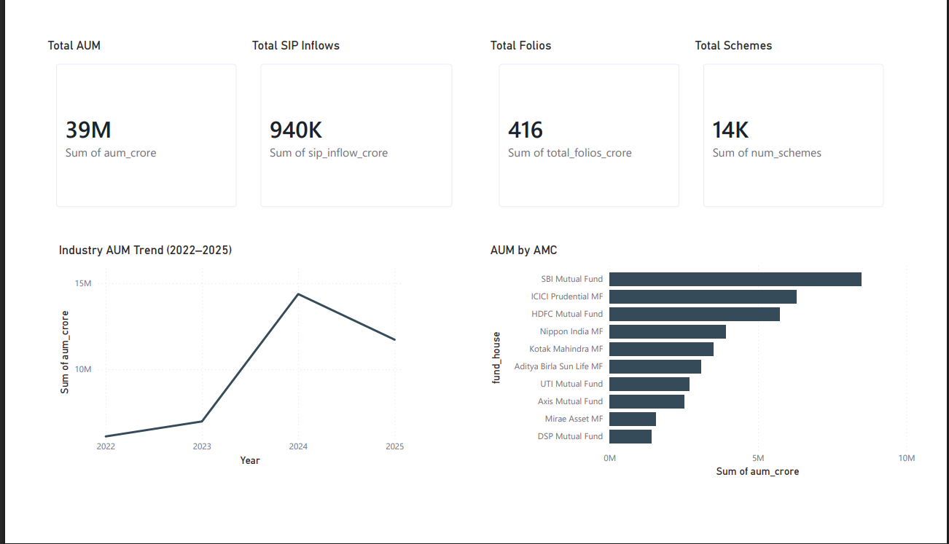
Figure 1: Industry Overview dashboard showing AUM growth, SIP inflows, folio count, and
fund house market share.
Fund Performance Analysis:
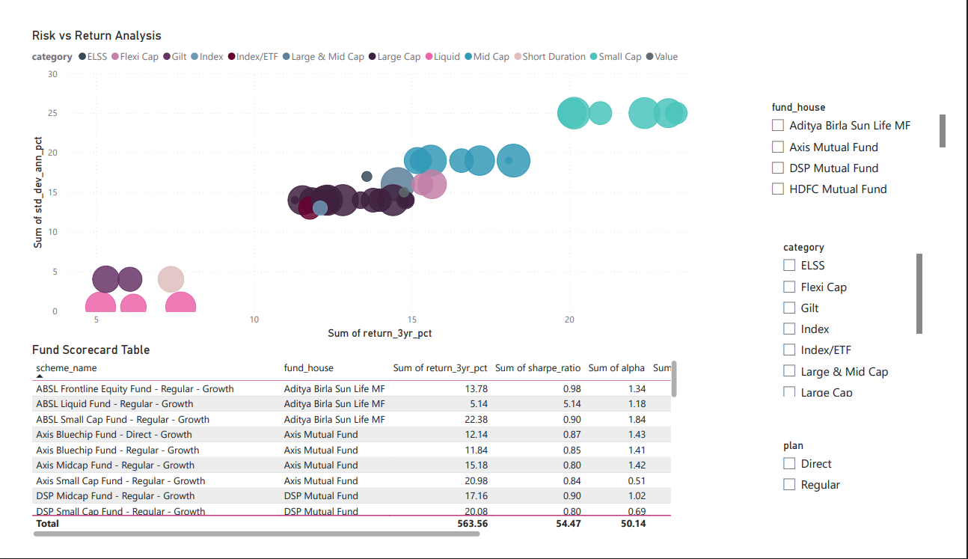
Figure 2: Fund Performance dashboard illustrating risk-return characteristics and
comparative fund performance metrics.
Investor Analytics:
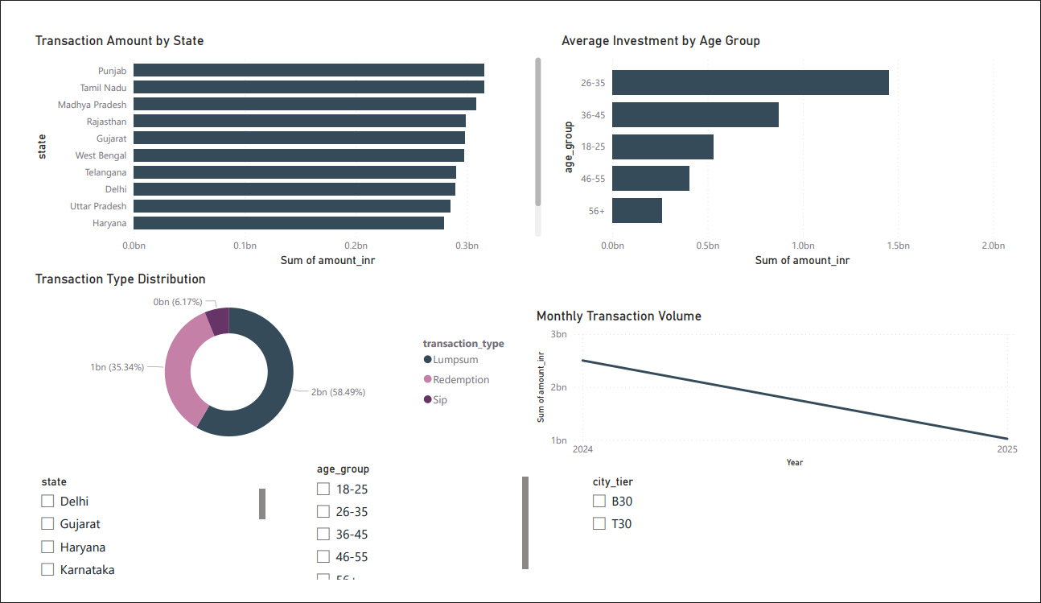
Figure 3: Investor Analytics dashboard highlighting investor demographics, transaction
behaviour, and geographic participation.
SIP & Market Trends:
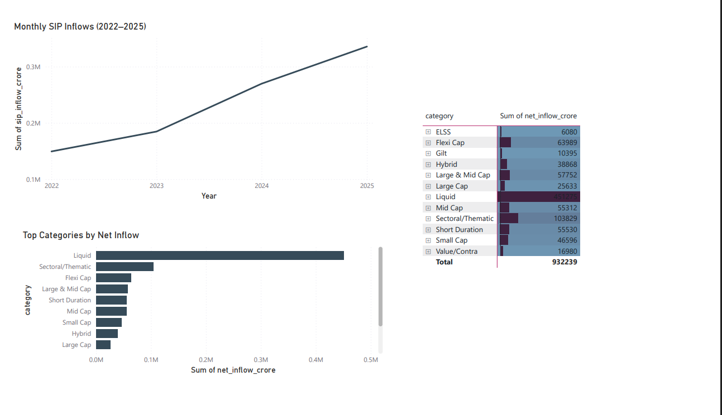
Figure 4: SIP & Market Trends dashboard showing SIP growth and category-wise investment
preferences.
Key Insights
1 Industry Growth
- Assets Under Management (AUM) showed strong growth between 2022 and 2025, indicating increasing investor participation in mutual funds.
2 SIP Adoption
- Monthly SIP inflows increased consistently over the analysis period, demonstrating strong investor confidence in systematic investing.
3 Fund Performance
- Small-cap and mid-cap funds delivered higher returns but exhibited greater volatility compared to large-cap funds.
4 Investor Behaviour
- Investors aged 26–35 contributed the highest investment amounts, making them the most active investor segment.
5 Risk Analytics
VaR, CVaR, Rolling Sharpe Ratio, and HHI analysis revealed significant differences in risk exposure and diversification across mutual fund schemes.
Limitations
. The analysis is based on historical data and does not guarantee future performance.
. Market conditions may change rapidly, affecting fund returns and risk metrics.
. Certain datasets were limited to the available project time period.
. Investor behaviour analysis does not capture external economic factors influencing
investment decisions.
. Advanced portfolio optimization techniques were outside the scope of this capstone project.
Recommendations
1 Investors should evaluate both returns and risk-adjusted metrics before selecting mutual
funds.
2 SIP investments should be encouraged as a long-term wealth creation strategy.
3 Portfolio diversification should be maintained to reduce concentration risk.
4 Fund houses should monitor SIP continuity and investor retention metrics.
5 Future enhancements may include machine learning-based fund recommendation systems
and predictive analytics models.
Conclusion
The Bluestock Mutual Fund Analytics Capstone successfully developed an end-to-end analytics platform for mutual fund analysis using Python, SQLite, and Power BI.
The project implemented a complete ETL pipeline, performed extensive exploratory and advanced analytics, developed interactive dashboards, and generated actionable business insights from mutual fund data.
Key areas including industry growth, fund performance, investor behaviour, SIP trends, and risk analytics were analysed using modern data engineering and business intelligence techniques.
The final solution demonstrates practical applications of data analytics, financial analysis, and dashboard development while providing meaningful insights into the Indian mutual fund industry. The project serves as a strong foundation for future enhancements involving predictive analytics, portfolio optimization, and intelligent investment recommendation systems

