VLM-based Blender Scene Quality Assessment
and Repair Experiment
当前 MCP 会话版诊断与修复闭环实验报告

实验摘要
本实验在当前打开的 Blender MCP 会话中构造一个含有故意错误的杯子-木桌场景，通过多视角渲染与场景 metadata 进行 VLM-style 质量评估，再根据结构化 detected issues 自动执行修复脚本。修复后总分从 42/100 提升到 90/100。

目标描述 | A ceramic cup should be placed on a wooden table under balanced studio lighting. The cup should be clearly visible in the camera view.
实验日期 | 2026-05-13
执行环境 | Blender 5.1 + official Blender MCP bridge + bpy repair scripts
核心闭环 | create bad scene -> render multiview -> export metadata -> VLM-style JSON evaluation -> repair -> re-render -> re-score

1. Experimental Goal
本实验验证一个最小可运行闭环：Agent 不只生成 Blender 场景，还能够把场景渲染成多视角图像，结合 metadata 诊断几何、布局、材质、光照和相机问题，并把诊断结果转化为可执行的修复动作。
为了让评测信号明确，第一轮场景被故意设置为坏样本：杯子悬空、光照过暗、杯子使用默认灰色材质、相机偏离主体。这类错误都可以被多视角图像和 metadata 同时观测。

2. Pipeline Design
造坏场景 | 通过 MCP 在当前 Blender 会话中生成 wooden_table、ceramic_cup、area_key_light 和 Camera，并保存 bad_cup_scene.blend。
渲染评估输入 | 渲染 camera/front/side/top/back 五视图，并导出 object、camera、light、bounding box 和 material metadata。
VLM 打分 | 读取五视图和 metadata，按固定 JSON schema 输出 total score、六项分数、detected issues 和 repair suggestions。
修复 | 根据 issue type 调用 repair_from_eval.py 中对应修复函数，直接修改当前 MCP 场景并保存 repaired_cup_scene.blend。
复评 | 重新渲染、重新导出 metadata，并生成 after repair 评分用于前后对比。

3. Visual Evidence
下面展示关键视角的 before/after 对比。为保证 Word 兼容性，每张渲染图都作为普通图片直接插入文档，不放入表格或复杂容器。
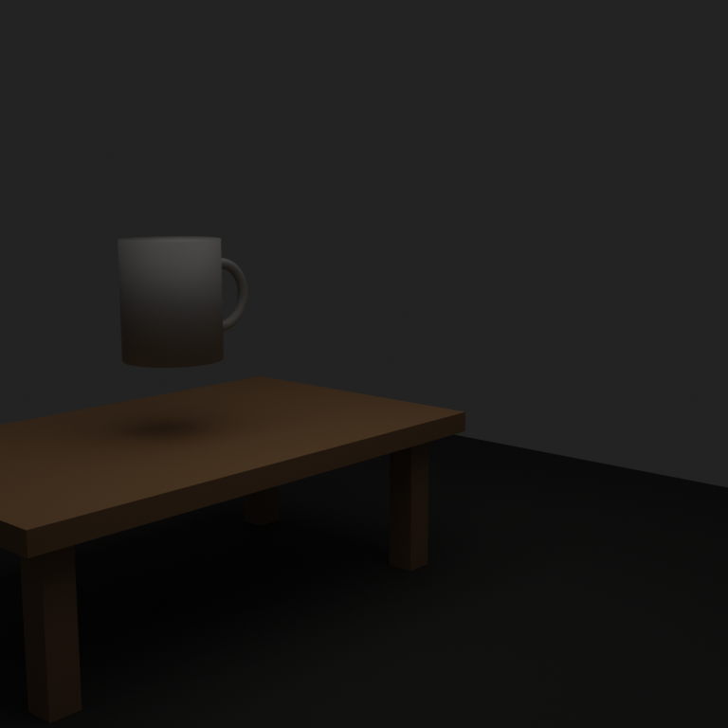
Figure 1. Before repair - camera view: dark lighting and weak framing
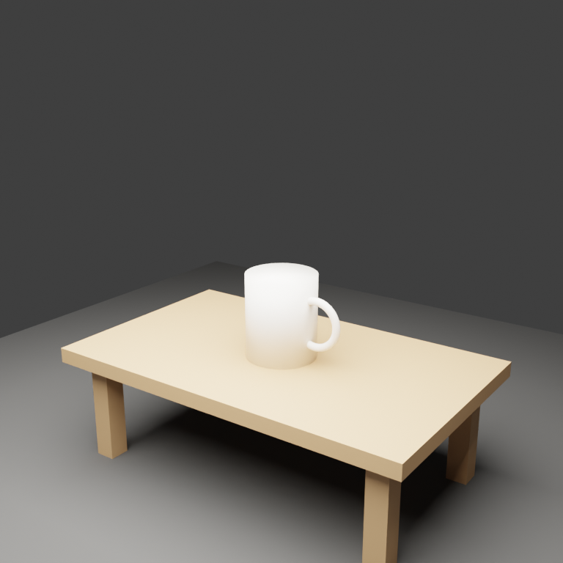
Figure 2. After repair - camera view: clear cup and table composition
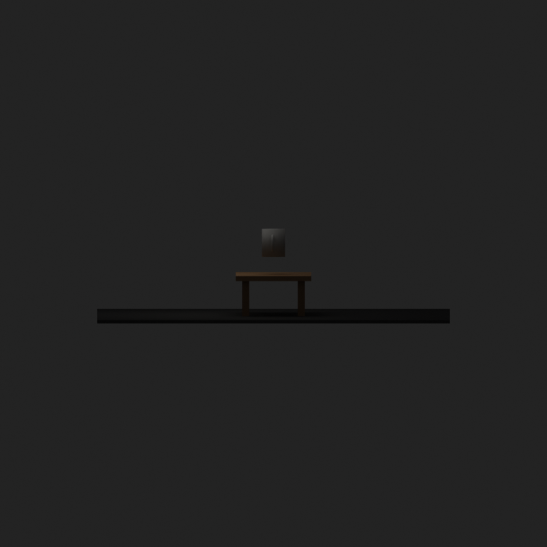
Figure 3. Before repair - side view: the cup is floating above the tabletop
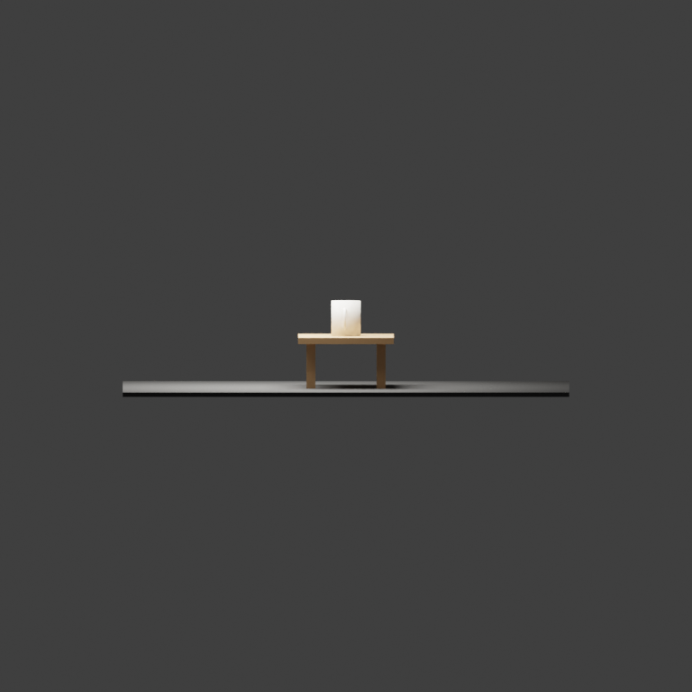
Figure 4. After repair - side view: the cup rests on the tabletop
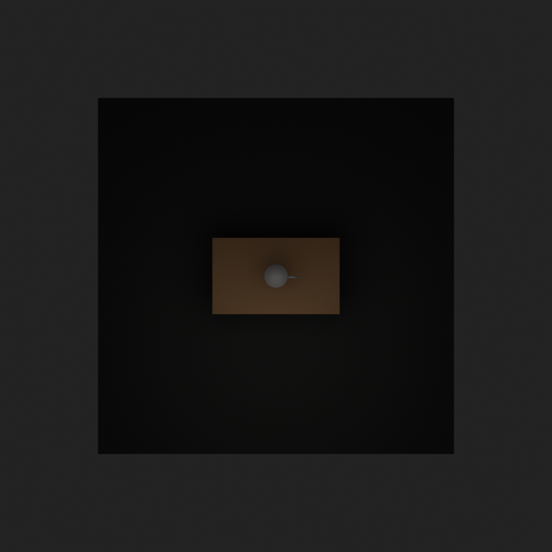
Figure 5. Before repair - top view: gray/default material under dark lighting
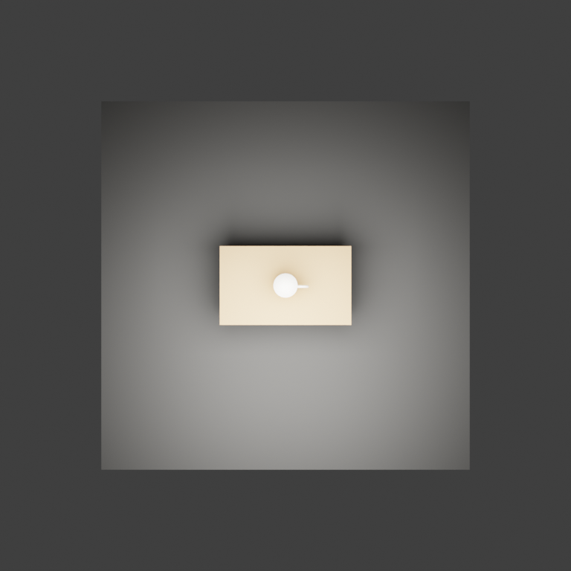
Figure 6. After repair - top view: white ceramic material and brighter scene

4. Evaluation Results
评分采用 100 分制：geometry 20、layout 20、material 15、lighting 15、camera 15、prompt alignment 15。修复后的提升主要来自布局、光照、材质和相机四个维度。
Metric | Before | After | Delta | Max
Total | 42 | 90 | +48 | 100
Geometry | 15 | 17 | +2 | 20
Layout | 5 | 19 | +14 | 20
Material | 4 | 13 | +9 | 15
Lighting | 4 | 13 | +9 | 15
Camera | 5 | 14 | +9 | 15
Prompt Alignment | 9 | 14 | +5 | 15

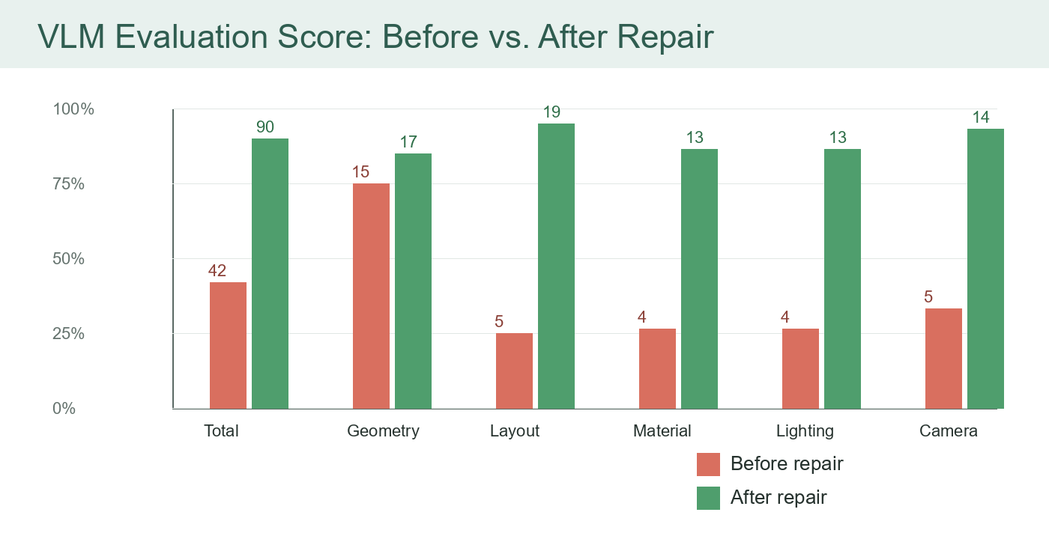
Figure 7. Score comparison before and after repair

5. Detected Issues Before Repair
Issue Type | Severity | Object | Evidence and Diagnosis
floating_object | high | ceramic_cup | front, side, camera: The cup is visibly suspended above the wooden tabletop. Metadata confirms the cup bottom is at Z=1.145 while the tabletop top is at Z=0.800.
underexposed | high | whole_scene | camera, front, side, top, back: All rendered views are very dark and the scene lacks balanced studio illumination. Metadata shows the area light energy is only 18.0 and color management exposure is -1.2.
missing_material | medium | ceramic_cup | camera, top: The cup appears as a plain gray/default material rather than a ceramic surface. Metadata lists the material as default_gray_cup_material.
camera_bad_framing | high | ceramic_cup | camera: The main subject is not well centered in the camera view, with the cup and table shifted toward the lower-left area and large unused dark space dominating the frame.

6. Metadata Verification
Cup bottom Z before | 1.145; tabletop top Z is 0.800, confirming a floating object.
Cup bottom Z after | 0.800; tabletop top Z is 0.800, confirming contact alignment.
Area light energy | 18.0 -> 520.0
Exposure | -1.2 -> 0.0
Cup material | default_gray_cup_material -> white_ceramic_material

7. Conclusion and Next Steps
本次实验说明：即使第一版 VLM 评分先采用人工/模型代理读取多视图的方式，闭环仍然可以稳定跑通，并且每个错误都能映射到具体 Blender API 修复动作。对于后续科研工作，这个 demo 可以扩展为小型 benchmark，覆盖更多物体类别、空间关系和错误类型。
下一步建议
将当前的 VLM-style 评分替换为外部 VLM API；增加自动重试与多轮 repair；把每轮 score delta、issue recall 和 repair success rate 统计为表格，从工程 demo 逐步推进到可投稿的实验设计。

