**任务型阅读**

**温馨提示：**

**1.请按住Ctrl，滑动鼠标滚轴，调节合适的观看比例。**

**2.点击菜单栏中的“视图——导航窗格”即可查看本文档目录，直接跳转至各个部分的对应内容。**

**真题典例**

**Passage 1**(2021陕西)

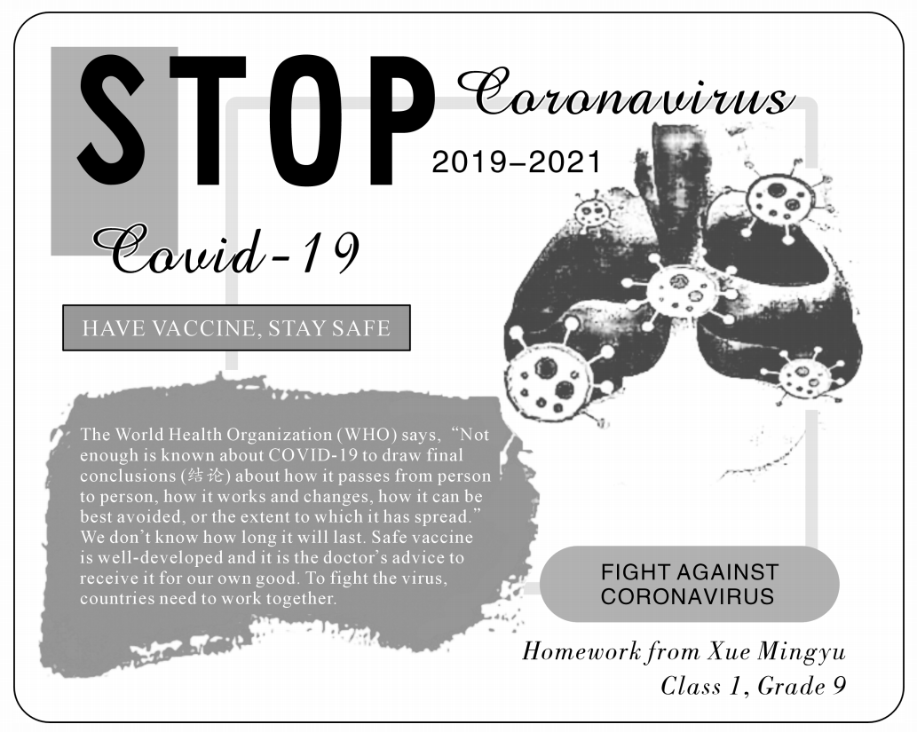

1. What does the writer mostly want to express in his poster?

He calls on（号召）the readers to ___________________ COVID-19.

2. Who created this poster and what was it made as?

It was created by a student named __________ and made as his _____________.

3. Which word means"疫苗"in the passage?

It is ______________.

4. What should countries do according to the student?

He thinks countries should _______________.

5. Why did the student choose the WHO's words for his poster?

He wanted to let readers know the ____________ of COVID-19.

**Passage 2**（2020陕西）

Let's say you are taking a walk along the road and you happen to see one or two waste bottles lying on the grass beside the road. What would you do?

You may have different choices. Firstly, you can leave the bottles there as they are. It was not you who threw them away. Why should you do something about it? This is quite OK. Secondly, you can pick them up and throw them into a dustbin (垃圾箱). By doing this, you have walked a step further to help make our **home** clean. This action is a better choice. Thirdly, you might want to pick them up and give them to an old man or woman who collects waste for a living. If this is your choice, you have walked even further. You're not only thinking about doing something for the environment, you're also developing yourself to be a person who would think of others and help them.

As for young kids, they may always have such a question：“When do I grow up？” Yes! When does a child grow up? And how can a kid know he or she has grown up? These are interesting questions. As for us, fifteen­year­olds, who are finishing middle school, we're no longer younger children. We should know whether or not we have grown up. When we start to have a sense of offering a helping hand for a cleaner city and greener world, and when we have a loving heart to think more of others than of ourselves and are ready to help them, we can say that we have grown up.

Remember：If we help others, others will help us. If we do our best for nature, nature will offer its best to us in return!

1. How did the writer start the passage?

The writer did it by giving a(n)________________ of daily life.

2. How many choices are there in the second paragraph?

There are ________________ choices.

3. What does it mean when you pick up the waste bottles and give them to someone else?

It is a sign that you're a ________________ person that has grown up.

4. What does the underlined word “**home**” refer to in the second paragraph?

It refers to the “________________” we live in.

5. How did the writer support the main idea in the passage?

The writer used ________________ as an example to support the idea.

**Passage 3**（2018陕西）

Eleven countries are building a great wall of trees across Africa. It is called the Great Green Wall. The aim is to bring life to the dry lands and help to fight the bad environment.

The wall is 8，000 kilometers long and 15 kilometers wide. It covers from Senegal in the west to Djibouti in the east, on the south of the *Sahara* *Desert*(撒哈拉沙漠). So far, Senegal has made the best progress by planting about 11，000，000 trees.

Many years ago, there were few trees in that area and the winds used to be very strong. It was harmful to the fields. Also, there was little rain, so few plants could grow and many people went hungry. Since the tree planting project started, the trees have provided food for the local people and increased the wetness(湿度) of the air. Little by little, there appeared green fields for people to grow plants.

The project which began in 2007 is supposed to cost a total of 8，000，000，000 dollars. Many countries are trying their best to help to continue the planting. So we will be able to see the whole green wall across Africa in the near future!

1. Why are the countries building the wall of trees?

They want to bring life to the dry lands and help to ．

2. Where is the great wall of trees?

It's of the Sahara Desert.

3. Why couldn't many plants grow in that area many years ago?

Because there were few trees, strong winds and ．

4. When did the project begin?

It began ．

5. What does the passage mainly talk about?

It mainly talks about in Africa.

**随堂测**

**Passage 1**

**原创热点素材—冬奥会开幕式**74

The opening ceremony of the Beijing 2022 Olympic Winter Games is held at the National Stadium in Beijing, Feb 4, 2022.

“It is time to show a modern China and ordinary Chinese people, especially the younger generation, ” said Zhang Yimou in Beijing on Friday.

About 3,000 people took part in the 140-minute opening ceremony. More than 90 percent of them are students between the ages of 5 and 25. Many live in villages and their parents are either ordinary farmers or workers. There were the square dancers from the ages of 5 to over 70. They performed in the 30-minute warm-up show before the ceremony. Square dancing is a popular national activity in China. It shows the positive attitude of Chinese people towards life.

“There were no stars, no celebrities or professional performers. Just ordinary people showed the world who they are,” said Zhang. He is the director of the 2008 Beijing Olympic Games ceremony. It offered audiences a look of China’s wonderful and long history.

He said the idea of the 2022 opening ceremony was totally different from that of the 2008 Summer Games.

“If we compare it with the ceremony in 2008 showing our history, we will find this one shows a modern China,” said the director. It is the respect for the ordinary people. It is the confidence to the country’s culture.

1.How did the writer start the passage?

The writer did it by giving a(n) of Beijing 2022 Olympic Winter Games.

2.How long is the opening ceremony?

It is for .

3.Why did Zhang choose the Square dancing in the warm-up show?

Because it is in China and it shows positive attitude of Chinese people towards life.

4.Which word means “名人” in Paragraph 4?

It is .

5.What does the passage mainly talk about?

It mainly talks about the of the 2022 opening ceremony.

**Passage 2**

**原创热点素材—感动中国人物：张顺东、李国秀夫妇**74

*Touching China* has been with us for 20 years since it first appeared. It shows many touching stories and brings many ordinary but shining names to us. **It** gives us lasting strength.

Zhang Shundong and Li Guoxiu accepts the 2021 annual Touching China awards. The couple from Pingzi village, Kunming, Yunnan province have shown that: beating all the difficulties to find love, build a family and lift themselves out of poverty.

Zhang Shundong and Li Guoxiu have only one hand and two legs in total. When Zhang Shundong was 6 years old, he lost his right hand. And his feet were badly hurt by high voltage（高电压）. Li Guoxiu, from a neighboring village was born without two arms. She finished middle school and learned how to work with her feet. The couple met in 1990 and got married in the same year.

For the disabled couple, they lived a hard life. But they are positive and always believe that they could live a good life if they work hard. Zhang Shundong said, “Life is not to wait out, but to work out. As long as we work hard every day, we can turn soil（泥土） into gold.” Zhang Shundong and Li Guoxiu create a happy family and live a hard-won life with their disabled bodies.

Zhang Shundong and Li Guoxiu never give in difficulties. They support and love each other in hardship. For Zhang Shundong and Li Guoxiu, they feel happier because they have worked harder.

**素材选自*China Daily***

1. What does “It” refer to in the first paragraph?

It refers to ____________ .

2. When did Zhang Shundong lose his right hand?

Zhang Shundong lost his right hand ____________ .

3. What kind of couple are Zhang Shundong and Li Guoxiu?

They are ____________ .

4. How did Zhang Shundong and Li Guoxiu lift themselves out of the poverty?

By ____________ with their disabled bodies.

5.Where can we probably read the passage?

We can read this passage in a(n) ____________ .

**Passage 3（选自《万唯中考2022完形填空阅读理解与新考法》）**

Sarah's school was having a big concert tonight. Everyone was excited about the concert. Though Sarah really wanted to play in the concert, she felt it was an impossible dream for her.

When Sarah arrived at school in the afternoon, her music teacher said to her that he wanted her to play Alonso's part because he had a cold. Sarah couldn't believe her ears. She wanted to, of course, but she was a little worried. Mr. Perez smiled, “Alonso plays well, and so do you. Have a try.”

Sarah began to play. She felt nervous and something seemed to go wrong. When Sarah finished, her eyes were filled with tears.

Without saying anything, Mr. Perez played a piece of piano music on his computer. The fast notes sounded like birds singing. The low, quiet notes were like snow falling. “That's beautiful. I wish I played like that！” Sarah said. “Sarah, I recorded the music just now. That was your playing！” Mr. Perez said.

“Do I really sound like that？” Sarah was shocked. “Sure, that's you！” Mr. Perez told her. “So, don't worry tonight. You work hard and you play very well. You should be confident. You're a great musician！Never forget to have fun and enjoy the music.”

1. What was Sarah's dream according to the passage?

Sarah's dream was to ________________ according to the passage.

2. How did Sarah feel when she was asked to play Alonso's part?

She felt ________________ when she was asked to play Alonso's part.

3. Why did Sarah cry after she finished playing?

She cried because ________________．

4. What did the teacher do to encourage Sarah?

The teacher encouraged Sarah by ________________．

5. What does the passage mainly tell us?

The passage is written to tell us ________________．

**Passage 4**（选自《陕西省初中学业水平考试评析及教学指导》英语试卷示例（二））

任务型阅读:阅读下面材料,根据材料内容，完成下列各题。(共5小题,计10分)

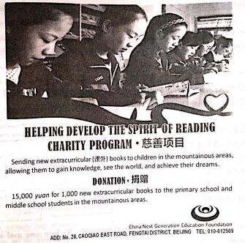

1. The true purpose of the charity program is to help develop children's___________________.

2. The foundation thinks that the books will help the children gain more knowledge, see the world

and___________________.

3. A total of___________________books worth￥15 ,000 will be donated.

4. For more information, we can either write a letter or___________________.

5. The way to achieve purpose of the program is to collect________________for_______________to the students in the mountainous areas.

**课后练**

**Passage 1**

Red noses are usually for clowns(小丑). But in the UK, there is a Red Nose Day.

Red Nose Day is a charity(慈善) day which happens every two years in the UK. The day started in 1988. It fell on March 15, 2020. Unlike the other charities, Red Nose Day raises money through a happy way. On this day, people did some funny things to make people laugh and raise money. They told jokes and danced in a funny way. Most importantly, they wore red noses.

Therefore, many comedy(喜剧) stars will take part in different kinds of activities, performing funny comedies with a red nose, which will make the audiences laugh. Many schools take advantage of this opportunity to carry out love education and organize small fund­raising(募捐) activities. Parents also encourage their children to participate in those activities actively.

Think of something unusual you would like to do. How about having red hair for the day? Before the big day, your friends and family say how much they would like to give you to do this and later you give away this money to charity. You can do all kinds of **cool_things** at school, too. Have a talk and decide what to do together with your teachers! Perhaps wear something red to school instead of your school uniform, or play Red Nose Day's games instead of having normal lessons.

And where does this money go? In the UK, it can help to find homes for young people who are living on the street. In Africa, the money can buy important medicine or give fresh water to villages.

1. When will the next Red Nose Day be held?

It will be held in ________________．

2. Why do schools hold activities on Red Nose Day?

Because they want to help students develop a sense of ________________．

3. What do the underlined words “**cool things**” refer to in the fourth paragraph?

They refer to some ________________ things you would like to do.

4. What is the purpose of mentioning “the UK” and “Africa” in the last paragraph?

To explain the ________________ of money.

5. What does the passage mainly talk about?

It mainly talks about ________________ in the UK.

**Passage 2**

Being filial(孝顺) to the elders always happen in our daily life. It has been a traditional virtue of the Chinese nation. There is an old saying goes, “Of all the virtues, filiality comes first. ” Now filial piety has triggered(引发) a hot expression.

Traditionally, kids would live with their parents until they pass away, especially for the boys. As they get older, they will take the responsibility to look after their parents. Usually, even if they’ve got married and have children, all of them will live with moms and dads.

However, changes have happened. Nowadays, young adults look so busy and independent in modern society that it’s hard for them to live with their parents. They move out and mind their own life. On some festival days, they probably spend a little time visiting their parents or caring about their life. Some even just send some gifts and money to them. They don’t show up in person because they think that those things can show their love and make their parents happy. However, those things are far from what their parents really hope for.

What can actually let parents much happier is children themselves but not gifts or money. No matter how busy we are, we should spend more time staying with our parents.

1. What does the writer mostly want to express in this passage?

He calls on the readers to their parents.

2. Which word means “美德” in the passage?

It is .

3. When should children take the responsibility to look after their parents?

They take the responsibility to look after their parents when they .

4. Why don’t young adults today live with their parents?

They are too to live with their parents.

5. What makes parents happy according to some young adults?

_____________________ that they send to their parents.

**Passage 3**（选自《万唯中考2022完形填空阅读理解与新考法》）

（注：该习题是《陕西省初中学业水平考试评析及教学指导》英语试卷示例（二）的类似题型）

If you happened to be hungry, what would you do? Would you have some of your favorite food? Well, just like your stomach, your mind can also become hungry. But it never lets you know this because you keep it busy thinking about your friends or favorite stars. So while it silently serves your needs, you may be, without even knowing it, quietly starving your mind and not letting it grow. When the mind loses its freedom to grow, creativity will come to a full stop. This might be the reason why we all sometimes think, “What happens next？” or “Why can't I think？”

Having hunger of the mind is something which can easily be solved by reading widely. Since it can also help to develop many other aspects of our lives, reading should be the first thing we should do to help our minds to grow. Once you start reading a book and your eyes begin running through its lines, your mind busily tries its best to explain the book's meanings to you. The interesting parts of the book are stored in your mind like a seed. Now this seed gets used by you, unknowingly, to develop your own new ideas. This seed, if it is planted many times, can help your ideas branch out and build relationships between new thoughts and concepts(概念). This is what we call creativity. Also, reading widely can work to increase your vocabulary. In only a few weeks after you have started reading widely, you will be surprised to find that you are able to talk with your friends in English or any other language and never run out of the right words to say.

So guys, do give food to your thoughts by reading, reading and then，more reading.

1. You can not ____________ your mind becomes hungry because you always keep it ____________ in thinking.

2. While it serves your needs in ____________， you are overspending it quietly. Gradually, it will not have the ability to grow. As a result, you will become less ____________．

3. People can ____________ the hunger of mind by reading widely. Reading is the first thing that helps our mind to grow.

4. During reading, your mind will busily ____________ to plant a seed in your heart by explaining the knowledge in books.

5. Reading widely can work to ____________．After a period of reading, you can ____________ your ideas with right words. If you want more thoughts, read more.

**参考答案**

**真题典例**

**Passage 1**

1.stop/fight（against）/prevent/avoid或be/stay/keep away from

2.Xue Mingyu homework

3.vaccine

4.work together

5.facts/information/situation(s)

**Passage 2**

1. example

2. three/3

3. helpful/kind/caring/...

4. neighborhood/country/city/...

5. what to do with waste bottles/the ways of dealing with waste bottles/...

**Passage 3**

1.fight/stop/prevent the bad environment

2.(from Senegal in the west to Djibouti in the east), on the south /south

3.(there was) little rain

4. in 2007

5. the Great Green Wall/the tree planting project/planting trees/tree planting/building a great green wall of trees/the project of planting trees/the project of the Great Green Wall/bringing life to the dry lands/environmental protection/protecting the environment/...

**随堂测**

**Passage 1** 1.fact 2.140 minutes 3.popular 4.celebrities 5.idea/meaning

**Passage 2** 1.*Touching China* 2.at age of six/when he was six years old

3.brave and positive/hard-working 4.working hard themselves 5.newspaper

**Passage 3**

1. play in the concert
2. surprised/shocked

3. she thought she performed badly

4. showing Sarah the music she played

5. to be confident/believe in ourselves

**Passage 4**

1. (spirit of) reading / reading ability/skills
2. achieve their dreams
3. 1,000 (new)(extracurricular)
4. make a phone call /call/ make a call
5. money; books

**课后练**

**Passage 1** 1.2022　 2.helping others/the poor (in a happy way)　 3.unusual　 4.use 5.Red Nose Day

**Passage 2** 1.spend more time staying with/caring about/for　 2.virtue　 3.get older　 4.busy and independent 5.Some gifts and money

**Passage 3** 1.know；busy 2.silence; creative 3.solve 4.try its best 5.increase your vocabulary；show/express/...