**【英语】“感动中国2022年度人物”满分作文重磅来袭！**

“感动中国2022年度人物”揭晓：钱七虎,邓小岚,杨宁,沈忠芳,徐淙祥,“银发知播”群体,徐梦桃,陈清泉,陆鸿,林占熺。不平凡的2022年，他们以凡人之力，书写中国人的年度精神史诗。  
 全国近3年中考作文命题也会从《感动中国》选取素材。如2022江苏淮安中考要求介绍“感动中国2021年度人物”江梦南的成长经历，并阐述个人如何实现梦想。  
 万唯中考命题研究中心特别推出“感动中国2022年度人物”英语作文专辑，精心打磨原创好题，提供高质量范文，供同学们阅读、学习，快一起来看看吧！

# 主题一：银发知播“吴姥姥”

万唯原创

春蚕不老，夕阳正红。“吴姥姥”用一条条趣味科普的短视频，在生活场景中讲解物理。假如你是李华，请根据以下提示，向英国网友Frank介绍“吴姥姥”，并分享看完她的视频后的感受。

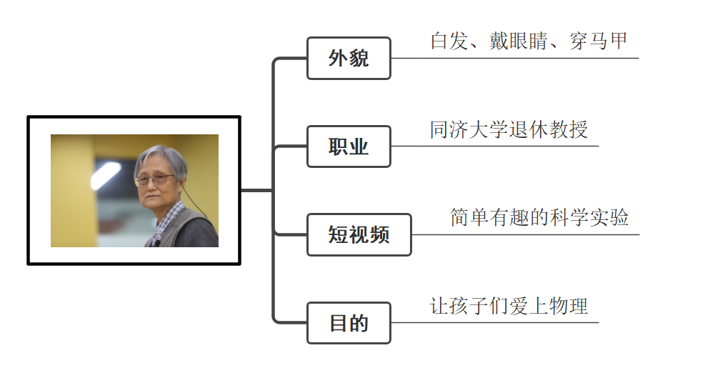

**参考词汇**：retired professor退休教授； vest马甲；pocket口袋

**要求**：1. 内容积极向上，并包含所给要点；

2. 结构完整，语句通顺，意思清晰、连贯；

3. 使用正确的和较为丰富的词汇和语法结构，书写

规范；

4. 文中不得透露个人信息；

5. 词数80左右（开头和结尾已给出，不计入总词

数）。

Dear Frank,

Recently, I’ve had a strong interest in physics,

What can you learn from Grandma Wu? Please write to tell me.

Yours,

Li Hua

满分作文

|  |  |
| --- | --- |
| Dear Frank,  Recently, I’ve had a strong interest in physics, because I watched some short videos about physics experiments **which were made by Grandma Wu①**.  Grandma Wu, who is with white hair and a pair of glasses, is a retired professor from Tongji University. Differently, Grandma Wu usually wears a vest with many pockets, where there are always a lot of interesting things. **In order to make more children fall in love with physics②**, she makes a number of videos about easy and interesting physics experiments. In the video, Grandma Wu uses normal things like bottles, glasses and silk scarves to explain the difficult knowledge. After watching her videos, I learn that “Interest is the best teacher”.  **Although she is in her seventies, she still tries her best to spread knowledge to the young③**. So as student, we should keep learning because knowledge is endless.  What can you learn from Grandma Wu? Please write to tell me.  Yours,  Li Hua | **亮点赏析**  **亮点1** 运用which引导的定语从句，说明物理实验的视频由“吴姥姥”制作；  **亮点2** 用in order to引出“吴姥姥”做实验的目的，同时使句子开头多样化；  **亮点3** 巧用although引导让步状语从句，侧面映衬了吴姥姥对于传播知识和文化的坚定信念。 |

参考译文

亲爱的弗兰克，

最近，我对物理产生了浓厚的兴趣，因为我看了一些由吴姥姥制作的关于物理实验的短视频。

吴姥姥，同济大学退休教授，有着一头白发，戴着一副眼镜。与之不同的是，吴姥姥通常穿着一件有很多口袋的背心，口袋里总是有很多有趣的东西。为了让更多的孩子爱上物理，她制作了许多简单有趣的物理实验视频。在视频中，吴姥姥用瓶子、眼镜和丝巾等普通物品来解释这些难以理解的知识。看完她的视频后，我知道了“兴趣是最好的老师”。

虽然她已经七十多岁了，但她仍尽力向年轻人传播知识。所以，作为学生，我们应该不断学习，因为知识是无穷的。

你从吴姥姥身上可以学到什么呢？请写信告诉我。

你的朋友，

李华

# **主题二：永不服输的陆鸿**

万唯原创

“能吃苦，肯奋斗，有担当，似一叶扁舟在激湍中逆流而上，如一株小树在万木前迎来春光。”这就是陆鸿，《感动中国》2022年度人物之一。虽幼时高烧导致身体残疾，但仍坚持学习，带领残疾人做自媒体、开网店……请你以“永不服输”为话题，写一篇不少于80词的英语短文，讲述陆鸿的成长经历以及他身上值得我们学习的优秀品质。

**参考词汇：**残疾的 disabled；自媒体owned media；坚持 persistence

**要求：**1. 短文条理清楚，行文连贯，可适当发挥；

2. 短文中不能出现真实的人名和地名；

3. 词数不少于80（开头已给出，不计入总词数）。

Among all the people who were presented with Touching China Award this year，Lu Hong left a deep impression on me.

___________________________________________________________________________________________________________________________________________________

满分作文

|  |  |
| --- | --- |
| Among all the people who were presented with Touching China Award this year，Lu Hong left a deep impression on me.  Lu Hong became disabled after a fever when he was a little boy. **However①**, he didn’t give up and kept learning. **Unluckily①**, after he graduated, he failed to get the opportunity to work because of his disability. For living, he repaired bikes, sold boiled water, and finally succeeded in running an album factory, **in which 21 disabled people were offered a chance to make money and realize their own value②**. He said that he understood how hard it was for the disabled to get a job.  In brief, being disabled exactly brings Lu Hong trouble and unhappiness, **but Lu shows the power of persistence and the warmth of kindness③**. Just as a saying goes, “What doesn’t kill you makes you stronger.” So let’s learn from him and make a contribution to our society. | **亮点赏析**  **亮点1** 巧用副词However，Unluckily进行衔接，使逻辑连贯，语言流畅；  **亮点2** 准确使用非限制性定语从句修饰先行词factory，内容充实，表达高级；  **亮点3** 用连词but连接前后句，使语言紧凑；用两个名词短语代替单一词汇，表达多样化。 |

参考译文

在今年获得感动中国奖的所有人物中，陆鸿给我留下了深刻的印象。

小时候陆鸿因发烧成了残疾人。然而，他没有放弃，并且坚持学习。不幸的是，他毕业后，由于残疾，未能获得工作机会。为了生活，他修理自行车，卖开水，最后成功地经营了一家相册工厂，21名残疾人在工厂里获得了赚钱和实现自己价值的机会。他说，他理解残疾人找工作是多么困难。

简言之，残疾确实给陆鸿带来了麻烦和不幸，但陆鸿展现了坚持的力量和善良的温暖。正如一句谚语所说，“无法击败你的事物终将使你更加强大。”所以，让我们向他学习，为我们的社会做出贡献。

# **主题三：我心目中的榜样**

万唯原创

“感动中国2022年度人物”名单于3月4日晚揭晓。为国铸盾的工程专家钱七虎、“千磨万击还坚韧”的冬奥冠军徐梦桃、默默耕耘十余载的教育志愿者邓小岚……他们的故事令人感动、催人奋进，是我们每个人学习的榜样。

假如你是李华，你校英语社团将举办以“The person I admire most”为主题的演讲比赛，请你根据要点提示，从“感动中国2022年度人物”中选择一位你学习的榜样，写一篇演讲稿。

**要点提示：**1. 他（她）的基本情况；

2. 他（她）的感人事迹；

3. 你敬佩他（她）的理由。

**要求**：1. 语句通顺，意思连贯，书写工整；

2. 文中不得出现你的真实姓名和学校名称；

3. 词数：不少于80（开头和结尾已给出，不计入

总词数）。

Good afternoon, everyone!

I’m glad to be here to give a speech. My topic is “The person I admire most”.

Thank you for your time !

满分作文

|  |  |
| --- | --- |
| Good afternoon, everyone!  I’m glad to be here to give a speech. My topic is “The person I admire most”. **The annual Touching China Award was presented by CCTV on March 4th and all of us were deeply moved by their moving stories①**.  The person I admire most is Xu Mengtao, a freestyle skier in China. She started her practice of gymnastics at the age of 4. **Being such a little girl, she tried her best to practice gymnastics no matter how hard it was.②** As years went by, Xu became a professional athlete. Before taking part in the Beijing 2022 Winter Olympics, she was once upset because of her illness. Encouraged by her father’s words, she decided to move on. Then she made all her efforts and after years of hard work, she finally became the first woman to win the Olympic gold medal in this event.  **Her story made me understand that the payoff of hard work may come late, but it will come for sure.③** We should always have faith in ourselves and never give up when facing difficulties.  Thank you for your time! | **亮点赏析**  **亮点1** 运用一般过去时的被动语态，丰富文章句式；同时引出话题；  **亮点2** no matter how引导的让步状语从句展现了徐梦桃坚持不懈的体育精神，为下文做铺垫；  **亮点3** 引用谚语总结全文，表达地道，升华主题。 |

参考译文

大家下午好，

我很高兴能在这里发表演讲。我的主题是“我最崇拜的人”。一年一度的感动中国颁奖（盛典）于3月4日在中央电视台播出，我们所有人都被他们的动人故事深深触动。

我最敬佩的人是中国自由式滑雪运动员徐梦桃。她4岁开始练习体操。作为一个小女孩，无论多么困难，她都倾尽全力练习体操。随着时间的推移，徐梦桃成为了一名职业运动员。参加北京2022年冬奥会之前，她曾因为自身疾病而沮丧低落。在父亲的鼓励下，她决定继续前进。然后，她付出了所有的努力，经过多年的努力，终于成为第一位在这个项目上获得奥运金牌的女性。

她的故事让我明白，努力付出终将会有回报，或早或晚。我们应该始终相信自己，在面对困难时决不放弃。

感谢您的倾听！