**阅读理解微技能**

**温馨提示：**

**1.请按住Ctrl，滑动鼠标滚轴，调节合适的观看比例。**

**2.点击菜单栏中的“视图——导航窗格”即可查看本文档目录，直接跳转至各个部分的对应内容。**

**—**词（组）义/句义猜测、写作意图

**真题典例**

(2021陕西, B)Look at the Earth from space. Why does our planet look so blue? It's blue because water covers almost three quarters of the Earth's surface. Water is not just an important part of our planet. It is an important part of our body, too. More than half of our total body weight is water.

Our body loses water whenever we exercise or go to the toilet. That's why we need to drink plenty of water every day. We drink water. We use it to cook, clean, and carry waste out of our homes. Farmers use it to grow vegetables and crops like rice and corn; factories use it to make products.

Since the 1950s, the amount(数量) of water people use has increased by three times. But the water supply(供应) hasn't. Scientists worry that soon there won't be enough water for us, as well as for the animals and plants that share our world. What can we do to help? Use water wisely.

Having enough water isn't our only problem. **We also need it clean**.

Right now, ships and factories are putting wastes into seas, rivers and so on. Even chemicals that farmers use are running into rivers and lakes. All this pollution can make the water dangerous to drink. It can also harm fish and other water­living lives.

We must do something to stop pollution. It's the best way to protect our world's most valuable natural resource(资源)．

1. How many important areas of water are mentioned in Paragraph 1?

A. One. B. Two. C. Three. D. Four.

2. The underlined sentence “**We also need it clean**.” in Paragraph 4 means “________”．

A. We also need water to wash things

B. We also need water that looks clean

C. We also need to keep water clean

D. We also need to discover clean water

3. This passage was written to ________．

A. ask people to value water

B. advise people to drink more water

C. introduce the uses of water

D. describe the situation of water supply

**随堂测**

**原创热点素材—滑雪少女谷爱凌**

It is a special day for Eileen Gu. She got the first place in the final run of the women’s free ski Big Air World Cup in America, on December 4th, 2021. When she was interviewed after the competition, she said excitedly, “I still cannot believe this just happened. I’m really lucky to ride with all the boys who are so great. I have so much respect for them. So I really wanted to encourage more girls to take up skiing.”

In fact, Gu had achieved some excellent results in other international events. She had shown best of herself every time before this competition. With a Chinese mother and an American father, Gu was born in 2003 and raised in San Francisco, California. But she announced in 2019 that she planned to compete for China in 2022 Beijing Winter Olympic. The US sports experts were so surprised about her decision. Gu has talent in skiing and rich experience of skiing, though she is very young. She began to take part in national competitions at 9 and won her first World Cup event at 15. Gu once wrote on her social media that she took pride in her Chinese origin.

In addition to skiing, Gu never puts studies aside. She graduated from the famous San Francisco University High School in just three years. So she could focus on skiing. From her experience, we learned that no matter when and where we are, we should love our motherland and give full play to our best efforts to realize our dreams and win glory(荣耀) for our country.

1.Which of the following is true according to the passage?

A.Gu only achieved excellent results in America.

B.Gu has a Chinese father and an American mother.

C.Gu likes skiing a lot but always puts studies aside.

D.Gu won her first World Cup event at fifteen years old.

2.The underlined word “origin” means in Chinese.

A. 体验 B. 出身 C. 比赛 D. 梦想

3.Eileen Gu is good at .

A. skiing and studying B. skiing and painting

C. studying and painting D. skiing and riding

4. The text is written mainly about .

A. how to take up a hobby B. how to realize our dreams

C. the introduction of Olympics D. the introduction of Eileen Gu

**课后练**

**Passage 1(**选自《万唯中考2022完形填空阅读理解与新考法》**)**

It is important to remain enough energy. Here are some ways to renew your energy.

**Lose the snooze**(小睡)

The snooze button is a comforting thing, but it doesn't do us any good at all. To feel and stay refreshed, you need to wake up and get up at the same time every day. A tip: keep the alarm far enough away that you have to get out of bed to turn it off. That will get you moving in the morning.

**Enter into your day carefully**

Use those extra minutes to start the morning slowly and calmly. Beginning by drinking a coffee and thinking about three things you're thankful for. Write them down. Get rid of each negative thought and replace it with a positive one—negative feelings take a lot of mental energy.

**Get moving**

Exercise can help make you stronger and healthier, so get the blood flowing early in the day if you can. If there's time for a trip to the gym or pool in the morning, that's **fabulous!**

**Balance your breakfast**

Try to eat a mix of food like whole grains, healthy fats and protein(蛋白质) to make sure your energy is enough as you go through the day. Eggs make an excellent start to the day.

**Take a break from the TV**

Give yourself a weekend break to spend a few hours in staying green places instead of staying indoors. Research has found that spending time in nature can lower blood pressure and improve mental health.

1. How does the writer like the snooze button?

A. Bad.　　　 B. Useful.

C. Hateful. D. Tiring.

2. Why does the writer suggest replacing negative feelings with positive ones?

A. Because each of us doesn't need negative feelings.

B. Because negative feelings may make us feel sad.

C. Because positive feelings can save us much mental energy.

D. Because negative feelings take a lot of time in our daily life.

3. The underlined word “**fabulous**” in Paragraph 4 means “________”.

A. great　　　　　 B. strange

C. easy D. popular

4. Which advice about renewing your energy isn't mentioned in the passage?

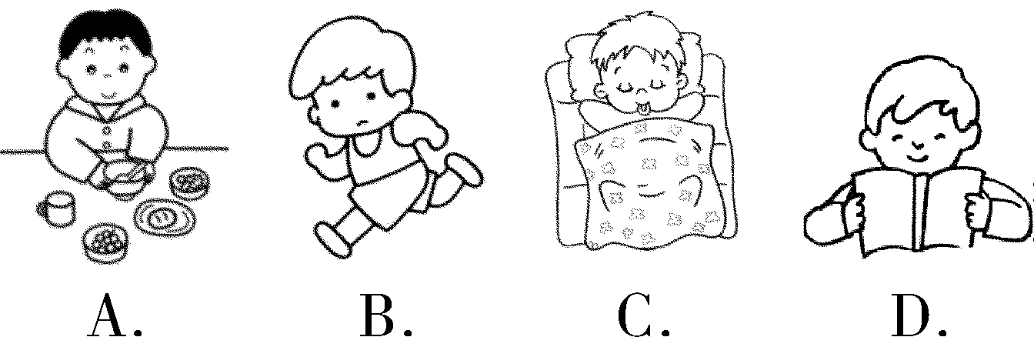

5. What is the purpose of the passage?

A. To explain the importance of movement.

B. To tell people how to renew the energy.

C. To advise people to eat breakfast.

D. To call on more people to pay attention to health problems.

**Passage 2**

Many students are afraid of taking examinations, but they are an important part of the educational experience. Students must keep studying for many years in order to be prepared for different exams. And they should **cultivate** study skills in their learning because these skills can help them in all of their courses.

One of the most important and simplest ways to prepare for exams is to have all classes and to take notes on lectures(讲座) and discussions. For effective(有效的) studying, however, these notes must be meaningful. Students should not write down everything that they hear but some key words and phrases that will remind them of the topics that were discussed. By focusing on the most important topics of the lecture or discussion in their note­taking, students will improve their understanding of the lesson.

While memory is an important part of studying, students should also try to improve their understanding of the main ideas in their courses. Before each text, students should look over the materials to get a general sense of the information that they are expected to learn. Next, students should think about the questions, trying to guess what they will be expected to learn. Then students read the text carefully, looking for the answers to the questions. For the fourth step, students recite(背诵) what they have learned. Finally, students must review the materials.

Time management skills are another necessary part of effective studying. Many students simply review before the exams. But this can limit long­term memories because students can easily forget the information they have put in their short­term memories. Studying is a long process.

1. The underlined word “**cultivate**” in paragraph 1 means “________”．

A. repeat B. change C. copy D. develop

2. How can students improve their understanding of a lesson?

A. By taking notes about some key points.

B. By looking over the materials before the class.

C. By writing everything they hear in class.

D. By communicating with teachers in time.

3. Which is the right order to better understand the main idea of a passage according to Paragraph 3?

① guess what to learn　② look through the passage　③ read carefully and find the answers

④ recite the passage 　⑤ review the passage

A. ④①②③⑤ B. ②③④⑤① C. ②①③④⑤ D. ①②③④⑤

4. The writer writes this passage mainly to ________．

A. introduce the ways of time management

B. help students to prepare for exams

C. tell students studying is a long process

D. encourage students to take notes while listening

**参考答案**

**真题典例**

1.B 2.C 3.A

**随堂测**

1.D 2.B 3.A 4.D

**课后练**

**Passage 1** 1.A　2.C 3.A 4.D 5.B

**Passage 2** 1.D　2.A 3.C 4.B