**Topics: Normal distribution, Functions of Random Variables**

1. The time required for servicing transmissions is normally distributed with *μ* = 45 minutes and *σ* = 8 minutes. The service manager plans to have work begin on the transmission of a customer’s car 10 minutes after the car is dropped off and the customer is told that the car will be ready within 1 hour from drop-off. What is the probability that the service manager cannot meet his commitment?
2. 0.3875
3. 0.2676
4. 0.5
5. 0.6987

***Answer)*** option B (0.26)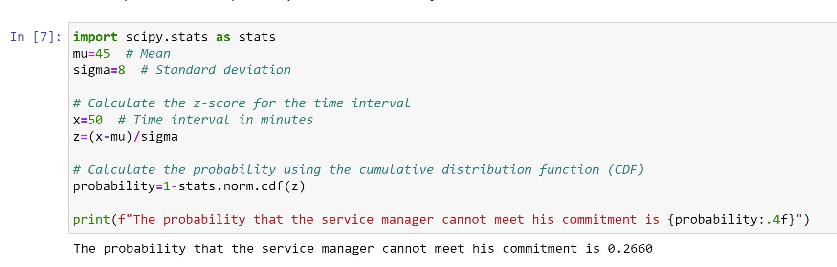

1. The current age (in years) of 400 clerical employees at an insurance claims processing center is normally distributed with mean *μ* = 38 and Standard deviation *σ* =6. For each statement below, please specify True/False. If false, briefly explain why.
2. More employees at the processing center are older than 44 than between 38 and 44.

***Answer)*** 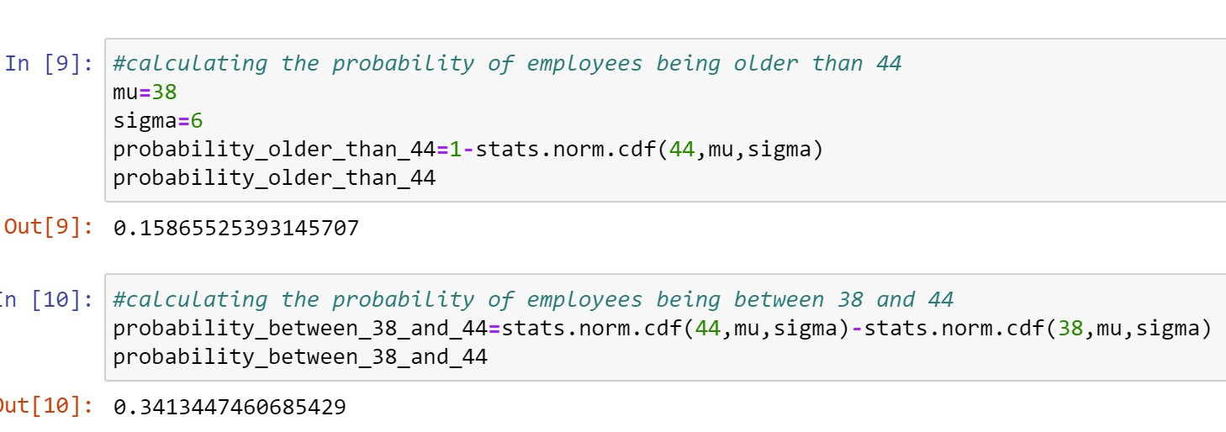

Here the probability between 38 & 44 is greater than probability older than 44. Therefore the statement A is False.

1. A training program for employees under the age of 30 at the center would be expected to attract about 36 employees.

***Answer)*** 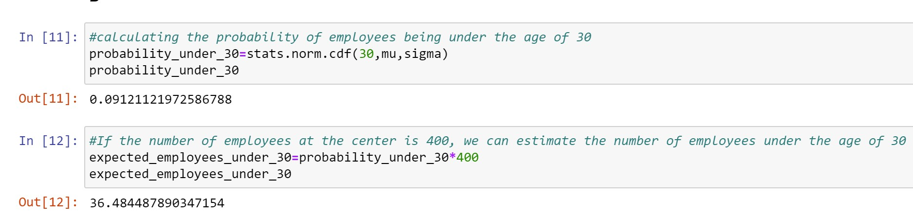

The expected value is 36. Therefore the statement B is True.

1. If *X1* ~ *N*(μ, σ2) and *X*2 ~ *N*(μ, σ2) are *iid* normal random variables, then what is the difference between 2 *X*1 and *X*1 + *X*2? Discuss both their distributions and parameters.

***Answer)*** *For 2X1*

* Distribution: Since X1 is normally distributed with parameters μ and σ2, 2X1 will also be normally distributed. The distribution of 2X1 will have the same shape as X1, but the mean will be 2μ (twice the mean of X1), and the variance will be 4σ2 (four times the variance of X1).
* Parameters: The mean of 2X1 is 2μ, and the variance is 4σ2.

*For X1+X2*

* Distribution: When adding two independent normal random variables, the resulting distribution is also a normal distribution. The mean of X1 + X2 will be the sum of the means of X1 and X2, which is 2μ. The variance of X1+ X2 will be the sum of the variances of X1 and X2, which is 2 σ2.
* Parameters: The mean of X1 + X2 is 2μ, and the variance is 2σ2.

1. Let X ~ N(100, 202). Find two values, *a* and *b*, symmetric about the mean, such that the probability of the random variable taking a value between them is 0.99.
2. 90.5, 105.9
3. 80.2, 119.8
4. 22, 78
5. 48.5, 151.5
6. 90.1, 109.9

***Answer)*** Option D (48.5,151.5)

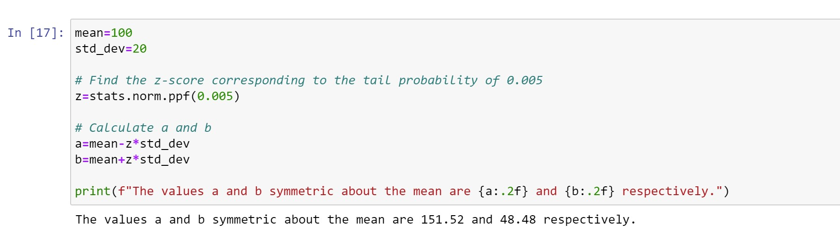

1. Consider a company that has two different divisions. The annual profits from the two divisions are independent and have distributions Profit1 ~ N(5, 32) and Profit2 ~ N(7, 42) respectively. Both the profits are in $ Million. Answer the following questions about the total profit of the company in Rupees. Assume that $1 = Rs. 45
2. Specify a Rupee range (centered on the mean) such that it contains 95% probability for the annual profit of the company.

***Answer)*** 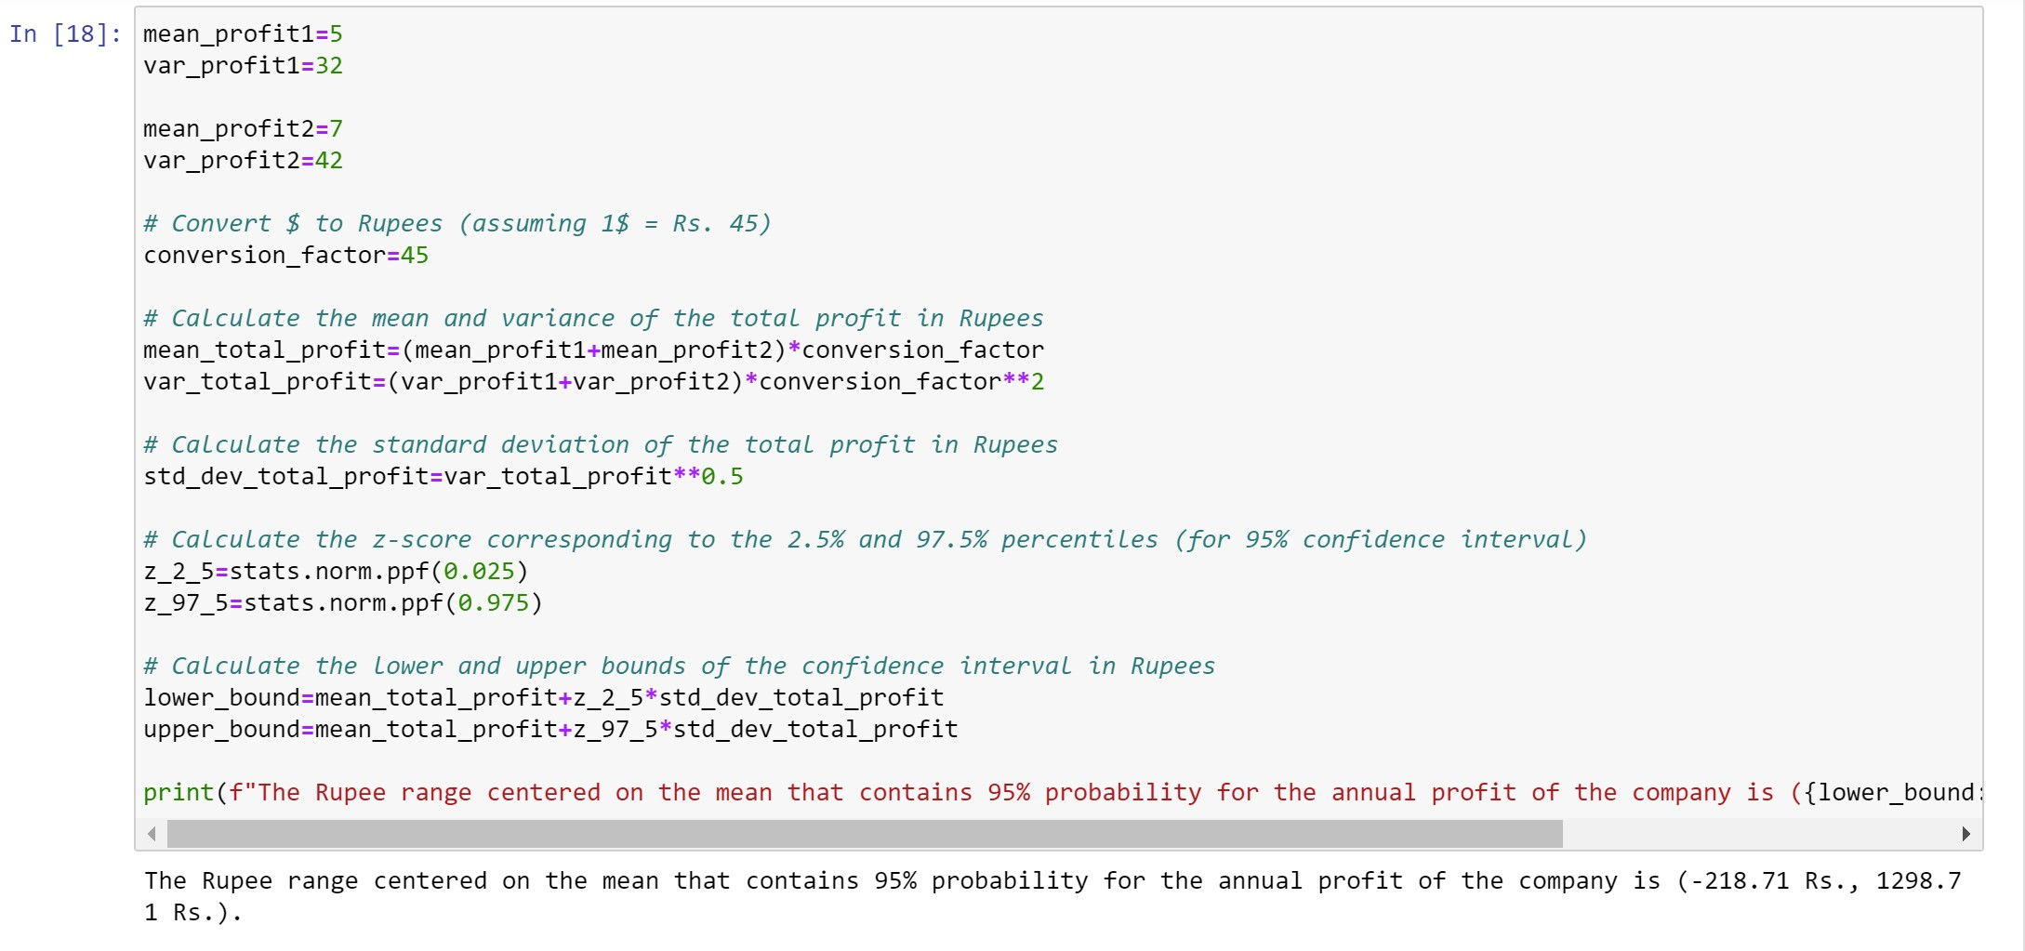

1. Specify the 5th percentile of profit (in Rupees) for the company

***Answer)*** 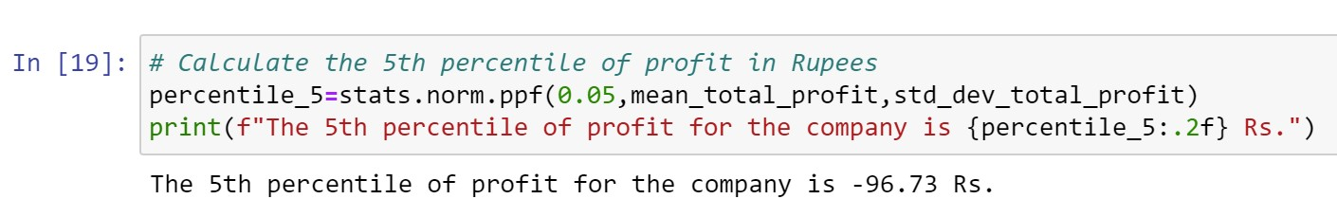

1. Which of the two divisions has a larger probability of making a loss in a given year?

***Answer)*** To determine which of the two divisions has a larger probability of making a loss in a given year, we can compare the mean values of the profit distributions. The division with a lower mean is more likely to make a loss. Here Profit1 has a mean of 5 million dollars and Profit2 has a mean of 7 million dollars. Since Profit1 has a lower mean, it has a larger probability of making a loss in a given year compared to Profit2.

Therefore, Profit1 is more likely to make a loss in a given year.