Topics: Confidence Intervals

- For each of the following statements, indicate whether it is True/False. If false, explain why.

- The sample size of the survey should at least be a fixed percentage of the population size in order to produce representative results.
Answer) False.
The statement is not entirely accurate. While it is true that a larger sample size generally improves the precision and reliability of survey results, there is no fixed percentage of the population size that determines representativeness. The representativeness of a sample depends on various factors such as the sampling method used, the characteristics of the population, and the research objectives. A fixed percentage may not be appropriate in all cases and can lead to under or oversampling certain groups.

- The sampling frame is a list of every item that appears in a survey sample, including those that did not respond to questions.
Answer) False.
The statement is incorrect. The sampling frame refers to the list or framework from which the sample is selected, typically consisting of all the eligible units in the target population. It should not include items that did not respond to the survey questions because they are not part of the actual sample. The sampling frame should only include those units that were eligible and had the chance to respond.

- Larger surveys convey a more accurate impression of the population than smaller surveys.
Answer) False.
The statement is not entirely accurate. While larger surveys can provide more precise estimates, it is not always the case that they convey a more accurate impression of the population. The accuracy of a survey depends on various factors, including the sampling method, sample representativeness, survey design, and data quality. A smaller, well-designed survey with a representative sample can still provide accurate information about the population, especially if it accounts for the necessary statistical considerations. The key is to ensure the survey methodology is sound and appropriate for the research objectives.

- PC Magazine asked all of its readers to participate in a survey of their satisfaction with different brands of electronics. In the 2004 survey, which was included in an issue of the magazine that year, more than 9000 readers rated the products on a scale from 1 to 10. The magazine reported that the average rating assigned by 225 readers to a Kodak compact digital camera was 7.5. For this product, identify the following:

- The population
Answer) The population in this case would be all readers of PC Magazine.
- The parameter of interest
Answer) The parameter of interest would be the average rating assigned to the Kodak compact digital camera by all readers of PC Magazine.

- The sampling frame
Answer) The sampling frame would be the list of all readers of PC Magazine.

- The sample size
Answer) The sample size mentioned in the statement is 225 readers who rated the Kodak compact digital camera.

- The sampling design
Answer) The sampling design is not explicitly mentioned in the statement. However, it can be inferred that PC Magazine asked all of its readers to participate in the survey, which suggests that it was an invitation for a voluntary response. This type of sampling design is known as a voluntary response or self-selected sample.

- Any potential sources of bias or other problems with the survey or sample
Answer) There are a few potential sources of bias or problems with the survey and sample in this scenario:

1. Self-selection bias: Since participation in the survey was voluntary, only those readers who were interested or motivated enough to respond would have participated. This can introduce bias, as the opinions of those who chose not to respond may differ from those who did.

2. Non-response bias: Even if the survey was sent to all readers, only a fraction (225 readers) responded. This could introduce non-response bias if the characteristics or opinions of the respondents differ significantly from those who did not respond.

3. Self-reporting bias: The ratings provided by the readers are subjective and based on their own perceptions and experiences. This can introduce bias due to individual preferences, opinions, or experiences that may not be representative of the entire population.

- For each of the following statements, indicate whether it is True/False. If false, explain why.

- If the 95% confidence interval for the average purchase of customers at a department store is $50 to $110, then $100 is a plausible value for the population mean at this level of confidence.

Answer) True.

- If the 95% confidence interval for the number of moviegoers who purchase concessions is 30% to 45%, this means that fewer than half of all moviegoers purchase concessions.
Answer) False.
If the 95% confidence interval for the number of moviegoers who purchase concessions is 30% to 45%, it does not necessarily mean that fewer than half of all moviegoers purchase concessions. The confidence interval represents the range within which we can be 95% confident that the true population proportion falls. In this case, it suggests that the true population proportion of moviegoers who purchase concessions is estimated to be between 30% and 45%. It does not provide conclusive evidence about whether it is less than or greater than half, as the interval includes values both above and below 50%.

- The 95% Confidence-Interval for μ only applies if the sample data are nearly normally distributed.
Answer) False.
The statement is not entirely accurate. The 95% confidence interval for μ (population mean) does not strictly require the sample data to be nearly normally distributed. Under certain conditions, even if the sample data are not normally distributed, the Central Limit Theorem states that the distribution of the sample means will approach a normal distribution as the sample size increases. As long as the sample size is reasonably large (typically above 30) and other assumptions are met (e.g., independence, random sampling), the 95% confidence interval for the population mean can still be valid and reliable, even if the original data are not normally distributed.

- What are the chances that ?

- ¼
- ½
- ¾
- 1
Answer) The chances that X bar (sample mean) is greater than mu (population mean) depend on the specific context and the distribution of the sample mean.
If we assume that the sample is drawn from a normally distributed population and the sample mean follows a normal distribution, then the chances can be determined by calculating the probability using the standard normal distribution and the appropriate z-score.
In a standard normal distribution, the mean is 0 and the standard deviation is 1. If we have the sample mean, the population mean, and the standard deviation of the population, we can calculate the z-score:

z = (X bar - mu) / (sigma / sqrt(n))

where sigma is the standard deviation of the population and n is the sample size.
We can then calculate the probability that X bar is greater than mu by finding the area under the standard normal distribution curve to the right of the calculated z-score.
P (X bar > mu) = 1 – P (Z < z)

In cases where the distribution of the sample mean is not known or assumptions cannot be made, the chances that X bar is greater than mu cannot be determined without additional information.

- In January 2005, a company that monitors Internet traffic (WebSideStory) reported that its sampling revealed that the Mozilla Firefox browser launched in 2004 had grabbed a 4.6% share of the market.

- If the sample were based on 2,000 users, could Microsoft conclude that Mozilla has a less than 5% share of the market?
Answer) 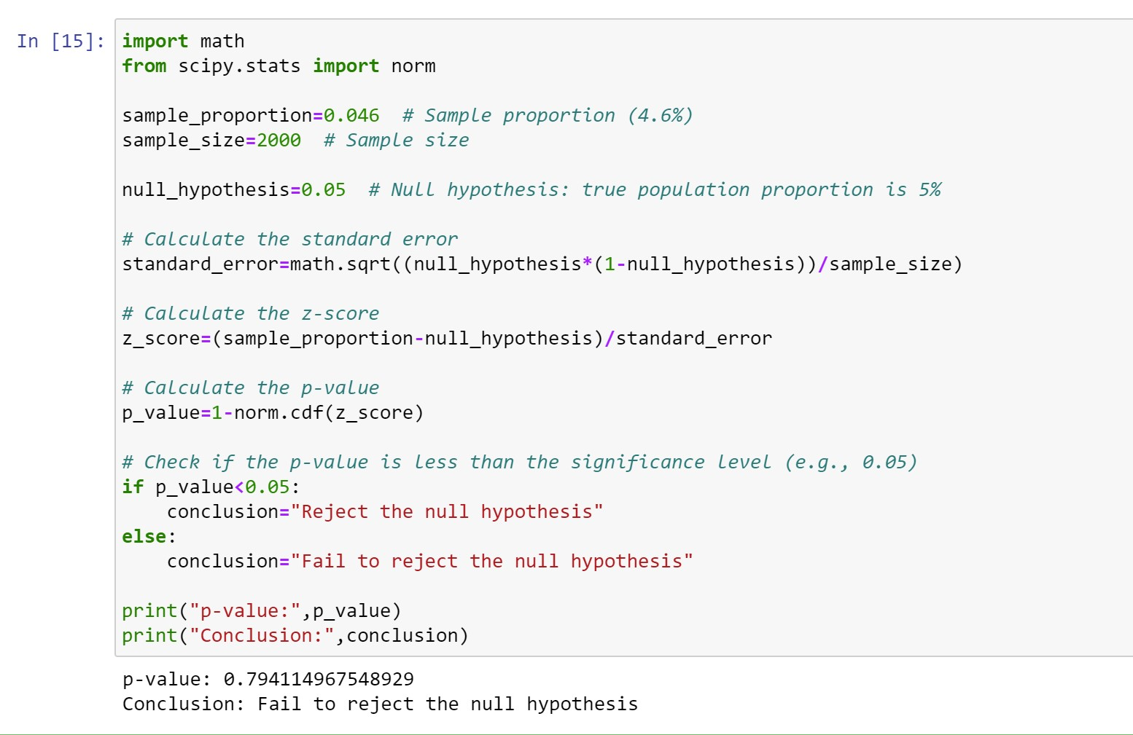

- WebSideStory claims that its sample includes all the daily Internet users. If that’s the case, then can Microsoft conclude that Mozilla has a less than 5% share of the market?
Answer) If WebSideStory claims that its sample includes all daily Internet users, then the reported 4.6% share of the market for Mozilla would represent an estimate of the true population proportion. In this case, Microsoft could not conclude that Mozilla has a less than 5% share of the market, as the reported estimate is based on the entire population of daily Internet users.

- A book publisher monitors the size of shipments of its textbooks to university bookstores. For a sample of texts used at various schools, the 95% confidence interval for the size of the shipment was 250 ± 45 books. Which, if any, of the following interpretations of this interval are correct?

- All shipments are between 205 and 295 books.
Answer) False. This interpretation is incorrect. The confidence interval provides an estimate of the range within which the true population mean is likely to fall, not the individual shipments themselves. It does not guarantee that all shipments are within this range.

- 95% of shipments are between 205 and 295 books.
Answer) False. This interpretation is incorrect. The confidence interval provides an estimate of the range within which the true population mean is likely to fall, not the individual shipments themselves. It does not guarantee that all shipments are within this range.

- The procedure that produced this interval generates ranges that hold the population mean for 95% of samples.
Answer) False. This interpretation is incorrect. The 95% confidence interval refers to the fact that if the sampling procedure were repeated multiple times, 95% of the resulting intervals would contain the true population mean. It does not imply that the generated interval holds the population mean for 95% of samples.

- If we get another sample, then we can be 95% sure that the mean of this second sample is between 205 and 295.
Answer) False. This interpretation is incorrect. The confidence interval relates to the population mean, not the mean of another sample. If another sample were taken, it would have its own unique confidence interval, and we cannot directly infer that the mean of the second sample would fall within the given interval.

- We can be 95% confident that the range 160 to 340 holds the population mean.
Answer) False. This interpretation is incorrect. The confidence interval provided is 250 ± 45, which means that we can be 95% confident that the true population mean falls between 205 and 295 books. It does not include the range 160 to 340, so we cannot make any claims regarding that range.

- Which is shorter: a 95% z-interval or a 95% t-interval for μ if we know that σ =s?

- The z-interval is shorter
- The t-interval is shorter
- Both are equal
- We cannot say
Answer) The t-interval is shorter.

The reason for this is that the t-distribution has fatter tails compared to the standard normal distribution (z-distribution). The t-distribution takes into account the additional uncertainty introduced by estimating the population standard deviation (s) from the sample data, whereas the z-distribution assumes knowledge of the population standard deviation (σ).
When estimating the population mean (μ), the t-distribution incorporates the additional variability resulting from estimating s, making the confidence intervals wider compared to the z-distribution. This is because estimating the standard deviation introduces more uncertainty into the estimation of the population mean.
Therefore, the t-interval will be shorter than the z-interval because it accounts for the added uncertainty, resulting in a larger margin of error and a wider interval.

Questions 8 and 9 are based on the following: To prepare a report on the economy, analysts need to estimate the percentage of businesses that plan to hire additional employees in the next 60 days.

- n = (Z^2 * p * (1 - p)) / E^2

Where:
n = sample size
Z = z-score corresponding to the desired confidence level
p = estimated proportion (0.5 is often used to get the maximum sample size when no estimate is available)
E = margin of error (expressed as a proportion)

- How many randomly selected employers (minimum number) must we contact in order to guarantee a margin of error of no more than 4% (at 95% confidence)?

- 600
- 400
- 550
- 1000
Answer) For a margin of error of no more than 4% at a 95% confidence level:
n = (Z^2 * p * (1 - p)) / E^2
= (1.96^2 * 0.5 * (1 - 0.5)) / (0.04^2)
n ≈ 600
Therefore, the minimum number of randomly selected employers we must contact to guarantee a margin of error of no more than 4% at a 95% confidence level is 600.

- Suppose we want the above margin of error to be based on a 98% confidence level. What sample size (minimum) must we now use?

- 1000
- 757
- 848
- 543
Answer) Now, let's calculate the sample size for a margin of error of no more than 4% at a 98% confidence level:
n = (Z^2 * p * (1 - p)) / E^2
= (2.33^2 * 0.5 * (1 - 0.5)) / (0.04^2)
n ≈ 848

Therefore, the minimum sample size required with a 98% confidence level is 848.

