**WEB DESIGN PROPOSAL**

***BUONO CHOCO ITALY*** *-* Italian Chocolate Festival Tour Map.

**SITE OBJECT**

**STRATEGY**

|  |  |
| --- | --- |
| Target Users | Italian Chocolate lovers |
| Primary Goal | Serve Information about Italian chocolate food. Help to know more about Italian food culture though chocolate. |
| Additional Goal | Attract tourists at home and abroad to Italy. Drive local chocolate sells. |
| Additional Goal | Attract people to Hot Italian Restaurant in China. |

**SCOPE**

**PROBLEM STATEMENT:**

How might we help Italian food lovers, especially Italian chocolate lovers to know more information about Italian chocolate so that they can enjoy their chocolate tour in Italy, make easy chocolate-related food at home on their own and share with friends.

**PAIN POINTS**

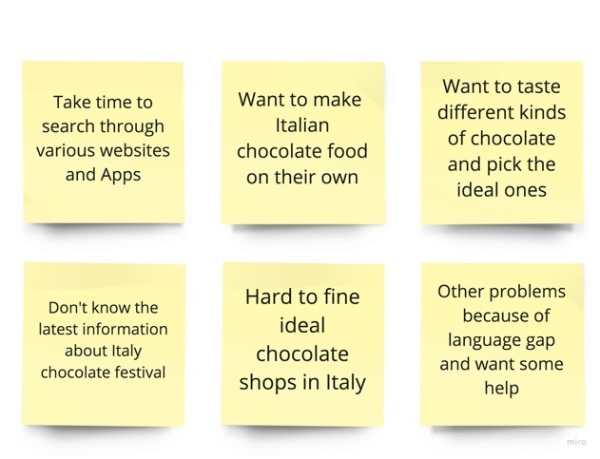

Additional Questionnaire for 15 Italian chocolate lovers, here is the result for reference：

⚬ When you come in Italy for to buy chocolate, what factors you will consider?

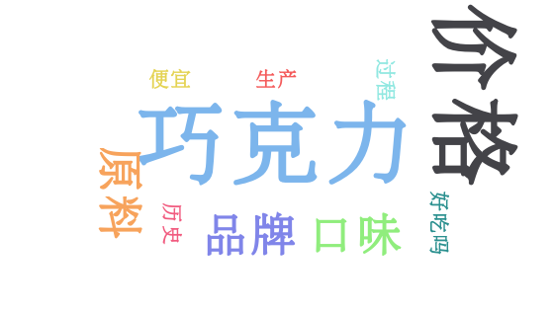

⚬ When you take part in chololate festival in Italy, what information will you look for?

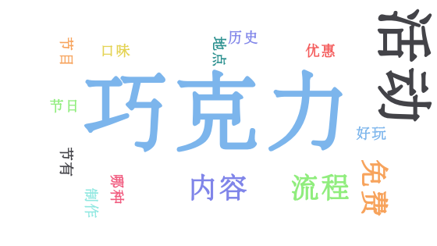

**A CUSTOMER JOURNEY MAP**

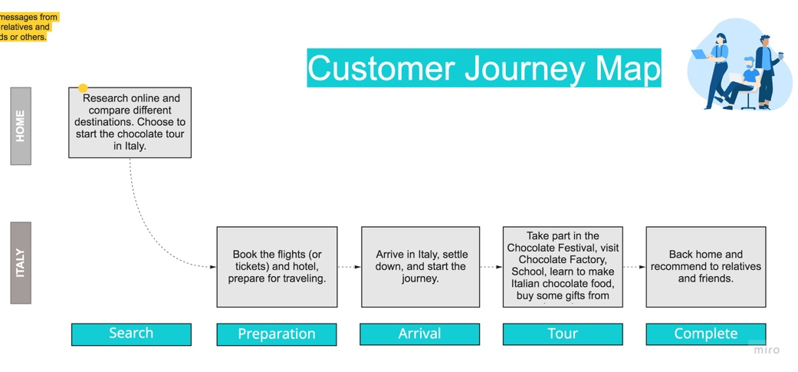

**A data flow diagram**

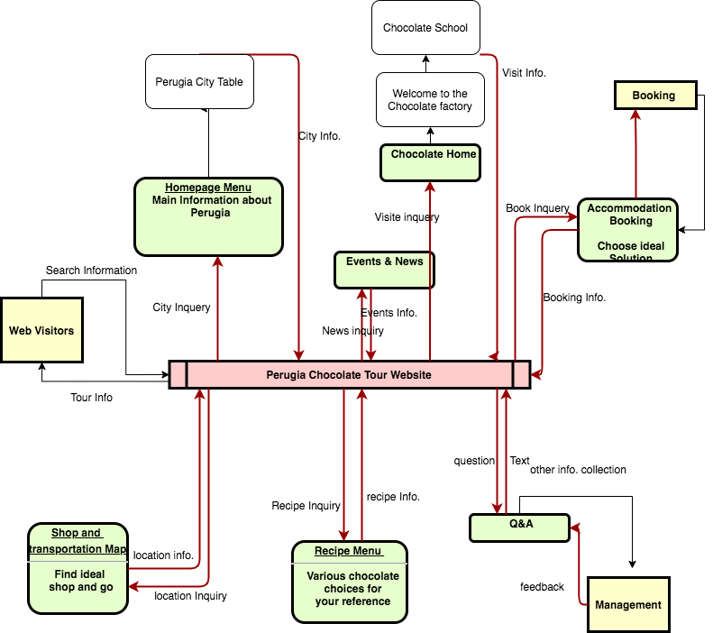

**key data views**

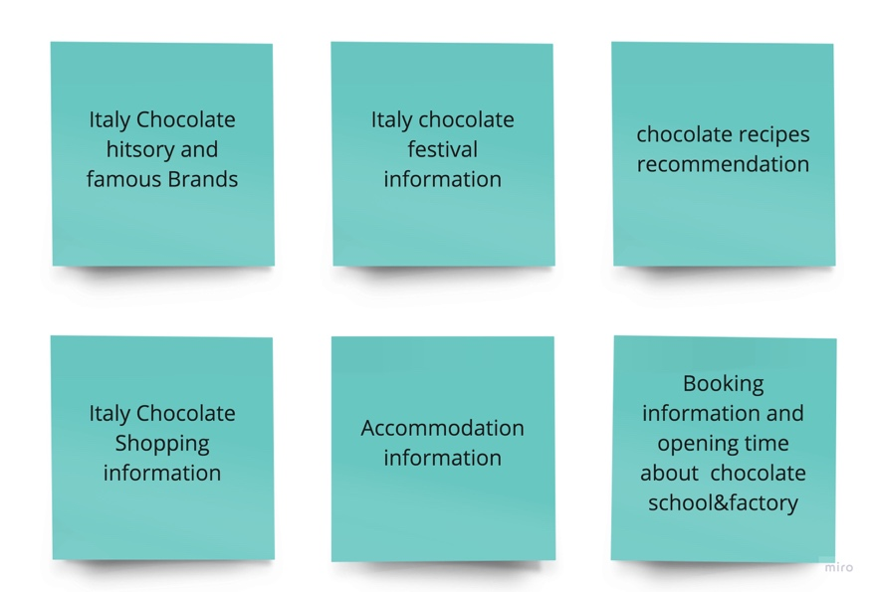

**An entity-relationship diagram** which can support the display of the views and development of the site structure

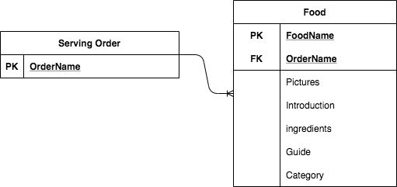

**Information Architecture**

⚬ **Home**

⚬ **Events – Italy Chocolate festival news**

⚬ **Chocolate Taste Recommendation**

⚬ **Chocolate Home – Italy Chocolate Factory & School**

⚬ **Recipes – Italian chocolate-related food**

⚬ **Q&A**

**Italian Food Serving Order**

