**Dataloaders:**

tu_berlin_dataloader.py – data loader for Tu-Berlin dataset.  
This dataset is located in the repository – "TU-berlin-dataset".  
alz_sketch_data_loader.py – data loader for the collected Alzheimer dataset.  
This dataset is located in the repository – "alzheimer_2024_07_18_blended_1_512".

**Train and test scripts**:

Pre-Train on Tu-Berlin dataset:

To pre-train a model on the Tu-Berlin dataset run the script -  
sbatch_script_pretraining.sh tu_berlin_train.py –config_file config_file.yml.

Test on Tu-Berlin dataset:

sbatch_script_pretraining.sh tu_berlin_test.py –config_file config_file.yml.

Alzheimer dataset train:

To train a model on the collected Alzheimer's dataset run the script -  
sbatch_script_alzheimer.sh alz_regression_train.py –config_file config_file.yml.

Test on Tu-Berlin dataset:

sbatch_script_alzheimer.sh alz_regression_test.py –config_file config_file.yml.

**Configuration Files:**The configuration files in this directory are divided into train and test configuration directories.  
Each of these directories is divided into Alzheimer's dataset and Tu-Berlin's dataset configuration sub-directories.

For the Tu-Berlin, the configuration directories contain sub-directories based on a chosen seed. This seed is used to split the Tu-berlin dataset to test set and train and validation set that is divided further into 5 folds such that 4 of these folds are training folds and the last fold is a validation set.

The Tu-Berlin configuration for training files looks as follows:   
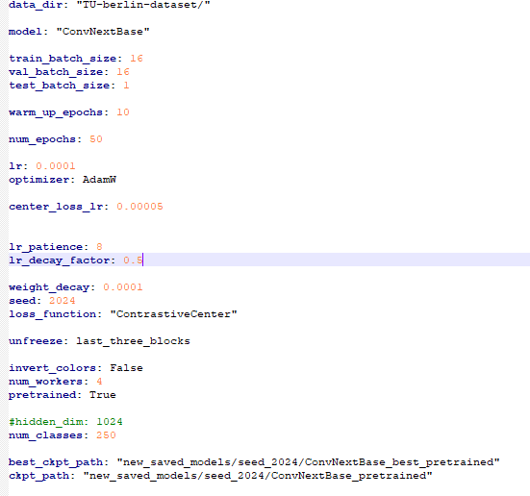

The Tu-Berlin Configuration for test/inference looks as follows:

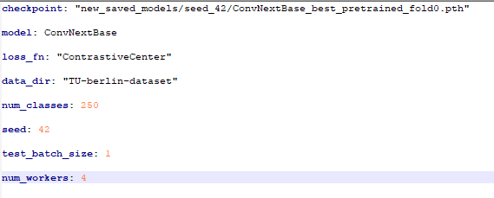

The Alzheimer's dataset training configurations files look as follows:

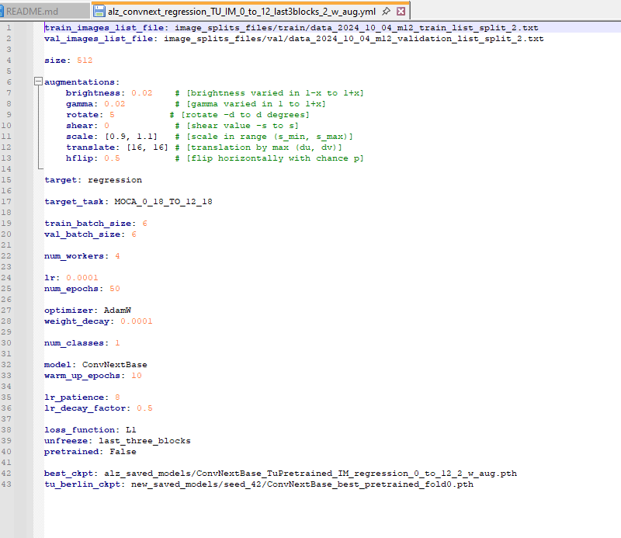

The Alzheimer's dataset test/inference configurations files look as follows:

