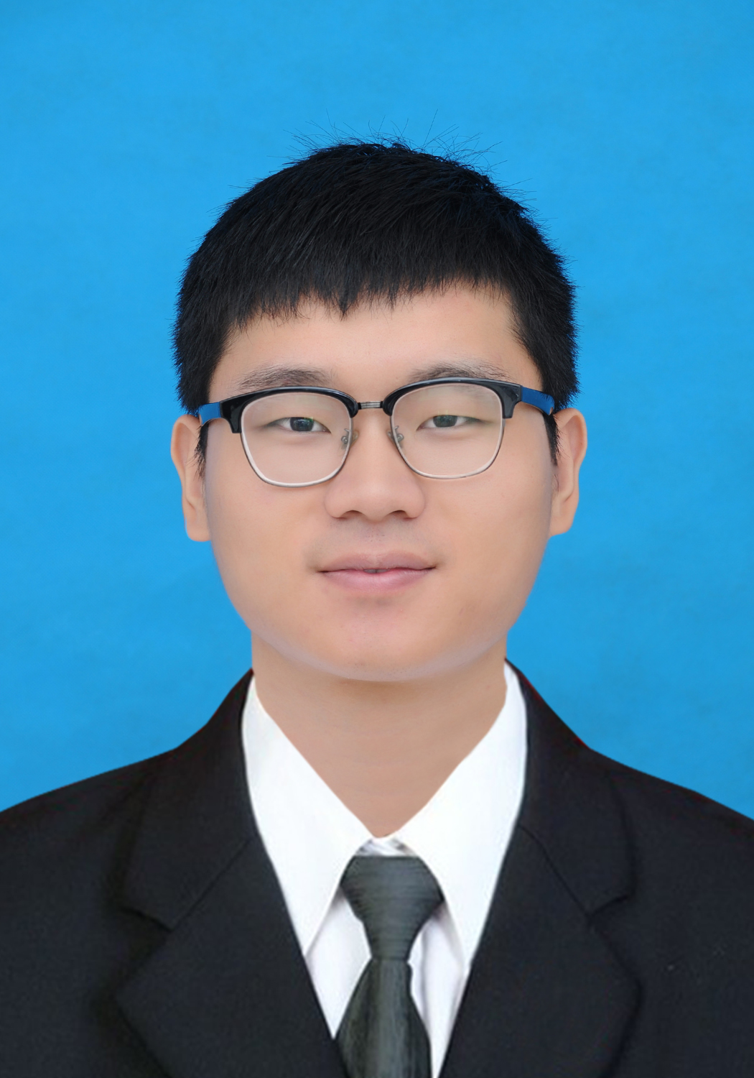

胡朝峰
——— 个人信息 ————
籍贯：安徽 阜阳 性别：男
生日：1992.08.10
政治面貌：共青团员
邮箱：846267943@qq.com
专业：动力工程
研究方向：CFD仿真优化，热管理系统仿真优化
求职意向：产品研发设计，营销服务，机械工程师
英语：CET4 501 CET6 483
———— 个人技能 ————
CAD/UG
PROE
Fluent/ICEM
Office
Photoshop
计算机二级
———— 教育背景 ————
湖南大学 2016.09-2018.07
动力工程 硕士 专业排名 5%

安徽工业大学 2011.09-2015.07
车辆工程 学士 专业排名 15%
———— 项目/科研经历 ————
2017.03-2017.07

动力电池液冷热管理系统及其优化设计
1.建立动力电池及热管理系统的三维模型；
2.分析热管理系统结构以及流体介质参数对于电池温度及均匀性的影响；
3.优化散热系统的布置、结构，将电池温度控制在一定范围内，并提高单体电池之间的温度均匀性
2016.12-2017.02
某进口涂料对彩钢瓦厂房夏季温度的影响
1.抽象建立厂房热物理模型；
2.分析涂覆涂料后厂房内温度的变化以及节能量的大小（即能减少多少热量进入厂房）；
3.根据涂料的成本以及节能量的大小计算出最优的涂层厚度；
2016.10-2016.12

某空气净化机风扇优化设计
1.对某空气净化公司提供的图纸简化，利用ICEM网格划分，导入Fluent中进行仿真；
2.根据仿真得到流场云图，流线迹线图，出口速度云图；
3.分析仿真结果，优化风道结构，提高出风效率以及减少风扇使用中产生的振动与噪音；
———— 实践/生活经历 ————
2015.07-2015.08 中国长安汽车集团股份有限公司 （合肥）
质量工程师 负责总装车间部分工位质量检测
2016.08-2016.09 湖南宏讯亿安新能源科技有限公司
使用UG进行三维模型的建立
2013.06-2013.08 芜湖奇瑞汽车 安庆中船柴油机厂 集瑞重卡
参观实习，了解机械工厂的基本运作
2013.12-2014.02 四川海底捞餐饮股份有限公司 （南京）
后堂部门主管 负责配料部门的人员与工作

———— 获得荣誉 ————
2016 湖南大学机械学院优秀学生干部
2016 湖南大学线上歌唱比赛三等奖
2016 湖南大学一等奖学金
2012 安徽工业大学二等奖学金
——— ———— 自我评价 ————
爱好广泛（唱歌，跑步，旅游），乐观上进，具有良好的团队精神，组织能力，优秀的逻辑思维以及创新意识，有较强的学习能力和抗压能力，敢于挑战自我。
Chaofeng Hu
E-mail:846267943@qq.com Tel:152-1106-5457
Seeking for a engineering position related to vehicle engineering
and thermal analysis
Education
Seeking for a R&D engineer position in biomass energy technology area
Hunan University Master in power engineering Sept,2016-Jun,2018
Anhui University of Technology Bachelor in vehicle engineering Sept,2011-Jun,2015
Skills
Research Area: Bio-pharmacy <Accurately describe research area>
gg Research Area: Bio-pharmacy <Accurately describe research
- English skills: CET-6:483; CET-4:501; Good abilities with listening, speaking and reading.
- Professional skills: being expert in CFD analysis ICEM, Fluent;Pro/Engineer UG and Auto CAD; Additional interest with Photoshop and Corel Video Studio.
- Computer skills: National Computer Rank Examination:Grade 2 :Visual Basic; Skilled in Microsoft Office.
Project Experiences
- Optimized design of the power battery management system which is cooled by liquid.
Mar,2017-Jul,2017
Description:establish three-dimensional model of the power battery management system and optimize the arrangement and structure of the cooling system to control the temperature of the battery within a certain range.
- Influence of coating on the temperature of workshop made of color steel tile on summer
Dec,2016-Feb,2017
Description:Analyze the influence of coating on the temperature of the building.The best coating thickness could be calculated according to the cost of coating and energy saving
- Optimization design of fan for air purifier. Oct,2016-Dec,2016
Description:The drawings about fans are simplified and imported into Fluent,and then simulation results could be obtained.According to the result, the air duct structure is optimized to improve the air blowing efficiency.
Social experience
- China Changan Automobile Group（Hefei） Jul, 2015-Aug,2015
Charging for components test in assemble workshop；
- Hidilao hot pot (Nanjing) Dec,2013-Feb,2014
Charging for the staff and matters in the batching Department. Making hot pot and delivering.
- Chery Automobile Corporation,China state shipbuilding corporation, Jun,2013-Aug,2013
An field trip,to learn basic operation of factory.
Honer
- Won the first prize scholarship in Hunan University;
- Won the outstanding student leaders in Hunan University;
- Won the second scholarship in Anhui University of Technology
Self-assessment
Various hobbies（reading sing running and traveling）;Honesty and Sincerity;active logic thinking;Strong learning ability; Responsibility and passion.

