1. Please use Unity5.6 or later (Unity5.6 or later is not tested),

Import Package-> Custom Package... BehaviorTree.unitypackage

1. 打开编辑器窗口

Window -> BehaviorTree

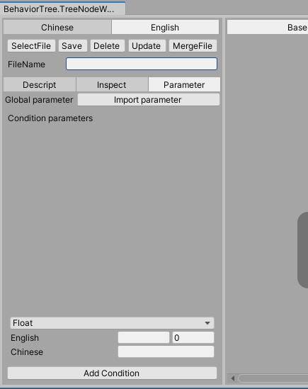

Select language button：Chinese、English

Switch to a different language, language table path

Assets\BehaviorTree\GameData\CSVAssets\table_text_localization.csv

1. The editor window that opens, As shown above

(3.1)**SelectFile**：Click the Select File button to open the selection window and select a saved configuration file to open

(3.2)**Save**：Enter the file name in the file name input box, click **Save** Button to save the configuration file in Json format to the directory Assets\BehaviorTree\GameData\BehaviorTree

(3.3)**Delete**：Click the Delete button to delete the file, filled in the file name input box

(3.4)**Update**：Click the **Update** button

Update all files in the folder:Assets\BehaviorTree\GameData\BehaviorTree

Savethe modification to the directory :Assets\BehaviorTree\GameData\BehaviorTree\Json

The specific modification logic must be in Implemented in a function: ConfigFileUpdate.UpdateData 函数中实现

(3.5)**MergeFile**：Click the **MergeFile** button，

Merge all files at **Assets\BehaviorTree\GameData\BehaviorTree** and save them to **Assets\StreamingAssets\Bina\behavior_tree_config.bytes** as binary files

1. **Options dialog**

(4.1)Descript:Description of the configuration file

For example: NPC AI configuration files and so on

(4.2)Inspector: Attribute parameters of a behavior tree node，Tell in the background

(4.3)Parameter：All environment variables configured by the behavior tree

(4.3.1) The environment variable type contains：float、int、long、bool、string

(4.3.2) Click the **Import parameter** ButtonImport variables from the configuration table into the current configuration file,The configuration table directory: Assets\BehaviorTree\GameData\CSVAssets\table_behaviortree.csv，Contains variable English name, Chinese name, type, and default value

(4.3.3) Under the window，Select variable type, fill in English name, Chinese name, default value, click Add Condition button, add variable value configuration file

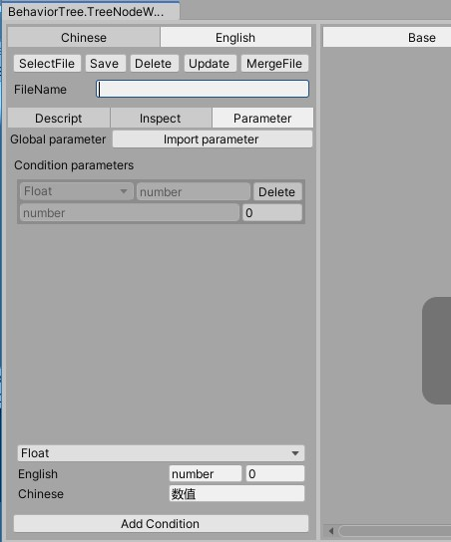

1. Edit the behavior tree node

(5.1)Add a node：Right-click in the blank area on the right of the window, select a node to be added from the menu bar, and click to add the node to the configuration file

Note: You need to add a composite node as the root node of the behavior tree (also known as the entry node)

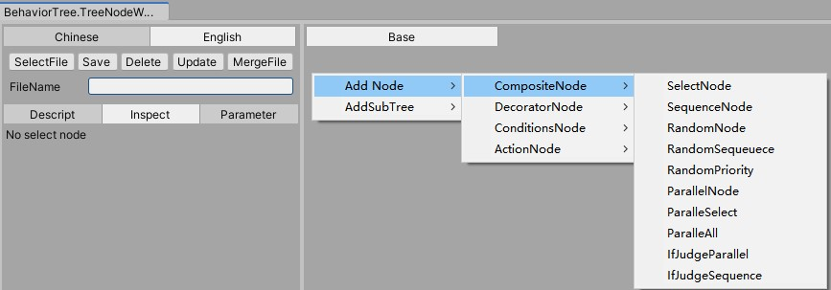

(5.2)Remove node：Right-click a Node, and choose **Delete Node** from the pop-up menu bar

(5.3)Node Add child nodes：

(5.3.1)Follow steps (5.1) to add multiple nodes to the configuration file

(5.3.2)Select a composite node, right mouse button, Popup menu bar, select **Make Transition**

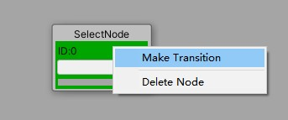

(5.3.3)Pull the mouse to pull out a line from the selected node, drag the line above other nodes, and click the left mouse button to add it as a child node

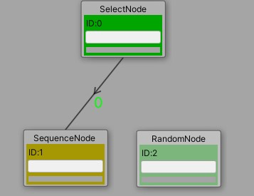

(5.4)Remove the parent node，Select a node that has a parent node, right mouse button, and choose **Remove Parent** from the pop-up menu

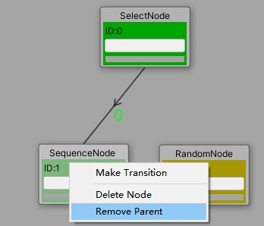

(5.5)Add the subtree：Right-click in the blank area to pop up the menu bar: Add subtree - > subtree

Subtree nodes are also composite nodes

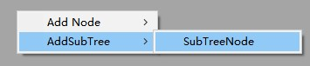

1. Add leaf node：Condition node and Action node

Right-click in a blank position , **Add Node** -> **Action Node**/**ConditionsNode** is added by clicking the left mouse button

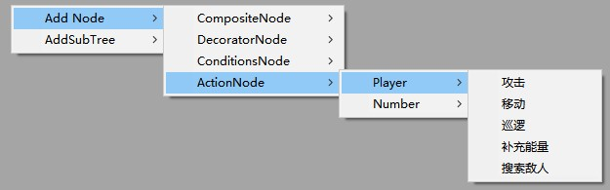

Here is a behavior tree configuration file that I edited

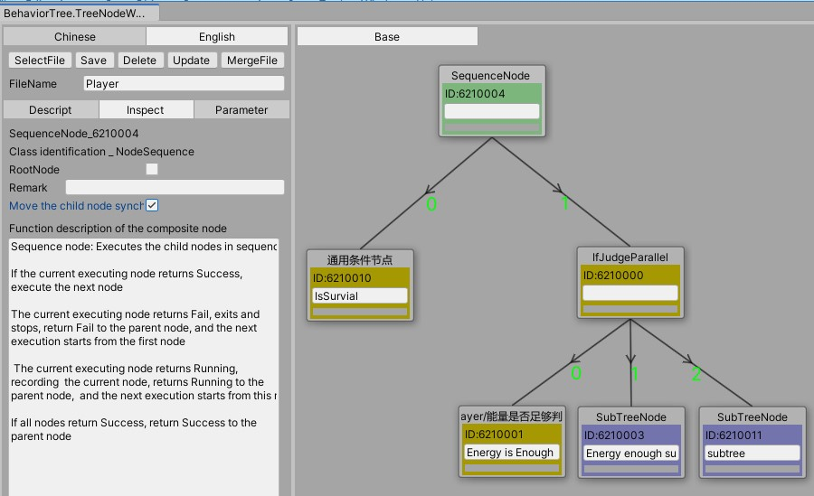

1. Interpretation of the **Inspector in (4.2)**

Select a node, and then select the **Inspectorl** option, which shows the selected node's properties, parameters, and node description

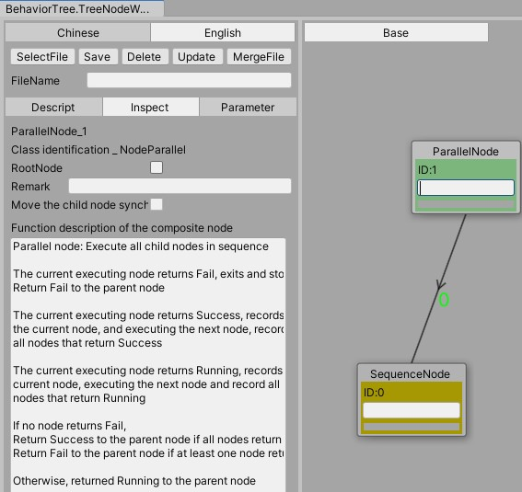

As shown above, the node is selected and the contents are displayed at the bottom of the view panel panel

(6.1) **ParallelNode**

(6.1.1)Node type and node ID

(6.1.2)**Class Identification**: The name of the script class that writes the node

(6.1.3)**RootNode**: To select a node, select the RootNode in the **Inspector**

(6.1.4)**Remark**: A simple description of a node for quick understanding of logic in a behavior tree

(6.1.5)**Move the child node synchronous**: If a node has child nodes and this option is checked, the child nodes will also be moved when the node is dragged

(6.1.6)**Function description of the composite node**:Logical description of the currently selected composite node

(6.2) **RandomPriority** Node

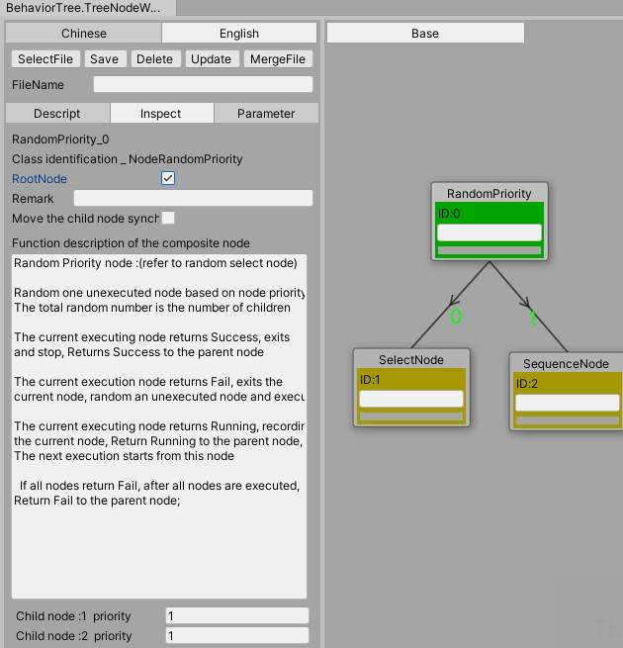

(6.2.1) The random weight node has an extra term：Random priority for each child node need to be filled in

**Child node: priority**

(6.3) **IfJudgeParallel** node

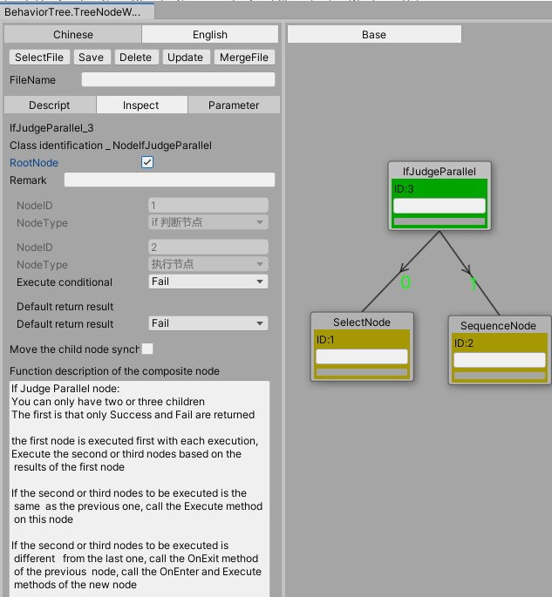

(6.3.1) node can be configured with two or three child nodes

(6.3.2) You can select the execution conditions of the second and third nodes in the **Inspector**. The execution conditions are the execution results returned by the first node, which can only be Fail or Success

(6.4) SubTree Node

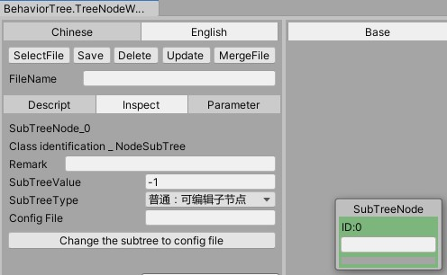

(6.4.1) Subtree types: there are two types

Common：可编辑子树节点

Configuration：读取配置文件

(6.4.2) If the subtree type is Common：可编辑子树节点，Double-click a subtree node to open a new editing panel. You can add nodes, delete nodes, and other operations in the newly opened subtree editing panel

(6.4.2.1) If the configured subtree can be shared by other modules, you can save the configured subtree as an independent configuration file, enter the file name in the **Config File**, and click **Change the subtree to config file**

(6.4.3)The subtree type is configuration：读取配置文件，Click the “**Select the subtree config file**” button, select a configuration file in the open window as the subtree configuration file, and double-click the subtree node to open and view the configuration of the selected file, but can not be modified here

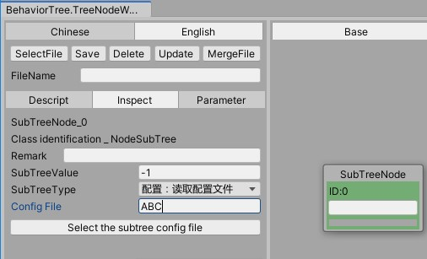

(6.5) Action Node

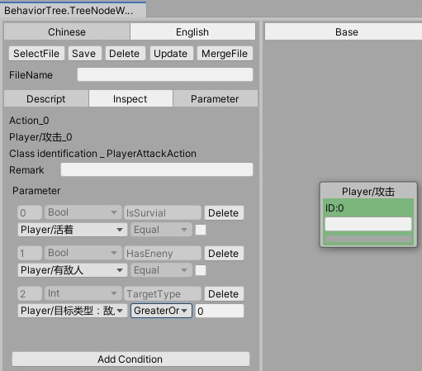

Click the **“Add Condition”** button to add parameters. When the behavior node needs to fill in some information, it can add parameters to it. The parameter value of the current behavior node configuration can be obtained in the code

(6.6) **Conditions Node**

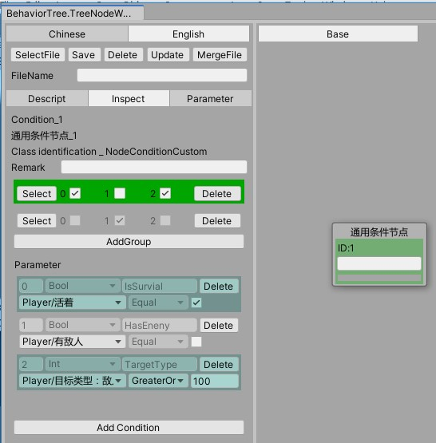

Condition node is divided into two kinds,

one is as above: **general condition node**

the other is a **custom condition node**

(6.6.1) **general condition node**：

(6.6.1.1)Click “**Add Condition**” button, add parameter, and then click “**Add Group”** button. As shown above, the node has three parameters and two groups

(6.6.1.2)The execution logic of the node is as follows

The first group:Two conditions，

IsSurvial = true，

TargetType >= 100，

Return SUCCESS if all are meet the conditions

The two group，One conditions，

HasEneny = false，

Return SUCCESS if meet the conditions

Otherwise return Fail

(6.6.1.3) Advantages of adding groups:Some logical decisions may require many different combinations, and multiple groups can be added to accommodate a variety of complex configurations

(6.6.2) Custom condition node：

When some logic is complex, or the value of some parameter variables is not convenient to be added as the environment variable of the behavior tree, it is necessary to define the condition node of XXX logic judgment by code logic

1. How are nodes used in the editor added to the editor?

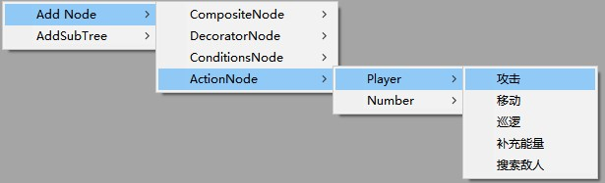

In general, **Composite Node** and **Decorator Node** do not need to be added, while conditional nodes and behavior nodes are added continuously as requirements change.

Open BehaviorConfigNode.cs

The Composite Node is added in BehaviorConfigNode.PrimaryNode() method

For example

Config<NodeSelect>(EnumNames.GetEnumName<NODE_TYPE>(NODE_TYPE.SELECT), (int)NODE_TYPE.SELECT);

Custom node

**Action Node** implementation **ActionBase**

**ConditionNode** implementation **ConditionBase**

in BehaviorConfigNode.Init() method to add **Custom Action Node**, **Condition Node**

Config<PlayerAttackAction>("Player/攻击");

To add default parameters for some nodes, you can use the

BehaviorConfigNode.ConfigDefaultParameter<T>(List<string> parameterList) where T : NodeBase, new() method to add

1. Extension : Dynamic subtree

When a character needs several different AI configurations at different levels or conditions, dynamic subtrees can be used, which can then be dynamically replaced by different AI subtrees through code logic.

Add the way:

Define subtreeClass implementation NodeSubTreeDynamicBase

overwrite CalculateNewSubTree() function，In this function, determine which subtree configuration file is currently being used and call SetSubTreeConfig(string config) function，For example,

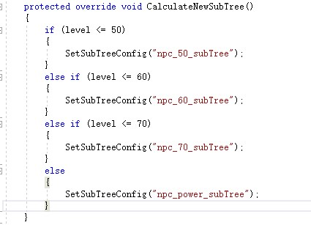

1. The behavior tree is edited, How is it used in the project?

open the scene: **Human**，Can run to view the AI effect

(1)**ConfigLoad.cs** Class load configuration files Assets\BehaviorTree\Resources\behavior_tree_config.bytes

(2)BehaviorData.cs analysis parsing configuration files

(3)SpriteManager.cs management BaseSprite.cs

(4)Instantiate BtConcrete.cs in the **BaseSprite.Init** function (Behavior tree instance)

(5)SpriteBTUpdateManager.cs Management classes for behavior trees

Add BaseSprite to SpriteManager, add BTConcrete of BaseSprite to SpriteBTUpdateManager

in SpriteManager.Update function call SpriteBTUpdateManager.Update

Delete BaseSprite in SpriteManager, Remove BaseSprite's BTConcrete from SpriteBTUpdateManager

1. ActionBase、ConditionBase、NodeSubTreeDynamicBase implementation IBTActionOwner，You can modify it according to your own project