**Projet de débruitage d’images**

HAI927I : Projet Image LIRZIN Léo – SERRANO Léa

po

Bruitage

Débruitage

Lien GitHub vers le projet: https://github.com/LIRZIN/HAI927-Projet_IMAGE

Lien Github vers le réseau de neurones utilisé: https://github.com/swz30/Restormer

Image de référence

Impulsif

Image bruitée ( gaussien )

Image de référence

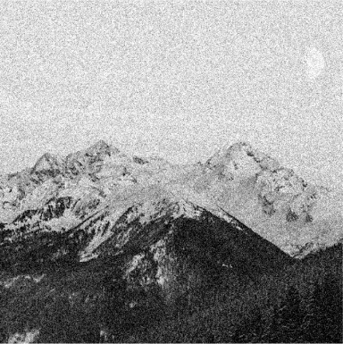

PSNR : 24.7

PSNR : 24.4

PSNR : 24.6

Algorithme Non-Local Means

Filtre gaussien

Filtre médian

Filtre moyenneur

Filtre moyenneur pondéré

Filtre gradient

Gaussien

Poivre et sel

v

PSNR : 23.1

PSNR : 20.9

PSNR : 23.7

Speckle

Poisson

* PSNR
* SNR
* SSIM
* RMSE

PSNR : 25.7

Mesure

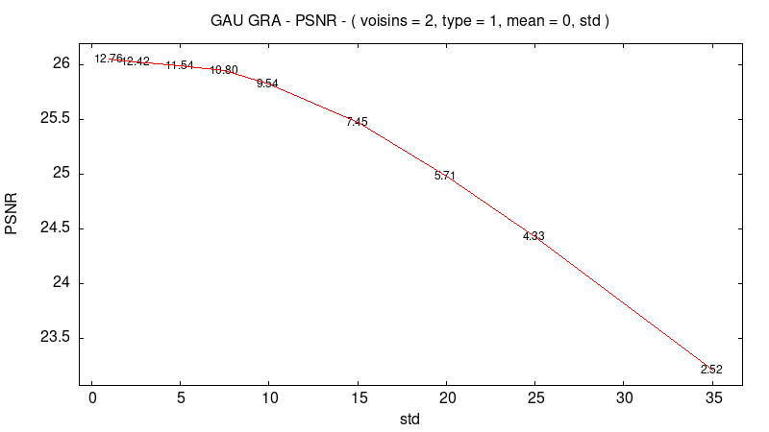

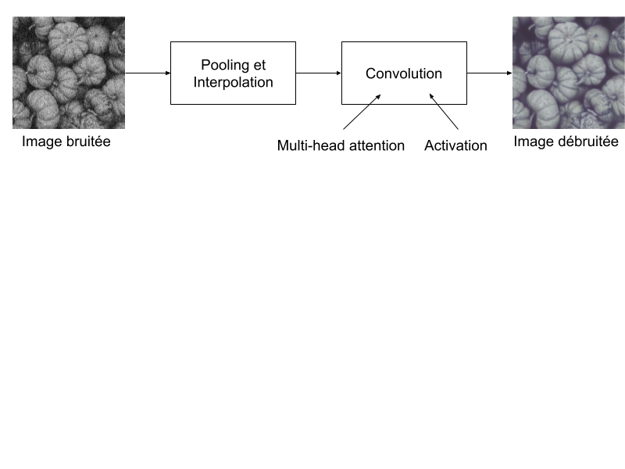

Supervisé par : William PUECH

Nicolas DIBOT

Réseau de neurones Restormer