GLOBAL Numerical-Accuracy Benchmark
Summary and Recommended Follow-up Checks
Masahiro Yoshimoto benchmark of GLOBAL modifications
Recommendation: The two proposed changes are numerically well motivated and the benchmark supports merging them into the official GLOBAL code, provided that one short convergence test is added before final approval.

1. Proposed modifications
Masahiro tested two independent numerical changes in GLOBAL:
- EDIFF refinement: change /200 to /2000. This makes the energy interval used before recalculating charge-changing cross sections about 10 times finer.
- Integration-step refinement: change coef_TXA from {1,10,100,1000,10000,100000} to {1,1,10,100,1000,10000}. This delays the rapid growth of the integration step by one decade.
- Combined case: both changes applied simultaneously.
Interpretation. The two changes address different numerical approximations. EDIFF controls how frequently energy-dependent cross sections are refreshed, while coef_TXA controls the thickness/integration step sequence. Therefore it is reasonable to test and, if validated, keep both changes.

2. Accuracy and smoothness
The benchmark uses 238U86+ at 345 MeV/u and calculates charge-state fractions as a function of Be and Ta target thickness. The modified calculations produce visibly smoother charge-state curves. This is consistent with reducing numerical discretization: the old EDIFF setting can hold cross sections fixed over a relatively large energy-loss interval, while the old coef_TXA sequence can increase the integration step quickly.
For EDIFF specifically, at 345 MeV/u the /200 setting corresponds to an energy-change scale of roughly 11 MeV/u, whereas /2000 reduces it to about 1.1 MeV/u. This provides a plausible physical/numerical explanation for the smoother thickness dependence.

3. Calculation-time benchmark
Condition | Be, 400 runs (s) | Ta, 400 runs (s) | Comment
Original | 20.304 | 16.638 | Baseline
EDIFF only | 17.237 | 15.068 | Faster in both tests
coef_TXA only | 15.420 | 17.691 | Be faster; Ta ~6% slower
Both | 14.765 | 18.256 | Be ~27% faster; Ta ~10% slower
Conclusion on speed. There is no evidence of a large systematic timing penalty. In the current benchmark the combined modification is substantially faster for Be and about 10% slower for Ta. Because the individual runs are short, the safest wording is: “No significant systematic increase in calculation time was observed in these tests.”
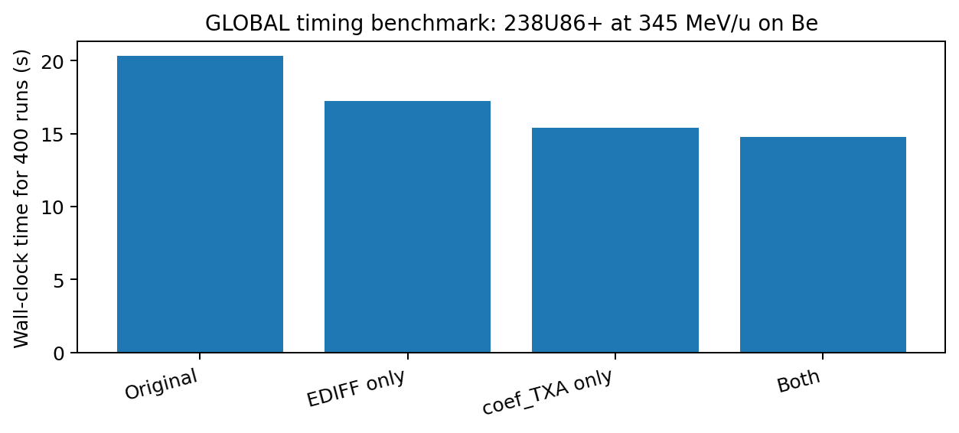
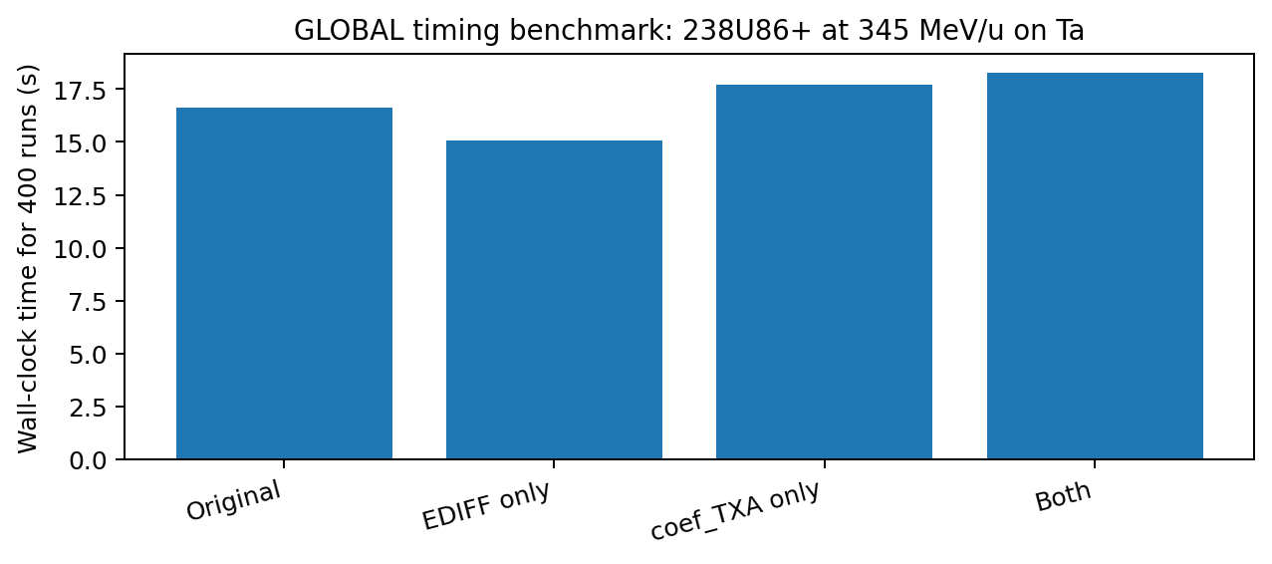

4. Additional checks requested before merging
Required: numerical-convergence check. This is the most important remaining test. For one representative Be case and one Ta case, compare the proposed settings against a still finer calculation. For example:
- Proposed: EDIFF /2000 + new coef_TXA.
- Finer EDIFF: /20000 + new coef_TXA.
- Finer integration: /2000 + one additional decade of step refinement.
If the finer calculations lie essentially on top of the proposed result, this demonstrates numerical convergence rather than simply producing a visually smoother curve.
Recommended quantitative checks:
- Report the maximum absolute change in charge-state fraction between the proposed and finer calculations, preferably for every populated charge state.
- Check charge-fraction normalization (sum close to 1) over the full thickness range and confirm that no new negative-population artifacts appear.
- If easy to instrument, count how often GLOBAL reduces DELT and restarts after a negative fraction. This may explain why the finer algorithm is faster for Be.
- Repeat the timing benchmark several times with the execution order rotated, then report the mean and spread. This will separate real performance differences from cache/system-load effects.
Optional broader validation:
- Add one lower projectile energy relevant to typical separator calculations (for example around 200 MeV/u).
- If convenient, test one additional projectile/target combination to make sure the improvement is not specific to 238U at 345 MeV/u.

5. Suggested merge decision
My assessment: the modifications should probably be accepted into the official GLOBAL GitHub version rather than kept as a private fork. The motivation is sound, the curves become smoother, and the present benchmark does not show a problematic calculation-time cost. A short convergence test would provide the strongest justification for making the new settings the default for all users.
Source benchmark: https://gist.github.com/yoshimotomasahir/34305a6e0bb60a410b40aa78925e90ef

