ARIS Prompt Radiation Utility
User and Maintenance Documentation
For ARIS prompt-radiation estimates based on the LISE⁺⁺ detailed template workflow
Prepared from the deployed Prompt Radiation Qt utility screenshots and current project structure.
Date: 17 July 2026
Version | Date | Prepared by | Prepared for | Notes
1.0 | 17 July 2026 | Oleg Tarasov with assistance of chatGPT | ARIS users | Initial documentation for the standalone deployed utility.

1. Purpose and Scope
The ARIS Prompt Radiation Utility is a standalone Qt Widgets application that automates the Detailed prompt-radiation template calculation currently performed with the spreadsheet workflow. It is intended as a practical bridge between LISE⁺⁺ output and the ARIS prompt-radiation estimate used for neutron monitor totals and dominant-contributor checks.
The present version reads two tab-delimited text input files exported from the FY2027 prompt-radiation spreadsheet and combines them with editable settings stored in an INI file. The same calculation core can later be integrated directly into LISE⁺⁺, replacing the text-file import with direct LISE⁺⁺ result access.
Current standalone status:
- This is an intermediate version that allows ARIS users to work with user text files exported from LISE results.
- Later, this utility is planned to be implemented directly in LISE⁺⁺ with a direct connection to the yield results and position results at DB0.
- The current source code and deployed package are available at https://github.com/LISEcute/PromptRadiationQt. The deployed folder allows users to run the PromptRadiation utility without having Qt installed.
- Primary calculation mode: Detailed prompt-radiation model.
- Primary input: isotope yields/rates/energies and DB0.x position information.
- Primary output: monitor dose-rate totals and the largest N0318 contributors.
- Primary editable settings: global parameters, monitor/location factors, and DB0.x stopping boundaries.

2. Deployment Folder and Required Files
For the deployed standalone version, keep the executable, the INI file, and the two prompt-radiation input text files in the same folder. In the current build this folder is typically the deployment folder such as _install.
For the latest shared ARIS version, use the GitHub project:
https://github.com/LISEcute/PromptRadiationQt
The repository includes the deployed folder so that users can run the utility directly, without installing Qt or Qt Creator.
File | Required? | Purpose
PromptRadiation.exe | Yes | Main executable for the standalone Qt utility.
PromptRadiation.ini | Recommended | Active settings file. If missing, source defaults are used and can be written back to a new INI.
PromptRadiation_InputYields.txt | Yes for text-file run | Tab-delimited yield/rate/energy input from Excel sheet “Template Detailed”, cells B4:G100.
PromptRadiation_InputPositions.txt | Yes for text-file run | Tab-delimited DB0.x position input from Excel sheet “Template Positions” / “TemplatePositions”, cells B4:G100.
Icons/* | No after build | Icons are compiled into the Qt resource file. Source tree keeps them for rebuilds.
Important spelling note: the current input files are named PromptRadiation_InputYields.txt and PromptRadiation_InputPositions.txt. This spelling is intentional in the deployed version and should be kept unless the code and deployment files are renamed together.

3. Quick Start for ARIS Users
1. Place PromptRadiation.exe, PromptRadiation.ini, PromptRadiation_InputYields.txt, and PromptRadiation_InputPositions.txt in the same deployment folder.
2. Start the application. The main window is titled “ARIS Prompt Radiation Utility”.
3. Check or edit settings under the Options menu: global settings, location factors, and DB0.x stopping boundaries.
4. Run Calculations -> Read example Yield and Position files and RUN.
5. Review the main-window output: input file paths, accepted/skipped rows, rate cutoff, number of rows used, monitor totals, and top N0318 contributors.
6. If necessary, adjust the INI settings or input files and run again.

4. Main Window and Menus
The main window uses a fixed-width font so that columns in the calculation report line up cleanly. The Calculations menu provides two execution actions in the deployed screenshot: reading the example Yield/Position text files and running the small internal example.
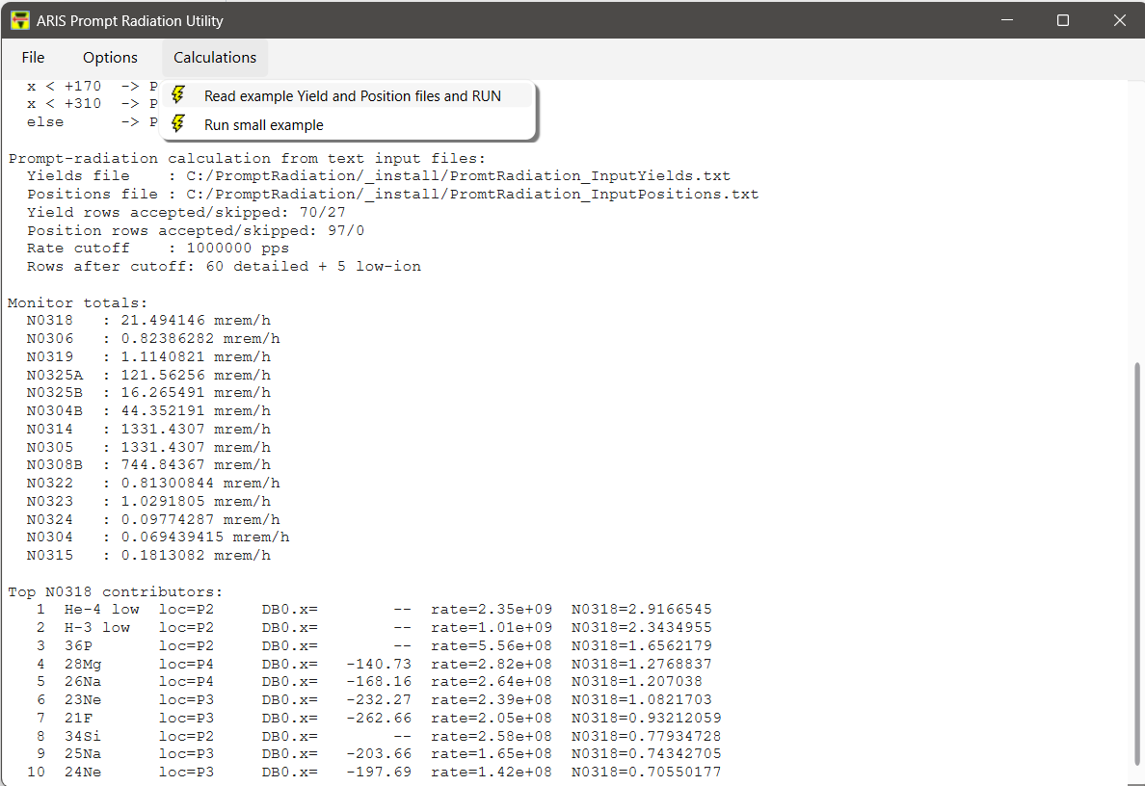
Figure 1. Main window after reading input text files and running the prompt-radiation calculation.

5. PromptRadiation Input Text Files
The current standalone workflow intentionally keeps the input simple: two tab-delimited text files are produced from the Excel template and read by the application. This makes the utility easy to test before direct LISE⁺⁺ integration.

5.1 Yield Input File
File name:
PromptRadiation_InputYields.txt
Source in Excel:
PromptRadiationTemplate_Expanded_FY2027.xlsx
Sheet: "Template Detailed"
Range: B4:G100
Expected columns:
Column | Meaning | Example | Used by calculation?
B | Fragment / isotope label | 28Mg | Yes, for matching and reporting
C | A | 28 | Yes
D | Z | 12 | Yes
E | Production mechanism | FA | Kept for information; not part of dose formula
F | Rate [pps] | 2.82e8 | Yes
G | Energy [MeV/u] | 206.60 | Yes, in the scaling factor

5.2 Position Input File
File name:
PromptRadiation_InputPositions.txt
Source in Excel:
PromptRadiationTemplate_Expanded_FY2027.xlsx
Sheet: "Template Positions" / "TemplatePositions"
Range: B4:G100
The first field is the fragment label, followed by numeric position data. The current utility uses the first numeric value after the fragment label as DB0.x in mm. The remaining numeric columns are preserved in the text file but are not needed by the present standalone calculation.
28Mg: -140.73 -146.71 8366000 12.01 26.74

6. Editable Settings and Dialogs
The application stores user-editable settings in an explicit INI file, not in the Windows registry. The default file is PromptRadiation.ini next to the executable. If the user loads or saves another INI file, that file becomes the active settings file for the current session.

6.1 Global Settings Dialog
The Global Settings dialog stores prompt-radiation parameters that are either used by the current calculation or reserved for the later direct LISE⁺⁺ integration. The dialog has a Reset defaults button, OK to save into the active INI file, and Cancel to discard changes.
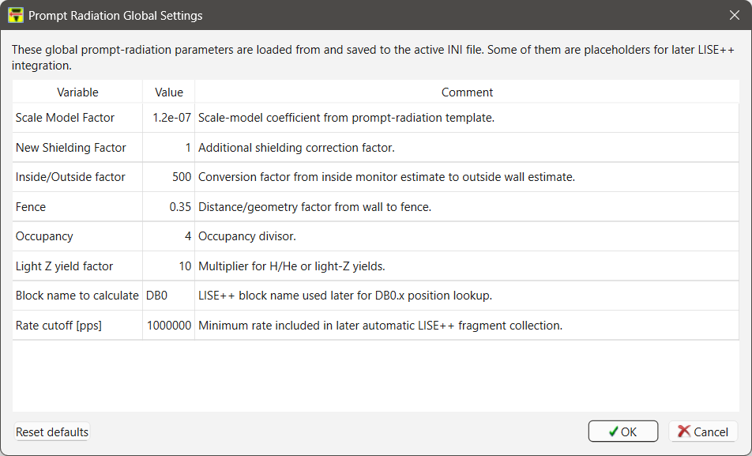
Figure 2. Global Settings dialog.
Variable | Default | Comment
Scale Model Factor | 1.2e-7 | Scale-model coefficient from the prompt-radiation template.
New Shielding Factor | 1 | Additional shielding correction factor.
Inside/Outside factor | 500 | Conversion factor from inside monitor estimate to outside wall estimate.
Fence | 0.35 | Distance/geometry factor from wall to fence.
Occupancy | 4 | Occupancy divisor.
Light Z yield factor | 10 | Multiplier intended for H/He or other light-Z yields during future automatic LISE⁺⁺ collection.
Block name to calculate | DB0 | LISE⁺⁺ block name intended for DB0.x position lookup.
Rate cutoff [pps] | 1e6 | Minimum detailed-fragment rate included in the text-file calculation.

6.2 Location Factors Dialog
The Location Factors dialog edits the monitor/location-factor table used in the dose-rate calculation. Rows are neutron monitors and columns are stopping locations. The Copy/Paste buttons allow moving values between the utility and Excel. OK saves the edited table to the active INI file.
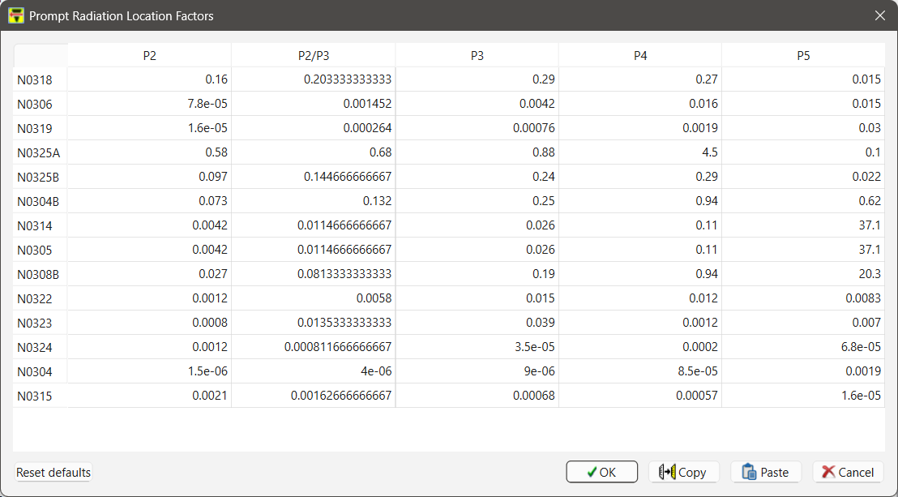
Figure 3. Location Factors dialog with monitor rows and P2/P2-P3/P3/P4/P5 columns.
- Rows: N0318, N0306, N0319, N0325A, N0325B, N0304B, N0314, N0305, N0308B, N0322, N0323, N0324, N0304, N0315.
- Columns: P2, P2/P3, P3, P4, and P5 stopping-location categories.
- The source code still contains default values; the INI file overrides them when present.

6.3 DB0.x Stopping Boundaries Dialog
The stopping-boundary dialog controls how DB0.x is converted into a stopping location. The six limits must be strictly increasing. If DB0.x is missing for a fragment, the current logic assigns P2.
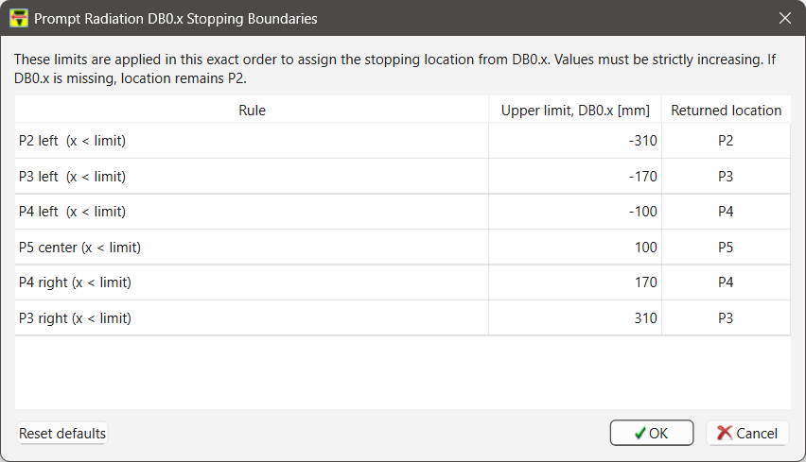
Figure 4. DB0.x stopping-boundary dialog.
x < Limit1 -> P2
x < Limit2 -> P3
x < Limit3 -> P4
x < Limit4 -> P5
x < Limit5 -> P4
x < Limit6 -> P3
else -> P2

7. PromptRadiation.ini
PromptRadiation.ini is the persistent settings file. It should be distributed with the deployed executable. If the INI file is missing or incomplete, the application falls back to defaults compiled into the source code. Reset commands restore source defaults and write them back to the active INI file.
Typical INI structure:
[GlobalSettings]
ScaleModelFactor=1.2e-7
NewShieldingFactor=1
InsideOutsideFactor=500
Fence=0.35
Occupancy=4
LightZYieldFactor=10
BlockNameToCalculate=DB0
RateCutoff=1e6
[LocationFactors]
N0318_P2=0.16
N0318_P2P3=0.20333333333333334
N0318_P3=0.29
...
[StopLocationBoundaries]
Limit1=-310
Limit2=-170
Limit3=-100
Limit4=100
Limit5=170
Limit6=310
Rule=x<Limit1:P2, x<Limit2:P3, x<Limit3:P4, x<Limit4:P5, x<Limit5:P4, x<Limit6:P3, else:P2

8. Calculation Workflow
When the user selects “Read example Yield and Position files and RUN”, the application performs the following operations:
1. Search for PromptRadiation_InputYields.txt and PromptRadiation_InputPositions.txt next to the executable and in supported working/source locations.
2. Read yield rows: fragment, A, Z, mechanism, rate, and energy.
3. Read position rows and build a fragment-to-DB0.x lookup table.
4. Load active settings from PromptRadiation.ini: global settings, location factors, and DB0.x stopping boundaries.
5. Apply the Rate cutoff [pps] to detailed yield rows.
6. Assign a stopping location from DB0.x using the six editable boundaries.
7. Calculate each fragment contribution for each neutron monitor.
8. Add the low-ion rows included in the current template/calculation core.
9. Print monitor totals and sort the largest contributors to N0318.

8.1 Dose Contribution Formula
For each accepted row, the current code follows the detailed-template structure. Energy is used in the scaling factor; DB0.x is used only for stopping-location assignment.
dose[monitor] = ratePps / 1.0e8 * scale(A, Z, energyMeVu) * locationFactor[monitor][location]
The scale term is the C++ translation of the Excel detailed-template scale column:
scale = pow(E / 160.0, 1.7)
* pow(Z / 20.0, -1.7)
* (A / 48.0)
* (pow(pow(A, 1.0/3.0), 2.0) / pow(pow(48.0, 1.0/3.0), 2.0))
* pow(A / 20.0, 1.0/3.0)
Energy units: the energy input is MeV/u, not total MeV. A higher energy increases the dose contribution through the pow(E/160, 1.7) factor.

9. Reading the Output
The main-window report includes several diagnostic sections:
Output line/section | Meaning
Yields file / Positions file | Shows exactly which input files were found and used.
Yield rows accepted/skipped | Accepted rows were parsed successfully. Skipped rows are headers, blank rows, invalid rows, or other non-data lines.
Position rows accepted/skipped | Parsed DB0.x lookup rows.
Rate cutoff | Active minimum rate threshold from Global Settings.
Rows after cutoff | Number of detailed rows used plus the number of low-ion rows added by the current calculation core.
Monitor totals | Summed dose-rate estimate for each neutron monitor in mrem/h.
Top N0318 contributors | Largest per-fragment contributors to N0318, sorted by N0318 contribution.
Monitor totals:
N0318 : 21.49 mrem/h
N0306 : 0.82 mrem/h
...
Top N0318 contributors:
1 He-4 low loc=P2 rate=2.35e+09 N0318=2.916...
2 H-3 low loc=P2 rate=1.01e+09 N0318=2.343...

10. Updating the Input Files from Excel
To update the calculation with a new LISE⁺⁺/Excel result set:
1. Open PromptRadiationTemplate_Expanded_FY2027.xlsx or the current approved prompt-radiation template.
2. Go to sheet “Template Detailed”. Copy cells B4:G100 and save/paste them as tab-delimited text named PromptRadiation_InputYields.txt.
3. Go to sheet “Template Positions” or “TemplatePositions”. Copy cells B4:G100 and save/paste them as tab-delimited text named PromptRadiation_InputPositions.txt.
4. Place both files next to PromptRadiation.exe in the deployment folder.
5. Run the utility and compare monitor totals against the spreadsheet for validation.
Recommended validation: after replacing the text files, compare N0318 and the dominant contributors with the spreadsheet before using the result operationally.

11. Notes for Developers and Maintainers
The current LISE-style project structure uses renamed files consistent with the LISE package conventions:
PromptRadiation.pro
mainPR.cpp
MainWindowPR.cpp / MainWindowPR.h
d_promtRad_GlobalSettings.*
d_promtRad_LocationFactors.*
d_promtRad_StopBoundaries.*
o_promptRad_Detailed.*
o_promptRad_LocationFactorsModel.*
o_promptRad_UiHelpers.*
Important maintenance points:
- Keep source defaults in o_promptRad_Detailed.cpp or the corresponding calculation source. The INI should override defaults, not replace them permanently.
- Keep the calculation formula unchanged unless Brad/Tom scaling or the approved spreadsheet changes.
- For direct LISE⁺⁺ integration, replace the text-file read step with direct extraction of the same fields from LISE⁺⁺ results.
- Treat the current text-file workflow as an intermediate validation/deployment stage before direct LISE⁺⁺ integration.
- Keep PromptRadiation.ini and the two text input files in the deployment package for standalone testing.
- Build folders, Qt Creator local files, and temporary folders should stay out of Git using .gitignore.

12. Troubleshooting
Problem | Likely fix
Input files not found | Place PromptRadiation_InputYields.txt and PromptRadiation_InputPositions.txt next to the executable. Check the exact spelling “Prompt”.
Too few rows after cutoff | Check Rate cutoff [pps] in Global Settings and verify that rates in the yield file are in pps.
Unexpected stopping locations | Check the DB0.x position file and the six DB0.x boundaries. Ensure the block name is DB0 for the current workflow.
Cannot save settings | Check write permission in the deployment folder or use File -> Save INI as to a writable location.
Location factor table looks wrong after paste | Paste tabular data with the same row/column layout as the dialog: monitors by rows and P2/P2-P3/P3/P4/P5 by columns.
Results differ from spreadsheet | Confirm that the same input range, rate cutoff, low-ion handling, location factors, and DB0.x boundaries are used.

13. Operational Reminder
This utility is intended to make the detailed prompt-radiation estimate reproducible and less error-prone, but the input data and parameters still need expert review. For operational use, keep the input files, INI file, and calculation output together with the corresponding LISE⁺⁺ setting/spreadsheet so that the estimate can be reproduced later.

