Important links

* Consent form- <https://utorontopsych.az1.qualtrics.com/jfe/form/SV_d1iQSbE2uSZWDQi>
* Questionnaires -<https://utorontopsych.az1.qualtrics.com/jfe/form/SV_3l92fmmlY0g3xNY>

**Zoom set-up**

* Experimenter should use the Zoom desktop application
* When scheduling a meeting, go to *Advanced Options > Automatically record meeting on the local computer.*

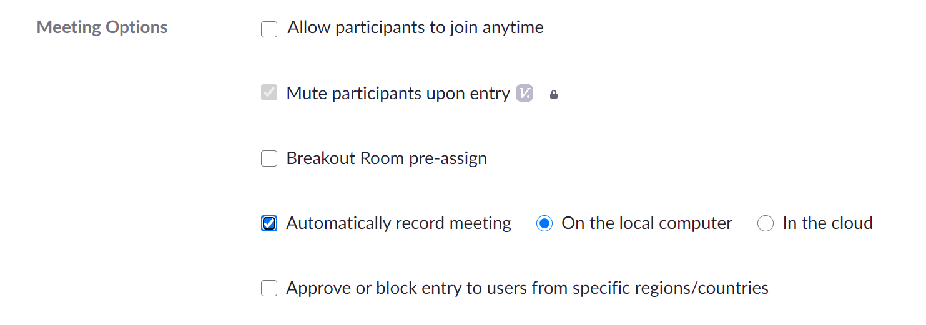

* Go to Zoom > Settings > Recording to find out where your recordings are being saved
* When scheduling a meeting, enable Waiting Room and Passcode for participants

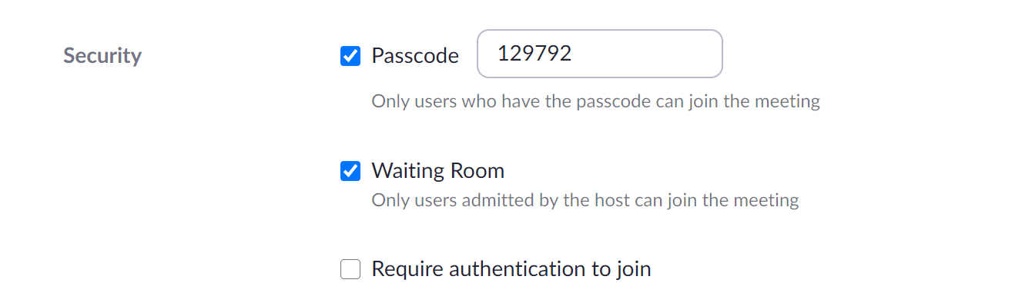

* Go to Zoom > Settings > Meeting > In Meeting (Basic) to enable **Annotation** and **Whiteboard** featuresfor both host and participant
  + Note: Enabling both the Annotation and Whiteboard settings will allow you and the participant to place a “stamp” on the shared screen for the training phase *(explained later in detail)*

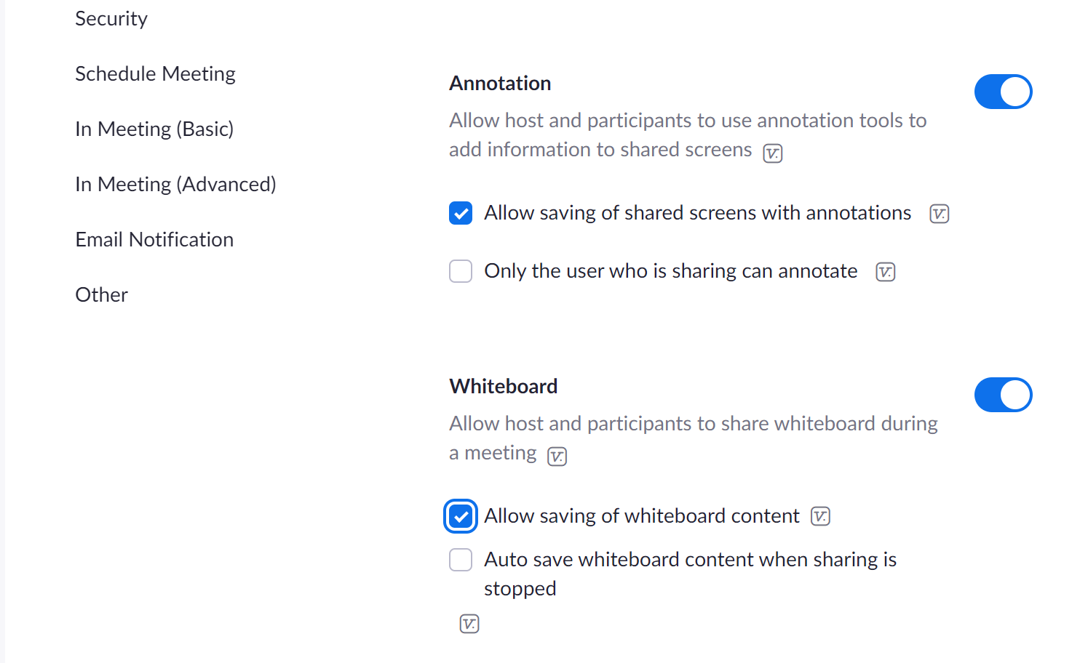

**Prior to day of experiment**

1. Experimenter schedules the video call on Zoom.

2. Email the Zoom invitation, Consent Form, and Questionnaire links to the parent.

a. Consent form <https://utorontopsych.az1.qualtrics.com/jfe/form/SV_d1iQSbE2uSZWDQi>

b. Questionnaire

<https://utorontopsych.az1.qualtrics.com/jfe/form/SV_3l92fmmlY0g3xNY>

c. You can track if the parent has completed the forms on the *Emotion Box Study spreadsheet:*

***Before the Zoom call begins***

3. Open the Emotion Box Study spreadsheet to check if the consent form has been filled. Also check the child’s date of birth to confirm with the parent.

4. Load the Certificate PowerPoint and have the participant’s name pre-filled.

5. Prepare the Training Phase template ppt file for screen sharing.

***Zoom call***

6. Allow the parent and participant into the Zoom call.

7. Enable screen sharing and open Powerpoint with the Training Phase template file.

8. Once everyone has settled down and is comfortable, begin the brief of the experiment.

**Before Experiment (Brief Description):** Describe the Experiment to the Parent over Zoom and obtain informed consent

“In this study we are looking to see how children categorize musical sounds based on the feeling the music expresses. The first part will consist of a training phase where we will show your child how to identify the different levels of the rating scale. We will do that live over Zoom.”

“The second part of the study will consist of a computer game. In the computer game, your child will meet cartoon animals who are listening to music. Your child will listen to the music and we will ask them questions about the feelings expressed through the music. It should take 15-20 minutes. During both parts, please let your child respond spontaneously, without affecting their response. There are no wrong answers and it’s important that they give us their own spontaneous response.

|  |
| --- |
| ***Before we begin, let’s confirm ___’s date of birth.***  *[****make sure they are still eligible for the study):*** *5 years old*  *We have received your consent form. Did you have any questions about the study?* |

9. *CONSENT FORM: MUST be completed before the study continues. If they have not filled out the Consent form yet, have the link on hand in case and, send it to them via the Zoom chat:*

*https://utorontopsych.az1.qualtrics.com/jfe/form/SV_d1iQSbE2uSZWDQi*

10. Prior to the Training Phase, demonstrate how to place a “stamp” using the Zoom ‘Annotate’ feature to parent and participant.

|  |
| --- |
| **How to Use ‘Annotate’ Feature on Zoom** *(to place “stamp” on the screen)*   * Go to Share Screen and open the “Training Phase Template” ppt. file        * Once you confirm that the participant can see your shared screen, explain to them how to put a “stamp” on the shared screen   + **Go to Annotate > Stamp**      * Allow participant to choose a stamp (as seen in screenshot below)      * Ask participant to try putting a stamp anywhere on the screen *(it should look something like this) :*        * **SIDE NOTE:** You can clear any of the drawings, or “stamps” that either you or the participant have placed on the screen if you go to **Annotate > Clear** *(as seen in the screenshot above)*   + This will be useful since you can clear the stamp before beginning each trial of the training phase |

11. Once you have confirmed that they are able to place a stamp on the screen using the **Annotate** feature, you can begin the Training Phase for either Valence or Arousal (depending on which version they are assigned)

**Arousal Training**

**Valence Training**

**Training for Arousal Version of the Experiment**

“Here we have five different spots. The different spots are for different feelings.”

[Stick Figure]

“How this little person feels can be shown by putting a stamp on one of the spots.”

**Stage 1: Two extremes**

“This end here (*far left black pedestal*) is for when the stickman feels very very sleepy. When he moves this way (to the right) he feels better and better, until he gets to this spot (*far right black pedestal*) where he feels very very wide awake.”

“Remember, this end (*pointing to the far left black pedestal*) is for when he feels very very sleepy, like when it is late at night and you’re in bed. Do you know how that feels? (*child responds)*.”

“This end (*pointing to the far right black pedestal*) is for when he feels very very wide awake, like when you’re moving around a lot. Do you know what that is like? (*Child responds*)”

*[Then the child is given practice trials for just the two end pedestals.]*

“The stick man is feeling very very sleepy. Can you put a stamp on the correct spot?”

“The stick man is feeling very very wide awake. Can you put a stamp on the correct spot?”

*[Get* ***3 in a row*** *correct to move on. Incorrect trials are corrected, and correct trials praised.]*

*[If correction is required, remind child of the label, then identify the correct pedestal and repeat the label]*

**Stage 2: Low Arousal**

*[Point to left half]*

“This end is for when the stick man feels sleepy. Remember, this spot is for when he feels very very sleepy, like when it's late at night and you’re in bed. But if he feels just a little sleepy, then he goes here (*pointing to the bad-grey box*) like when you yawn. A little sleepy is right beside very sleepy”.

Now can you tell me what this spot means (grey)? How about this one (black)?

*[Then the child is given practice trials for just the two bad boxes.]*

“The stick man is feeling very very sleepy. Can you put a stamp on the correct spot?”

“The stick man is feeling a little sleepy. Can you put a stamp on the correct spot?”

*[Get* ***3 in a row*** *correct to move on. Incorrect trials are corrected, and correct trials praised.]*

*[If correction is required, remind child of the label, then identify the correct pedestal and repeat the label]*

**Stage 3: High Arousal**

*[Point to right half]*

“This end is for when the stick man feels wide awake. Remember, this spot is for when he feels very very wide awake, like when you’re jumping around. If the stickman feels awake but not as much as in this spot (good black box), then he goes in this spot (good grey box).

This spot is for when the stickman feels wide awake, like when you are walking around. Now can you tell me what this box means (grey)? How about this one (black)?

*[Then the child is given practice trials for just the two good boxes.]*

“The stick man is feeling very very wide awake. Can you put a stamp on the correct spot?”

“The stick man is feeling wide awake. Can you put him in the correct box?”

*[Get* ***3 in a row*** *correct to move on. Incorrect trials are corrected, and correct trials praised.]*

*[If correction is required, remind child of the label, then identify the correct spot and repeat the label]*

**Stage 4: Four Levels**

*[Choose a random label out of the four labels we have learned (very very sleepy, very very wide awake, little sleepy, wide awake) and ask kid to put the stamp on the correct spot]*

*[Get* ***FIVE in a row*** *correct to move on. Incorrect trials are corrected, and correct trials praised.]*

*[If correction is required, remind child of label, then identify the correct pedestal and repeat the label]*

**Stage 5: Normal**

*[Point to the middle white]*

*“We have one spot left that we haven’t talked about yet”.*

“We have the middle spot left. This spot is for when the stick man feels normal. He’s not feeling sleepy and he’s not feeling wide awake – he’s just feeling normal.

Remember, this side is for when he feels sleepy *(point to left)* and this side is for when he feels wide awake *(point to right)*, and this middle spot is for when the stickman feels normal, not sleepy or wide awake.”

*[Then the child is given practice trials for just the middle box.]*

“The stick man is feeling normal. Can you put a stamp on the correct spot?”

*[Get* ***2 in a row*** *correct to move on. Incorrect trials are corrected, and correct trials praised.]*

*[If correction is required, remind child of label, then identify the correct pedestal and repeat the label]*

**Final Training:**

“Now we are going to use the whole screen. Can you show me how you feel today?”

*[after the child shows you, show them the stickman on the screen and say the following]*

“Eg. One day the stickman felt very very sleepy. Where should he go?”

*[show child stickman and ask them to put a stamp on what they think is the correct spot]*

*[Repeat for each label. Get FIVE in a row correct to move on. Incorrect trials are corrected, and correct trials praised.]*

*[If correction is required, remind child of the label, then identify the correct pedestal and repeat the label]*

**Training for Valence/Pleasure Version of the Experiment**

“Here we have five different spots. The different spots are for different feelings.”

[Stick Figure]

“How this little person feels can be shown by putting a stamp on one of the spots.”

**Stage 1: Two extremes**

“This end here (far left black pedestal) is for when the stickman feels very very bad. When he moves this way (to the right) he feels better and better, until he gets to this spot (far right black box) where he feels very very good.”

“Remember, this end (pointing to the far left black pedestal) is for when he feels very very bad, like when someone breaks all your toys or when you have a nightmare. Do you know how that feels? *(child responds)*.”

“This end (pointing to the far right black pedestal) is for when he feels very very good, like when you get a lot of toys. Do you know what that is like? *(Child responds)*”

[Then the child is given practice trials for just the two end boxes.]

“The stick man is feeling very very bad. Can you put a stamp on the correct spot?”

“The stick man is feeling very very good. Can you put a stamp on the correct spot?”

[Get 3 in a row correct to move on. Incorrect trials are corrected, and correct trials praised.]

[If correction is required, remind child of label, then identify the correct pedestal and repeat the label]

**Stage 2: Displeasure**

[Point to left half]

“This end is for when the stick man feels bad. Remember, this spot is for when he feels very very bad, like when someone breaks all your toys. But if he feels just a little bad, then he goes here (pointing to bad-grey box) like when someone breaks just one of your toys. A little bad is right beside very bad”.

Now can you tell me what this box means (grey)? How about this one (black)?

[Then the child is given practice trials for just the two bad pedestals.]

“The stick man is feeling very very bad. Can you put a stamp on the correct spot?”

“The stick man is feeling a little bad. Can you put a stamp on the correct spot?”

[Get 3 in a row correct to move on. Incorrect trials are corrected, and correct trials praised.]

[If correction is required, remind child of the label, then identify the correct pedestal and repeat the label]

**Stage 3: Pleasure**

[Point to right half]

“This end is for when the stick man feels good. Remember, this spot is for when he feels very very good, like when you get lots of toys. If the stickman feels good but not as much as in this spot (good- black pedestal), then he goes in this spot (good-grey pedestal).

This box is for when the stickman feels a little good, like when you get only one toy. Now can you tell me what this spot means (grey)? How about this one (black)?

[Then the child is given practice trials for just the two good pedestals.]

“The stick man is feeling very very good. Can you put a stamp on the correct spot?”

“The stick man is feeling a little good. Can you put a stamp on the correct spot?”

[Get 3 in a row correct to move on. Incorrect trials are corrected, and correct trials praised.]

[If correction is required, remind child of the label, then identify the correct pedestal and repeat the label]

**Stage 4: Four Levels**

[Choose a random label out of the four labels we have learned (very very bad, very very good, little bad, little good) and ask kid to put the stickman in the correct spot]

[Get FIVE in a row correct to move on. Incorrect trials are corrected, and correct trials praised.]

[If correction is required, remind child of label, then identify the correct pedestal and repeat the label]

**Stage 5: Normal**

[Point to the middle white]

“We have one left that we haven’t talked about yet”.

“We have the middle spot left. This spot is for when the stick man feels normal. He’s not feeling bad and he’s not feeling good – he’s just feeling normal.

Remember, this side is for when he feels bad (point to left) and this side is for when he feels good (point to right), and this middle spot is for when the stickman feels normal, not bad or good.”

[Then the child is given practice trials for just the middle box.]

“The stick man is feeling normal. Can you put a stamp on the correct spot?”

[Get 2 in a row correct to move on. Incorrect trials are corrected, and correct trials praised.]

[If correction is required, remind child of label, then identify the correct pedestal and repeat the label]

**Final Training:**

“Now we are going to use the whole screen. Can you show me how you feel today?”

*[after the child shows you (by placing stamp on a spot), show them the stickman and say the following]*

“Eg. One day the stickman felt very very bad. Where should he go?”

*[show child stickman and ask them to put a stamp on what they think is the correct spot]*

*[Repeat for each label. Get* ***FIVE in a row*** *correct to move on. Incorrect trials are corrected, and correct trials praised.]*

*[If correction is required, remind child of the label, then identify the correct pedestal and repeat the label]*

**Testing Phase for Valence or Arousal Version of the Experiment**

“Now let’s do part 2! Your child will be playing a computer game in which they meet cartoon animals who are listening to music. Your child will listen to the music and will be asked to answer questions by clicking on the screen. It will take approximately 15 minutes to complete. I will send the link to access the computer game in the Zoom chat. All instructions are narrated in the game so please adjust your device to a comfortable volume. Have fun playing the game! You can turn off my video but I’ll stick around so that if you have a question you can ask me.”

**After the Testing Phase**

Thank ____ so much for participating! Did you have fun? You did such a great job! Now I can tell you a little bit more about the purpose of the experiment. _____

The purpose of this experiment is to examine how 5 year-old children identify emotions that they hear in music.

By the time we are adults, it is easy for us to identify the emotion we hear in a piece of music. For example, everyone agrees that the Jaws theme song sounds scary, whether they have had music training or if they never learned anything about music at all! We want to know if children interpret emotions in music the same way as adults. Do you have any questions about the research?

[if they ask further questions you can tell them about the different scales, but don’t use the words valence/arousal - use the words “good vs. bad” and “intense vs. calm” instead)

**If the parent has not completed the Questionnaire yet:** Please make sure to fill out the questionnaire after this call ends. If you do not have the link, we can send it again.

We will send you ____’s certificate after this meeting. You will also receive a $5 gift card for either Amazon, Walmart or Indigo as a Thank-You. Which one do you prefer? Do you have any questions?

Thank you again for your participation!

|  |
| --- |
| **NOTE: During the experiment, ask the parent if we can take a photo for the certificate by having the child smile at the camera.**   * Alternatively, you can ask the parent to send a picture of their child (through email or Zoom chat) to add to the certificate * For more instructions how how to create a “Jr Scientist” certificate, refer back to the TEMPO lab manual (page 24) |

**After the Zoom Call**

1. Once you have received the Questionnaire from the parent, finish making the certificate.
   1. Follow instructions on the Certificate Template to add the photo
   2. Use the “Name of the certificate” as indicated on the Questionnaire form
   3. Email the participant’s certificate to the parent
   4. After making the certificate, remember to save as a PDF. Name the file as the Child’s initials and indicate the study name.
2. Go back to the Emotion Box Masterlist and any necessary notes regarding the experiment (e.g. child refused to participate, child did not finish the computer game, etc).