Summary of Waterloo Region Vote Intention, Spring 2021

Simon J. Kiss

Matthew Arp

Scott Lu

05/05/2021

## Introduction

## Federal Vote

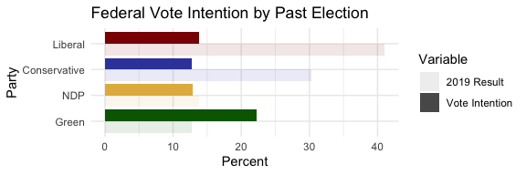

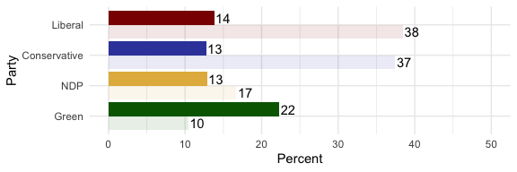

## Provincial Vote

