Summary of Waterloo Region Vote Intention, Spring 2021

Simon J. Kiss

05/05/2021

# Introduction

These graphs are based on pre-built code and a test file provided to us. When we get the full data-set, we will be able to simply plug it in, re-run this and get this document.

At this point, I would welcome any additional tips about additional cross-tabs people may find interesting as well as any tweaks about the appearances of these graphs.

Right now these are all based on weighted data, which we will be provided. In addition, please note that the ideology variable is pretty crude. It is taken by summing each person’s reported federal vote 2019, provincial vote 2019, and federal vote intention and provincial vote intention. Responses for the NDP were scored with 1, the Greens were scored 1.5, the Liberals scored with 2 and the Conservatives (PCs) scored with 3.

# Polls

We have grabbed the published polls for the recent period for Ontario. I thought it would be useful to compare the standing in Waterloo Region with provincial poll results at the same time period.

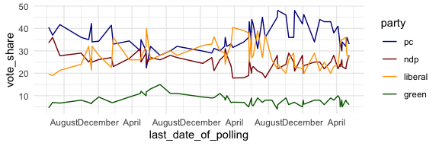

Publicly available polls, Ontario. This can obviously be tweaked for appearance

# Federal Vote

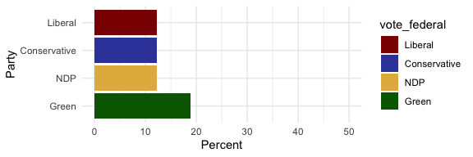    
   
   
   
 

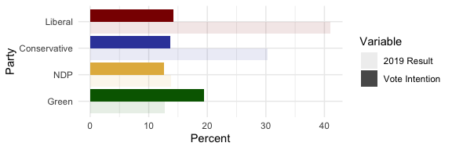

Federal Vote Intention By 2019 Result

   
   
   
 

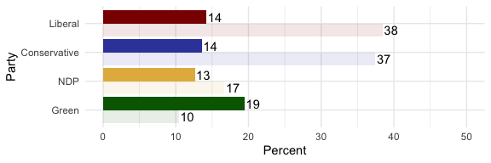

Federal Vote Intention By Historic Average

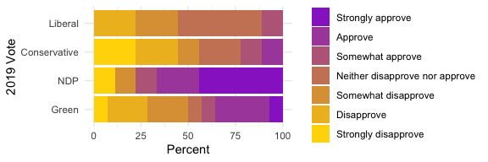

Approval of Trudeau handling by 2019 Vote

# Provincial Vote

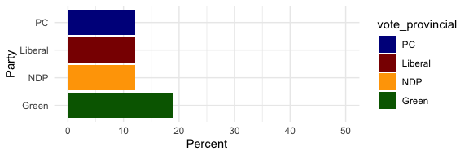

Distribution of Provincial Vote Intention, Waterloo Region 2019

   
   
 

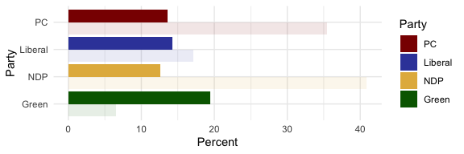

Provincial Vote Intention By 2018 Result

   
 

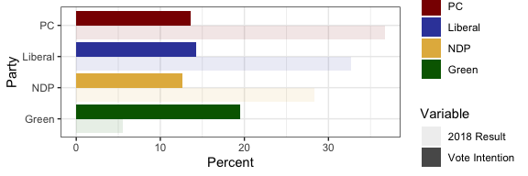    
   
   
 

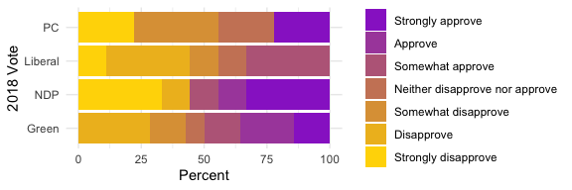

Approval of Ford Handling by 2018 Vote

# Vaccine Hesitancy

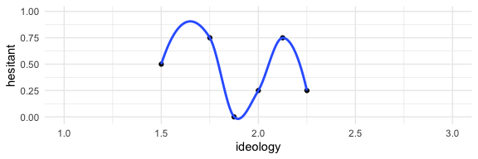

Correlation of Vaccine Hesitancy By Ideology