Summary of Waterloo Region Vote Intention, Spring 2021

DRAFT: Not for circulation or attribution

Simon Kiss[1]

Andrea Perrella[2]

Anthony Piscitelli[3]

05/05/2021

# 1 Headline Findings

1. Liberals lead in Waterloo Region in spring, federally and provincially. Federally, **28% of all respondents and 49% of all decided respondents** said they would vote Liberal. The latter number is an increase of 11 percentage points over the Liberals’ 2019 results in Waterloo Region.
2. Provincially, the Liberals lead, but the the gap was much smaller. **22% of all respondents said they would support the Liberals compared to 18%** for the PCs. This rose to 33% for decided voters for the Liberals and 29% for the PCs. **This gap is just within the study’s margin of error**
3. Share of 2019 Liberal voters who approved of Justin Trudeau’s handling of the pandemic was **13 percentage points** higher than the share of 2018 PC voters who of Doug Ford's handling of the pandemic (73% versus 60%) (see Tables 3.2 and 4.2). **Trudeau had better evaluations from his most recent voters than Ford did.**
4. Controlling for past federal and provincial votes, **approval of handling the pandemic** was a significant predictor of whether a voter would vote for both parties (see Tables ??, ??)
5. Conclusion: The Trudeau government’s handling of the pandemic helped its political standings and the Ford government’s handling of the pandemic hurt its chances in Waterloo Region.
6. Waterloo Region is an important bellwether set of ridings in Ontario. Table 6.1 and 6.2 show the number of ridings since 2003 in provincial and general elections that have returned members whose party formed the government.

# 2 Study details

* Survey of voters in Waterloo Region via cell, landline and web
* Conducted by the University of Waterloo Survey Research Center
* Sampled 502 residents`
* Margin of error associated with a survey this size is +/- 4 percentage points
* Survey overrepresented women (54% of the sample), over educated (46% of the sample with degrees, v. 25% in the population) and older people (30% and 20% were men and women over 65 in the sample, versus 17% and 19% of the population). Sample was very closely matched geographically.
* Weights have been calculated to ensure the sample is matched on sex, education and age.
* Survey dates were from March 10 2021 to April 22 2021. This covered the start of the third wave and the provincial government’s most recent stay-at home order of April 7th, 2021.
* More details available from the authors technical documentation

# 3 Federal Vote Intention, Spring 2021

Figure 3.1 shows the weighted federal vote intention of all voters, *including undecided voters*, in Waterloo Region, spring 2021.

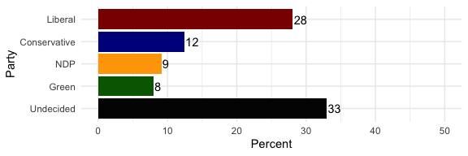

Figure 3.1: Distribution of Federal Vote Intention, Waterloo Region 2021

Figure 3.2 shows the weighted federal vote intention in Waterloo Region, spring 2021, *excluding* undecided voters.

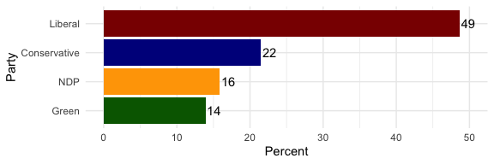

Figure 3.2: Distribution of Federal Vote Intention, Decided Voters Only, Waterloo Region 2021

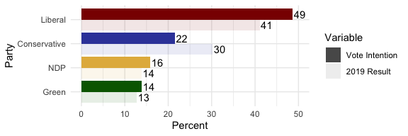

Figure 3.3: Federal Vote Intention By 2019 Result

To add a bit of context we can compare these with the last election’s results. Figure 3.3 shows the current results of *decided* voters only, compared to the results of the 2019 federal election. Note that the Liberals were eight points ahead than their 2019 results, while the Conservatives were behind their past results.

Lastly, we can also compare the spring survey of voters with the historic average levels of support received by the parties in Waterloo Region. Figure 3.4 shows this, including only *decided voters*.

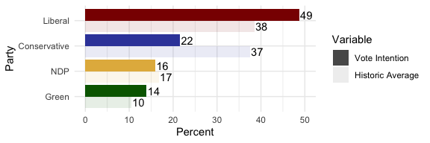

Figure 3.4: Federal Vote Intention Compared To Historic Averages

## 3.1 Assessment Of Federal Handling Of The Pandemic

Table 3.1 shows that 61% of the respondents approved of how Trudeau had handled the pandemic.

Table 3.1: Support For Trudeau’s Handling of The Pandemic

Approval

Pct

Approve

61

Disapprove

29

Neither

10

If we break it out by vote intention, obviously we get different results. Figure 3.5 shows the assessment of Prime Minister Justin Trudeau's handling of the pandemic by reported vote in the 2021 federal election.

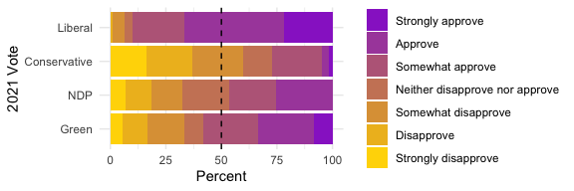

Figure 3.5: Approval of Trudeau handling by 2021 Vote Intention

More specifically, table 3.2 shows that 73% of people who voted Liberal and 16% of people who voted Conservative approved of the job that Justin Trudeau has done handling the pandemic.

Table 3.2: Approval of Trudeau’s Handling Of The Pandemic By Past Vote

Approve

Neither

Disapprove

Liberal

73

7

20

Conservative

16

13

71

NDP

54

17

28

Green

40

19

41

Other

9

29

61

Did Not Vote

59

29

12

DK

61

24

15

# 4 Provincial Vote

Figure 4.1 shows the distribution of the provincial vote intention, *including undecided voters*.

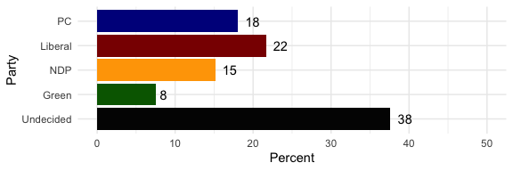

Figure 4.1: Distribution of Provincial Vote Intention, Waterloo Region 2019

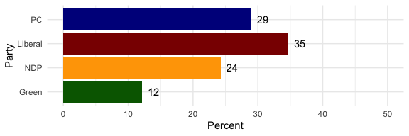

Figure 4.2: Distribution of Provincial Vote Intention, Waterloo Region 2019, Decided Voters Only

Figure 4.3 shows the current provincial vote intention *amongst decided voters* compared to the 2018 results. The Liberals have almost doubled their support amongst decided voters; the NDP have lost more than half their supporters.

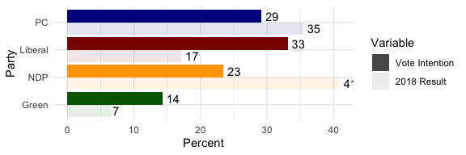

Figure 4.3: Provincial Vote Intention By 2018 Result

Figure 4.4 shows the current voting intention by the parties’ historic averages in Waterloo region.

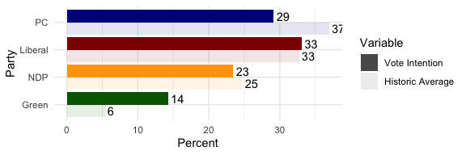

Figure 4.4: Provincial Vote Intention By Historic Average

Table 4.1 shows that 61% of the respondents approved of how Ford had handled the pandemic.

Table 4.1: Support For Ford’s Handling of The Pandemic

Approval

Pct

Approve

47

Disapprove

44

Neither

9

Figure 4.5 shows the distribution of approval of Ford’s handling of the pandemic by 2022 vote intention.

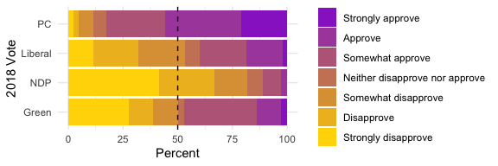

Figure 4.5: Approval of Ford Handling by 2022 Provincial Vote Intention

Table 4.2 shows that 61% of past PC voters approve of the job that Ford is doing, while only 51% of Liberal voters and only 29% of past NDP voters approve.

Table 4.2: Approval of Doug Ford’s Handling Of Pandemic By 2018 Past Vote

Approve

Neither

Disapprove

PC

61

7

32

NDP

29

7

64

Liberal

56

4

40

Green

38

0

62

Other

0

0

100

Did Not Vote

34

34

32

DK

43

22

35

# 5 Vaccine Hesitancy

Table 5.1: Vaccine Hesitancy by 2018 Vote

Not Hesitant

Hesitant

n

PC

80

20

103

NDP

96

4

77

Liberal

100

0

135

Green

83

17

43

Other

100

0

2

Did Not Vote

84

16

79

DK

80

20

58

# 6 Waterloo Region As Bellwether

Table 6.1: Waterloo Region Ridings As Provincial Bellwether

Year

# Ridings

# of Government MPPS

Percent

2003

3

1

33

2007

4

2

50

2011

4

2

50

2014

4

2

50

2018

5

3

60

Table 6.2: Waterloo Region Ridings As Federal Bellwether

Year

# Ridings

# of Government MPPS

Percent

2004

4

3

75

2006

4

2

50

2008

4

4

100

2011

5

4

80

2015

5

5

100

2019

5

5

100

1. Laurier Institute for the Study of Public Opinion and Policy, Wilfrid Laurier University
2. Laurier Institute for the Study of Public Opinion and Policy, Wilfrid Laurier University
3. Laurier Institute for the Study of Public Opinion and Policy, Conestoga College