The LIST-Parser offers you specific language specific data from a text as represented in the table below:

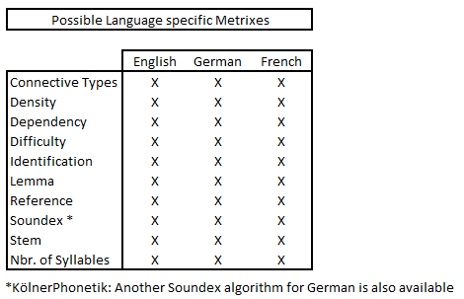

Example Code:

Text text = new Text(“location/to/a/text.txt”, Language.EN);

After the tool completed the computation, several options can be received by simply using the geta functions listed below:

