**How to modify or change user information**

To change your password and/or view and modify your user information, select your email address located at the top of your screen.

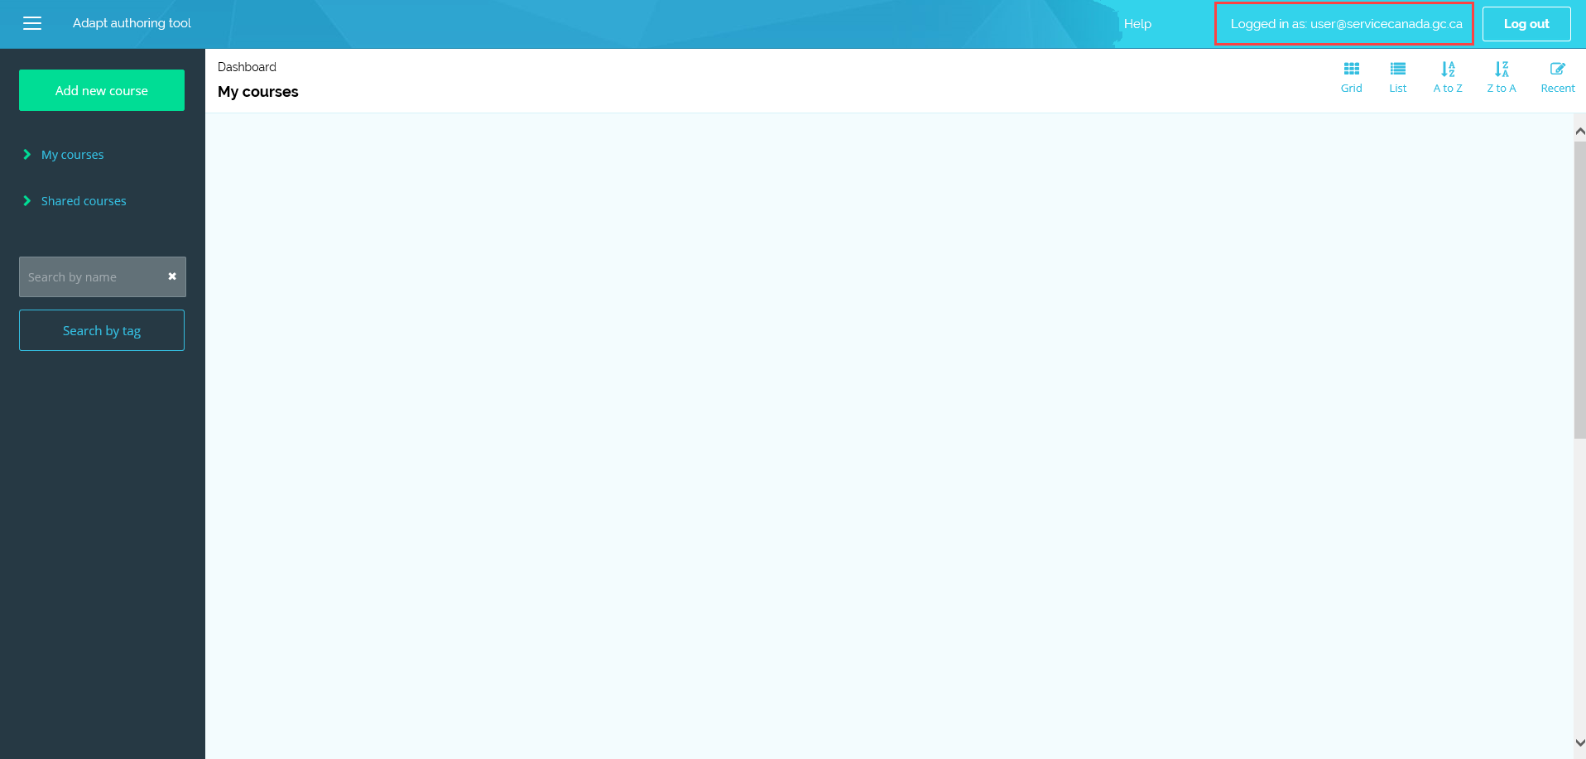

To modify your user information, simply update your information and select the button labelled **Save**. 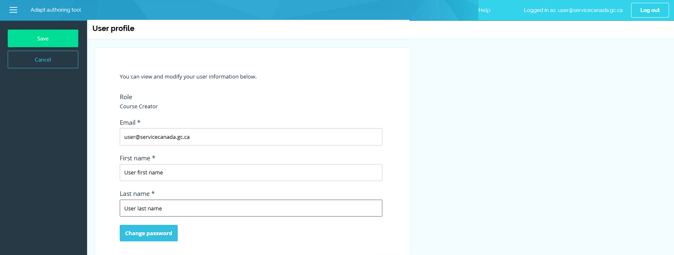

To change your password, select the button labelled **Change password**.

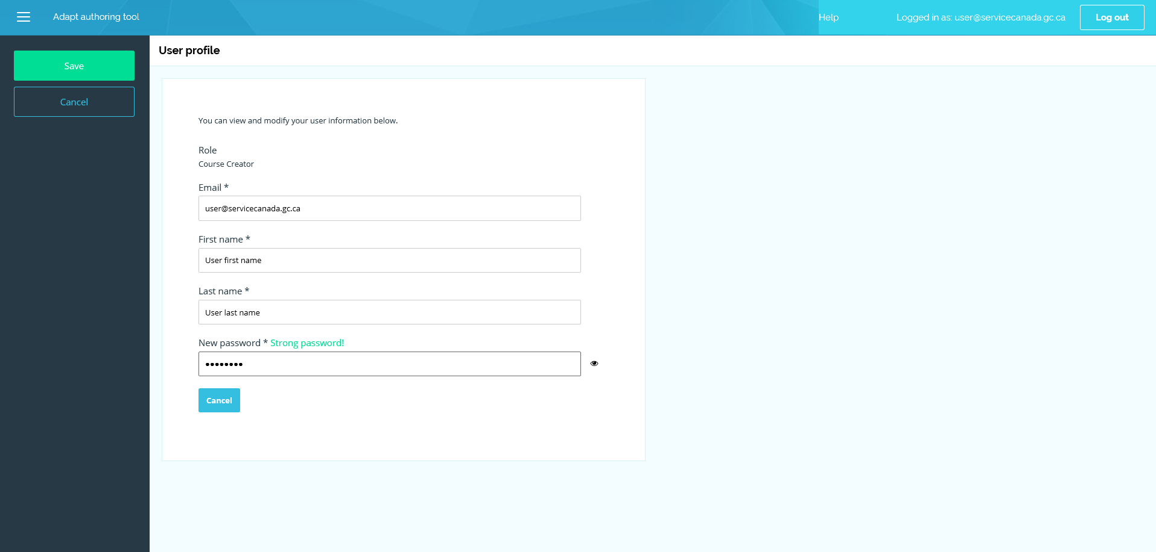

This displays a **New password** field where you can update your password. At least 8 characters (including uppercase and lowercase letters, numbers and symbols) are required.

**Note**: If you forget your password or username, please send a message to [NC-SIGA-SABA-APPRENTISSAGE-ILMS-SABA-LEARNING-GD@hrsdc-rhdcc.gc.ca](mailto:NC-SIGA-SABA-APPRENTISSAGE-ILMS-SABA-LEARNING-GD@hrsdc-rhdcc.gc.ca?subject=Demande%20de%20cr%C3%A9ation%20de%20compte%20Adapt%20%7C%20Request%20for%20Adapt%20account%20creation).

Once your password is updated, select the button labelled **Save** to update the information, and return to your Dashboard.