**How to Log Into Your Adapt Account**

Congratulations on completing the **Adapt Authoring Tool – Beginners** course!

Since you have made it this far, it is now time to get some hands-on experience using Adapt. However, in order to do that, you need to set up an Adapt account. Select the link provided in the “Account Creation” section of the course to obtain a username and password.

Once you receive an email reply with your username and password:

1. Select this [Adapt Learning](https://esdcadapt.canadacentral.cloudapp.azure.com/#user/login) link to go to the Adapt login page. You may want to bookmark this page for future reference! Please note we recommend using Microsoft Edge, the approved departmental browser.
2. Log in using the username (your email address) and the password provided.

Once you log in, you will be taken to the Adapt Dashboard.

The default view for the Dashboard is **My courses**, and it displays courses that you have already created in Adapt. For a new user, this page will be blank.

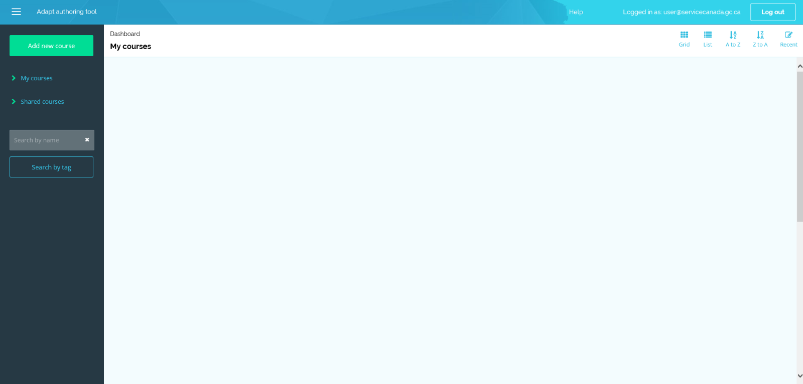

Once your user profile is created, you will see the information you provided in your original account creation request (Email address, First name, and Last name).

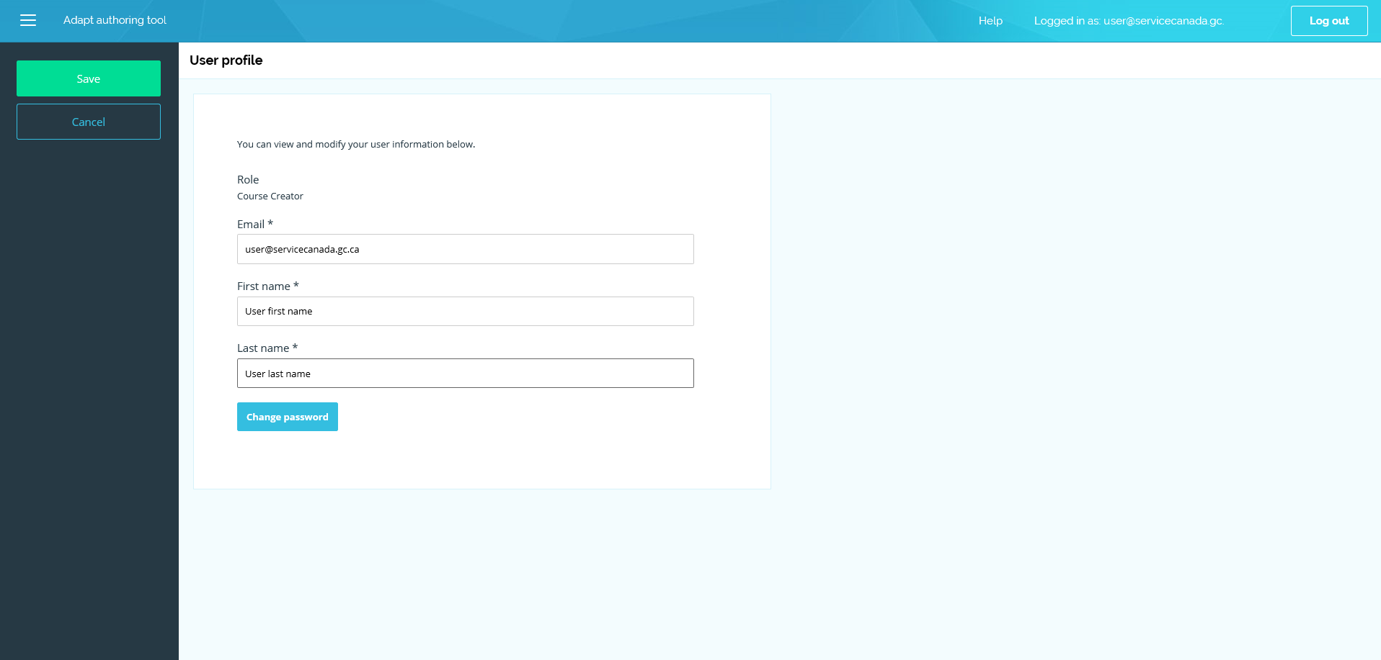

If you wish to modify your user information, select your email address located at the top of your screen.

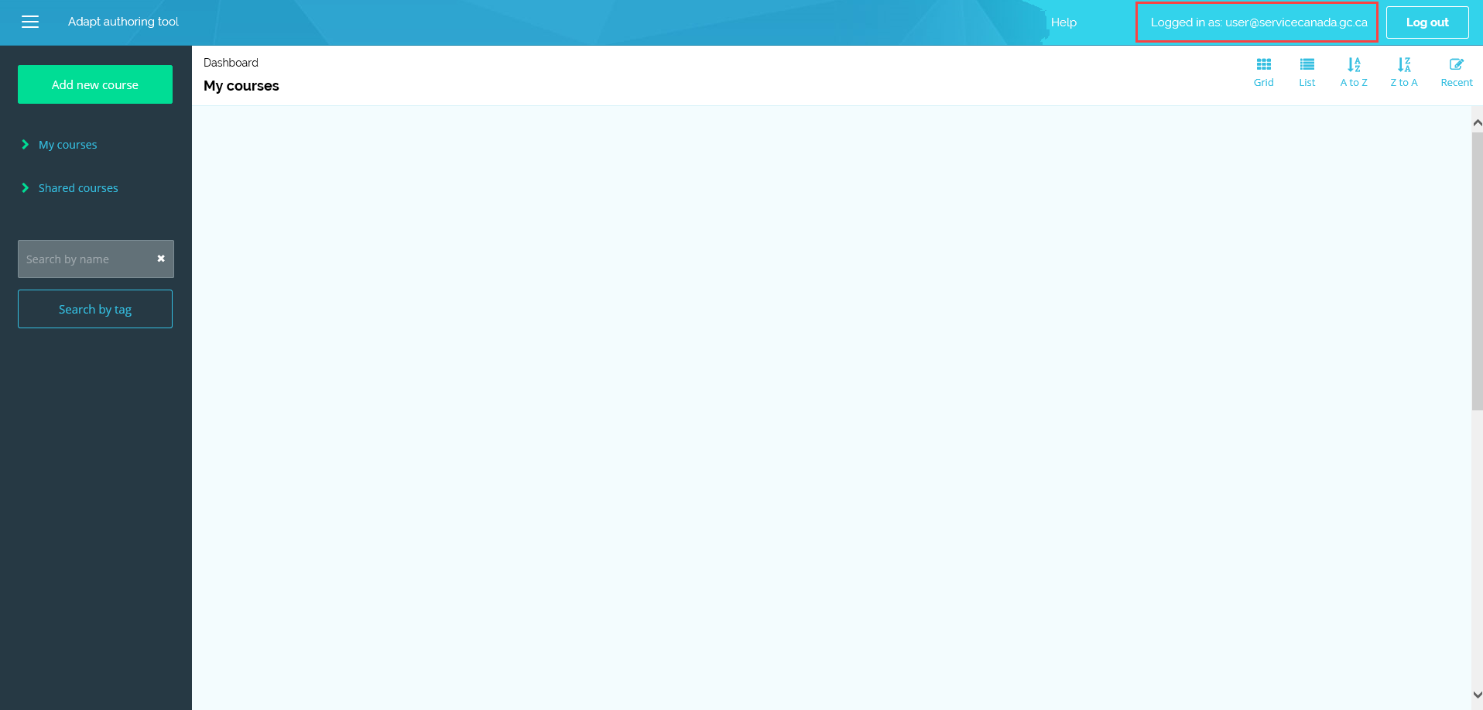

Select the button labelled **Save** to accept any changes**.**

**Note**: If you forget your password or username, please send a message to [NC-SIGA-SABA-APPRENTISSAGE-ILMS-SABA-LEARNING-GD@hrsdc-rhdcc.gc.ca](mailto:NC-SIGA-SABA-APPRENTISSAGE-ILMS-SABA-LEARNING-GD@hrsdc-rhdcc.gc.ca?subject=Demande%20de%20cr%C3%A9ation%20de%20compte%20Adapt%20%7C%20Request%20for%20Adapt%20account%20creation).

Once you return to your Dashboard, you can select how your courses are displayed (**Grid, List**, alphabetical [**A to Z** or **Z to A**], or **Recent**) by selecting one of the buttons located at the top of the screen.

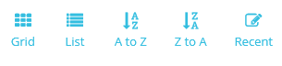

The sidebar allows you to:

* Add a new course (button labelled **Add new course**),
* View courses you have created, (**My courses**), and
* View **Shared courses** (created by others and shared with you)**.**

**Note**: You can also use the sidebar to search a course by name or by tag. Please connect with your Adapt super user for more guidance.

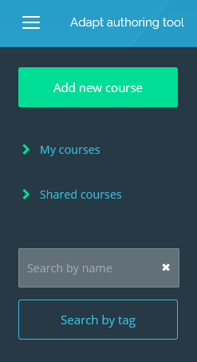

**Note**: Besides being able to view shared courses, you can also edit or delete them.

**Warning:** If you delete a shared course, it will also delete it from the account of the author.

To share a course that you have created, you will have to select **Project settings** from the sidebar. You will learn more about this in future modules, or please connect with your Adapt super user for more guidance.

There is also a buttonlabelled **Add new course** on the sidebar. Selecting this button allows you to create a new Adapt course.

Please refer to the “Exploring Components” section of the **Adapt Authoring Tool – Beginners** to review the walkthrough for setting up the basic components.