Download bag_to_csv,py from:

<http://www.clearpathrobotics.com/assets/guides/kinetic/ros/Converting%20ROS%20bag%20to%20CSV.html>

Then put the bag file and the python file in the same folder, run the python file.

The python file will convert every rostopic into csv files.

Choose the one with name: _slash_detection_slash_vision_objects_slash_front.csv, which contains the coordinates of the bounding box:(in yolo format)

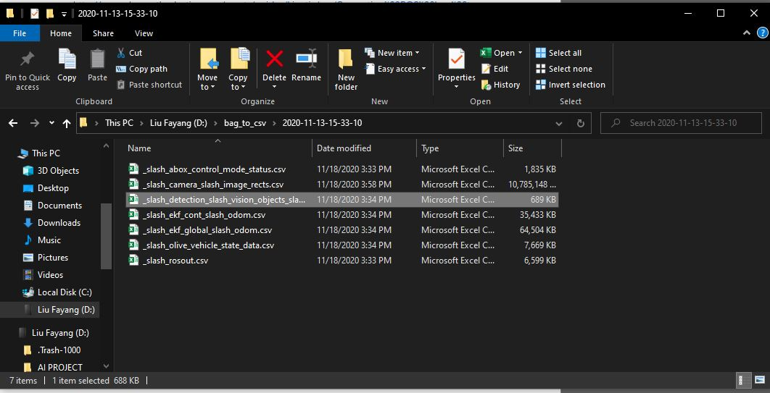

Delete other files.

Note: Do not convert the csv file into a xsl file, otherwise later the csv_to_txt file won’t work.

Data preparation can be done with excel.